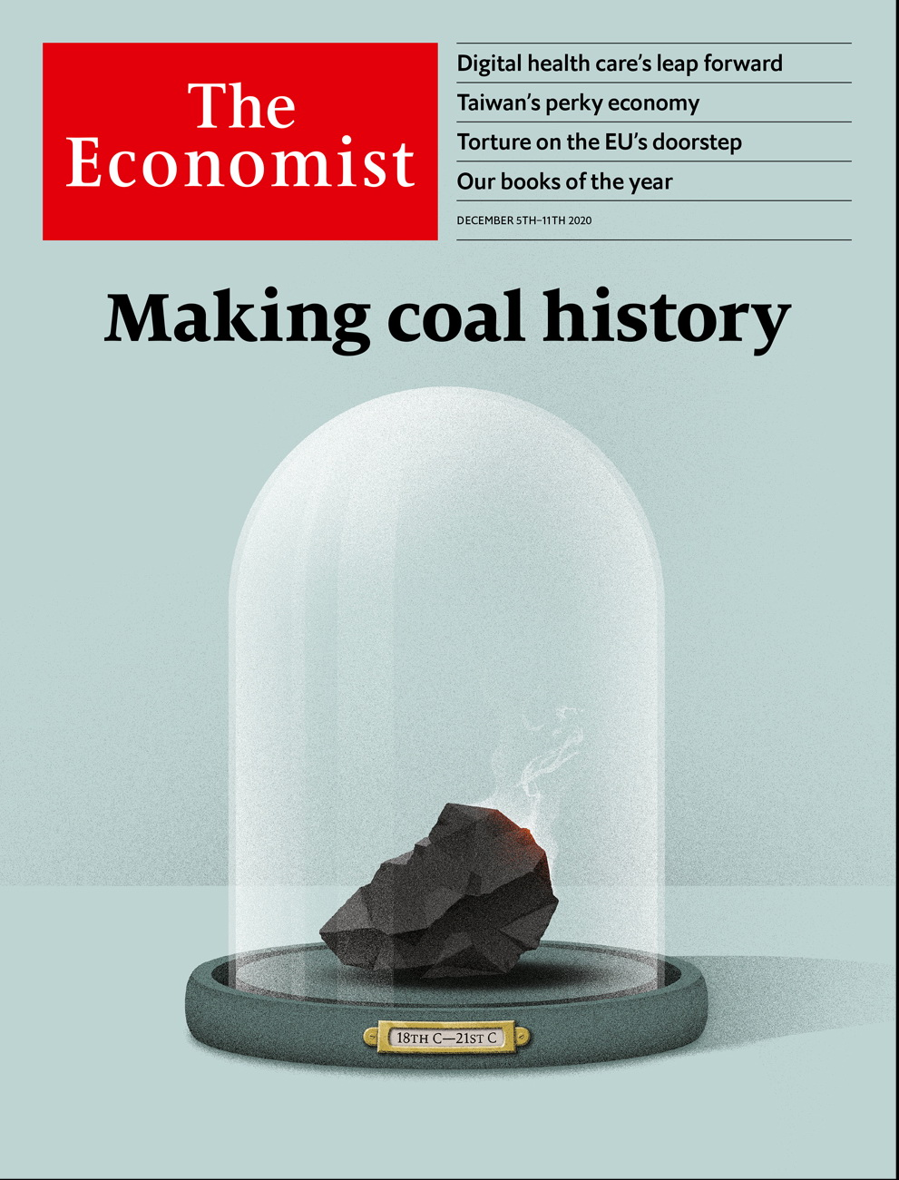

# Table of Contents

The world this week

Politics this week

Business this week

KAL’s cartoon

Leaders

Energy: Make coal history

Belarus: The colours of terror

Health care: Alive and kicking

America and Iran: Towards a better nuclear deal

“The Crown”: Uneasy lies the head of production

Letters

On Afghanistan, diplomats, Hong Kong, the Democrats, the colour black, hipsters: Letters to the editor

Briefing

Coal’s endgame: Crushing it

Asia

The Taiwanese economy: Tiger balm

Inequality in India: Compounding

Coal and climate in Australia: Losing seam

Indonesian politics: Son set

Ungulates in Japan: Hungry for visitors

Banyan: Death of a novelist

China

The coastguard: Great white hulls

Where the party wants him: Jailings in Hong Kong

Housing in Hong Kong: Phew, no democrats

Chaguan: The downside of bullying

United States

The economy: You must believe in spring

Campaign financing: Not for sale

Corporate transparency: Shell collecting

Water: With the lead piping

America’s spies: Shadow business

Lexington: Jake Sullivan to the rescue

Middle East & Africa

America and Iran: Back to the future

Burundi and Tanzania: No haven

Ethiopia’s civil war: Victory, defeat and confusion

Nigeria: Death in a rice field

The Americas

Cuba: The art of dissent

Canada: Alberta goes green

Bello: The man without a plan

Europe

Belarus: A new country struggles to be born

Turkey: Picking up the pieces

France: A screeching U-turn

Dutch populism: On the Chopin block

Charlemagne: To ski or not to ski?

Britain

The National Health Service: Unleashed

Trans rights: Bellwether?

The Brexit endgame: How late it was, how late

Eastern European migration: Farewell to all that

Cyber defence: Use the force

Retailing: Shopocalypse

Bagehot: Tidying Boris up

International

The modern household: Nuclear retreat

Business

Health care and technology: The dawn of digital medicine

Pandemic gastronomy: Malls’ last stand

Carmaking: In the hot seat

Exchange-traded fiends: Boiling point

Business software: Get me some Slack

Chinese hoteliers: Hospitable climate

Stakeholderism: Swiss miss

Bartleby: Managing by Zooming around

Schumpeter: Feathering its own Nestlé

Finance & economics

Ping An: Metamorphosis

Financial-market data: Go figure

Joe Biden’s advisers: Top picks

Buttonwood: The ABC of the euro zone

Music rights: Tuning in

India’s market rally: Dramatic disconnect

Free exchange: The disintermediation dilemma

Science & technology

Computational biology: The shapes of things to come

Space flight: Tally ho!

Sustainable fishing: The ones that got away

Vaccine safety: An injection of urgency

Books & arts

Books of the year: Cold comforts

Books by Economist writers: Private passions

Economic & financial indicators

Economic data, commodities and markets

Graphic detail

Vaccines and stockmarkets: What goes up

Obituary

Diego Maradona: A boy and a ball



Friday, December 4, 2020

|  |  |
| --- | --- |
| The world this week | 3 |
| Leaders | 5 |
| Letters | 1 |
| Briefing | 1 |
| Asia | 6 |
| China | 4 |
| United States | 6 |
| Middle East & Africa | 4 |
| The Americas | 3 |
| Europe | 5 |
| Britain | 7 |
| International | 1 |
| Business | 9 |
| Finance & economics | 7 |
| Science & technology | 4 |
| Books & arts | 2 |
| Economic & financial indicators | 1 |
| Graphic detail | 1 |
| Obituary | 1 |

### 加迪迪QQ1562739651问外刊群群号

|  |  |  |
| --- | --- | --- |
|  | Sections | Leaders |

The world this week

Politics this week

.

Business this week

.

KAL’s cartoon

.

|  |  |  |
| --- | --- | --- |
|  | Sections | Leaders |

|  |  |  |  |
| --- | --- | --- | --- |
|  | Articles | Sections | Next |

# Politics this week

Dec 3rd 2020 |

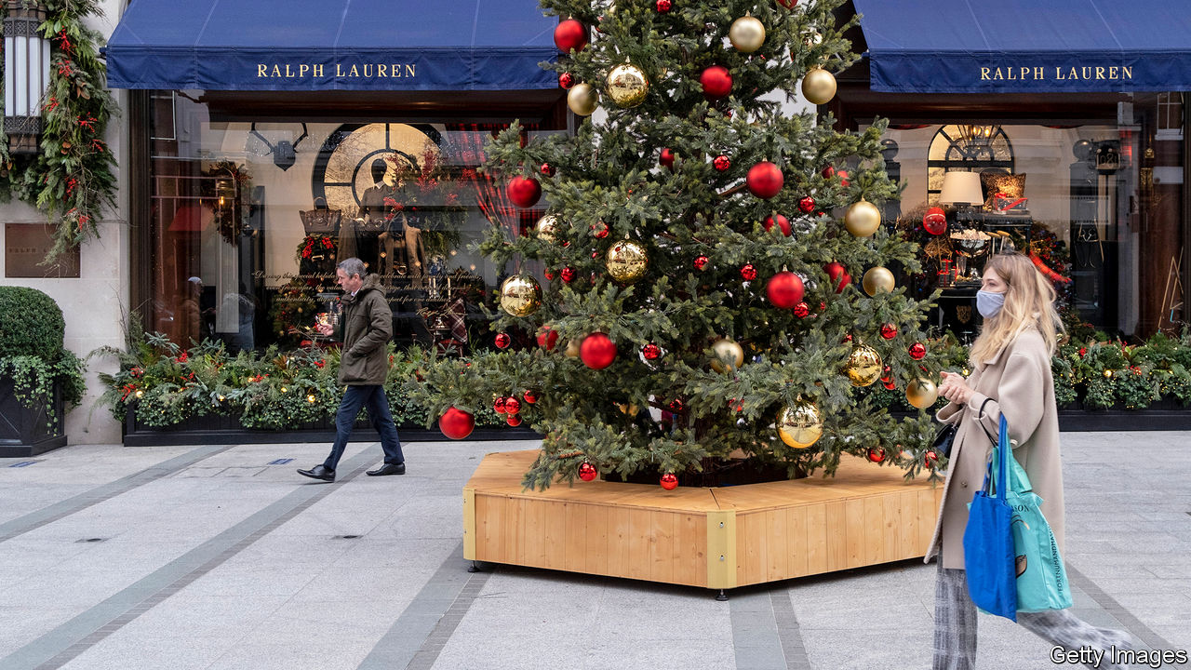

Britain became the first country to license a fully tested vaccine for covid-19. The medicines regulator gave its approval to the Pfizer/BioNTech jab following a “rolling review” process, used to assess promising vaccines during a health emergency. Data from the vaccination programme will continue to be reviewed as they become available. Priority distribution will start within a week. America is expected to approve a vaccine soon and the EU by the end of the month.

Boris Johnson faced his biggest backbench rebellion since becoming prime minister over the confusing rules in the new regional tier-system that replaced lockdown in England. Parliament approved the plan. Customers may order booze in pubs only if it comes with a substantial meal. A pub renamed one of its beers “Substantial Meal”.

President Emmanuel Macron of France ordered his government to redraft a proposed law that would have made it illegal in some circumstances to publish photographs of police. He did so after CCTV footage of three cops beating and racially abusing a black man went viral. Such footage might have been illegal to publish under the proposed law, civil libertarians noted.

Tributes were paid to Valéry Giscard d’Estaing, the president of France from 1974 to 1981, who has died aged 94. Mr Giscard d’Estaing helped formalise a role for the summits of Europe’s heads of state through the European Council. In France he battled the Catholic church to liberalise abortion and divorce laws.

Cuban police arrested 14 members of a dissident group called Movimiento San Isidro. They had locked themselves into the movement’s headquarters in Havana, and some went on hunger and thirst strikes, to protest against the jailing of Denis Solís, a rapper charged with disrespecting authority. After the raid hundreds of activists gathered at the culture ministry. In a small but rare concession, the vice-minister of culture met a delegation representing them.

Brazil’s space agency reported that 11,000 square km (4,000 square miles) of forest were destroyed in the Amazon from August 2019 to July 2020, the most since 2008.

Ethiopian forces entered Mekelle, the capital of the northern region of Tigray, less than a month after the start of a civil war between the federal government and the regional one. Tigrayan fighters have withdrawn from towns in the region in order to launch a guerrilla war.

Bobi Wine suspended his presidential campaign in Uganda after members of his staff were injured when security forces fired rubber bullets at one of his rallies. In November at least 54 people were killed, most of them by the security forces. Mr Wine is running against Yoweri Museveni, who has led Uganda since 1986.

The Iranian government accused an opposition group of working with Israel to assassinate Mohsen Fakhrizadeh, Iran’s most senior nuclear scientist, using a remote-controlled machine gun. Iran’s parliament passed plans to ramp up the country’s nuclear programme. But President Hassan Rouhani opposed the move, which would endanger a potential rapprochement with America under Joe Biden.

Israel’s parliament passed a preliminary proposal to dissolve itself, moving the country closer to a fourth election in under two years.

Joe Biden filled out the rest of his economic team for his incoming government. Cecilia Rouse will lead the Council of Economic Advisers, and Brian Deese the National Economic Council. Both were advisers in the White House during the global financial crisis in 2009. The choice of Neera Tanden to head the Office of Management and Budget is more controversial. Ms Tanden has reportedly deleted 1,000 tweets that disparaged Republican senators she now has to count on to confirm her in the job.

A court in Hong Kong sentenced a prominent pro-democracy activist, Joshua Wong, to more than 13 months in prison for his role in a protest last year. Agnes Chow and Ivan Lam, who were fellow leaders of his now disbanded group, Demosisto, were also jailed.

In Beijing a court began hearings into a case involving a woman who says a television host sexually harassed her. He has denied the charge. The alleged offence has become a cause célèbre among campaigners in China for women’s rights.

Hundreds of thousands of farmers besieged Delhi, blocking highways. They demanded the scrapping of recent agricultural reforms, which could allow the Indian government to stop offering guaranteed prices for crops.

Indonesia called off plans for an 11-day holiday subsuming Christmas and the new year, for fear that people travelling would spread covid-19. The extra holidays had been intended to make up for ones scrapped earlier this year to help curb the epidemic.

The National Assembly in South Korea approved a change allowing K-pop stars who have won government awards to defer mandatory military service until the age of 30, instead of 28. This came days before the 28th birthday of a member of BTS, the world’s most successful band.

## Coronavirus briefs

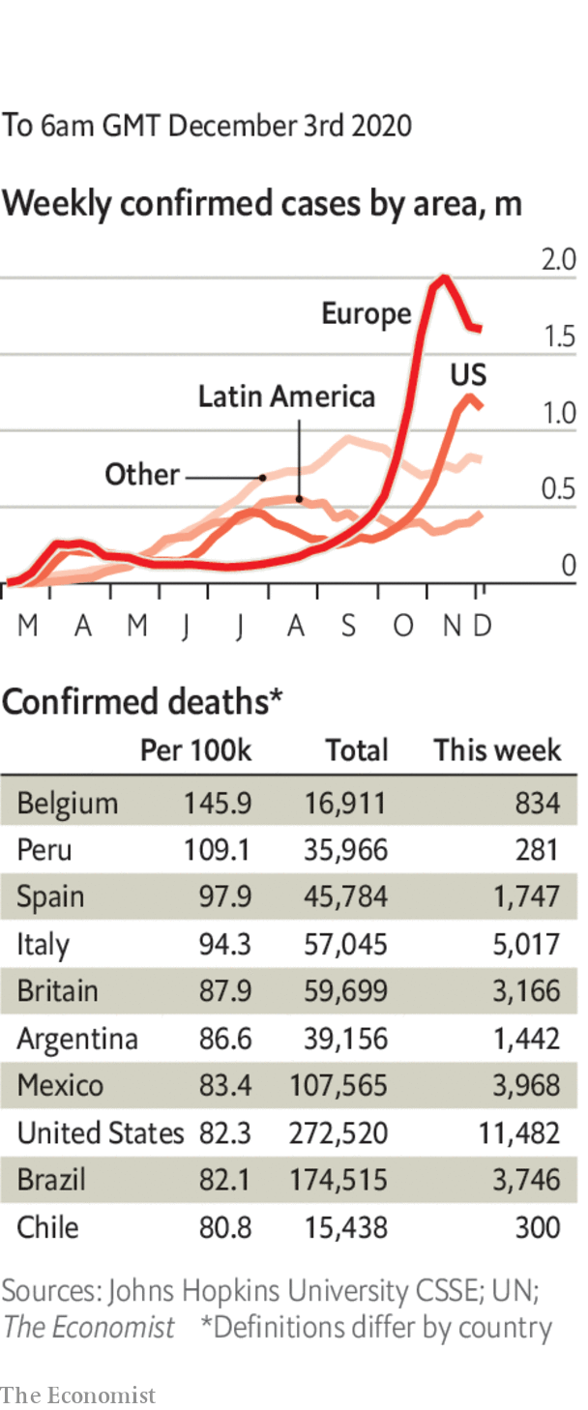

The number of daily deaths in America approached their highest levels during the pandemic. The number of people in hospital with the disease surged in November and is now above 100,000.

Los Angeles County, the most populous in the United States, entered a three-week period of tight restrictions during which people are urged to stay at home and wear face masks outside. Meeting other households is banned.

Vietnam reported its first locally transmitted case of covid-19 in nearly three months.

Many businesses reopened in Ireland after a six-week lockdown. People still cannot travel outside their county, however, except for work, study or health reasons.

Hong Kong reduced the limit on the number of people who can gather in public from four to two.

This article was downloaded by calibre from <https://www.economist.com/the-world-this-week/2020/12/03/politics-this-week>

|  |  |  |  |
| --- | --- | --- | --- |
|  | Articles | Sections | Next |

|  |  |  |  |
| --- | --- | --- | --- |
| Previous | Articles | Sections | Next |

# Business this week

Dec 3rd 2020 |

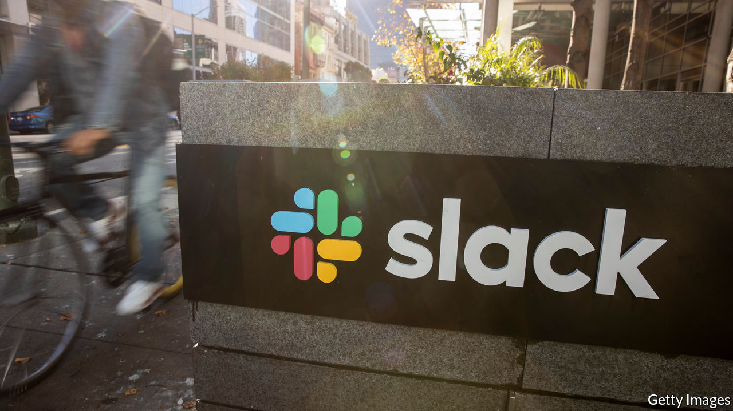

Salesforce agreed to buy Slack for $27.7bn, combining its range of business software with a chat platform tailored to companies. United they will increase competition for Microsoft, which has pulled ahead of many rivals in this year of working from home, when firms have relied on cloud services more than ever. Microsoft’s Teams platform has also been a formidable challenger to Slack. Shares in Slack have performed poorly compared with other providers of remote tech. See [article](https://www.economist.com/node/21795946).

## What looms for Zoom?

Zoom, one of the chief beneficiaries from the turn to remote working, reported that revenue soared by 367% in its latest quarter, year on year, to $777m. But its share price took another knock, as the news on vaccines and the prospect of a return to office normality raised more questions about its future.

There was more consolidation in the data-provision industry, as S&P Global , best known for compiling credit ratings, struck a deal to acquire IHS Markit, an American-British information provider. At $44bn, it is the largest takeover in America this year. See [article](https://www.economist.com/node/21795944).

Airbnb said it would price its forthcoming IPO at between $44 and $50 a share, which would value it at up to $35bn. That is double a private estimate from earlier this year, when the home-rental firm was hit by lockdowns. It has since bounced back, as people seek remote dwellings either to work in or to get away from it all. The pandemic “has accelerated the ability to live anywhere” Airbnb recently said.

China followed through with its threat to impose tariffs of between 107% and 212% on Australian wine imports. China is the biggest market for Aussie wineries. Beijing says the tariffs are an anti-dumping measure to stop Australian imports damaging the domestic wine industry, but it has slapped tariffs on other Australian goods this year, as the countries’ diplomatic relations have worsened.

The government might be about to change in Washington, DC, but a new law that may in effect ban trading in shares of Chinese companies on American stock exchanges over concerns about their accounting practices is very close to becoming reality. The House of Representatives unanimously passed the bill this week. It has already cleared the Senate. Chinese companies would have three years to comply with the law. See [article](https://www.economist.com/node/21795921).

The organisation that runs Libra, a cryptocurrency that has been proposed and backed by Facebook, renamed the project “Diem”. Following criticism from regulators around the world the payments system has much less scope than its creators had hoped, but according to reports the first Diem dollar, backed by the American dollar, could be launched next month.

ExxonMobil wrote down $20bn-worth of assets in natural gas. The energy company was the world’s biggest by market capitalisation seven years ago. It has yet to report a profit this year and was removed from the Dow Jones Industrial Average in August.

Turkey’s economy grew by 15.6% in the third quarter over the previous three months, and by 6.7% compared with the same quarter last year. The spurt in growth was fuelled by government-backed credit. However, with exports falling, a widening current-account deficit could spell more trouble for the lira.

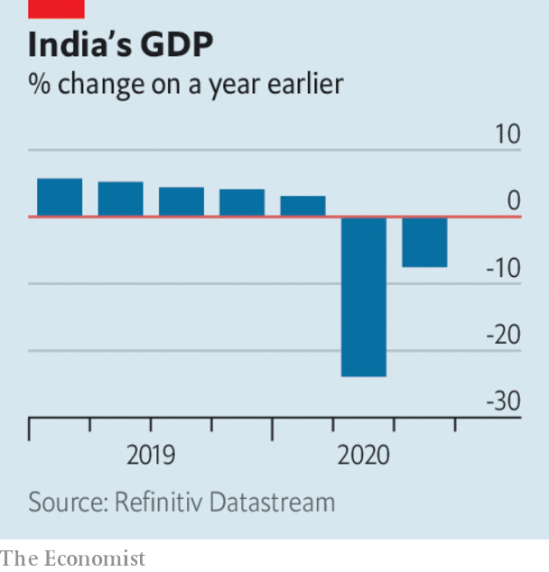

India’s economy is still struggling, contractingby 7.5% in the three months ending September, year on year. Still, that was an improvement on the previous quarter, when GDP shrank by 24%. See [article](https://www.economist.com/node/21795903).

The OECD’s latest outlook forecast that global GDP will return to pre-pandemic levels by the end of next year, if outbreaks of covid-19 are under control and vaccines are widely available. It forecasts the world economy will grow by around 4% in both 2021 and 2022. The recovery will be uneven, however. China and other non-OECD countries will chalk up faster growth rates than developed ones.

In Britain, the pandemic pushed more long-struggling retailers to the wall. Arcadia, which owns a string of high-street clothing brands, such as Topshop and Burton, fell into administration. That led the firm behind a potential rescue of Debenhams to pull out of its deal; the department-store chain now faces liquidation. The collapse of both retailers puts 25,000 jobs at risk. See [article](https://www.economist.com/node/21795887).

## Golden State loses its lustre

Hewlett Packard Enterprise, which provides computer servers and IT services, decided to move its headquarters from Silicon Valley to Houston. In 2015 HPE split from the PC-and-printer business that was Hewlett Packard, a computing pioneer born in Silicon Valley and often synonymous with the famous tech cluster. HP computers is still based there, though the region’s high living costs and terrible traffic have made Texas a tempting location for many tech companies.

This article was downloaded by calibre from <https://www.economist.com/the-world-this-week/2020/12/03/business-this-week>

|  |  |  |  |
| --- | --- | --- | --- |
| Previous | Articles | Sections | Next |

|  |  |  |  |
| --- | --- | --- | --- |
| Previous | Articles | Sections | Next |

# KAL’s cartoon

Dec 3rd 2020 |

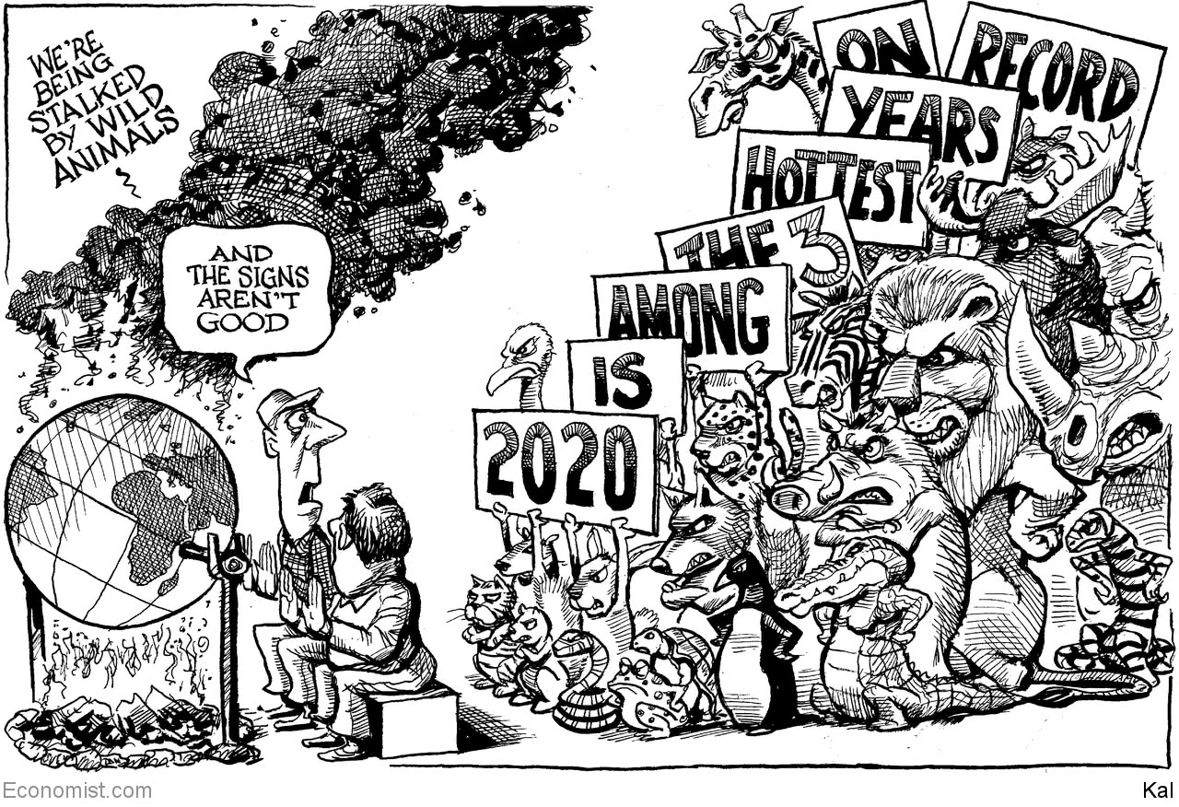

This article was downloaded by calibre from <https://www.economist.com/the-world-this-week/2020/12/03/kals-cartoon>

|  |  |  |  |
| --- | --- | --- | --- |
| Previous | Articles | Sections | Next |

|  |  |  |
| --- | --- | --- |
| The world this week | Sections | Letters |

Leaders

Energy: Make coal history

.

Belarus: The colours of terror

.

Health care: Alive and kicking

.

America and Iran: Towards a better nuclear deal

.

“The Crown”: Uneasy lies the head of production

.

|  |  |  |
| --- | --- | --- |
| The world this week | Sections | Letters |

|  |  |  |  |
| --- | --- | --- | --- |
|  | Articles | Sections | Next |

#### Killing coal

# Time to make coal history

Coal is at the toxic heart of the fossil fuel economy

Dec 3rd 2020 |

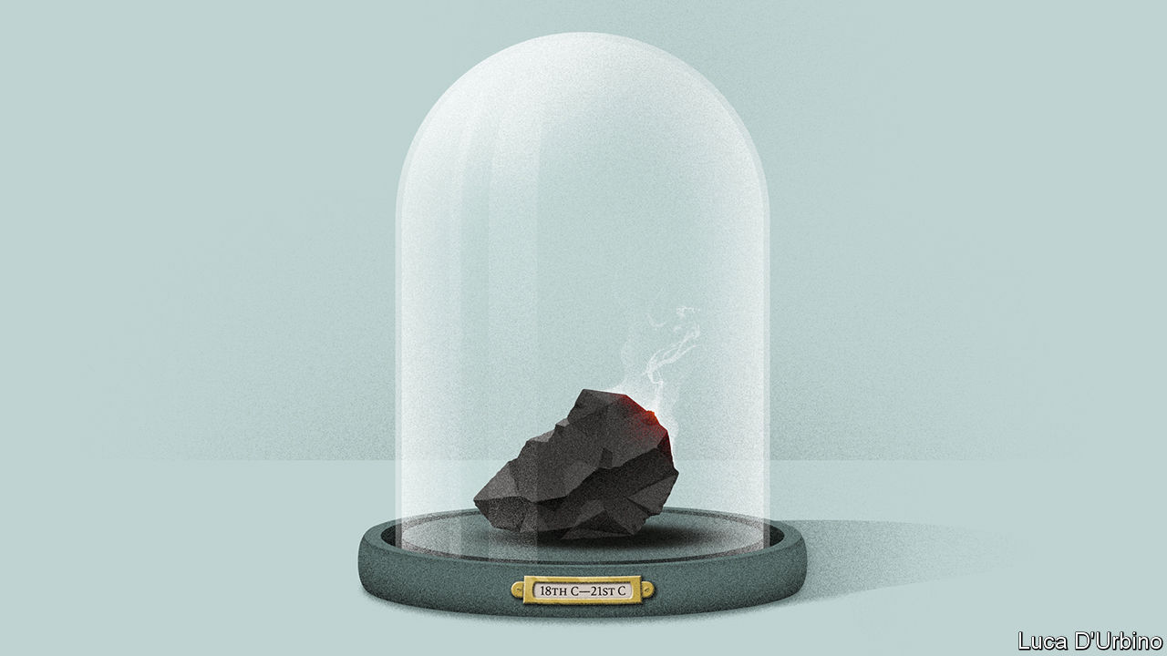

AROUND THE world the mood is shifting. Xi Jinping has adopted a target to cut China’s net carbon emissions to zero by 2060. Under Joe Biden, America will rejoin the Paris agreement, which it adopted five years ago. In the financial markets clean-energy firms are all the rage. This month Tesla will join the S&P 500 share index—as one of its largest members.

Remarkably, in a realm where words are cheap, there has been action, too. In America and Europe the consumption of coal, the largest source of greenhouse gases, has fallen by 34% since 2009. The International Energy Agency, an intergovernmental body, reckons that global use will never surpass its pre-covid peak.

Yet coal still accounts for around 27% of the raw energy used to power everything from cars to electric grids. Unlike natural gas and oil, it is concentrated carbon, and thus it accounts for a staggering 39% of annual emissions of CO² from fossil fuels (see Briefing). If global emissions are to fall far enough, fast enough, the task now is to double down on the West’s success and repeat it in Asia. It will not be easy.

Coal came of age in the Industrial Revolution. In the rich world its use in furnaces and boilers peaked in the 1930s and faded as cleaner fuels became available. Consumption in the West has recently collapsed. In Britain the last coal-fired power plants could close as soon as 2022. Peabody Energy, a big American coal miner, has warned that it may go bankrupt for the second time in five years.

Although carbon prices accelerated the shift in Europe, the Trump administration has favoured America’s coal industry with deregulation and political support—and still it has declined. One reason is competition from cheap natural gas produced in America by fracking. Tax credits and subsidies have prompted renewables to scale up, which has in turn helped drive down their costs. Solar farms and onshore wind are now the cheapest source of new electricity for at least two-thirds of the world’s population, says BloombergNEF, a data group. As coal faces cleaner rivals and the prospect of more regulation, banks and investors are turning away, raising coal’s cost of capital.

This is a victory, but only a partial one. In the past decade, as Europe has turned against coal, consumption in Asia has grown by a quarter. The continent now accounts for 77% of all coal use. China alone burns more than two-thirds of that, followed by India. Coal dominates in some medium-sized, fast-growing economies, including Indonesia and Vietnam.

If the aim is to limit global temperature rises to 2°C above pre-industrial levels, it is no good waiting for Asia’s appetite for coal to fade. New plants are still being built. Many completed ones are not yet fully utilised and still have decades of life in them. Nor is it enough to expect a solution from “clean coal” technologies, which aim to capture and store emissions as they are released. They may help deal with pollution from industrial uses, such as steelmaking, but they are too expensive for power generation.

Hence Asia needs new policies to kick its coal habit, and soon. The goal should be to stop new coal-fired power plants being built and to retire existing ones. Some countries have taken a first step, by imposing new targets and bans. The Philippines has declared a moratorium on new plants; Japan and Bangladesh are slowing construction, too. China’s new five-year-plan, which will be published next year, may limit coal use. It should set its cap at current levels, so that the decline can start immediately.

If targets are to be credible, Asian countries must tackle deeper problems. The strategy that worked in Europe and America will get them only so far, because the mining firms, power stations, equipment-makers and the banks that finance them are often state-controlled. Market forces and carbon taxes, which use price signals to change incentives, are therefore less effective. And coal politics is treacherous. The coal economy forms a nexus of employment, debt, tax revenues and exports. China has used its Belt and Road Initiative to sell both mining machinery and power plants. Across the region, local governments depend on coal for revenues. Many will defend it ferociously.

One step in fighting regional lobbies is to redesign power systems so that renewables can compete fairly and incentives work. Most renewables provide only intermittent power, because the weather is changeable. National smart grids can mitigate this by connecting different regions. Too many of Asia’s electricity systems muffle market signals because they are locked into legacy long-term supply contracts with coal firms, and because they are riddled with opaque subsidies and price caps. Removing these so that markets and taxes work better will let renewable power undercut coal.

The other step is to compensate losers. The lesson from destitute mining towns in south Wales and West Virginia is that job losses store up political tensions. Coal India, the national mining colossus, has 270,000 workers. From Shanxi province in China to Jharkhand in India, local governments will need fiscal transfers to help rebalance their economies. Banks may need to be recapitalised: China’s state lenders may have up to $1trn at stake.

Europe and America have shown that King Coal can be dethroned, but they cannot be bystanders as Asia works to complete the revolution. Coal powered the West’s development. In 2019 coal consumption per person in India was less than half that in America. It is in Asia’s long-term interests to topple coal, but the short-term political and economic costs are large enough that action may be too slow. If politicians in Europe and America are serious about fighting global warming, they must work harder to depress coal elsewhere. That includes honouring prior promises to help developing countries deal with climate change.

Ultimately, though, the responsibility will lie with Asia itself. And the good news is that it is overwhelmingly in Asia’s interest to do so. Its people, infrastructure and agriculture are dangerously exposed to the droughts, flooding, storms and rising sea levels caused by climate change. A growing middle class yearns for their governments to clean up Asia’s choking metropolises. And renewable energy offers a path to cheaper power, generated at home, as well as a source of industrial employment and innovation. Coal’s days are numbered. The sooner it is consigned to museums and history books, the better. ■

For more coverage of climate change, register for The Climate Issue, our fortnightly [newsletter](https://www.economist.com/theclimateissue/), or visit our [climate-change hub](https://www.economist.com/news/2020/04/24/the-economists-coverage-of-climate-change)

This article was downloaded by calibre from <https://www.economist.com/leaders/2020/12/03/time-to-make-coal-history>

|  |  |  |  |
| --- | --- | --- | --- |
|  | Articles | Sections | Next |

|  |  |  |  |
| --- | --- | --- | --- |
| Previous | Articles | Sections | Next |

#### The colours of terror

# The world should not ignore systematic torture in Belarus

Having stolen an election, the regime is brutalising those who object

Dec 5th 2020 |

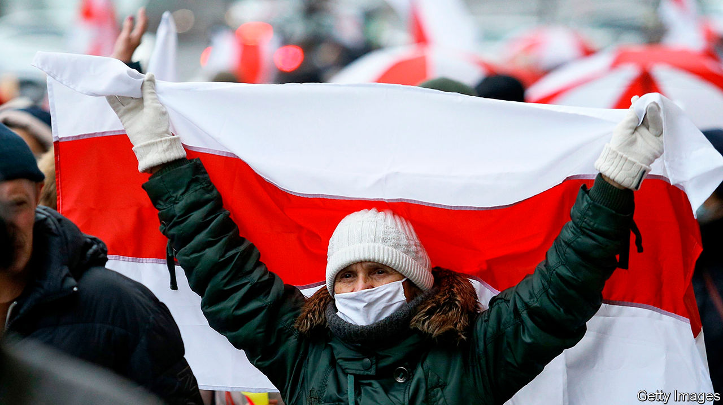

GREEN MEANS humiliation, which may involve sexual abuse or the threat of rape. It is reserved for young men sporting dreadlocks, long hair or piercings. Yellow paint, when daubed on those who ask too many questions or argue with riot police, spells a beating. Those who try to run away or resist arrest are sprayed with red paint and subjected to torture so severe that it could leave them disabled for life.

Colour-coding prisoners is standard practice in Belarus, a European country that has been ruled by Alexander Lukashenko for the past 26 years. What is new is that since August, when Mr Lukashenko declared himself president again after another fraudulent election, his goons have used colour codes to systematise the brutalisation of thousands of peaceful protesters, according to Nash Dom, a Belarusian NGO.

The colour codes testify to the scale both of state terror and of the national resistance movement. Over the past four months more than 30,000 people have been detained, and some 4,000 have alleged they have been tortured. Some have been stripped naked, shot with rubber bullets from close range, sodomised with truncheons or driven through a corridor of thugs for more beatings. Victims are paraded and humiliated on state television. Terrified into submission, some are forced to apologise on air for imaginary crimes.

Mr Lukashenko has so far stopped short of opening fire on demonstrators. However, several have been killed. The latest, 31-year-old Roman Bondarenko, a military veteran and children’s art teacher, was reportedly bludgeoned to death for trying to stop Mr Lukashenko’s thugs from taking down red and white ribbons, a symbol of national resistance. A doctor who tried to save him, and who contradicted the official story that Mr Bondarenko was drunk, was arrested and forced to recant on camera.

That such abuse can take place in a country which borders the European Union is a blot on the continent’s reputation. Yet the response from the EU’s key member states has been limp. Many European leaders, including Angela Merkel, the German chancellor, and Emmanuel Macron, the French president, have made the symbolic gesture of meeting Svetlana Tikhanovskaya, the probable true winner of the rigged election in August, who has since then been forced into exile (see [article](https://www.economist.com/node/21795908)). But sanctions against the Belarusian regime have been limited to a travel ban and an asset freeze for a few named officials, including Mr Lukashenko. In a slap to the Belarusian people, Israel has sent its ambassador to present Mr Lukashenko with his credentials.

The main reason for European inaction and Mr Lukashenko’s staying power is Russia, which has forged a kind of political union with Belarus. Vladimir Putin, Russia’s president, has warned the West against meddling in what he claims as his backyard. After his invasion of eastern Ukraine in 2014, few Western leaders are willing to wade in. But there are some simple steps that they could and should take, preferably together.

To start with, they should stop buying chemicals, petrol and metal from Belarus’s state-owned firms and impose sanctions on anyone who does. More important, they should offer the prospect of justice to the people of Belarus and punishment to their torturers. They should do so not just for the sake of Belarusians but also to honour their own values. Next year, when Joe Biden is president of the United States, he should do the same.

Violence is carried out not by abstract agencies, but by specific people who serve in them and hide their faces beneath balaclavas. Those agencies should be designated for what they are—organs of terror. Western governments should take a cue from Lithuania and Poland in collecting evidence and setting up investigations into crimes against humanity. They should apply the principle of universal jurisdiction in cases of torture. Standing up for human rights in Belarus is not interference. It is the duty of every self-respecting country. ■

This article was downloaded by calibre from <https://www.economist.com/leaders/2020/12/05/the-world-should-not-ignore-systematic-torture-in-belarus>

|  |  |  |  |
| --- | --- | --- | --- |
| Previous | Articles | Sections | Next |

|  |  |  |  |
| --- | --- | --- | --- |
| Previous | Articles | Sections | Next |

#### Alive and kicking

# The digital surge in health care

How will the pandemic change health care?

Dec 5th 2020 |



VAST, BUREAUCRATIC and amorphous, health care has long been cautious about change. However, the biggest emergency in decades has caused a revolution. From laboratories to operating theatres, the industry’s metabolism has soared, as medical workers have scrambled to help the sick. Hastily and often successfully, they have improvised with new technologies. Their creativity holds the promise of a new era of innovation that will lower costs, boost access for the poor and improve treatment. But to sustain it, governments must stop powerful lobbies from blocking the innovation surge when the pandemic abates.

Covid-19 has led to the spectacular development of vaccines using novel mRNA technologies. But there have also been countless smaller miracles as health workers have experimented to save lives (see article). Obsolete IT-procurement rules have been binned and video-calls and voice-transcription software adopted. Machines are being maintained remotely by their makers. With patients stuck at home, doctors have rushed to adopt digital monitoring of those recovering from heart attacks. Organisational silos have been dismantled. All this has taken place alongside a boom in venture-capital-raising for medical innovation: $8bn worldwide in the most recent quarter, double the figure from a year earlier. JD Health, a Chinese digital-medicine star, has just listed in Hong Kong (see article).

More innovation is needed. Global health spending accounts for 5% of GDP in poor countries, 9% in rich ones and 17% in America. The industry employs over 200m people and generates more than $300bn of profits a year. But as well as being risk-averse, it is insulated from change. Patients may not know which treatments are effective. The need to pool risk among many people creates administrative leviathans, typically national-health schemes in Europe, or insurers in America and some emerging economies. Complex rules enable firms to extract high profits.

The result is that productivity growth has been sluggish. High costs mean that many people in the developing world lack access to health care. Low efficiency may cause a fiscal crisis in some rich countries over the next two decades, as ageing populations force medical bills up further.

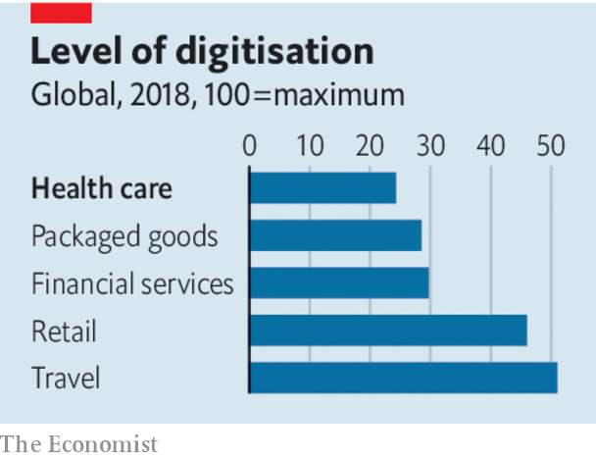

The pandemic helped show what is possible, partly because it got people to put aside their caution. Remote medical consultation and monitoring can lower costs and increase access. The share of remote visits at the Mayo Clinic, an American health provider, rose from 4% before the pandemic to 85% at the peak. Sehat Kahani, a Pakistani firm, has helped female remote doctors treat the poor in a socially conservative society. Ping An Good Doctor, a Chinese portal, had 1.1bn visits during the height of the pandemic there.

A surge in online pharmacy would increase competition. On November 17th Amazon announced its entry into the field, which promises to disrupt America’s industry dominated by big pharma and middlemen. That is just the start. Data-rich diagnosis could help specialists in routine analysis of, say, medical scans such as X-rays. A new generation of continuous glucose monitors for diabetics benefits from recent improvements in sensors. In time artificial intelligence will lead to drug innovations. This week DeepMind, an AI laboratory, announced a breakthrough in the analysis of proteins (see article).

Many of these trends should improve efficiency directly—with lower office rents, or the allocation of doctors in real time to rural areas where surgeries are scarce. But they are also likely to unleash a burst of competition and continuous improvement. More data will make it simpler to judge which treatments are most effective, the holy grail of medicine. Personal-health monitoring will mean that treatment becomes more preventive rather than reactive. And with more information, patients can make better decisions.

Governments can do their bit to help. Big health-care firms, such as insurers, and state-run health schemes, should be eager to recognise new digital services and pay for them. Germany and China have passed laws or new rules urging reimbursements of online services, for example. The evaluation of digital services for efficacy should be faster. America’s Food and Drug Administration has modernised its approval process for apps.

The other priority for governments is to build a system for the flow of health-care data. Individuals should have control over their records and grant permission to providers to gain access to them. India is creating national health IDs that will aim to combine privacy with mass data. Around the world hundreds of millions of medical records need to be anonymised and aggregated more efficiently so that researchers can scour data sets for patterns.

A rare chance to improve the quality of health care and lower its costs may vanish by the end of 2021. Exhausted health-care workers may prefer a rest to a revolution. Some of today’s medtech startups will flop, prompting a backlash. A few big tech firms may try to monopolise pools of data. And the industry’s powerful lobbies will try to lock out competitors. Health care is not a field where you set out to learn from your mistakes. Yet the pandemic has revealed that the industry became too used to being careful. It has redefined what is possible.■

This article was downloaded by calibre from <https://www.economist.com/leaders/2020/12/05/the-digital-surge-in-health-care>

|  |  |  |  |
| --- | --- | --- | --- |
| Previous | Articles | Sections | Next |

|  |  |  |  |
| --- | --- | --- | --- |
| Previous | Articles | Sections | Next |

#### Towards a better nuclear deal

# Joe Biden should drive a hard bargain with Iran

He has leverage. He should use it

Dec 5th 2020 |

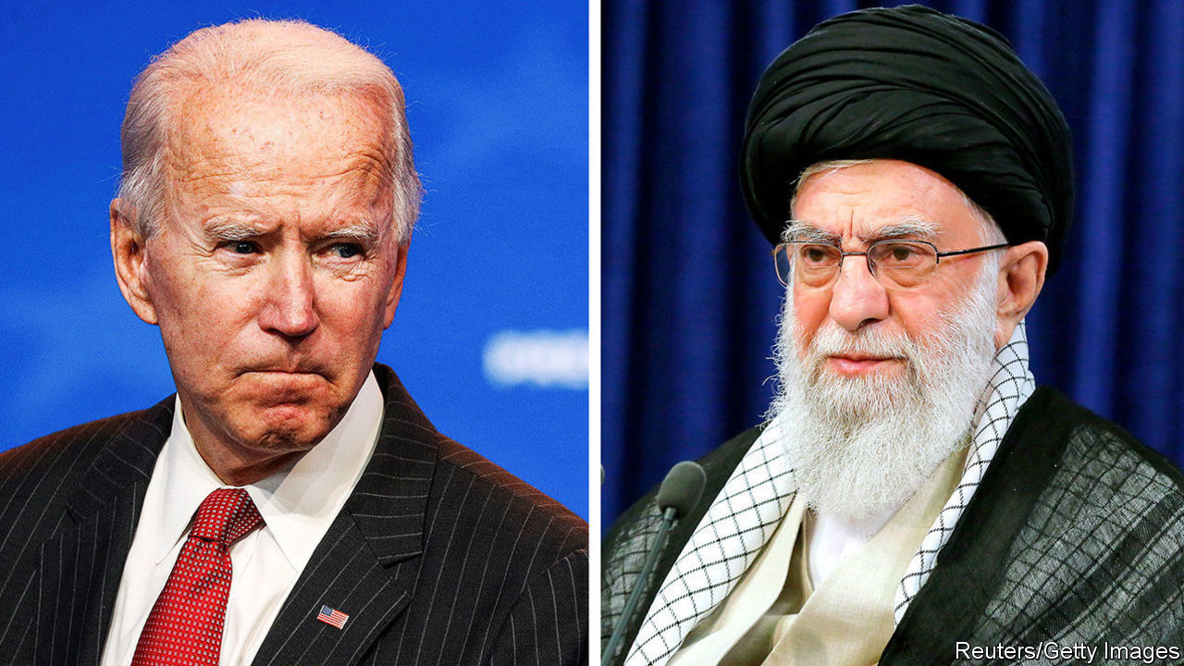

FOR THE past four years Iran’s enemies in the Middle East have had a friend in the White House. President Donald Trump blamed Iran for the region’s problems, sold arms to Israel and Arab states, and pulled America out of the deal that saw Iran limit its nuclear programme and agree to inspections in return for the lifting of international sanctions. In November Mr Trump retweeted news of the assassination of Mohsen Fakhrizadeh, the architect of Iran’s past nuclear-weapons programme.

The killing appears to have been the work of Israel, which has a history of bumping off Iranian nuclear scientists. With the clock ticking on the Trump administration, it may have been an attempt to scorch the earth before Joe Biden takes over. When it comes to Iran, Mr Biden prefers statecraft to sanctions and talks to targeted killings. He promises to return to the nuclear deal if Iran, which began breaching parts of it last year, moves back into compliance (see article).

More diplomacy would certainly be welcome. Mr Trump’s policy of “maximum pressure” has hurt Iran by cutting it off from the world economy—but the administration never seriously pursued a new deal. Iran is now closer to a bomb than it was at the start of Mr Trump’s term. Although covert operations may set Iran’s nuclear programme back, negotiations hold out the promise of a more lasting solution. Before Mr Biden jumps back into the nuclear deal, however, he should consider how things have changed since it was signed in 2015.

Start in the Gulf. The region has long lived under an American security umbrella. Yet when Iran carried out a series of attacks, including missile strikes, Mr Trump barely stirred. That not only raised doubts about American deterrence; it also highlighted a flaw in the nuclear deal, which says little about Iran’s missile programme and regional aggression. Such concerns have brought Israel and the Gulf states together. The United Arab Emirates and Bahrain have normalised relations with Israel, which is also working with Saudi Arabia. As the mullahs step up their nuclear activity, this anti-Iran axis is growing bolder. Israel may be behind several covert attacks inside Iran this year.

Things are also different in Iran. Five years ago Barack Obama’s team dealt with a pragmatic administration there. But the pragmatists have been discredited by the failure of the nuclear deal to bring economic benefits. Hardliners won parliamentary elections this year and one may win the presidential election in June. Iran’s response to the killing of Mr Fakhrizadeh highlights the tug-of-war between the camps. Parliament approved plans to stray further from the nuclear deal and kick out international inspectors. Hassan Rouhani, the relatively moderate president, opposes the bill.

All this complicates Mr Biden’s effort to turn back the clock. But America’s position has changed, too. The new administration may not like how Mr Trump and his team have handled Iran, but they have bequeathed it an extensive sanctions regime. Iran’s GDP fell by 5.4% in 2018 and 6.5% in 2019, and it is expected to fall again this year. The value of the Iranian rial has collapsed. The annual rate of inflation is around 30%. Although the ruling elite have found ways around sanctions, ordinary people are hurting. Their protests are put down by ruthless security men, but Iran’s clerical rulers are nervous.

Were Mr Biden to jump back into the nuclear deal quickly, it would mean lifting the sharpest sanctions and giving up much of this leverage. That would be a mistake. The president-elect says he wants to re-establish trust with America’s allies, but he will do that by negotiating competently, not by rolling over. Although he is unlikely to satisfy Israel, Saudi Arabia or Republicans, he should use his leverage to wring more out of Iran.

Mr Biden’s priority should be to extend the original accord, which expires over the next decade. Iran’s leaders appear open to the suggestion. They are less keen to discuss missiles, Iran’s principal means of deterrence. But Mr Biden should demand that they forswear long-range rocket launches and the transfer of missiles to regional proxies. In return he could gradually ease Iran’s economic pain and throw in sweeteners, such as access to dollars and more civilian nuclear co-operation.

There are steps Mr Biden can take in the meantime to lower tensions with Iran, such as lifting Mr Trump’s more symbolic sanctions. But he should drive a hard bargain with the mullahs. He is in a position to negotiate a broader, longer-lasting deal with Iran. He should take advantage of it. ■

This article was downloaded by calibre from <https://www.economist.com/leaders/2020/12/05/joe-biden-should-drive-a-hard-bargain-with-iran>

|  |  |  |  |
| --- | --- | --- | --- |
| Previous | Articles | Sections | Next |

|  |  |  |  |
| --- | --- | --- | --- |
| Previous | Articles | Sections | Next |

#### Uneasy lies the head of production

# Does it matter if “The Crown” fictionalises reality?

It is more truthful than the story the royals sold

Dec 5th 2020 |



“I’M STRUGGLING TO find any redeeming features in these people at all,” says Margaret Thatcher to her husband Denis in the course of a visit to Balmoral Castle, where the Thatchers are snubbed, humiliated and forced to play an after-dinner game called Ibble Dibble in which players smear their faces with burnt cork while getting drunk. Oliver Dowden, Britain’s culture secretary, takes a similar view of the portrayal of the Royal Family in “The Crown”. He believes that the real royals have been traduced by Netflix, which makes the drama, and has demanded that the company issue a health warning before future episodes, pointing out that the programme is fiction.

It seems odd that a government led by a man who is writing a book on Shakespeare should insist on historical accuracy in drama. Boris Johnson has not been heard complaining that “Richard III” libels a supposedly non-nepoticidal monarch. All drama that involves real people is, to some extent, fiction: when Charles and Diana stared into each other’s eyes and realised it was over, no one else was in the room where it happened. If those being portrayed are dead, decently behaved and unimportant, nobody cares what lines script writers make up for them. But if they are alive, adulterous and the heir to the throne, things are bound to get sticky.

It is not surprising, then, that the release of the latest episodes has been accompanied by the sound of remote controls ricocheting off Home County walls. Conservatives are furious because their pin-up, Margaret Thatcher, appears as a rasping termagant determined to spill the blood of Argentines and rub the noses of the poor in the dirt. The royals’ friends and flunkeys are outraged that the Windsors are portrayed as cold-hearted bullies who drive Diana to bulimia. The series, they claim, is untrue, unfair and will harm the monarchy.

If the monarchy is so vulnerable that a man pretending to be Prince Charles saying mean things to a woman pretending to be his wife damages it gravely, then the institution has probably outlived its usefulness. Famous people are often portrayed in ways they do not like, but that is one of the costs of free speech. If they feel strongly enough about it, they can sue; but Netflix’s lawyers are probably not sitting by the phone.

The most interesting charge is of untruth. Certainly, “The Crown” distorts chronology and invents events. Prince Philip was not estranged from his mother. The queen did not visit Churchill on his deathbed. The row between Lord Mountbatten and Prince Charles before the prince’s mentor is blown up by the IRA is, so far as anybody knows, made up. Yet the monarchy, too, is a purveyor of fiction. “Richard III” was propaganda written by a Tudor toady to justify the overthrow of the previous regime. The Windsors constructed their own happy-family story, which turned out to be less true than the fictionalised tale of dysfunction and despair. And, all in all, they do not come badly out of “The Crown”. Its theme is the conflict between duty and personal fulfilment, which causes pain to cascade down from generation to generation. That is no fiction.

Since a government wedded to free speech is unlikely to haul Netflix’s chief executive to the Tower of London for ignoring Mr Dowden, the intervention should be read as mere virtue-signalling to conservative Britons. Still, the government’s concern for veracity is welcome. Perhaps in future Mr Johnson will pay closer attention to the truth than he did when heading a campaign to leave the European Union which claimed that Brexit would save the country £350m a week, or when he said over a year ago that a trade deal was “oven-ready”. Those lies could lead to a geopolitical divorce far messier than the Windsors’.■

This article was downloaded by calibre from <https://www.economist.com/leaders/2020/12/05/does-it-matter-if-the-crown-fictionalises-reality>

|  |  |  |  |
| --- | --- | --- | --- |
| Previous | Articles | Sections | Next |

|  |  |  |
| --- | --- | --- |
| Leaders | Sections | Briefing |

Letters

On Afghanistan, diplomats, Hong Kong, the Democrats, the colour black, hipsters: Letters to the editor

.

|  |  |  |
| --- | --- | --- |
| Leaders | Sections | Briefing |

|  |  |  |  |
| --- | --- | --- | --- |
|  | Articles | Sections | Next |

#### On Afghanistan, diplomats, Hong Kong, the Democrats, the colour black, hipsters

# Letters to the editor

A selection of correspondence

Dec 5th 2020 |

Letters are welcome via e-mail to letters@economist.com

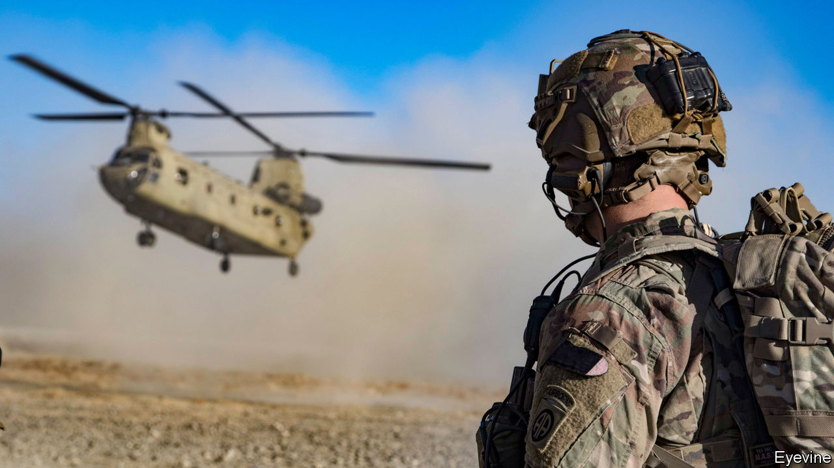

## Left to stand alone

You warned of the dire implications of America withdrawing from Afghanistan (“[Leaving too soon](https://www.economist.com/leaders/2020/11/21/donald-trump-risks-handing-afghanistan-to-the-taliban)”, November 21st). Certainly, the parallels with the Soviet withdrawal in 1989 and the eventual collapse of the Najibullah regime are uncomfortable. However, it was not the withdrawal of Soviet combat troops that brought about the collapse, but the ending of Russia’s subsidies in 1992.

Other pivotal moments in Afghanistan’s history are also linked to the withdrawal of subsidies, from the rivalries between Shah Shujah and Dost Mohammad in the early 19th century, culminating in the first Anglo-Afghan war, to arguments over military pay in 1879, which led to the murder of the British envoy, and through to post-1918, when Britain cut its subsidy. There is a pattern here. Intimately linked to the historic, systemic weakness of the Afghan state and its inability to raise taxes, the government is beholden to those who subsidise it. When the money runs out, it fails.

The key to securing Afghanistan’s future is to keep the government financially afloat. NATO has promised that funds will be provided until 2024. That is a start, but 2024 too closely matches the post-Soviet trajectory to be comfortable. Instead, our commitment should be as open as our military one has been. That may give a chance for the post-Taliban generation to take power and for the country’s economy to flower.

The Taliban always taunt us, “You may have the watches but we have the time.” We should now respond, “Yes, but we have the money.”

SIMON DIGGINS  
Defence attaché, Kabul 2008-10  
Rickmansworth, Hertfordshire

Had the Americans followed your line of thought, they would still be involved in Vietnam.

ALEXANDER CASELLA  
Former UNHCR director for Asia  
Geneva

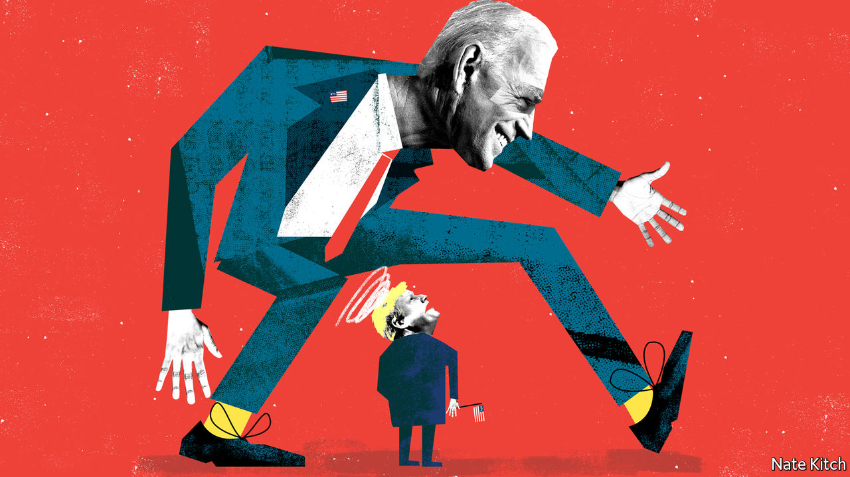

## An honourable man

[Bagehot](https://www.economist.com/britain/2020/10/24/what-joe-biden-means-for-boris-johnson) was in error in stating that Kim Darroch was “sacked” as Britain’s ambassador to Washington after a confidential memo critical of the Trump administration was leaked (October 24th). In fact, he resigned after the president tweeted that his administration would no longer deal with the envoy, and Boris Johnson failed to support him. Mr Darroch acted with honour and a sense of the national interest.

PAUL TAYLOR  
Saint-Remy-de-Provence, France

## Hong Kong’s legislature

You reported that four legislators in Hong Kong were disqualified from office (“[Leaving in despair](https://www.economist.com/china/2020/11/14/hong-kongs-legislature-has-been-stripped-of-a-vocal-opposition)”, November 14th). What you did not say is that each of the four had earlier been barred from running for re-election by the returning officers. It was found they had not genuinely upheld the Basic Law and honoured their pledge of allegiance to the Special Administrative Region, which is required under Article 104.

As the elections to the Legislative Council were postponed in September for a year because of the pandemic, a decision was made by the National People’s Congress Standing Committee, the highest organ of state power. The logic is simple. People not qualified to contest the election should not be allowed to continue to serve as legislators in the current extended Legco.

The Special Administrative Region government is not targeting any member of the Legco. Nor are we suppressing political parties or silencing dissenting views. There is no question of the Legco becoming a “rubber stamp” body.

Our rules relating to the behaviour of public officers follow international norms. In Britain, members of Parliament must take an oath of allegiance to the crown before assuming office. In America members of Congress must swear to support and defend the constitution.

It is regrettable that 15 lawmakers subsequently chose to resign from the Legco. For them to abandon their monitoring role in providing checks and balances for the government is an irresponsible act that serves the interests of no one.

MATTHEW CHEUNG KIN-CHUNG  
Chief secretary for administration  
Hong Kong Special Administrative Region Government

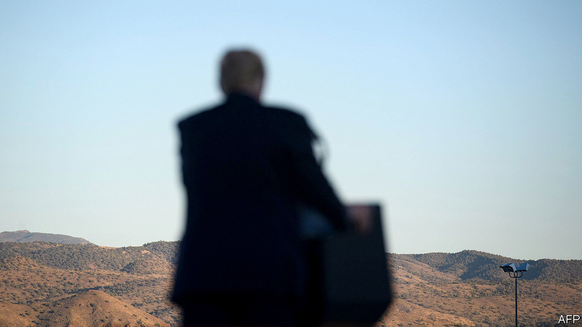

## Political diversity

It is correct and reasonable to suggest that the structure of America’s electoral college is disadvantageous to the Democrats because of the current geographical distribution of the party’s supporters (“[City v hills](https://www.economist.com/united-states/2020/11/14/our-analysis-of-the-election-results-suggests-that-2020-accelerated-a-long-running-trend)”, November 14th). But there are pros and cons in all democratic systems, and there are arguments for the characteristics that yield this particular outcome as well as arguments against. You recognise that Democrats tend to live in more “diverse” cities, but you also note that they tend to “cluster” to a greater extent. Crucially, it is the latter point that works against Democrats.

Diversity is a word we hear a lot of these days, often in support of laudable policies. But it involves including all parts of our society in the political conversation. If the Democrats cannot win rural votes, maybe they have a problem with diversity, which the electoral-college voting system is merely helping point out.

STEPHEN NASH  
Chiddingfold, Surrey



## The dark art

J.M.W. Turner was another artist drawn to the evocative possibilities of the colour black, especially in his watercolours and paintings depicting the utilitarian grime of the Industrial Revolution (“[Paint it black](https://www.economist.com/books-and-arts/2020/11/07/for-centuries-the-colour-black-has-tested-artists-ingenuity)”, November 7th). Black is an essential element in his numerous images of steamboats, which marked early 19th-century technological progress. In “Peace: Burial at Sea”, a hulking black steamship dominates the canvas, extruding heavy dark smoke; its blackened sails a sombre reference to the death of his colleague Sir David Wilkie (“I wish I had a colour to make them blacker,” Turner said). The painting is on display as part of the Turner’s Modern World exhibition at Tate Britain.

WILLIAM RODNER  
Norfolk, Virginia

Pierre Soulages, who will be 101 this month, has devoted the second part of his very long life exclusively to the colour black, or rather non-colour, as he calls it. It is not so much black that interests him as the emotions elicited by the reflection of light off black paint and the intense sensorial and introspective experience this brings the viewer.

Unlike Anish Kapoor, who featured in your article, Mr Soulages does not resort to a new material but works on the texture of paint and pigment, matte or gloss, breaking up the surface with lines, contours, crevasses and forms that either absorb or reflect the light, thereby leading the viewer into another world, beyond black: outre-noir.

He has exhibited extensively outre-Atlantique, but perhaps not outre-Manche?

ELIZABETH CARROLL SIMON  
Paris



## Trend setters

The spread of a global hipsterism (“[Flat white world](https://www.economist.com/international/2020/11/07/even-as-traditional-globalisation-has-slowed-a-new-kind-has-sped-up)”, November 7th) is simply another case of the rest of the world taking to American popular culture, whether for good or ill. This has a long history. Romans once thought it was hip to act like Greeks. Even Virgil got into the act, and he was no hipster.

PHIL HOLT  
Ann Arbor, Michigan

This article was downloaded by calibre from <https://www.economist.com/letters/2020/12/05/letters-to-the-editor>

|  |  |  |  |
| --- | --- | --- | --- |
|  | Articles | Sections | Next |

|  |  |  |
| --- | --- | --- |
| Letters | Sections | Asia |

Briefing

Coal’s endgame: Crushing it

.

|  |  |  |
| --- | --- | --- |
| Letters | Sections | Asia |

|  |  |  |  |
| --- | --- | --- | --- |
|  | Articles | Sections | Next |

#### Coal’s endgame

# The dirtiest fossil fuel is on the back foot

Time to topple it for good

Dec 3rd 2020 | LONDON AND NEW YORK

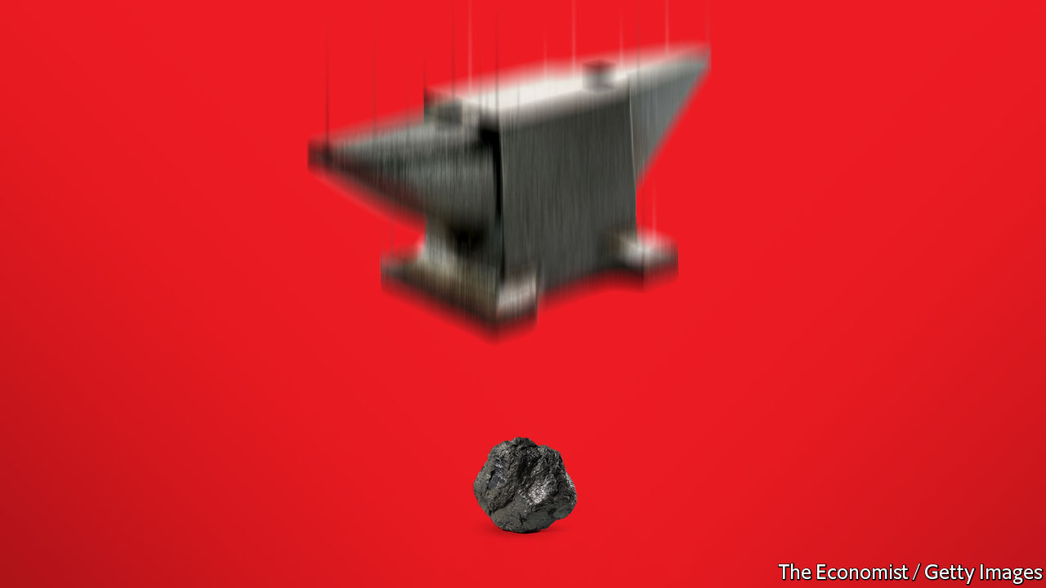

ESCALANTE, A coal-fired power station north of New Mexico’s Zuñi mountains, is designed to produce some 250MW of electricity. Since August, however, it has produced none. Nor will it ever do so again.

The economic slump brought on by the covid-19 pandemic hit electricity demand around the world; non-renewable generators of all sorts reduced their output. But in many places the owners of coal-fired plants went further. Britain shut a third of its remaining coal-fired generating capacity in the first half of the year. In June Spain closed seven coal-fired stations from A Coruña to Córdoba, halving the country’s coal capacity. Even in India, where coal generates nearly three-quarters of all electricity, the crown slipped a tiny bit: 300MW of Indian coal-fired power was retired in the first half of the year, according to Global Energy Monitor, a non-profit, and no new coal plants were built.

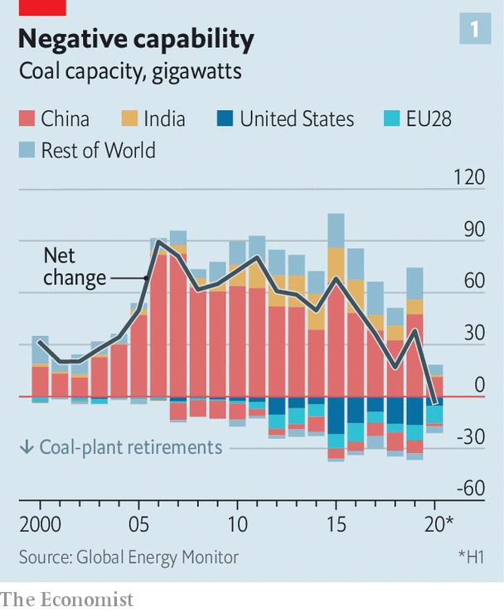

Consumption of coal has been on a slightly downward-sloping plateau for some years. But the capacity to burn it continued to increase, suggesting that things might change. Now the world’s capacity to generate electricity from coal, too, has begun to drop (see chart 1). It is a significant milestone in the fight against climate change.

For the world to meet the ambitions it set itself at the Paris climate summit five years ago, that milestone needs to quickly vanish in the rear-view mirror: coal’s decline needs to be made both steep and terminal. Coal-fired generation typically emits a third of a tonne of carbon dioxide for every megawatt-hour of electricity generated, around twice the emissions from a natural-gas plant. And although coal is used directly in some industrial processes, such as steelmaking, two-thirds of the stuff is burned to generate electricity—a role that many other technologies can fulfil more cleanly and even more cheaply.

Eliminating coal-fired electricity generation is thus a big but doable deal. Failing to get that deal done will see the world blaze past the Paris agreement’s goal of keeping global warming since the Industrial Revolution “well below” 2°C.

## A tale of three continents

The global peak in coal-fired capacity masks divergent stories in different countries. In the West, countries whose economic ascent was powered by coal and colonialism have been reducing their coal use for years and are shedding capacity with gusto. In South America and Africa—South Africa apart—coal has never been a big part of the energy mix. But Asia’s largest countries depend overwhemingly on coal for the electricity their economies need, and they are still adding capacity.

Merely using the capacity they already have in place could easily push the world past the Paris limits. According to Dan Tong, a researcher at UC Irvine, coal plants operating and proposed in 2019 would, if operated to the end of their lives, emit 360bn tonnes of carbon dioxide—a total dominated by Asia.

The Intergovernmental Panel on Climate Change (IPCC) calculates that if the world is to have a decent chance of keeping warming below 1.5°C—the Paris agreement’s stretch goal—it has to keep all future emissions of carbon dioxide and other greenhouse gases down to the equivalent of 420bn-580bn tonnes of carbon dioxide. Today’s coal plants could use up 60-85% of that budget on their own. The 2°C budget is more generous: 1,170bn-1,500bn tonnes of carbon dioxide. But if existing coal plants use up between a quarter to a third of that allowance, the chances of staying within the bounds are slim.

Coal’s decline in the West has been made possible by three mutually reinforcing developments: government policy, cheaper alternatives and restricted access to capital.

A growing number of governments have adopted policies designed to support clean energy and/or to eliminate coal. In 2013 Britain imposed a “carbon-price floor” on emissions by electricity generators which made coal a more expensive fuel. In 2015, in the run-up to Paris, the country mandated that coal-fired power in England, Wales and Scotland be phased out within a decade. Sixteen countries in the European Union either have a plan to phase out coal or are mulling one; even in those that do not, the carbon prices imposed by the EU’s Emissions Trading Scheme have made burning coal more expensive in recent years. Some owners of coal-fired stations have chosen to shut them rather than make the investments necessary to comply with new environmental standards which enter into force next year.

They can do so because of the increasing availability of other sorts of power. In America the alternative which started coal’s rout was a glut of gas created by the country’s fracking boom. But at both federal and state level America has also supported renewables, as has Europe. And as those policies have increased the scale at which renewables operate, their costs have plunged. BloombergNEF, a data group, calculates that better technology and cheap capital mean that, if you divide the amount of energy that can be expected over the lifetime of a new solar farm in Germany by the cost of building and operating that farm, the “levelised cost of electricity” (LCOE) you get is lower than the marginal cost of electricity from a German coal plant. The same is true for onshore wind in Britain; BloombergNEF expects new American wind and solar to pass the threshold next year.

Banks have tightened finance for coal, too, wary of stricter regulation, stranded assets and continued pressure from green investors. In all, more than 100 financial institutions, from Crédit Agricole to Sumitomi Mitsui, have set limits on the financing of coal projects, according to the Institute for Environmental Economics and Financial Analysis.

The effects have been impressive. In Britain the share of electricity generated by coal fell from 40% in 2013 to 2% in the first half of this year; the country now burns less coal than it did when the first coal-fired power station was built in 1882. In the EU coal-fired power generation nearly halved between 2012 and 2019. In America President Donald Trump’s promise that he would save the nation’s “beautiful” coal industry proved as worthless as it was misguided. Coal-fired electricity generation was 20% lower in 2019 than in 2016, when he was elected. Peabody Energy, an American company that digs more coal than any other listed firm, warned in November that it might file for bankruptcy for the second time in five years.

This displacement needs to be speeded up and prolonged. The unique circumstances of 2020 have seen a 7% drop in coal consumption. According to a report published this week by the UN and an international coalition of climate researchers, hitting the 2°C Paris target would require coal consumption to drop by the same amount every year for a decade. To hit the 1.5°C limit would require cuts of 11% year on year.

## Prevaricate not

Those reductions would need to be even steeper were it not for the report’s assumption that, by 2030, a billion tonnes of carbon dioxide produced in power stations and industrial plants will be captured on site and sequestered away underground, a process known as carbon capture and storage, or CCS. At the moment the world’s CCS capacity is 4% of that. The technology could definitely be useful in steelworks and the like. Adding it to coal-fired electricity plants, though, is a pricey undertaking in which companies have very little experience. What is more, CCS has a long history as what Duncan McClaren of Lancaster University calls a “technology of prevarication”. Holding the possibility of emissions-free coal open but not realising it simply prolongs the status quo. Easier, cheaper and more definitive just to generate electricity by other means, such as renewables and nuclear.

Analysis like this has led Antonio Gutteres, the UN secretary-general, to call for coal-fired electricity to be eliminated worldwide by 2040; he says the OECD, a club of rich countries, should get to zero by 2030. That would require a huge increase in effort. Japan currently envisages getting 26% of its electricity from coal in 2030. Germany plans to go on using coal until 2038. Though American coal use has fallen, its outright abolition will be staunchly opposed by some.

That said, the fall so far has been deeper and faster than most expected. Portugal, which had planned to be coal free by 2030, now looks like hitting that target in 2021. Perhaps political pressure, industrial momentum and business opportunity can speed things up elsewhere, too.

If Mr Gutteres’s exhortation gives non-OECD countries a decade longer, it reflects the fact that many, especially in Asia, have a lot more to do. Asia is currently home to nearly 80% of coal consumption. Most of that—52% of the global total—takes place in one country: China. India, Asia’s second-biggest market, consumes less than a quarter as much.

The growth in China’s coal-fired generating capacity between 2000 and 2012 helped reshape the global economy and drive a 200% increase in Chinese GDP per person. It also nearly tripled the country’s carbon-dioxide emissions, making it the largest emitter in the world. Its effects on air quality hastened millions of deaths.

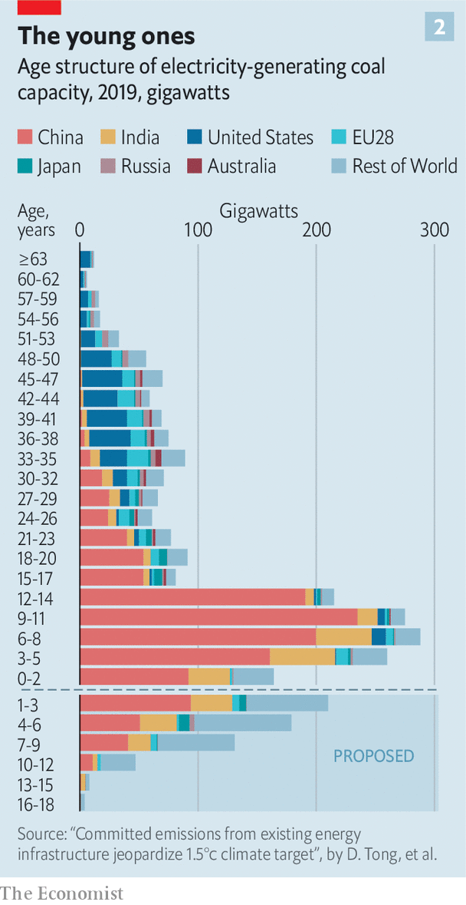

Though new installations have never stopped, concerns over pollution and a glut of generating capacity have seen their rate decrease (see chart 2). The State-owned Assets Supervision and Administration Commission of the State Council, which oversees several large coal companies, has drafted plans to reduce coal capacity by one-quarter to one-third. Meanwhile alternatives are on the rise. The government’s spending on nuclear power handily outstrips that of any other country, and it has built up a massive renewables sector. The LCOE from new coal plants in China is already higher than that for solar and onshore wind farms, according to BloombergNEF. By the middle of the decade, the firm’s analysts calculate, the LCOE of onshore wind and solar will be less than the marginal cost of operating existing coal plants (see chart 3).

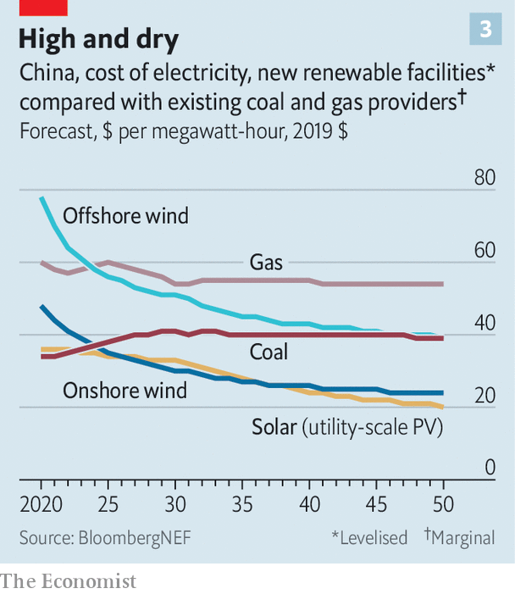

Add to all this the country’s recently promulgated target of carbon neutrality by 2060 and the future of coal in China might seem to be one of rapid withering. Yet coal-plant construction shot up in 2019. And in the first five and a half months of 2020 provincial governments, keen to boost employment and economic growth, gave companies permission to add a further 17GW of new coal capacity. Various state-owned companies such as State Grid, the country’s giant utility, China Electricity Council, the coal industry’s main lobby, and some provincial governments want to see this growth sustained, even though a lot of current capacity is underutilised. One argument is that more electricity will be needed to supply demand from the electrification of heating and cars. Lauri Myllyvirta, an analyst at the Centre for Research on Energy and Clean Air, a research institute, estimates that the China Electricity Council’s statements imply a net increase in national coal capacity of 150-250GW.

Two eagerly awaited documents should reveal how much influence these pro-coal lobbies have. One is China’s 14th five-year plan, which will be published early in 2021. The other is the new “nationally determined contribution”, or NDC, required of the country under the Paris agreement—a list of its emission-reduction plans. If the five-year plan includes a near-term cap on coal capacity and the NDC calls for a peak in carbon emissions by 2025 it will signal a real turning away from coal (though perhaps not one fast enough for Mr Gutteres).

## Other countries’ coal

Chinese interests in new coal plants do not stop at the country’s borders. Chinese-financed coal plants in other countries are on course to add 74GW of coal capacity between 2000 and 2033, according to Kevin Gallagher and his colleagues at Boston University. Chinese-funded foreign fossil-fuel plants—the vast majority of which burn coal—account for 314m tonnes of carbon dioxide every year. That is nearly as much as the total annual emissions from Poland. The past decade has seen Chinese companies seek new opportunities for coal-plant construction in Indonesia, Vietnam, Pakistan and Bangladesh, though Bangladesh and Vietnam have both started considering cuts in their plans for future coal capacity. If China limits coal at home, those concerns will work even harder to find growth elsewhere while the country’s miners, too, look for new markets.

In Japan a similar dynamic is at play as the coal industry and its financiers look for new opportunities. This year the country set new limits on the financing of foreign coal plants, but loopholes remain. In November development banks from around the world issued a statement that they, too, would consider ways of reducing fossil-fuel investments. But they resisted pressure from Mr Guterres and others to eliminate such investments entirely.

In India, as in China, significant new coal-fired capacity is planned on top of ambitious government targets for boosting solar power, the intermittency of which policymakers worry about. As India contemplates surging future demand for power, it has fewer alternatives to coal than China. The infrastructure for importing natural gas is underdeveloped and the fuel itself pricey; nuclear capacity is growing only slowly.

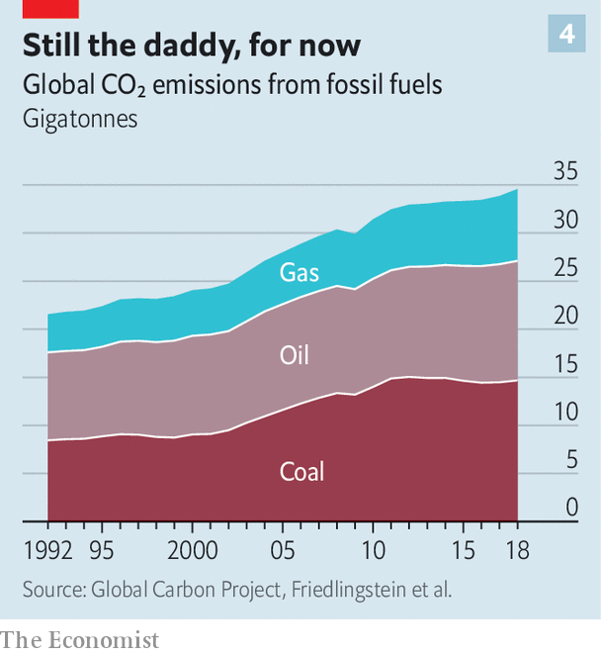

Ajay Mathur of the Energy & Resources Institute, in Delhi, argues that low utilisation rates of existing coal plants mean there is little rationale for further construction. But coal remains a political force. India’s state-owned banks have financed much of its development. Power markets give coal-fired plants fixed payments, which lessen their incentives to work flat out but also make it harder for solar power to break in. In states such as Chhattisgarh and Jharkhand jobs provided by Coal India Limited, the state-owned coal behemoth, are vital to the economy. And the government has recently authorised the development of new privately owned mines to reduce India’s imports of foreign coal. With new miners come new constituencies to advocate for coal’s future.

Similar political obstacles exist elsewhere. Fitch, a ratings agency, pointed out earlier this year that for all Indonesia’s professed desire to limit pollution, its price caps on coal for domestic power generation are designed to keep coal-fired power cheap and promote economic growth. This limits competition from other fuels. Markets rigged for coal in countries with expanding energy needs will not necessarily last all that long. But the new coal capacity they bring into being may stick around for decades.

If it can be made politically feasible, redesigning electricity markets—easing rigid power-purchase agreements in India and Indonesia, for instance—can quickly boost renewables, and the batteries which smooth out their contributions. Carbon prices, too, make coal less competitive, and if designed in such a way that their benefits are visible to all—perhaps as dividends—they may offer a counterbalance to the concentrated political power of coal lobbies.

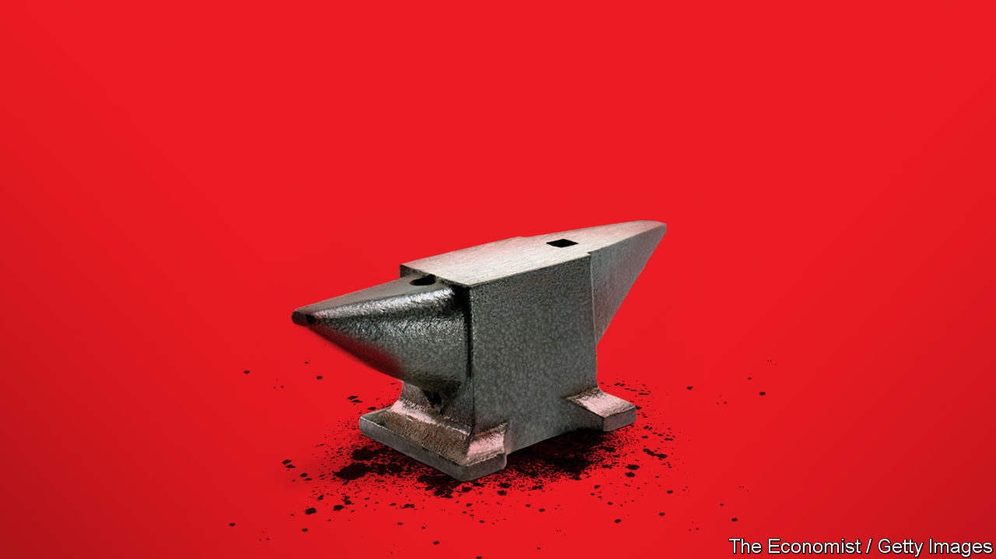

Perhaps most important, though, is support for those who will suffer from coal’s demise. “If you’ve got 30 years, one can plan a phase-down,” says Mr Mathur. “If you’ve got ten years, it is shutdowns and large financial transfers.” Mine closures must include support and retraining for affected workers. And there is scope for more creative assistance from the West—which has an interest in reducing coal emissions wherever they come from. The private arm of the Inter-American Development Bank recently helped a Chilean developer replace coal assets with wind turbines by means of a low-interest loan. The Sierra Club, Carbon Tracker and Rocky Mountain Institute, three green groups, suggest paying for reverse auctions in which developing-country coal-plant owners bid for debt-forgiveness to retire their coal stations early in favour of clean power. Only if alternatives are made attractive to incumbents can coal be crushed as speedily and completely as the world requires. ■

For more coverage of climate change, register for The Climate Issue, our fortnightly [newsletter](https://www.economist.com/theclimateissue/), or visit our [climate-change hub](https://www.economist.com/news/2020/04/24/the-economists-coverage-of-climate-change)

This article was downloaded by calibre from <https://www.economist.com/briefing/2020/12/03/the-dirtiest-fossil-fuel-is-on-the-back-foot>

|  |  |  |  |
| --- | --- | --- | --- |
|  | Articles | Sections | Next |

|  |  |  |
| --- | --- | --- |
| Briefing | Sections | China |

Asia

The Taiwanese economy: Tiger balm

.

Inequality in India: Compounding

.

Coal and climate in Australia: Losing seam

.

Indonesian politics: Son set

.

Ungulates in Japan: Hungry for visitors

.

Banyan: Death of a novelist

.

|  |  |  |
| --- | --- | --- |
| Briefing | Sections | China |

|  |  |  |  |
| --- | --- | --- | --- |
|  | Articles | Sections | Next |

#### Tiger balm

# Covid-19 has ravaged economies all over the world—but not Taiwan’s

It has fended off the epidemic and is welcoming back firms that had decamped to China

Dec 2nd 2020 | TAOYUAN

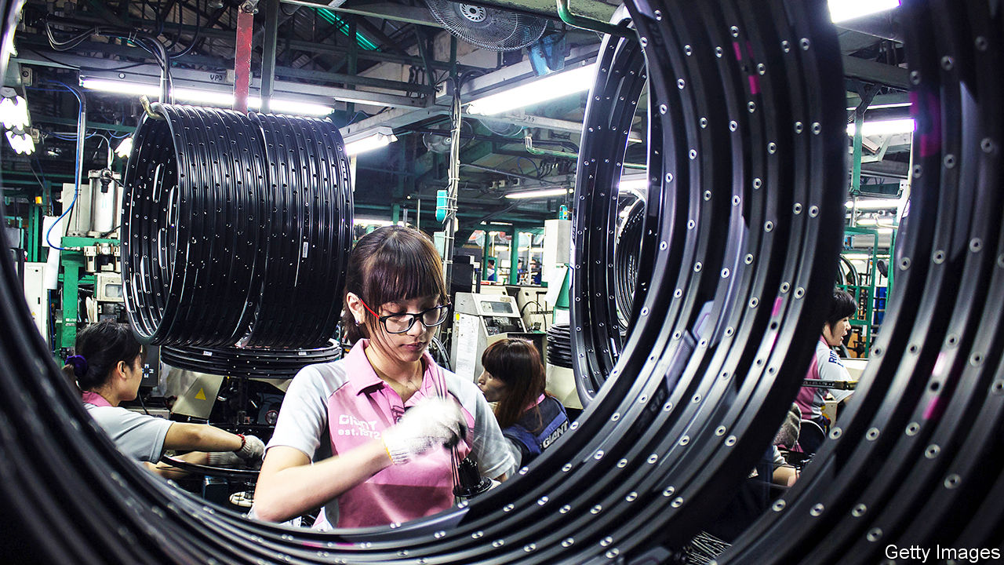

THREE YEARS ago a prominent scholar declared that Taiwan’s economy was “on the brink of death”. The wording was extreme but the sentiment was widely shared. Taiwan faced a litany of seemingly intractable problems. Many of its best companies had moved to China; wages were stagnant; growth was grinding ever lower and the population was ageing rapidly. Its glory days as an Asian tiger—celebrated for its rapid development—seemed firmly in the past.

Yet in 2020 Taiwan has turned the clock back: it is, again, one of the world’s fastest-growing economies. Granted, its GDP is projected to expand by only about 2% this year. But it is in rare company, with fewer than a dozen economies expected to grow at all, thanks to the coronavirus. For the first time in decades, Taiwan’s economy may even grow faster than China’s. The question is whether Taiwan’s surprising strength marks a new departure, or whether it is simply a brief deviation from continued descent.

Two factors tied to the pandemic help account for Taiwan’s relative success this year. First, it was the only country to contain covid-19 without sweeping closures of schools, offices and shops. Its government, alert to new diseases in China, started screening visitors from Wuhan at the end of 2019, as soon as reports emerged of a mysterious pneumonia outbreak. Thanks to fine-grained contact-tracing and near-universal mask-wearing, life has carried on more or less as normal. Since July revenues for retailers and restaurants alike have increased compared with a year earlier.

Second, Taiwan’s manufacturers have been well-positioned to cater to global demand, such as it is. From tiny semiconductors to giant computer servers, electronics account for a third of Taiwan’s exports. With so many people suddenly forced to work from home, sales of products such as tablet computers and headphones have been strong. So while global trade this year will shrink by about 10%, Taiwan’s exports are up by nearly 5%.

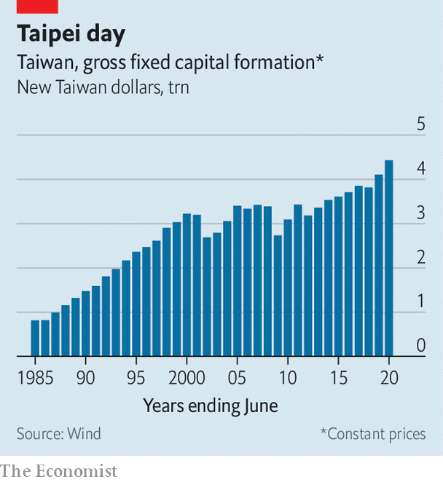

Both these sources of out-performance will presumably fade when the pandemic ebbs. Taiwan has also, however, been a beneficiary of tensions between China and America. Taiwanese firms that had previously invested in China have shifted some of their operations back home, in order to avoid American tariffs. Those returning include Giant, a bicycle producer, Long Chen, a paper company, and Compal, a computer manufacturer. Investments in factories and other fixed assets in Taiwan reached an all-time high last year of over NT$4trn ($140bn), and are on track for a new record this year (see chart).

The clanging reverberating through Hwa Ya Technology Park in Taoyuan, a big city in the north of the island, is evidence of the construction boom. Quanta Computer, one of the world’s biggest electronics manufacturers, is stepping up domestic production of sophisticated servers that it once made in China. And workers are tearing down blue plastic scaffolding covering an even larger server factory being built for NT$15bn ($525m). “It will be ready quickly,” a helmeted worker says cheerfully.

Some in Taiwan worry that this momentum, catalysed by Donald Trump’s trade policies, will fizzle out when Joe Biden enters the White House. Although Mr Biden has pledged to take a hard line on China, he may be willing to roll back tariffs. But Gordon Sun of the Taiwan Institute of Economic Research thinks Taiwanese companies will continue to diversify away from China. “They cannot afford to get caught in another trade war, even if the possibility is low,” he says.

The return to Taiwan, if sustained, would partly address one of the concerns hanging over its future: the relentless migration of good companies and good jobs to China. Some 400,000 Taiwanese, about 2% of the population, now live across the Taiwan Strait. Taiwanese businesses speak with trepidation about the emergence of a “red supply chain” in China that will soon challenge the likes of Foxconn, a Taiwanese contract manufacturer which makes most of Apple’s iPhones. Competition from China has also contributed to anaemic wage-growth in Taiwan. Adjusted for inflation, salaries have been flat since 2000, averaging just under $20,000 a year.

Yet the surge in investment in Taiwan has clear limits. President Tsai Ing-wen often refers to the country’s “five shortages”, shorthand for its finite supply of land, water, power, workers and talent. Only so much can be done on a small island that is committed to phasing out nuclear power and that has one of the lowest birth rates in the world. Taiwan’s population is set to start shrinking this year, and the government forecasts that it will drop from 24m today to 16m in 2070.

Added to these chronic woes are the hard realities of Taiwan’s reliance on China. Nearly 40% of Taiwan’s exports go to China and Hong Kong. “Taiwan can’t just get rid of China’s economy and search for other growth engines,” says Chen Chien-liang, an economist who served under the previous administration, which tried to draw closer to China.

The saving grace for Taiwan is that China needs Taiwanese products as much as Taiwanese firms need the Chinese market. Chinese firms are still far from matching the wizardry of TSMC, the Taiwanese company that churns out the world’s most advanced semiconductors. China has done little worse to the Taiwanese economy recently than limit the flow of tourists from the mainland (ironically, this may have helped insulate Taiwan from covid-19). America may in fact do more damage if it promulgates new rules that prevent TSMC from working with Chinese customers such as Huawei, a telecoms giant.

For Liang Kuo-yuan of the Yuanta-Polaris Research Institute the economic prescription for Taiwan is simple, if tough to pull off. The island must make itself as indispensable in industries such as medical devices and batteries, he says, as it has in semiconductors. Such high-value niches will help protect Taiwan from Chinese pressure, and will also fit with Taiwan’s limited resources and falling population.

A single year of impressive growth does not move Taiwan closer to that objective. Mr Liang, for one, frets that China is outdoing Taiwan in its long-term economic planning. But stellar performance in this most challenging year has at least given many in Taiwan a shot of confidence, after years of gloom. Across the road from the Hwa Ya Technology Park in Taoyuan, Chris Liang runs a small restaurant. Among his customers from tech firms, the change in sentiment has been almost palpable, he says. “Our epidemic control has changed people’s attitudes about the economy. People are more optimistic.” ■

Editor’s note (December 3rd): This story has been updated since publication.

This article was downloaded by calibre from <https://www.economist.com/asia/2020/12/02/covid-19-has-ravaged-economies-all-over-the-world-but-not-taiwans>

|  |  |  |  |
| --- | --- | --- | --- |
|  | Articles | Sections | Next |

|  |  |  |  |
| --- | --- | --- | --- |
| Previous | Articles | Sections | Next |

#### Compounding inequality

# India’s super-rich are getting much richer

Even as the economy shrinks by a tenth

Dec 5th 2020 | DELHI

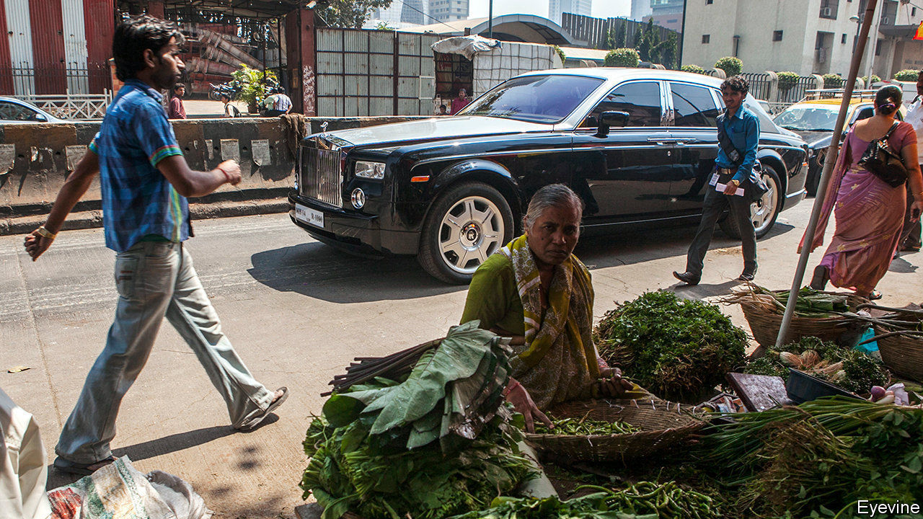

SOME PEOPLE have almost all the luck. Over the past year, as India’s economy has shrunk by around a tenth and tens of millions of Indians have lost jobs or sunk into poverty, the fortunes of the country’s two richest people have swollen. Gautam Adani, whose conglomerate sprawls from ports to coal mines to food, has seen his personal wealth more than double, to some $32bn. Mukesh Ambani’s riches, which derive from oil refining, telecoms and retail, among other things, have grown by just 25%, albeit to an intimidating $75bn or so.

The share of wealth and income going to the top 1% has been rising rapidly in recent years in India, as it has been in many countries. Last year they hoovered up 21.4% of earnings, just ahead of their counterparts in Russia, according to the World Inequality Database. Credit Suisse, a bank, puts their share of India’s wealth at 39%, well ahead of the richest 1% of Americans or Chinese. Most alarmingly, in India some of the rich have become super-rich by using their heft to crush smaller competitors and thus corner multiple chunks of the economy. The tilt in fortunes has rewarded not so much technical innovation or productivity growth or the opening of new markets as the wielding of political influence and privileged access to capital to capture and protect existing markets.

Merely a decade ago, according to data compiled by Marcellus, an investment-advice firm, among listed firms in India the 20 most profitable generated less than a third of profits. They now account for 70%. A study by Krishna Kant, a journalist, reveals that between 2014 and 2018 competition within ten different industries, from aviation to tyres, deteriorated markedly.

Across Indian markets, only the shares of giant firms have gained consistently over the past decade, says Rohit Chandra of IIT Delhi, a university. International investors have noticed, and now bet increasingly not on promising new firms but on big old ones, which they expect to get even bigger. The government boasts that the five months from April to August saw a record $36bn in foreign investment, suggesting that its wise policies have sustained confidence during the covid-19 epidemic. What it trumpets less loudly is that more than half of that money, including hefty investments from Facebook and Google, poured into Mr Ambani’s hands alone.

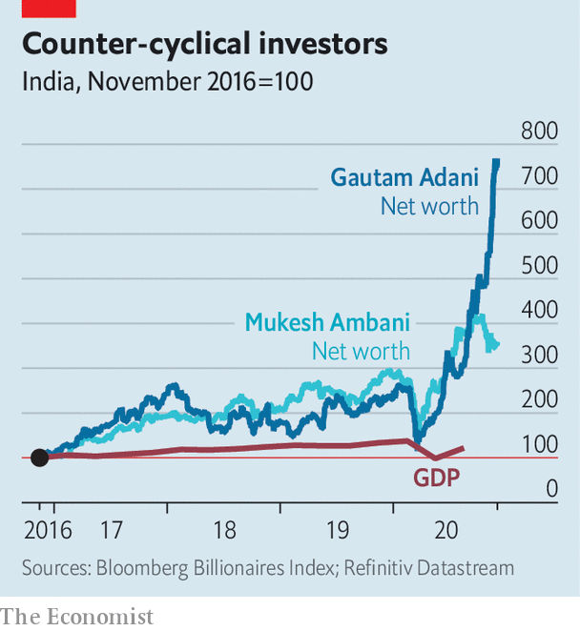

It is easy to understand why. Things have a way of turning out as Mr Ambani wishes. Back in 2016, for instance, the tycoon used his massive earnings from petrochemicals to take a $25bn gamble, plunging into the maturing mobile-phone market. His timing was exquisite. Just as he rolled out a free service to lure customers, the government withdrew 86% of the country’s paper currency, leaving most of India strapped for cash and eager to find savings. Rival companies also found themselves burdened by lawsuits and crushing penalties for back taxes. Regulators ignored complaints. “If his firm were Chinese it would have been charged with dumping,” says one economist.

Mr Adani enjoys a similar Midas touch. In early 2019 his group, which controls around a quarter of India’s port capacity, ventured into a new field when the government tendered six 50-year airport-management contracts. Competing against established firms, Mr Adani nevertheless won all six. He has since bought two more, including a 74% share in Mumbai airport, India’s second-busiest. More recently, Mr Adani has counterbalanced big stakes in coal-fired power with lots of renewable energy, winning a $6bn government contract in June for various solar projects. The share price of Adani Green Energy, a subsidiary, has risen tenfold since March.

Some of India’s tycoons have prospered because they have learned not just to weather unpredictability, but to game the system. That system, alas, is failing India’s poor. Measures of malnutrition and stunting reveal an alarming backward slide over the past year. The unemployment rate shows some recovery from the worst of the covid shock, but that fails to capture the astonishing bleakness of India’s labour market. Before covid hit, barely 40% of adults were in paid work, according to the Centre for Monitoring the Indian Economy, a research firm. Now only 36% are. The rest, including legions of housewives, see no point in even looking for a job. ■

This article was downloaded by calibre from <https://www.economist.com/asia/2020/12/05/indias-super-rich-are-getting-much-richer>

|  |  |  |  |
| --- | --- | --- | --- |
| Previous | Articles | Sections | Next |

|  |  |  |  |
| --- | --- | --- | --- |
| Previous | Articles | Sections | Next |

#### Losing seam

# As the federal government harrumphs, Australia moves away from coal

Both its states and its export markets have pledged drastic cuts in carbon emissions

Dec 5th 2020 | MUSWELLBROOK

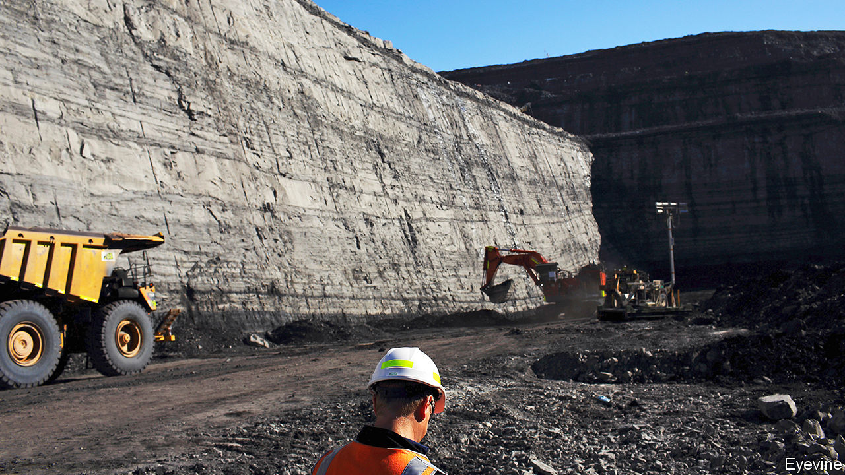

IF A COAL-FREE future awaits the town of Muswellbrook, in New South Wales, there is little sign of it. It is surrounded by vast canyons of grey and brown rock—open-cast coal mines. Nearby, two huge power plants burn their output for electricity. More is piled onto sooty trains which rumble constantly through the town, conveying its riches east, to the port of Newcastle, from which the coal is shipped across Asia.

According to Muswellbrook’s mayor, Martin Rush, the surrounding region is the source of more than a tenth of the world’s internationally traded thermal coal (the sort burnt in power plants, as opposed to coking coal, which is used to make steel). Fully one third of locals rely on the stuff for well-paid work. The problem is that, in the next five years, three of the area’s mines will close. So will one of the ancient power stations, as utilities replace coal with cheaper, cleaner energy. Mr Rush reckons that it will take “between 20 and 30 years” for the local industry to die out altogether. Some miners hope for longer. Either way, says Mike Kelly of the local chamber of commerce, no one denies that the long-term trend is down.

The same realisation is dawning across Australia. Its three biggest export markets for fossil fuels—China, Japan and South Korea—have all recently pledged to achieve carbon neutrality by the middle of the century or just after. Another buyer of Australian coal, the Philippines, has banned new coal-fired power plants.

The federal government, a right-wing coalition, appears in denial about this changing outlook. Scott Morrison, the prime minister, insists he is “not concerned about our future exports”. When ANZ, a bank, said in October that it would stop funding new coal mines, coal-loving MPs griped that it was “virtue-signalling” and called for a boycott. (Australia’s three other big banks had already pledged to steer clear of coal.) A government minister told pension funds, which are also selling sooty investments, that their goal should be to maximise returns and “not to change the earth’s temperature”.

The politicians’ misgivings are understandable. Coal is Australia’s second-biggest export, bringing in almost A$70bn ($49bn) in 2019. It also provides two-thirds of its electricity. The industry’s hold over politics is such that three of Mr Morrison’s four most recent predecessors lost power after trying to curb the country’s emissions of greenhouse gases.

Yet even right-wingers in the federal parliament harp on less than they used to about the need to open new mines or subsidise coal-fired power stations, notes Greg Bourne of the Climate Council, a green pressure group. And while they may have prevented the federal government from taking steps to curb the use of coal, they cannot prevent Australia’s states and territories from trying to. In fact, every one of them has set a target of reducing net emissions to zero by 2050, although Mr Morrison refuses to do so. The tiny Australian Capital Territory, host to Mr Morrison’s government in Canberra, already generates all its power from clean sources. In October South Australia became, for an hour, the world’s first big jurisdiction to run only on solar power.

But it is a state run by the same coalition as the federal government, New South Wales, that has the most ambitious plan to decarbonise, notes Simon Holmes à Court of Melbourne University. It has pledged to underwrite 12 gigawatts of clean-energy projects and a further two gigawatts of energy storage to back them up over the next ten years. That would be enough to power several smaller states on its own.

The state’s energy minister, Matt Kean, won support from the coal lobby in the coalition by promising A$32bn of investment in regions that will need it as mining declines. When the legislation passed the state parliament in late November, only One Nation, a populist party, opposed it. Mr Kean takes this as a sign that “we have wrested back control” from “the coal barons that have decided energy policy in this country for generations”.

Miners, though, argue that these grand green plans will inevitably lead to higher power prices and thus crimp economic growth. Ditch coal, and all Australians “will have to downgrade their lifestyle”, says Gus Mather, who makes equipment for the mines. Muswellbrook is planning multiple clean-energy schemes, from pumped-hydro to biofuels. But Mr Rush, the mayor, worries that no coal town has ever managed to stop digging the stuff up and remain prosperous. ■

For more coverage of climate change, register for The Climate Issue, our fortnightly [newsletter](https://www.economist.com/theclimateissue/), or visit our [climate-change hub](https://www.economist.com/news/2020/04/24/the-economists-coverage-of-climate-change)

This article was downloaded by calibre from <https://www.economist.com/asia/2020/12/05/as-the-federal-government-harrumphs-australia-moves-away-from-coal>

|  |  |  |  |
| --- | --- | --- | --- |
| Previous | Articles | Sections | Next |

|  |  |  |  |
| --- | --- | --- | --- |
| Previous | Articles | Sections | Next |

#### Son set

# Indonesian politics is becoming a family affair

Both the president’s son and his son-in-law are standing in regional elections

Dec 3rd 2020 |

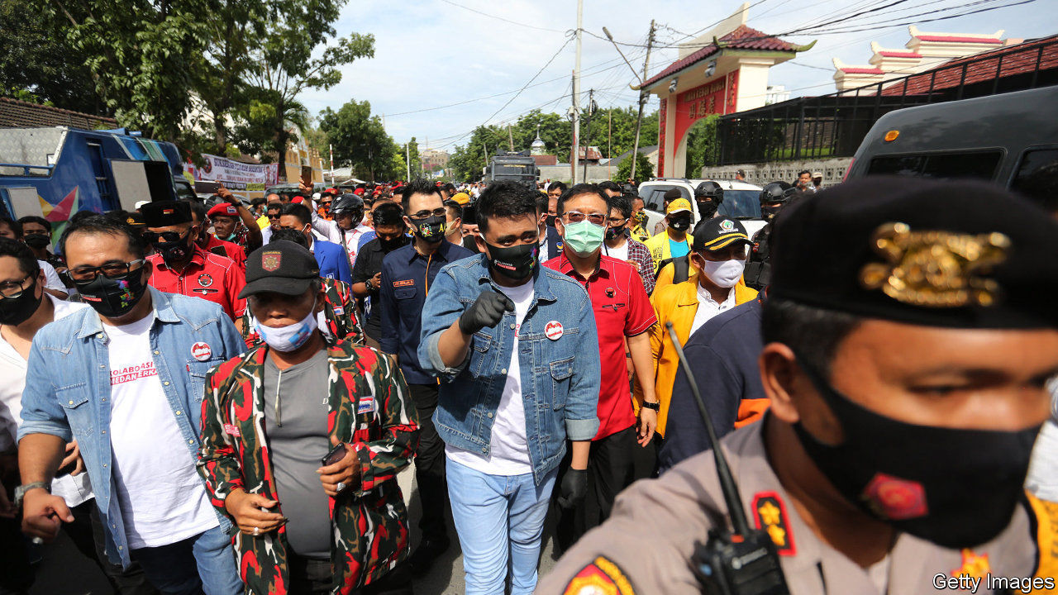

WHEN JOKO WIDODO was elected president of Indonesia in 2014, it marked a turning-point in the country’s politics. Jokowi, as he is better known, hails from a humble background—he grew up in a riverside shack—yet managed to vault himself into the nation’s highest office. It was the first time that somebody who did not belong to the political or military elite was in charge of the country. True to his image as an outsider, he vowed that budding politicians in his family would not ride on his coat-tails, writing in his autobiography, published in 2018, that “becoming a president does not mean channelling power to my children”.

But since his re-election last year, Jokowi seems to have had a change of heart. Both his son and son-in-law, neither of them with any experience in politics, are running in regional elections on December 9th under the banner of Jokowi’s party, the PDI-P. His son, Gibran Rakabuming Raka, is running for mayor of the city of Surakarta, the job that was his father’s political launchpad. Mr Gibran is so far ahead of his opponent in the polls that December 9th will be less an election, more a coronation.

Jokowi is unusual only in his initial refusal to smooth the way for his offspring. Since the advent of democracy in 1998, and the devolution of power from central to local governments shortly after that, politicians have sought to establish dynasties. A growing number are doing so at the local level. In elections held in 2015, 52 candidates, or 3% of the total, were related to politicians who currently or previously led a regency (county), city or province, according to Yoes Kenawas, who studies dynasticism in Indonesian politics. In next week’s local elections, nearly three times as many candidates—about 10% of the total—have family connections.

Jokowi’s son and son-in-law are not the only people with ties to the presidential palace to have entered the fray. The vice-president’s daughter, who is running for mayor of South Tangerang, a city abutting Jakarta, the capital, is competing against the niece of the defence minister. In eastern Java the 28-year-old son of Jokowi’s cabinet secretary is running for regent.

This is the first time that so many relatives of national figures are running in local elections, according to Mr Yoes. Many of those national figures are themselves dynasts. The defence minister, Prabowo Subianto, was married for a long time to a daughter of Suharto, Indonesia’s dictator of 31 years. Suharto came to power by overthrowing Sukarno, Indonesia’s first president. Sukarno’s daughter, Megawati Sukarnoputri, was president from 2001 to 2004, and remains the head of the PDI-P.

The Indonesian public is put off by the cosiness of its political class, so much so that in 2015 the national parliament passed a law barring the relatives of incumbents from running for regent, mayor or governor. The law was deemed unconstitutional by the courts and overturned later that year, yet the public’s distaste persists: nearly 61% of those surveyed in July by Kompas, a local magazine, disapproved of relatives of politicians running for regional offices.

Yet politicians keep trying to entrench power within their families—often because the opportunities to make money that come with a political office are too good to turn down. Political parties do little to discourage nepotism. They are, after all, animated by personalities, not by policies, points out Ben Bland of the Lowy Institute, a think-tank in Australia. They therefore need politicians with name recognition to propel them to victory: better the relative of a somebody than a nobody.

Plus, candidates must bear the cost of campaigning, which is becoming ever more exorbitant. Parties therefore need candidates who either have deep pockets themselves or know people who do. The prohibitive cost of running for office means that “it is virtually impossible” for those without means or “connections with established patronage networks to prevail”, says Vedi Hadiz of the University of Melbourne in Australia.

It is up to the “smart and discerning” Indonesian public to decide whether his son is fit for office, Jokowi told the BBC earlier this year. But the high cost of campaigning and the associated preponderance of well-connected candidates mean that a growing share of those running for office come from the same background, winnowing the options available to voters. Many would-be politicians doubtless balk at pitting themselves against an opponent backed by a powerful family.

Take Mr Gibran. He risked running unopposed, which would have underscored the perception that he was coasting on his father’s reputation. Heroically, somebody threw his hat into the ring at the last minute: Bagyo Wahyono, a tailor. He says he had no desire to run in the election—“I actually don’t like politics,” he told a local magazine. The chairman of the organisation funding his campaign denies the allegation that Mr Bagyo is a “puppet” of the PDI-P, put up to ensure Mr Gibran had some competition. If smart and discerning voters have doubts about that, it is not clear how they can express them. ■

This article was downloaded by calibre from <https://www.economist.com/asia/2020/12/03/indonesian-politics-is-becoming-a-family-affair>

|  |  |  |  |
| --- | --- | --- | --- |
| Previous | Articles | Sections | Next |

|  |  |  |  |
| --- | --- | --- | --- |
| Previous | Articles | Sections | Next |

#### Hungry ungulates

# A crash in tourism leaves Japanese deer ravenous for treats

The sacred deer of Nara miss their old diet of rice crackers

Dec 3rd 2020 | TOKYO

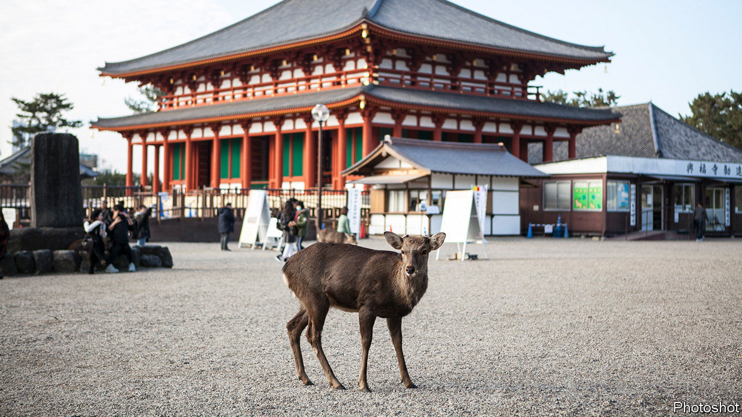

THE MORE than 13m tourists who visit Nara, an ancient capital of Japan, each year tend to follow a well-worn path. On their way into a park at the edge of the city they pass the towering wooden pagoda of Kofuku-ji, a temple complex founded in 710. They continue to nearby Todai-ji, gazing in awe at Japan’s largest Buddha, a bronze behemoth weighing 400 tons and standing 15 metres tall. And finally they feed shika senbei, a special kind of rice cracker, to the sacred deer, some 1,300 of which live in the park.

The deer, though wild, have come to love the crackers. With tourism reduced to a trickle because of the pandemic, they are hungry. Many have begun wandering far from home in search of food. A recent study by the Nara Deer Preservation Foundation and Tatsuzawa Shirow of Hokkaido University shows that 20% fewer are spending their days in the park; incidents of damage caused by deer in town have shot up. The less enterprising ones, apparently accustomed to eating only crackers, have become emaciated.

The deer are not the only ones going hungry. So are businesses in places like Nara, which have come to rely ever more heavily on tourism in recent years. Fewer than 7m foreign tourists visited Japan in 2009; last year some 32m did. Revenue from tourism hit a record 4.8trn yen ($46bn). With the Olympics scheduled for this past summer, Japan had hoped to welcome 40m foreigners this year. Instead, after a near-total closure of its borders because of the pandemic, arrivals have dropped by 99.4%.

The government has tried to cushion the blow by encouraging its own citizens to get out more. The Diet earmarked ¥1.35trn ($12.9bn) for “Go To Travel” subsidies, which provide discounts of up to 35% at domestic hotels and inns; a concurrent programme called “Go To Eat” applies to restaurants. The ministry of tourism says nearly 40m nights have been booked under the programme since it was launched in July. That is a pyrrhic victory: the campaign is thought to have contributed to a recent uptick in covid-19. Daily cases reached a record of 2,680 on November 28th. Suga Yoshihide, Japan’s prime minister, recently announced that the subsidies would be suspended in areas with high caseloads. In addition, older Japanese have been asked not to make use of them.

Japan is loth to give up on tourism, or to let the infrastructure that supports it wither. (Mr Suga himself championed tourism as chief cabinet secretary to his predecessor, Abe Shinzo.) Officials see spending by foreign visitors as a means to compensate for Japan’s own shrinking population. Tourism may also help make Japan more open to foreign migrants in the future, says Saito Jun of the Japan Centre for Economic Research, a think-tank in Tokyo.

Meanwhile, the more resourceful deer in Nara have reverted to a healthier diet of plants and nuts, which has been good for their insides. Their droppings, made pale and runny by the crackers, have become firmer and darker again. If only belt-tightening were as good for the economy. ■

Editor’s note: Some of our covid-19 coverage is free for readers of The Economist Today, our daily [newsletter](https://my.economist.com/user#newsletter). For more stories and our pandemic tracker, see our [hub](https://www.economist.com/news/2020/03/11/the-economists-coverage-of-the-coronavirus)

This article was downloaded by calibre from <https://www.economist.com/asia/2020/12/03/a-crash-in-tourism-leaves-japanese-deer-ravenous-for-treats>

|  |  |  |  |
| --- | --- | --- | --- |
| Previous | Articles | Sections | Next |

|  |  |  |  |
| --- | --- | --- | --- |
| Previous | Articles | Sections | Next |

#### Banyan

# Remembering Mishima, a writer of genius who committed seppuku

To add to the spectacle, he first staged a quixotic “coup”

Dec 3rd 2020 |



BIRTH IS THE obvious place to start a life story, but how can Mishima Yukio’s not begin with death? That of Japan’s finest author of the 20th century was both spectacular and absurd.

On November 25th 1970, Mishima led members of his private army into the main military base in the centre of Tokyo and launched a “coup” patently intended to fail. The commander was taken hostage. In white headband and a uniform that a biographer, Damian Flanagan, describes as easily mistaken for a bell boy’s, Mishima stepped out onto a balcony and called upon the hundreds of members of the Self-Defence Forces (SDF) below to revolt and tear up Japan’s pacifist constitution. Imposed by American occupiers, it had diminished the standing of the emperor and forbidden a conventional army (and still does). “Aren’t you samurai? If you are samurai, why do you defend a constitution that rejects you?” The soldiers responded with cries of “Fuckwit!”

Back in the commandant’s office, Mishima, a stickler for timekeeping, removed his watch and prepared for seppuku, or ritual suicide. Kneeling, he pushed his short sword into the left side of his intestines and, grunting, moved it across. A first accomplice was to complete the suicide with a swift beheading but messed up—Mishima’s overdeveloped neck muscles from years of physical training did not help. A second delivered the final cut. Then the first disembowelled himself and was beheaded in turn. The front page of the evening edition of Asahi Shimbun showed the two heads on the carpet next to the scabbard of the long sword.

Many Japanese remember exactly where they were on hearing the news. Mishima was the author of 34 limpid novels, more than 70 plays and scores of lighter tales for a mass market. He was Japan’s first media supasuta (superstar). He acted in films and posed as a model. He had sought illumination in India a year before the Beatles. He had sharp sartorial sense and twinkling wit. He topped Heibon Punch magazine’s Mr Dandy awards.

Yet Mishima’s commemoration was long the preserve of right-wing fanatics. For all his cosmopolitanism, in his later years Mishima embraced the notion that a Japanese life should only be lived through worship of the emperor. His ideal, he told a hall of left-wing students at University of Tokyo in 1969 was how, before the second world war, the word “emperor” had once “prefaced all intentions”.

Mishima was born into a stifling household: his domineering grandmother cocooned him indoors and his father destroyed his writings. He came of age just before Japan’s defeat in 1945. His generation was taught to sacrifice the most beautiful thing they had—their lives—for the emperor. But when called up, puny Mishima failed his medical. Hirano Keiichiro, a novelist, says “survivor’s guilt” played a big part in his militarism.

Fused to it was his obsession with pleasure, pain and homoeroticism. In one of his greatest novels, “The Temple of the Golden Pavilion”, a monk burns a temple because it is too beautiful. Mishima, in turn, was building his body for a final sacrifice.

Yet Mishima’s life-defining death channelled the nihilism of Nietzsche more than anything essentially Japanese. The act mattered as much as the word. Mishima had no time for intellectuals who never left their towers, says Roger Pulvers, an author and translator. The uncovered footage of Mishima’s debate with the students, at the height of huge anti-American and anti-establishment protests, was recently made into a documentary, “Mishima: the Last Debate”. “If you’d mentioned ‘Emperor’ just once,” Mishima declares at one point, “I’d have joined your cause. Gladly.”

Younger Japanese have flocked to see the documentary. Mishima’s books are selling well too. That would have pleased him. But he would have been appalled at the prospect of people “placidly enjoying...lockdown thanks to Zoom, Netflix and Uber Eats, totally comfortable with the prospect of a future controlled by artificial intelligence and big data”, as Peter Tasker, a pundit based in Tokyo, puts it in Nikkei Asia, alluding to Nietzsche’s “last man”.

Many wonder how things might have been, had Mishima survived. In one novel, Oe Kenzaburo, a Nobel laureate, has Mishima released from prison after 30 years to become the leader of a 21st-century cult. If that is not as far-fetched as his actual death, then Mishima has made sure, as he knew he would, that he would always have the last word.

This article was downloaded by calibre from <https://www.economist.com/asia/2020/12/03/remembering-mishima-a-writer-of-genius-who-committed-seppuku>

|  |  |  |  |
| --- | --- | --- | --- |
| Previous | Articles | Sections | Next |

|  |  |  |
| --- | --- | --- |
| Asia | Sections | United States |

China

The coastguard: Great white hulls

.

Where the party wants him: Jailings in Hong Kong

.

Housing in Hong Kong: Phew, no democrats

.

Chaguan: The downside of bullying

.

|  |  |  |
| --- | --- | --- |
| Asia | Sections | United States |

|  |  |  |  |
| --- | --- | --- | --- |
|  | Articles | Sections | Next |

#### Great white hulls

# A new law would unshackle China’s coastguard, far from its coast

It is the world’s biggest, and intends to use its muscle

Dec 5th 2020 |

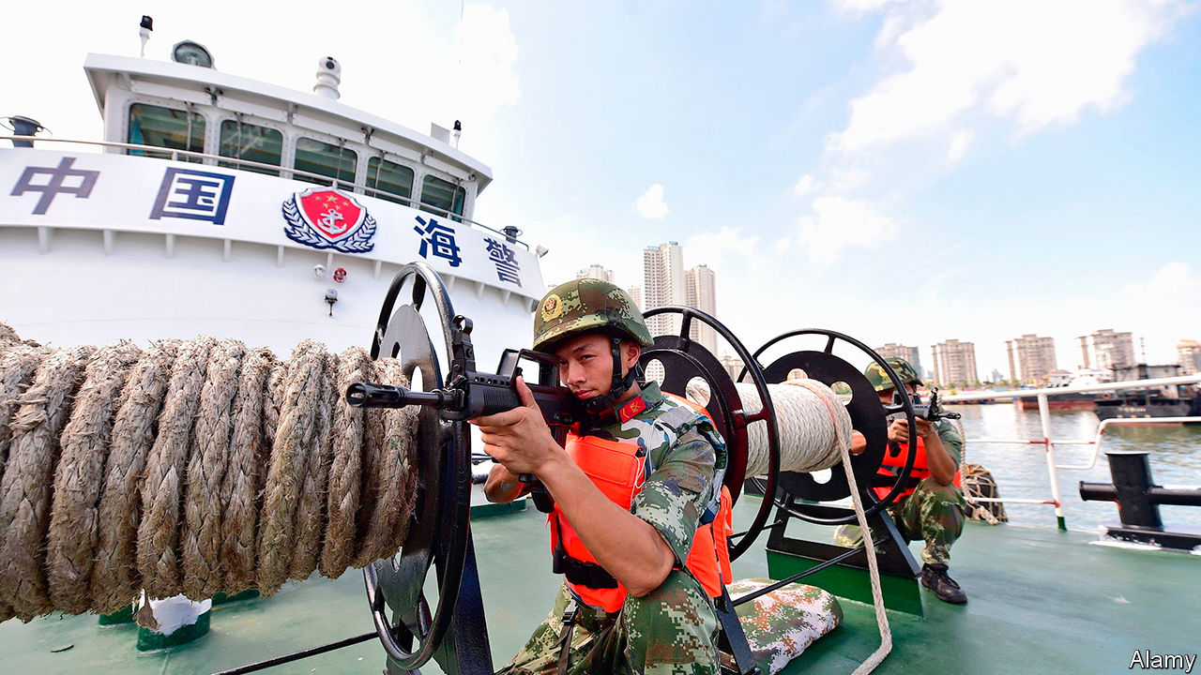

THE ZHAOTOU-CLASS cutter may be a lowly coastguard ship. But it is no pushover. At 12,000 tonnes, it is the world’s largest vessel built for such use. It looms over most American or Japanese destroyers. Its roomy deck accommodates two helicopters, a 76mm gun and a thicket of other weaponry. China has two of them. One is deployed on its east coast. The newest, CCG 3901 (the letters stand for “China Coast Guard”), set sail in 2017 on its maiden patrol of the South China Sea, its designated sphere of operation. Nowhere around China’s shores are waters more contested. The arrival of the behemoth is intended to make a point: China backs its claims in that area with a panoply of steel.

Soon CCG 3901 will have extra ammunition. In November China published a draft law that would empower the coastguard to demolish other countries’ structures built on Chinese-claimed reefs, and to board and expel foreign vessels. In some circumstances it could even fire on hostile ships. The deadline for public comment expired as The Economist went to press.

Over the past decade, the seas around China have been roiled by rival activity and enmity. In the East China Sea, Chinese vessels have been probing waters around the Japanese-held Senkaku islands—uninhabited outcrops which China also claims (and calls the Diaoyu). In the South China Sea China has turned disputed reefs into island fortresses. America and its allies have in turn sent a growing parade of warships to challenge China’s claims there. China’s navy, the world’s largest, has been ever more active, too. But its coastguard, also the world’s largest, has become increasingly important in this contest.

In 2013 China merged several civilian maritime law-enforcement agencies into a new unified one, called the Chinese Coastguard Bureau. Five years later this was put under the command of the People’s Armed Police, a paramilitary force that reports to the Central Military Commission, the country’s supreme military body. In effect, this turned China’s coastguard into a branch of the armed forces—much like its counterparts in America and India.

It has also benefited from a shipbuilding spree. Today China’s coastguard has more than 500 ships. In the region, Japan is a distant second with 373. Others trail far behind. Taiwan has 161, the Philippines 86 and Indonesia a mere 41. China’s ships have got beefier, too. A decade ago China had just ten vessels with a full-load displacement of at least 1,500 tonnes (about the size of a small warship). By 2015 it had 51 such ships. Today it has 87, says the International Institute for Strategic Studies, a London-based think-tank.

Many of the coastguard’s ships now dwarf the largest warships in the region’s smallest navies. The most capable, says Olli Suorsa of the S. Rajaratnam School of International Studies (RSIS) in Singapore, are “essentially navy ships painted white”, minus the missiles (though that is also true of Japan’s coastguard). The Type 818 patrol ship, for instance, is a modified version of the Chinese navy’s Type 054A frigate. Such large ships are less agile than smaller ones, but they convey suitable menace.

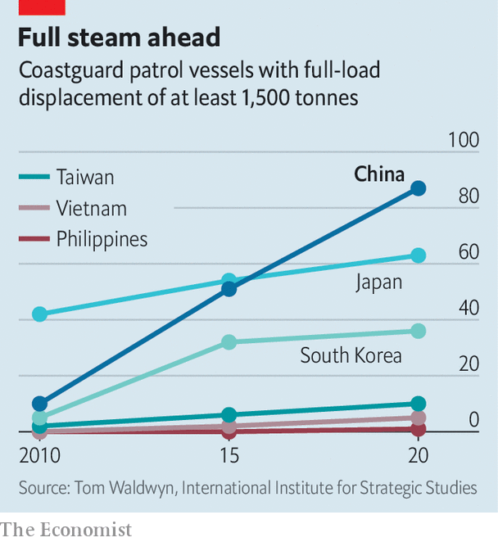

That comes in handy, for China uses its coastguard not only for routine maritime law-enforcement—such as catching smugglers—but also to project power. When China dispatched the HD8, a survey vessel, to Vietnam’s exclusive economic zone last year, it sent a flotilla of coastguard ships, including the CCG 3901, as back-up. Some blocked Vietnamese coastguard ships from approaching. When the HD8 was sent to Malaysian economic waters in April, the CCG 3901 tagged along again. A report published last year by the Centre for Strategic and International Studies in Washington, found that 14 Chinese coastguard vessels patrolling disputed features in the South China Sea had broadcast their location on the Automated Identification System, an international ship-tracking network, to demonstrate a “routine, highly visible Chinese presence”. The Chinese coastguard’s near-constant vigil in the South China Sea has been helped by the supplies it receives from China’s newly built outposts there.

In the East China Sea, coastguard ships have spent a record number of days this year near the Senkakus. In October two of its vessels sailed in the islands’ territorial waters (ie, less than 12 nautical miles from shore) and stayed for longer than 39 hours, the previous record.

Sometimes the coastguard is used in support of China’s “maritime militia” of armed fishing vessels, which the country uses to establish a presence in disputed waters. In April Vietnam accused China’s coastguard of ramming and sinking a Vietnamese fishing vessel near the Paracel islands in the South China Sea, to which both countries lay claim. It was the second such incident there in less than a year.

America worries about the Chinese coastguard’s growing role as an enhancer of Chinese maritime power. Last year an American admiral hinted that, in the event of a clash, America’s navy would treat vessels belonging to China’s coastguard and maritime militia no differently from those of its navy. In October America said it would explore the viability of deploying its own coastguard vessels to American Samoa, in the South Pacific, to counter China’s “illegal, unreported and unregulated fishing, and harassment of vessels”.

China has reacted huffily to other countries’ concerns about the draft coastguard law. To some extent, it is right to be miffed. Most of the bill’s provisions match those of laws elsewhere and accord with international norms, says Collin Koh of RSIS.

But there is every reason to worry about the Chinese law’s proposed scope. It covers China’s “jurisdictional waters”, a term that the country applies to most of the South China Sea, says Ryan Martinson of the US Naval War College. Most of those waters are claimed by other countries or regarded as part of the global commons. China’s sweeping assertion of rights there was largely rejected in 2016 by the Permanent Court of Arbitration, an international tribunal in The Hague. Article 22 of the draft bill would allow China’s coastguard to create “temporary exclusion zones”, potentially cordoning off swathes of open ocean.

According to Mr Koh, the Chinese coastguard has been complaining for years that it needs such a law to give it more clout in its dealings with rival forces in the South China Sea. The coastguard is “powerful”, says Hu Bo, director of the Beijing-based South China Sea Strategic Situation Probing Initiative, a think-tank. But, he adds, it has a “heavy task”. In 2016, when Indonesia’s navy fired on a Chinese fishing boat and detained its crew, the coastguard felt powerless to respond—worried, apparently, that using force without explicit legal backing might harm China’s image. “It was a big failure,” says Mr Martinson. “There was likely a lot of soul-searching after that.” The new law will serve notice that the white-hulls may shoot back. ■

This article was downloaded by calibre from <https://www.economist.com/china/2020/12/05/a-new-law-would-unshackle-chinas-coastguard-far-from-its-coast>

|  |  |  |  |
| --- | --- | --- | --- |
|  | Articles | Sections | Next |

|  |  |  |  |
| --- | --- | --- | --- |
| Previous | Articles | Sections | Next |

#### Where the party wants him

# Joshua Wong is jailed

A leader of Hong Kong’s pro-democracy movement gets 13 months

Dec 3rd 2020 |



JOSHUA WONG, one of the best-known faces of Hong Kong’s pro-democracy movement, was sentenced on December 2nd to more than 13 months in prison for his role in a protest last year. Mr Wong, pictured, has been riling the Chinese Communist Party for over a decade with his activism. Agnes Chow and Ivan Lam, co-leaders of his now-disbanded group, Demosisto, also received jail sentences of several months each.■

This article was downloaded by calibre from <https://www.economist.com/china/2020/12/03/joshua-wong-is-jailed>

|  |  |  |  |
| --- | --- | --- | --- |
| Previous | Articles | Sections | Next |

|  |  |  |  |
| --- | --- | --- | --- |
| Previous | Articles | Sections | Next |

#### Lantau Tomorrow Vision

# Hong Kong’s big housing plan faces little resistance

With democratic opposition silenced, the decks are clear to build homes for 1m people on artificial islands

Dec 5th 2020 | HONG KONG

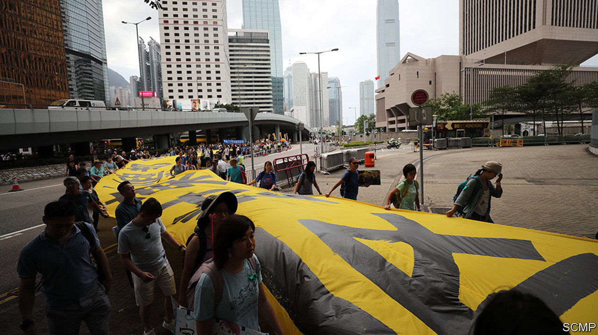

WHEN HONG KONG’S legislature was stripped last month of an opposition after the government expelled four pro-democracy lawmakers and the remaining 15 resigned in sympathy, many in the territory feared this would allow the passage of controversial bills with a minimum of critical scrutiny. In the coming weeks, one proposed law is likely to prove that such worries are justified.

The bill would permit the spending of HK$550m ($71m) on a feasibility study for the biggest infrastructure project ever proposed in the city. The scheme, Lantau Tomorrow Vision, would involve creating 17 square kilometres of artificial land off Lantau, Hong Kong’s largest island. The government says housing built on this, much of it subsidised, could accommodate up to 1.1m people—about one-seventh of the current population. The estimated price tag is at least HK$624bn. Critics say the project is unnecessary, expensive and threatens rare species, including the pink dolphin.

In her annual policy address on November 25th, Hong Kong’s leader, Carrie Lam, said the scheme would “bring enormous economic benefits to Hong Kong”. It would also please the authorities in mainland China. They see it as a catalyst for their own “Greater Bay Area” idea for building Hong Kong and nearby cities inland into a giant metropolis. Shenzhen, the mainland city closest to Hong Kong, wants a high-speed rail link with the Lantau project.

Some developers would like to go further. The Hong Kong Real Property Federation, a lobby group, has suggested that the mainland should lend Guishan, an island 5km south of Lantau, to Hong Kong to allow it to build artificial land there for 800,000 Hong Kongers. But Mrs Lam says the idea would not go down well in Beijing, given President Xi Jinping’s green proclivities. She has not explained why he does not object to the Lantau scheme on such grounds.

In September more than 40% of those surveyed by the Hong Kong Public Opinion Research Institute opposed the project. Many would prefer the building of more housing near the mainland border on old industrial sites. But pro-government politicians in that semi-rural area object. Sadly for Mrs Lam, they have an outsize voice on the 1,200-member committee that picks the winning candidate for her job. Should she decide to seek re-election in 2022 she will need all the votes she can get. ■

This article was downloaded by calibre from <https://www.economist.com/china/2020/12/05/hong-kongs-big-housing-plan-faces-little-resistance>

|  |  |  |  |
| --- | --- | --- | --- |
| Previous | Articles | Sections | Next |

|  |  |  |  |
| --- | --- | --- | --- |
| Previous | Articles | Sections | Next |

#### Chaguan

# How China’s bullying could backfire

Humiliating those who defy it does not make them love China’s government

Dec 5th 2020 |

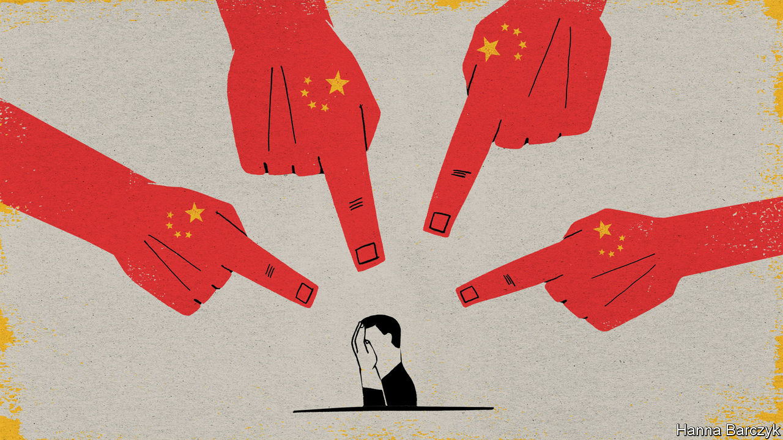

CHINA BULLIES other countries because it works. Once told that they have crossed a “red line” by harming China’s interests or calling out its misdeeds, many governments crumble swiftly. Others fold after suffering months of threats, trade boycotts and cancelled official meetings. But in China’s long experience, almost all—even sometimes America—climb down eventually, sending envoys to sue for peace. True, some Western leaders pay public lip-service to their own country’s values as they land in far-off Beijing. Once the press is shooed from the room, however, the foreign visitors get down to dealmaking. They bow to China’s mix of market power, geopolitical importance and ruthlessness.

Lately, bullying others into furtive submission has not been enough for Communist Party chiefs. Increasingly, they seem bent on humiliating countries that show defiance, notably small or mid-sized allies of America. Just now, it is Australia’s turn for punishment. Its transgressions include taking a lead among American allies in banning the use of 5G network equipment from Huawei, a Chinese telecommunications giant, and calling for an independent probe into the origins of covid-19. China has imposed hefty tariffs on Australian wine and blocked imports of everything from coal to lobsters. In November Chinese diplomats made public a list of 14 ways in which Australia was “poisoning bilateral relations”. The charge-sheet rebuked Australia for allowing news outlets, members of parliament and think-tanks to criticise China. Late last month China’s foreign ministry pounced on an Australian government report into unlawful, brutal killings of prisoners and civilians in Afghanistan by Australian troops. Zhao Lijian, a ministry spokesman and licensed provocateur on social media, said the report exposed the hypocrisy of Western concerns about human rights. On November 30th Mr Zhao tweeted a crude photo-montage made to look like an Australian soldier slitting an Afghan child’s throat. Mr Zhao demanded that troops be held accountable—serenely ignoring the fact that Australia’s inquiry had already recommended that 19 soldiers face criminal investigation.

At first sight, such Chinese provocations look clumsy, indeed self-defeating. By offending lots of ordinary Australians, they complicate life for those businesspeople and politicians who want their government to placate China in hopes of restoring normal, profitable trade flows. That underestimates the calculating nature of Mr Zhao’s tweets and other Chinese attacks, which are not intended to win over Australian hearts and minds. Their aim is partly domestic: to demonstrate the foreign ministry’s fighting spirit to Chinese leaders and online nationalists. The intention is also to demonstrate China’s strength and to provoke such a sense of crisis that Australian political and business leaders are desperate to seek a truce. China’s outlandish attacks are pseudo-populism: a calculated ploy to press elites into cutting a deal.

China may yet feel vindicated in its choice of tactics. Australia may cave. If it does not, and China decides to sacrifice relations with Australia for years to come, a ghastly warning will be sent to other trade partners that imagine they can criticise China with impunity. The world is a rough place on the eve of 2021. China feels in better shape than most. While other large economies remain battered by covid-19, it has already returned to growth. When enunciating their core national interests, Chinese leaders are at least predictable. In contrast, America’s allies have spent four years absorbing hard lessons about the impermanence of American interests that once seemed carved in stone—lessons that will outlive the Trump presidency.

Yet conversations in recent weeks with more than a dozen ambassadors in Beijing reveal a striking change of mood. Westerners know that they often struggle to understand the incentives that guide Chinese officials. But envoys in Beijing increasingly suspect that China’s rulers are misreading the mood in democracies. In particular, Communist Party bosses are too disdainful of Western public opinion, which is swinging against China in ways that will constrain governments, at least somewhat, as they strive to balance economic interests and democratic values.

## China prefers to be admired, but will settle for fear

Western unity is too fragile to enable many formal displays of solidarity with Australia. And multinational corporations are not about to leave China. For lots of big firms, their only profitable business unit this year is Chinese. But China’s assertiveness abroad, and its hardline ideological turn at home, are creating political uncertainties that businesses cannot ignore. The talk is of hedging now, and of diversifying future investments. There will be no binary moment when the West switches from engagement to decoupling. However, China is teaching the West to be more defensive. Over time, more individual, seemingly unconnected decisions will be a no, not a yes: whether to allow this Chinese investment, buy that sensitive technology from a Chinese firm, or sign an exchange deal with a Chinese university. That could have surprising cumulative effects. Western defensiveness will not stop China from rising, but it could alter China’s trajectory, perhaps steering it towards dominance of only part of the world: a techno-authoritarian sphere in tension with a more liberal bloc.

For decades, countries have tolerated Chinese bullying. For that, thank pragmatism, naivety and cynicism among politicians and business bosses, and broad indifference among publics. Now, however, China seems bent on changing countries that it deems hostile, so that governments, news outlets, universities and other institutions never defy China again. Some trade partners, especially in China’s backyard, will feel bound to submit. Others may prove more stubborn. China is no longer just a foreign-policy puzzle. As its confidence swells, and its technological footprint grows, it is ready to challenge how Western societies work at home. Imposing that sort of humiliation comes with costs. ■

This article was downloaded by calibre from <https://www.economist.com/china/2020/12/05/how-chinas-bullying-could-backfire>

|  |  |  |  |
| --- | --- | --- | --- |
| Previous | Articles | Sections | Next |

|  |  |  |
| --- | --- | --- |
| China | Sections | Middle East & Africa |

United States

The economy: You must believe in spring

.

Campaign financing: Not for sale

.

Corporate transparency: Shell collecting

.

Water: With the lead piping

.

America’s spies: Shadow business

.

Lexington: Jake Sullivan to the rescue

.

|  |  |  |
| --- | --- | --- |
| China | Sections | Middle East & Africa |

|  |  |  |  |
| --- | --- | --- | --- |
|  | Articles | Sections | Next |

#### You must believe in spring

# America’s economic recovery no longer looks so strong

A difficult winter looms

Dec 5th 2020 |

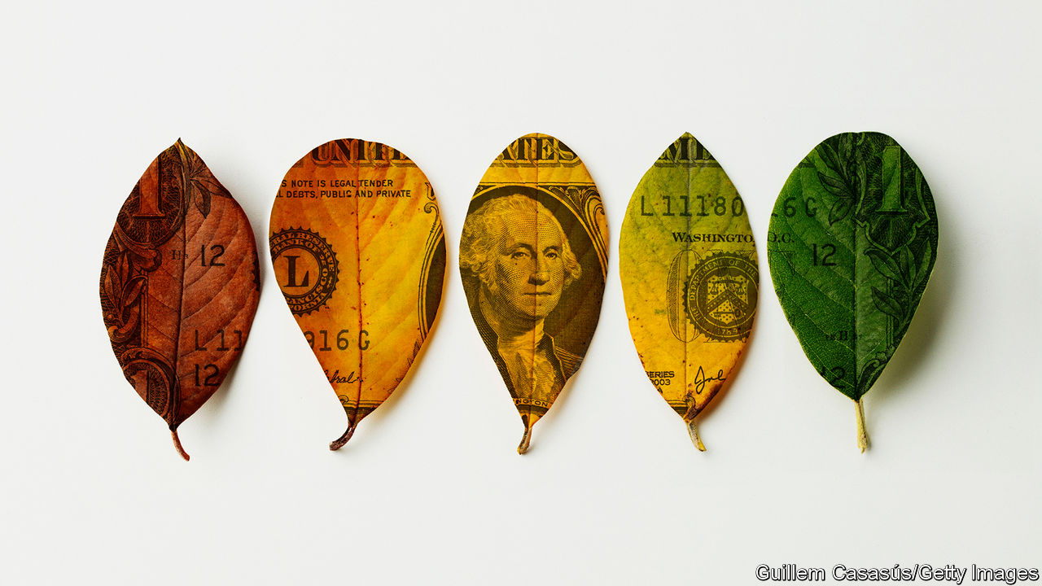

Editor’s note: Some of our covid-19 coverage is free for readers of The Economist Today, our daily [newsletter](https://my.economist.com/user#newsletter). For more stories and our pandemic tracker, see our [hub](https://www.economist.com/news/2020/03/11/the-economists-coverage-of-the-coronavirus)

IN THE SUMMER and autumn America’s economy roared back. After peaking at nearly 15% of the labour force, unemployment fell like a stone, while in the third quarter GDP bounced from its lockdown-induced slump. The recovery of the world’s largest economy seemed oddly impervious to a second and then a third wave of coronavirus infections, even as economic activity in other parts of the world took a hit.

Yet there are growing concerns that the run of surprisingly good economic news is over, at least until a vaccine becomes widely available. In congressional testimony on December 1st Jerome Powell, the chairman of the Federal Reserve, said the recovery was slowing, while the decision on the same day by a bipartisan group of senators to release a proposal for a stimulus package reflects the same fears. The jobs report for November, which was to be released shortly after The Economist went to press, will probably be a downbeat one by recent standards—and whatever it shows, it is old news, since the surveys for the report were taken some weeks ago. More up-to-date figures show that the recovery has lost steam. That is bad news for the millions who remain out of work, as well as the rapidly growing share of Americans who are living in poverty.

Official statistics tend to be produced with long lags. So during the pandemic economists have turned to “high-frequency” data, largely produced by the private sector and generated by consumers’ and firms’ transactions, to measure the economy in real time. Wall Street banks now routinely provide clients with updates on everything from weekly electricity consumption to daily hotel bookings. The high-frequency data do not map onto the official kind perfectly. But they are useful for finding turning-points. They pinpointed the start of the downturn in March long before the official statistics could.

America is at another turning-point. STR, a data provider, finds that in the week ending November 21st hotels were running at 40% occupancy, down from 50% only weeks ago. The number of diners in restaurants has sharply declined in recent weeks, suggest data from OpenTable, a booking platform, with the fall even steeper in the states hardest hit by the virus. A recovery in air-passenger numbers appears to have ground to a halt as well.

Other real-time measures capture economic activity more broadly. The share of small firms which have temporarily closed is probably rising. Consumer spending in the week ending November 22nd was down by 5% compared with the one before, according to Cardify, a data provider. Using mobility data from Google, The Economist has constructed an economic-activity index measuring visits to workplaces, transport hubs and places of retail and recreation. After rising steadily during the autumn, the index has fallen back—though America still looks better than Europe, where the economic-activity index has crashed as governments have imposed another round of lockdowns. JPMorgan Chase, a bank, produces an estimate of monthly American GDP growth from a range of real-time data. In a report published on December 2nd, it suggests that output stopped growing in November.

Three factors explain the slowdown. To some extent it was inevitable. Loosening lockdowns had allowed millions of people to return to work and start spending again. But there was no comparable loosening of coronavirus restrictions after that. So it was never realistic for America to repeat the 7.4% quarter-on-quarter GDP growth that it saw in July to September.

Fiscal policy is the second factor. Another reason the economy bounced back so quickly in the summer was the enormous generosity of the stimulus packages agreed by Congress in the spring, worth some $3trn (or 14% of GDP). Yet Congress has so far failed to agree to another one, even though the most bullish forecasters still reckon a package worth over $500bn is required to help the economy back to some semblance of normality. A programme set up by President Donald Trump to raise unemployment-insurance (UI) payments by $300 a week, which had boosted aggregate household incomes by 1.5%, wound down in October. States and local governments, facing a severe budget crunch, cut over 1m jobs in the first six months of the pandemic, more than they lost even during the financial crisis of 2007-09.

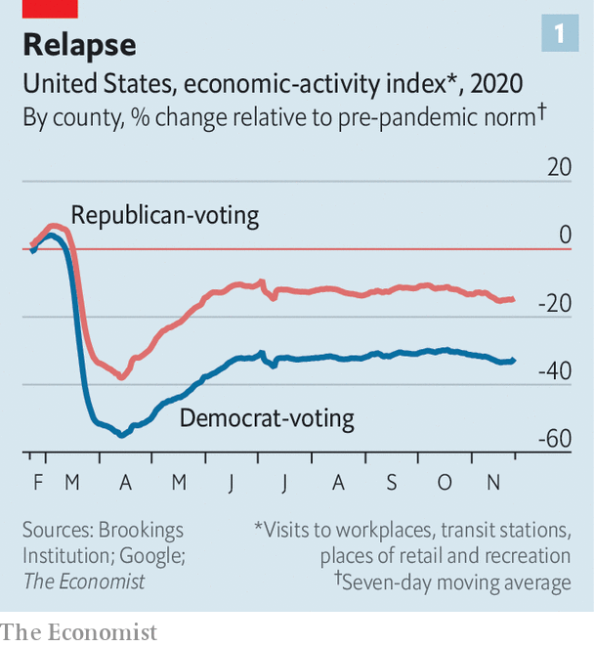

The third and most important reason for the slowdown is the virus itself. Until recently many Americans, especially in Republican-leaning areas, seemed oddly happy to go about their business as normal. In South Dakota in September and October, for instance, visitors to sites of retail and recreation were 1.5% higher than usual for that time of year, even as coronavirus infections surged. Analysis by The Economist, drawing on Google data and work by Mark Muro and colleagues at the Brookings Institution, a think-tank, found that in the summer and autumn people in pro-Trump areas were half as likely to avoid public places as people living in areas that had voted for Joe Biden (see chart 1).

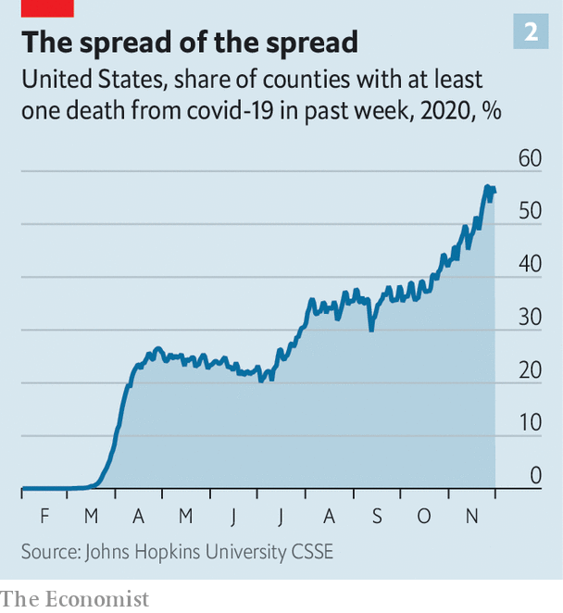

But now even people in the most pro-Republican areas appear to be getting skittish, too. In the week before Thanksgiving attendance at South Dakotan recreation-and-retail was 8% lower than normal. The continued increase in coronavirus cases may partially explain this, but a rise in death rates may be more significant. Research by Austan Goolsbee and Chad Syverson, both of the University of Chicago, finds that local deaths from coronavirus have a big impact on a local economy, perhaps because they bring home the seriousness of the situation. Deaths lag behind cases, and the share of American counties with at least one death from coronavirus in the previous week is soaring (see chart 2). Surveys suggest that a growing share of people worry about catching the virus.

The economy will rise again once a vaccine becomes available. Roughly 40% of the country should be vaccinated by March, suggests a recent paper by Goldman Sachs, a bank, putting America behind only Britain in terms of the speed of the rollout. And the vaccine-induced boost could be bigger than many expect. So far the pandemic has left surprisingly few scars on America’s economy. Business bankruptcies and the number of people in long-term unemployment remain lower than during the financial crisis of 2007-09.

Until then there will be further drags on the economy. Two further provisions related to UI, one which expanded eligibility to include the self-employed and gig workers, and one which provided extra weeks of benefits for recipients, are due to expire at the end of the year. A number of emergency lending programmes are also likely to end at that time. And the pandemic remains out of control. America, and especially its poorest folk, face a tough winter.■

This article was downloaded by calibre from <https://www.economist.com/united-states/2020/12/05/americas-economic-recovery-no-longer-looks-so-strong>

|  |  |  |  |
| --- | --- | --- | --- |
|  | Articles | Sections | Next |

|  |  |  |  |
| --- | --- | --- | --- |
| Previous | Articles | Sections | Next |

#### Not for sale

# How much does a few billion dollars get you in 2020?

If you’re the Democratic Party, not much at all

Dec 5th 2020 | WASHINGTON, DC

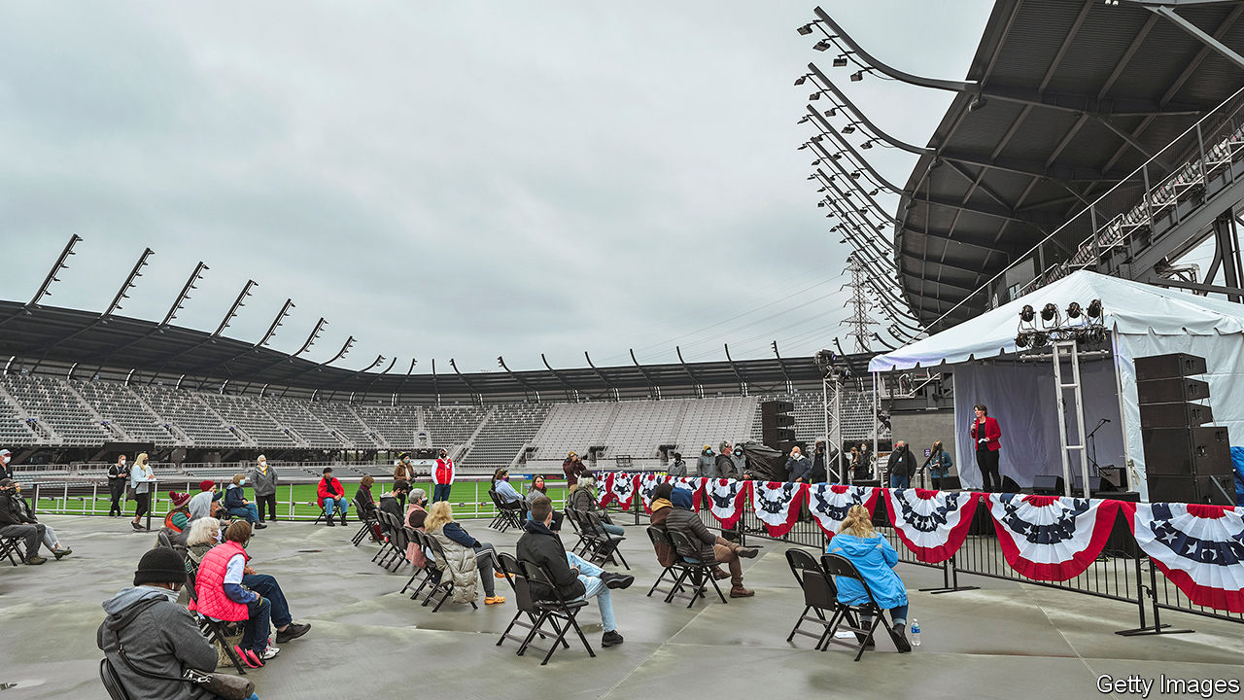

IN THE HEADY days before the elections on November 3rd, when Democrats dared to dream of unified control of Washington and a coming progressive remake of America, two especially optimistic indicators elicited particular giddiness. First, of course, were the horse-race polls showing Joe Biden ahead of President Donald Trump by nine or so percentage points. But there was also the money race, which Democrats were winning handily: Mr Biden’s campaign raised $952m, or nearly 60% more than Mr Trump’s campaign, described by reporters as a profligate operation limping cash-strapped into November.

The down-ballot races looked even more favourable. In an election that cost a remarkable $14bn—more than twice the price tag in 2016—Democrats were spending 80% more than Republicans, the most lopsided advantage ever according to analysis by the Centre for Responsive Politics (CRP), a research outfit. Unfortunately for them, a few extra billion seemed not to go very far in 2020. Democrats lost seats in the House of Representatives and the party faces an uphill battle to take the Senate, by the thinnest possible margin, when run-off elections are held in Georgia in January.

Whether campaign spending actually moves voters is an unsettled debate—one of special academic interest to American political scientists and of special pecuniary interest to America’s political-consulting-industrial complex. The political consultants would probably point to the robust correlation between raising the most money and winning an election: even in 2020, 89% of House candidates who spent most went on to win; the same was true of 70% of Senate candidates (albeit a two-decade low, according to the CRP).

Political scientists would counter that a correlation is just that—perhaps one driven spuriously by the fact that truly hopeless candidates generally have a difficult time raising money. Candidates who are guaranteed to win also attract a lot of campaign donations from those who want access to them. The more nuanced assessment is that campaign spending can move voters on the margins, going furthest in less prominent and less polarised races (like primaries) where more voters are uninformed and undecided.

Democrats will want a more thorough post-mortem than that, though, given not just their recent grief but also a cruel irony of history. As the Supreme Court issued ruling after ruling deregulating campaign financing, most prominently in its Citizens United decision ten years ago, Democrats fretted that free-flowing dollars from rich Republican donors would place them at a permanent disadvantage, consigning them to the minority for the foreseeable future. But when they managed to secure a serious cash advantage, through considerable investments in online fundraising and free-spending by billionaires of their own like Michael Bloomberg, they found it was not as decisive as they had hoped.

One partial explanation for the misfire is that better online fundraising enables greater hauls that are distributed inefficiently. Polls consistently showed that Amy McGrath had little chance of unseating Mitch McConnell, the Republican majority leader in the Senate, and yet she managed to raise $88m because there were thousands of Americans not in Kentucky willing to set their dollars on fire for the warm feeling of spiting Mr McConnell (and probably ignoring their local state legislative elections where Democrats were shut out). The top three employers for people donating to Ms McGrath were the University of California, Alphabet (based in Silicon Valley) and Microsoft (based in Seattle). West-coast cash helped buy a lot of television adverts for Ms McGrath ($18.6m-worth), with little chance of wooing Republican voters in the first place and diminishing marginal returns afterwards.

Alexandria Ocasio-Cortez, the prominent Democratic socialist representative, issued a two-pronged post-mortem of her own soon after the disappointing election: moderate Democrats had failed to win because they had ignored online advertising on platforms like Facebook, and had neglected the years-long organising it takes to turn out voters. The first part of her theory is suspect, but the second may be correct.

This is aptly demonstrated by what happened in Maine, where Democrats hoped that Sara Gideon would topple Susan Collins, the longtime Republican senator. Ms Gideon certainly did not neglect internet advertising—spending nearly three times as much as her opponent on Google advertising and four times as much on Facebook ads. But Mainers bristled at the out-of-state canvassers imported by Ms Gideon for her campaign. “Canvassing, phone-banking and people sending postcards is all a Band-Aid for a lack of social ties in the community,” says Eitan Hersh, a political scientist at Tufts who has written a withering denunciation of political hobbyism in America. Democrats opt for quickly constructing and then dismantling expensive get-out-the-vote operations in each cycle, Mr Hersh adds, whereas Republicans are able to tap more durable networks built around churches and gun clubs.

Ultimately, money probably matters less than voters suspect. In a provocative (and highly-cited) paper entitled “Why is there so little money in US politics?”, three political scientists pointed out that if campaign financing were really just an auction for federal spoils, then there ought to be much more of it given the colossal sums at stake. Instead, they argue persuasively that most campaign spending is driven by political dilettantes. During the Trump era, many incensed Democrats were willing to donate record sums to chasing lost causes. Campaigns (and their paid consultants) know that viral advertisements are a ticket to huge sums of internet cash. The donors, on the other hand, have little idea how effective their dollars will be.■

Dig deeper:  
Read our [latest coverage of the presidential transition](https://www.economist.com/us-election-2020), and then sign up for Checks and Balance, our [weekly newsletter](https://www.economist.com/checksandbalance/) and [podcast](https://www.economist.com/checks-and-balance-our-weekly-podcast-on-american-politics) on American politics.

This article was downloaded by calibre from <https://www.economist.com/united-states/2020/12/05/how-much-does-a-few-billion-dollars-get-you-in-2020>

|  |  |  |  |
| --- | --- | --- | --- |
| Previous | Articles | Sections | Next |

|  |  |  |  |
| --- | --- | --- | --- |
| Previous | Articles | Sections | Next |

#### Shell collecting

# Congress edges closer to cracking-down on anonymous shell corporations

America’s laws have made money-laundering too easy. That looks set to change

Dec 5th 2020 | WASHINGTON, DC

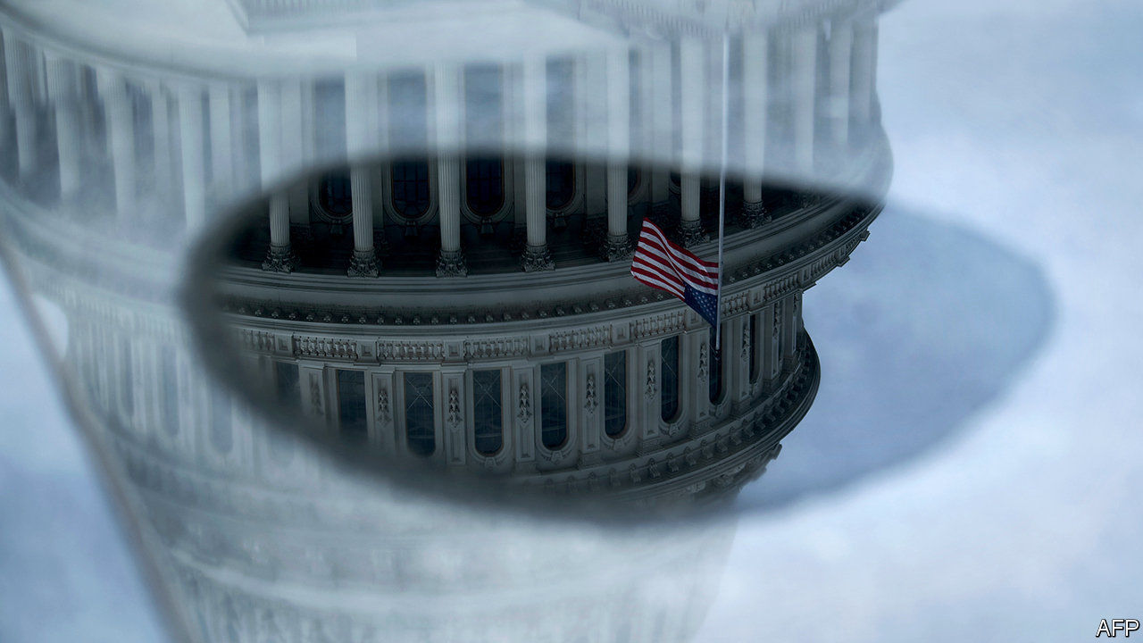

OUT OF THE $4.5bn pilfered from 1MDB, a Malaysian state development fund, at least $1bn is alleged by American prosecutors to have been embezzled into the United States—spent in a Gatsby-esque frenzy on, among other things, a Manhattan penthouse, a Beverly Hills mansion and financing Hollywood films (including, naturally, “The Wolf of Wall Street”). America’s porous rules on anonymous shell companies make disguising the origins of money fairly straightforward. The Tax Justice Network, a good-government group, ranks America as the second-worst performer on its annual financial-secrecy index—ahead of famous tax havens like Switzerland and Luxembourg, and eclipsed only narrowly by the Cayman Islands. As recently as last year, American prosecutors were trying to wrest control of a 36-storey office building on Fifth Avenue in Manhattan, probably worth close to $1bn, on the grounds that it was secretly owned by the government of Iran, which is subject to some of the heaviest sanctions in the world.

Shell games such as these hide not only the penthouses of kleptocrats, but the financial networks for traffickers of arms, drugs and humans. Congress is on the cusp of making them harder to execute. The must-pass annual defence bill is slated to include legislation requiring companies to disclose to the Treasury Department’s enforcement division their beneficial owners (those who actually enjoy the proceeds rather than those who sign the paperwork). “The biggest vulnerability in our anti-money-laundering regime is the incorporation of anonymous shell companies,” says Clark Gascoigne, a senior policy adviser at the FACT Coalition, another anti-corruption outfit that has spent years pushing for the pending legislation. At present, notes Mr Gascoigne, there are more onerous disclosure requirements for obtaining a library card in all 50 states than for starting a new limited-liability company.

America’s law-enforcement agencies are keen to get such data. “The strategic use of these entities makes investigations exponentially more difficult and laborious,” a senior FBI official testified to Congress last year. In fact, there is impressively little organised opposition to the new rules, which have strong bipartisan support. The Bank Policy Institute, a lobbying group, is a firm supporter (banks not only spend a non-trivial share of operating expenses on anti-money laundering compliance, but would also rather avoid news stories about terrorism financing). So, too, is the US Chamber of Commerce, which until June had opposed such measures. The National Federation of Independent Business, a small-business lobby, is putting up a last stand of resistance, fretting that the new disclosure requirements would impose onerous paperwork requirements of 2.5 hours a year.

If it passes, the legislation would be the culmination of a long campaign. Banks were fairly quick to support the change. Realtors (estate agents to Brits) took longer to come round, as did the secretaries of state in places that make lots of money from incorporation fees. (Delaware earns almost as much from charging businesses as it does from its personal income tax.)

The bill would bring America’s rules closer to Europe’s. Britain has required disclosure of beneficial owners since 2016 (its register, unlike the one proposed by Congress, is public). The European Union required its member states to set up comparable schemes by January of this year. America has used the global heft of the dollar to go after international flows of illicit cash, while being permissive towards the ideal vehicles for money-laundering. That means “the United States is increasingly helping to facilitate the very narcotics traffickers, human smugglers, terrorist networks and kleptocrats that weaken US national security,” according to Jodi Vittori of the Carnegie Endowment for International Peace. That looks likely to change. ■

This article was downloaded by calibre from <https://www.economist.com/united-states/2020/12/05/congress-edges-closer-to-cracking-down-on-anonymous-shell-corporations>

|  |  |  |  |
| --- | --- | --- | --- |
| Previous | Articles | Sections | Next |

|  |  |  |  |
| --- | --- | --- | --- |
| Previous | Articles | Sections | Next |

#### With the lead piping

# Millions of Americans still get their drinking water from lead pipes

Why a century-old problem seems so hard to fix

Dec 5th 2020 | CHICAGO

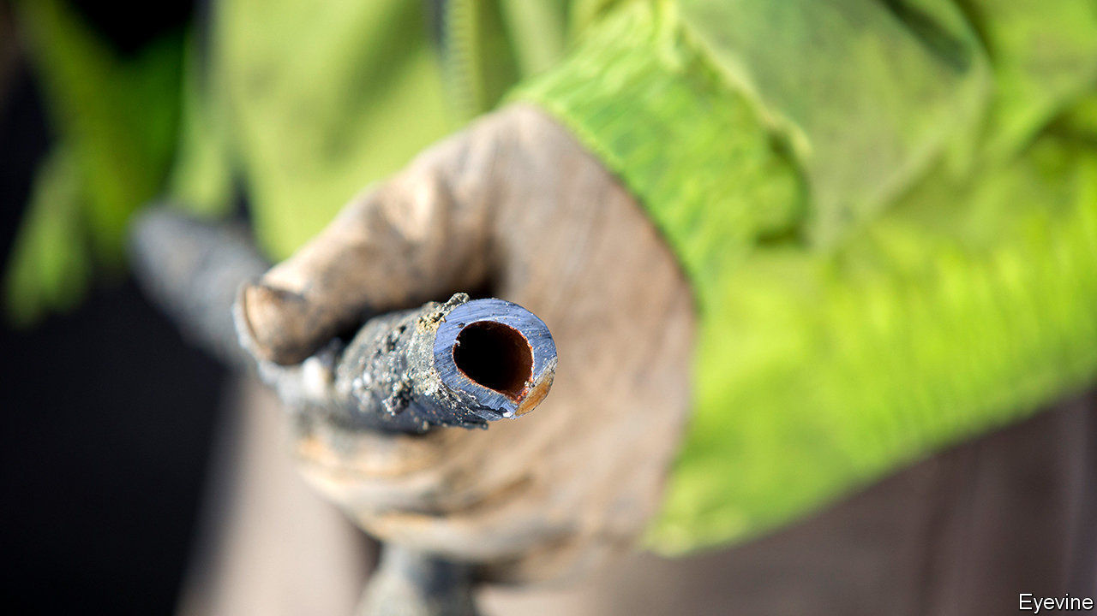

OVER A CENTURY has passed since the dangers of consuming lead became widely known. Ingesting even small quantities damages young brains and may raise the risk of heart problems. Yet residents of Chicago—and many other cities—still mostly swig from taps fed by lead pipes. About 400,000 lead service lines connect to the mains in the Windy City, linking about four in five of all houses there. One study of nearly 3,000 homes, two years ago, found two-thirds had elevated levels of lead in their water.

In Chicago some residents are told to flush their taps before drinking, to fit filters or avoid boiled water (doing so can concentrate higher levels of lead). Older houses in poorer districts may be worst affected. Since this problem has been identified for so long, why does it persist?

The city’s water woes can be blamed in part on the historic clout of industrial lobbyists and a union of plumbers. In the last century, even as other cities stopped installing the pipes or started removing them, they nudged Chicago’s political bosses to set rules making lead pipes compulsory. That lasted until a federal ban on new lead pipes in 1986. More than three decades on, Lori Lightfoot recently became the first mayor to set out a plan to fix things. The catch? It will cost $8.5bn, which the city government does not have. At the current pace of replacing fewer than 800 pipes a year, notes an alderman, residents won’t all get lead-free water until the mid-26th century.

Mayors are more alert to the problem these days, especially since the water crisis in 2014 in Flint, Michigan exposed residents to high levels of lead leaching from their pipes. Flint is spending $100m upgrading its system. Erik Olson of the Natural Resources Defence Council, who has campaigned on the issue for 30 years, says thousands of water systems across the country, serving tens of millions of people, still face “serious problems”. The new attention to the problem encourages him.

A clutch of newish studies on the effects of lead exposure has helped. The hypothesis that lead damage to developing brains causes violence later in life is one of the great mysteries of social science—widely believed by those who plot the decline in violence against the decline in lead exposure and note how the two track each other; widely mistrusted by researchers who mutter about correlation and causation. Newer studies are more nuanced. One, by James Feigenbaum of Boston University and Christopher Muller of Berkeley, tried to control for other factors by comparing cities where the pH of the water supply was below seven, making it acidic, and causing lead to leach into water. The authors found acidic water tallied with more crime.

Some cities flush chemicals—ortho-phosphates—into pipes, to coat them to stop lead getting into the water. Milwaukee spends $400,000 a year to do so. That helps, but disturbances—such as when mains pipes are replaced but service lines to homes are not—can shake out particulates that remain in water. Karen Dettmer, superintendent of water works in Milwaukee, says events in Flint spurred her city to stop all repairs of lead lines. They also found, in 2017, ten schools fed by lead lines that were promptly replaced. Nurseries run from private homes remain exposed.

Milwaukee is trying to replace 1,100 lead lines each year—hoping to emulate cities such as Lansing, Madison and Green Bay which have recently replaced all their pipes. Pittsburgh, Newark and other cities also plan to do so. But the cost of replacing one pipe averages $11,000 in Milwaukee (it was lower elsewhere). And with service lines mostly on private land, the job involves negotiations and cost-sharing with owners. Doing it all “will take about 70 years, that’s not fast”, she says. Much housing stock is decades old and pipes inside homes may also be a source of lead.

With federal help, states and cities might move faster. One concern is regulation. The EPA last updated its Lead and Copper Rule, setting out how fast lead pipes should be replaced, in 1991. It requires 7% of them in a given site to be swapped out yearly, though this has evidently not been enforced. An amendment the EPA sent to the White House in July, which is still awaiting Donald Trump’s signature, would relax that to 3% a year. (It would also tighten rules to speed replacement in schools.) Mr Olson calls the proposed change “appalling”.

Cities want to make changes, but swapping out 10m service lines could cost $50bn, says Mr Olson (it is cheaper to do it in bulk). Twice this summer the Democrat-run House of Representatives passed bills to start paying for it—first a $22.5bn authorisation, then an appropriations bill that set aside $1bn for this fiscal year. Proposed infrastructure bills also include sums for removing lead pipes. But in the Senate such plans have, so far, led nowhere.

Joe Biden’s administration could nudge things on. The EPA may set higher standards again and might order overdue public hearings on the topic, perhaps in badly afflicted cities like Flint. A bill co-sponsored by a Republican congressman from New Jersey, Chris Smith, would require all lead pipes to be replaced within a decade. His timetable may look too ambitious, but waiting for 500 more years to fix the problem isn’t much of a plan, either.■

This article was downloaded by calibre from <https://www.economist.com/united-states/2020/12/05/millions-of-americans-still-get-their-drinking-water-from-lead-pipes>

|  |  |  |  |
| --- | --- | --- | --- |
| Previous | Articles | Sections | Next |

|  |  |  |  |
| --- | --- | --- | --- |
| Previous | Articles | Sections | Next |

#### Shadow business

# America’s intelligence agencies prepare for life after Trump

Repairing their reputation with sources and allies is not their biggest challenge

Dec 5th 2020 | WASHINGTON, DC

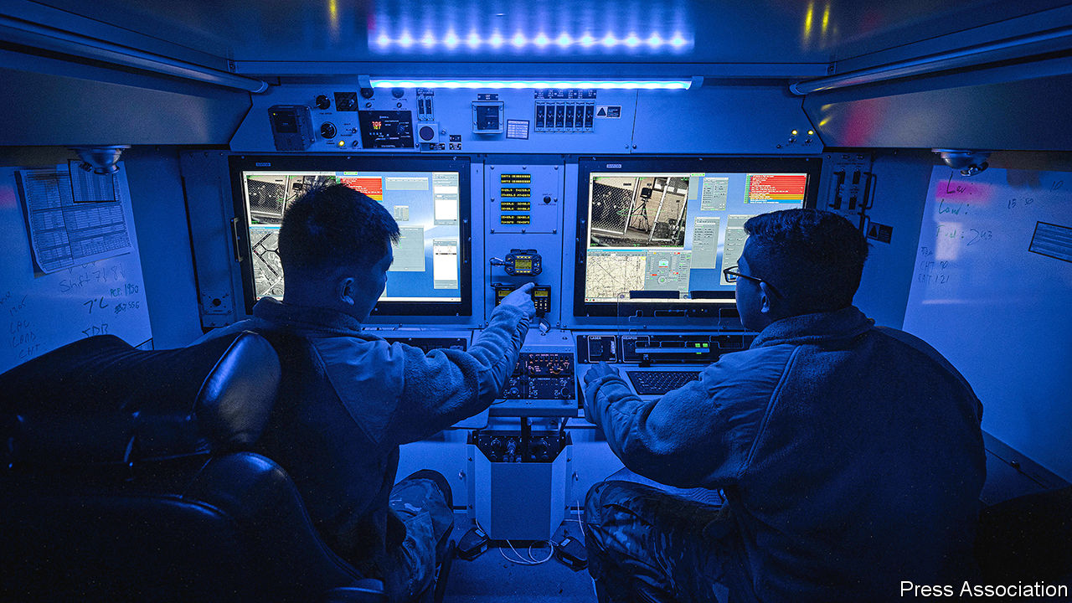

“THE WHOLE job of the intelligence community (IC),” explains Angus King, a senator from Maine whom Joe Biden considered naming Director of National Intelligence, “is to seek the truth and tell the truth…[and to] provide absolutely unvarnished information without worrying what the leader wants to hear.” Most presidents value such independence. Donald Trump, less so. Over the past four years, he has compared intelligence agencies to Nazis, rubbished intelligence that displeased him and replaced professionals with unqualified sycophants. Doug Wise, a former deputy director of the Defence Intelligence Agency (DIA), calls Mr Trump “the global equivalent of an intelligence cancer”, who has damaged morale within agencies and emboldened America’s adversaries.

The Biden administration will need to undo that damage, while also responding to emerging threats with a set of institutions often deemed too tied to outdated practices. Mr Biden’s first steps are promising. He says he wants his national-security officials to “tell me what I need to know, not what I want to know”. The last two of Mr Trump’s four directors of national intelligence (DNI)—a role created in the wake of the September 11th attacks to promote better information-sharing among the 17 entities comprising America’s intelligence apparatus—were a former ambassador and a three-term congressman, both of whom had negligible intelligence experience. They were there, according to Robert Cardillo, another former DIA deputy director, “as yes-men to ensure the IC didn’t give [Mr Trump] any trouble.”

Mr Biden nominated Avril Haines as DNI on November 24th. She was Barack Obama’s deputy national security adviser and deputy CIA director; John Brennan, her boss at CIA, praises her “humility, interpersonal skills and tremendous capability,” as well as a “work ethic...beyond peer”. She vowed to “speak truth to power” if confirmed. Her priority, according to Mark Warner, the leading Democrat on the Senate intelligence committee, is “restoring morale [and] reaffirming the notion that [analysts] speak the truth, even if it’s not the administration’s position.”

Undoing the damage abroad could prove trickier. On the one hand, intelligence sharing among the Five Eyes countries—America, Australia, Britain, Canada and New Zealand—proceeded more or less as usual during Mr Trump’s tenure. The non-American intelligence agencies were occasionally more careful than usual in what they told the White House, to avoid triggering a presidential tantrum. Some worried that intelligence coming in the opposite direction may at times have been coloured by Mr Trump’s political considerations. But intercepted communications are shared almost automatically. And Mr Cardillo says that most allies expressed “relief” when he told them: “I get it, I know what’s in the headlines and what you’re seeing on Twitter, but we’re still here, we still have this relationship.”

## Trust funds

On the other hand, many worry that Mr Trump’s denigration of his own spies has emboldened America’s adversaries. His carelessness with classified information—early in his presidency he offhandedly divulged some to Russia’s foreign minister—may make it harder for America to attract would-be sources. The seasoned professionalism of the national-security team that Mr Biden has already assembled may calm some nerves, but restoring America’s reputation for stability and care for its intelligence sources will take more than just words, and longer than just months.

Yet it is challenges unrelated to Mr Trump that are likely to prove trickier. After two decades of relentless focus on counter-terrorism, the agencies are shifting resources and attention to “great-power” rivals, above all China. That requires different skills and capabilities than those wielded in the militarised war against jihadists. As Mr Warner notes, “it’s not just about who has the best rocket or submarine. Who’s going to control the 5G network? What will be the ethical and legal criteria around AI?...We kind of fell asleep at the wheel, and China flooded the zone with engineers in standard-setting areas.”

If all that were not enough, intelligence agencies are also facing something akin to the problems media companies ran into when news moved from the printed page to the internet, and readers no longer needed a paper to give them information such as sports results or the next day’s weather forecast. “Seventy years ago when intelligence agencies were being set up, collecting and analysing secrets was deemed the best way to understand the world,” says Carmen Medina, a former deputy director of intelligence at the CIA. Today, she says, “a lot of the information that they stamp secret on, I can find anywhere else.”

Open-source intelligence, from commercial satellite imagery to social media, cannot substitute for the most hallowed sources—an agent in the Kremlin, say—but it offers insight without the encumbrances of classification. A new generation of officials and lawmakers have grown up in a world where they expect “answers on demand”, says Zachery Tyson, a former intelligence official at the Pentagon. “They are not going to use an IC where you have to go four floors down into the basement and log on to a secret computer with four different passwords to access a simple answer that you can approximate on Google.” ■

Dig deeper:  
Read our [latest coverage of the presidential transition](https://www.economist.com/us-election-2020), and then sign up for Checks and Balance, our [weekly newsletter](https://www.economist.com/checksandbalance/) and [podcast](https://www.economist.com/checks-and-balance-our-weekly-podcast-on-american-politics) on American politics.

This article was downloaded by calibre from <https://www.economist.com/united-states/2020/12/05/americas-intelligence-agencies-prepare-for-life-after-trump>

|  |  |  |  |
| --- | --- | --- | --- |
| Previous | Articles | Sections | Next |

|  |  |  |  |
| --- | --- | --- | --- |
| Previous | Articles | Sections | Next |

#### Lexington

# Jake Sullivan to the rescue

The Democrats’ Golden Boy augurs a return to competent foreign policymaking

Dec 5th 2020 |

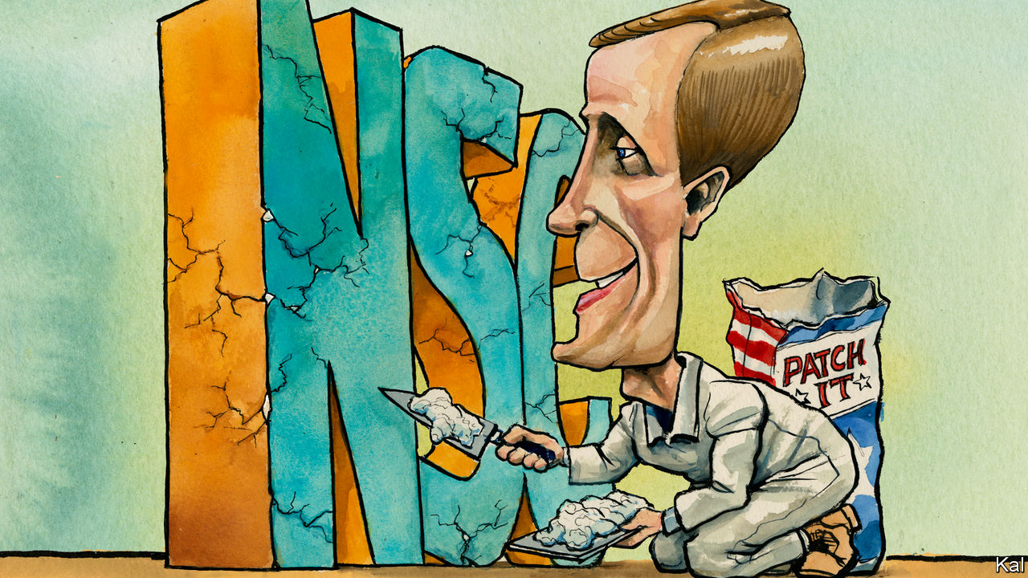

AT THE HOARY age of 36, Jake Sullivan delivered this life lesson to graduating students of the University of Minnesota. “Reject certitude. And don’t be a jerk. Be a good guy.” He cannot be accused of ignoring his advice. The Democratic wunderkind, who eight years later will become the youngest national security adviser since McGeorge Bundy in 1961, has a reputation for high-grade amiability that is even rarer in Washington, DC, than his big brain.

“He’s the smartest guy in the room, but he’s not cocky about it,” says Senator Amy Klobuchar, a fellow Minnesotan, who hired Mr Sullivan from the Minneapolis law firm where he had taken a brief break from elite institutions (Oxford, Yale Law, a clerkship at the Supreme Court). When he left her office to work on Hillary Clinton’s 2008 presidential campaign, he promised to return. He proceeded instead to make himself indispensable, in the State Department, White House and on the trail, to Mrs Clinton, Barack Obama and Joe Biden in turn, including as the then vice-president’s NSA. (“He did the trifecta,” quips Ms Klobuchar, a trifle ruefully.)

Even Iran’s mullahs were said to appreciate his lack of condescension, after he was charged by Mrs Clinton with a series of top-secret missions to the Gulf that opened a path to the Iran nuclear deal. More remarkably still, the mullahs of the Democratic left like him, too. This is on account of his intraparty peacemaking for Mr Biden; and also a soul-searching essay on the limits to neoliberalism that he penned in the wake of Mrs Clinton’s loss to Donald Trump—for which, as her policy chief, he held himself partly to blame. The bipartisan foreign-policy world has welcomed his latest elevation with a gusto that goes beyond the usual post-Trump relief. “He’s a terrific choice,” says Stephen Hadley, former national security adviser to George W. Bush. “He’s a good person, very smart and very balanced.”

Such plaudits may prove hard to live up to. Especially as Mr Sullivan will be judged by harsher standards than his recent predecessors. Mr Trump’s half-dozen national security advisers have been weighed by the media and Democratic opposition chiefly on their reported willingness to restrain the president’s excesses. Thus the extraordinary turnabout in John Bolton’s reputation on the left. Only Michael Flynn, who this week called for a military coup and the imposition of martial law to overturn the election, has been skewered for the failure of Mr Trump’s foreign policy. Mr Sullivan can expect much stiffer criticism for much smaller setbacks. Barbed comments from Republican hawks such as Tom Cotton and Marco Rubio, for whom any association with the Obama administration is unforgivable, suggest it has already begun.

On his core responsibilities—which will include restoring sanity to the inter-agency process and managing the rivalries it breeds—he will nonetheless start with big advantages. He knows Mr Biden’s mind and has his confidence; the president-elect calls him a “once in a generation intellect”. He has comradely relationships with Tony Blinken and other senior Biden nominees—and a habit of continually questioning his own assumptions which creates an impression of open debate. Often noted by those who have worked with him, this quality is also indicated by Mr Sullivan’s self-critical recent writing, including that essay on economic policy, another in defence of American exceptionalism (“Despite its flaws, America possesses distinctive attributes…”) and a synthesising third essay, in Foreign Policy, on his ambition to bring foreign and domestic policy into alignment.

His willingness to adapt suggests the fear that Mr Biden’s security agenda will be too backward-looking may be overblown. When Mr Biden said this week that he would not hurry to scrap the tariffs on China, and that he would try to expand as well as to reconstitute the Iran deal, he echoed positions that Mr Sullivan had previously laid out. The Biden administration will focus on rehabilitating the traditional means of statecraft—including diplomacy and basic competency—that the Trump administration disdains. But it will husband whatever useful leverage its predecessor has accrued, while pursuing some of the same hawkish objectives.

Mr Sullivan will find his grander scheme to integrate foreign and domestic policy tougher going. He makes a strong case—in his Foreign Policy piece and elsewhere—that globalisation has made this essential (as the pandemic underlined). Also that the cosy foreign-policy world needs better answers (as Mr Trump’s success showed) for its populist critics. Mr Biden’s promise of a “foreign policy for the middle class” speaks to the same concern. And Mr Sullivan can be expected to make at least modest efforts to address it. As NSA, he might be expected to play an unusually big role in trade and immigration discussions. By the same token, expect domestically orientated agencies—such as Health and Human Services—to play a bigger part in the inter-agency security debate.

## Everything’s Jake

Yoking together foreign and domestic objectives could also be offered as a political rationale for the more ambiguous relationship with China that Mr Biden wants. Where any engagement with the Party is currently considered a show of weakness, Mr Biden might argue that closer ties in areas such as public health and climate change are urgently required by the needs of ordinary Americans. But these would be marginal developments, far short of the transformation Mr Sullivan advocates, and for a familiar reason. Presidents pay such heed to foreign policy in part because their prospects of passing much on the home front are so limited. Linking foreign and domestic objectives will not fix the partisan dysfunction underlying that failure, as Mr Sullivan must realise.

His return to government is therefore liable to be much less ambitious than his writings might suggest. Meeting his admirers’ expectations will be hard. But in picking Mr Sullivan, Mr Biden has given himself a better chance of bringing a period of disarray in American foreign policymaking to a close.■

Dig deeper:  
Read our [latest coverage of the presidential transition](https://www.economist.com/us-election-2020), and then sign up for Checks and Balance, our [weekly newsletter](https://www.economist.com/checksandbalance/) and [podcast](https://www.economist.com/checks-and-balance-our-weekly-podcast-on-american-politics) on American politics.

This article was downloaded by calibre from <https://www.economist.com/united-states/2020/12/05/jake-sullivan-to-the-rescue>

|  |  |  |  |
| --- | --- | --- | --- |
| Previous | Articles | Sections | Next |

|  |  |  |
| --- | --- | --- |
| United States | Sections | The Americas |

Middle East & Africa

America and Iran: Back to the future

.

Burundi and Tanzania: No haven

.

Ethiopia’s civil war: Victory, defeat and confusion

.

Nigeria: Death in a rice field

.

|  |  |  |
| --- | --- | --- |
| United States | Sections | The Americas |

|  |  |  |  |
| --- | --- | --- | --- |
|  | Articles | Sections | Next |

#### Back to the future

# Joe Biden wants to re-enter the nuclear deal with Iran

Sounds simple, but he faces some big obstacles

Dec 5th 2020 | BEIRUT AND JERUSALEM

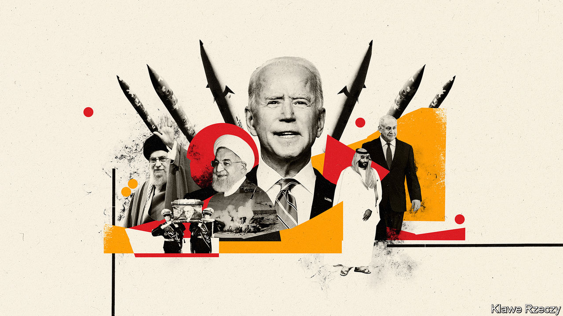

THE ASSASSIN was not a human. Mohsen Fakhrizadeh, erstwhile maestro of Iran’s nuclear-weapons programme, was gunned down on November 27th by a remote-controlled machinegun mounted on an exploding pickup truck—if Fars, an Iranian news agency, is to be believed. “No one was present at the scene,” said Ali Shamkhani, the head of Iran’s national security council. Other accounts suggest that gummen—human ones—were on the ground, and escaped. The bullets were certainly real.

Mr Fakhrizadeh, notionally a physics professor, was the brains behind Project Amad, Iran’s clandestine pursuit of nuclear weapons from the 1980s to 2003. After Iran’s leaders halted the formal programme, Mr Fakhrizadeh continued to dabble in dual-use research, presumably to keep alive the possibility of a bomb. Documents stolen by the Mossad, Israel’s intelligence agency, suggest that 70% of Mr Fakhrizadeh’s staff under Project Amad stayed with him in a new organisation.

That made him a marked man. Several of his underlings were killed in suspected Israeli hits from 2007 to 2012. When Binyamin Netanyahu, Israel’s prime minister, presented the stolen files in 2018, he singled out Mr Fakhrizadeh by name. Israel’s motive for killing him might have been to set back Iran’s nuclear programme by eliminating its most experienced manager. But the likelier aim was to hobble the efforts of Joe Biden, America’s president-elect, to resuscitate the nuclear deal signed between Iran and six world powers in 2015.

Under the deal, called the Joint Comprehensive Plan of Action (JCPOA), Iran agreed to curb its nuclear programme and open itself up to rigorous inspections in return for the lifting of international sanctions. President Donald Trump called it the “worst deal ever”, pulled America out of it in 2018 and has lashed Iran with sanction upon sanction. Iran responded in 2019 by attacking international shipping and striking Saudi Arabia with drones and missiles. It has also gradually violated the deal’s provisions. Iran has now accumulated 12 times more enriched uranium than permitted—enough for a pair of bombs, if enriched further. It has also enriched some of that to higher levels of purity than allowed, conducted research on advanced centrifuges and moved some of them to an underground facility. But Iran has not substantially interfered with inspectors from the International Atomic Energy Agency (IAEA), the UN’s nuclear watchdog.

In theory, turning the clock back should be simple. Mr Biden says he will rejoin the JCPOA if Iran returns to compliance. Javad Zarif, Iran’s foreign minister, has said that if Mr Biden lifts sanctions “we too can immediately return to our full commitments in the accord.” There will be a narrow window between Mr Biden taking office on January 20th and Iran’s own presidential election on June 18th, notes Ilan Goldenberg of the Centre for a New American Security, a think-tank in Washington. “The cleanest, easiest and simplest option is a mutual return to the JCPOA,” he says. In practice, things could prove more complicated.

Start with Iran, whose leaders were initially delighted by Mr Biden’s victory and the prospect of rejuvenated oil sales and trade. In meetings Mr Zarif excitedly repeated the name of John Kerry, Mr Biden’s chosen climate envoy and Mr Zarif’s opposite number during the negotiation of the JCPOA. Yet Mr Zarif is a member of Iran’s pragmatist camp, which has been undermined by the failure of the JCPOA to deliver economic benefits.

Hardliners won a thumping victory in parliamentary elections in February (after many more moderate candidates were banned). They fear that a restoration of the nuclear deal would revive the fortunes of the pragmatists. Some want reparations for American sanctions. Mr Fakhrizadeh’s assassination—met with lukewarm condemnation from Europe—has handed them more ammunition. The Islamic Revolutionary Guard Corps (IRGC), Iran’s principal military force, quickly rallied its proxies in parliament. On December 1st lawmakers passed a bill calling on the government to enrich uranium to near weapons-grade and, if certain American sanctions are not lifted soon, kick out the IAEA’s inspectors. Iran’s defence minister said that the budget of Mr Fakhrizadeh’s old organisation would double.

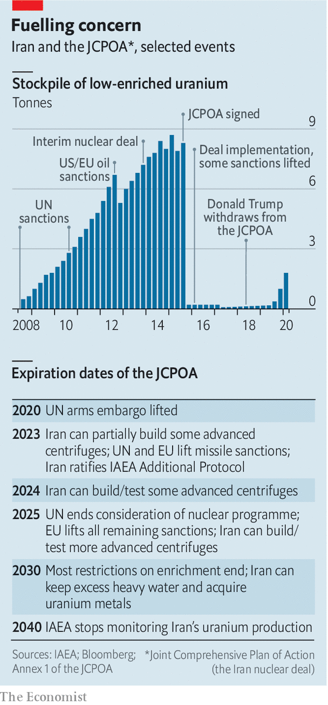

The JCPOA is viewed sceptically in America, Israel and the Gulf states, too. Critics point to three issues. One is its timeline (see chart). An arms embargo on Iran expired in October. Restrictions on advanced centrifuges and missile imports and exports will end, or “sunset”, in three years. Most other restrictions will do so in a decade (though heightened IAEA scrutiny will last for ever). A second grievance is Iran’s burgeoning missile programme, the sophistication of which was displayed in January, when Iran retaliated for America’s assassination of Qassem Suleimani, head of the IRGC, with precise strikes on American troops in Iraq. A third is Iran’s behaviour in the region, in particular its sponsorship of armed groups like Hizbullah, a Lebanese militia-cum-political party.

America’s Israeli and Arab allies, along with many hawks in Washington, would like Mr Biden to wring concessions from Iran on these issues before rejoining the JCPOA. “I think the balance of power has moved to the Americans,” says Amos Yadlin, a former head of Israeli military intelligence, who points to unrelenting American sanctions and the killing of Suleimani, among other factors. Recent Israeli intelligence assessments concur that economic pressure has put Iran’s regime in a position of “unprecedented precariousness”.

Iran’s economy is “anaemic” and inflation “persistent”, says Esfandyar Batmanghelidj of Bourse & Bazaar, a website that analyses Iran’s economy. GDP shrank by 5.4% in 2018 and 6.5% in 2019, and will contract again this year (thanks in part to covid-19). That has led to protests. But it has not caused regime change, as some in the Trump administration hoped. “We are far from the collapse scenario often discussed,” says Mr Batmanghelidj. Firms that track tankers even claim that Iranian oil exports rose sharply in September in defiance of American sanctions. The state’s ruthless security forces keep a lid on discontent. A year ago they killed hundreds of protesters in two days. “I don’t see any danger to internal stability,” says an Iranian academic.

Mr Biden anyway rejects the idea of putting preconditions on a return to the JCPOA. “Look, there’s a lot of talk about precision missiles and all range of other things that are destabilising the region,” he told Thomas Friedman of the New York Times. But “the best way to achieve getting some stability in the region” is to deal “with the nuclear programme.” Jake Sullivan, who will be Mr Biden’s national security adviser, says other issues will be dealt with in later negotiations. The content and timing of such talks are up in the air, though they will probably involve fresh concessions on both sides—what diplomats call a “more-for-more” deal. Iran would probably seek access to dollars, an easing of energy and manufacturing sanctions and a legally binding agreement that could not be overturned as easily as Mr Trump sundered the JCPOA, says Ellie Geranmayeh of the European Council on Foreign Relations, a think-tank.

America’s priority should be to extend the sunset clauses on Iran’s enrichment activity, suggests Gary Samore of Brandeis University, who served as Mr Obama’s arms-control tsar from 2009 to 2013. Mr Yadlin says the sunsets should be extended to 30 years rather than 15, that IAEA inspections should be “everywhere” with “no limits” and that Iran should be forced to divulge full details of its weapons-related work. “If you collect these three, I will sleep better at night,” he says. Mr Goldenberg suggests that because the sunsets are a decade away, America would be better off “building out a regional dialogue” between Iran and its rivals, using innocuous issues, such as co-operation against covid-19, as stepping stones to more contentious ones.

If Mr Biden simply returns to an unreconstructed JCPOA, or if subsequent talks go nowhere, he can expect stiff opposition from America’s regional allies. “If they bring to us an additional agreement that’s the same quality as the JCPOA, we will do our best to change it,” says an Israeli official. “At the end of the day we will not rest until we have a better solution.” A confrontation between Mr Netanyahu and Mr Biden is “inevitable”, says Raz Zimmt of the Institute for National Security Studies in Tel Aviv, a veteran Iran-watcher in Israeli intelligence. “It’s in Netanyahu’s political interests to continue taking as hard a line as possible and no one in government or the security establishment can currently contradict him publicly.”

Mr Netanyahu has ample means of influencing the American and Iranian calculus. During the Obama administration the perennial threat of Israeli air strikes on Iran’s nuclear programme was a major impetus for both sanctions and diplomacy. It led America to collaborate with Israel on a landmark cyber-attack, known as Stuxnet, on Iranian centrifuges. Along with the assassination of Mr Fakhrizadeh, Israel is thought to be responsible for a string of explosions at nuclear facilities over the summer. And it is putting pressure on Iran beyond its borders, too. “Things are happening in Syria that did not happen in the past,” says the Israeli official, coyly. “Iranian equipment worth billions of dollars has been burned.” The latest suspected Israeli air strike in Syria was on November 29th, killing an Iranian commander on the border with Iraq.

Iran’s Arab rivals are similarly worried, though less capable and more cautious. They have watched as Iran’s regional influence has grown in Syria, Iraq and Yemen in the years since the JCPOA was signed. Their doubts about America deepened last year after Mr Trump’s feeble response to an Iranian drone-and-missile attack on important Saudi oil facilities. These concerns have gradually driven into the open an Arab-Israeli axis. In August the United Arab Emirates (UAE) established diplomatic ties with Israel. Bahrain followed a month later. Prince Muhammad bin Salman, Saudi Arabia’s de facto ruler, is thought to have met Mr Netanyahu in November.

Arab states have little to offer Israel by way of muscle. They could allow Israeli warplanes to fly over their territory en route to Iran, and might share whatever intelligence the Mossad has not already gathered. More effective would be joint lobbying in Washington against the JCPOA. That would make it trickier for Mr Biden to fortify it, or any follow-on deal, with a legislative stamp of approval. Over time, though, Arab and Israeli interests may diverge. Israel’s biggest concern is quelling Iran’s nuclear activity. The Gulf states are most worried about Iran’s regional influence.

They are also more vulnerable to escalation, should fresh sanctions or Israeli sabotage prompt Iran to lash out again. The UAE may have the Arab world’s best army, but an economy that relies on travel and trade—and imports almost all its necessities—can be easily disrupted. “We’re the first country across the water from Iran,” says an Emirati diplomat. “We always need to exercise de-escalation.” The UAE was notably quick to deplore Mr Fakhrizadeh’s assassination and urge “maximum restraint”.

In the short term Iran’s leaders must decide whether and how to avenge Mr Fakhrizadeh’s killing. Their response to Suleimani’s death was theatrical but did not hurt America much. They know that striking Israel directly would risk incurring a severe response—perhaps even from Mr Trump, who could leave the fallout to his successor. An attack on one of Israel’s new friends in the Gulf might send a message without provoking a war.

Yet some Iranian officials still counsel restraint in the hope of smoothing the path back to the JCPOA. After 30 years as supreme leader, Ayatollah Ali Khamenei is fading. The transition preoccupies his court. “For continuity when the supreme leader dies, they need to get the oil revenues flowing again, and for that they need some kind of accommodation with the US,” says the Iranian academic. Iran would not be averse to doubling the duration of the sunset clauses as part of a broader set of compromises, says Vali Nasr, a former State Department official. It may even agree to pull back from some regional conflicts, particularly Yemen. But it would probably want to see matching gestures from its Arab rivals. That would entail a level of trust that may be hard to reach. ■

Dig deeper:  
Read our [latest coverage of the presidential transition](https://www.economist.com/us-election-2020), and then sign up for Checks and Balance, our [weekly newsletter](https://www.economist.com/checksandbalance/) and [podcast](https://www.economist.com/checks-and-balance-our-weekly-podcast-on-american-politics) on American politics.

This article was downloaded by calibre from <https://www.economist.com/middle-east-and-africa/2020/12/05/joe-biden-wants-to-re-enter-the-nuclear-deal-with-iran>

|  |  |  |  |
| --- | --- | --- | --- |
|  | Articles | Sections | Next |

|  |  |  |  |
| --- | --- | --- | --- |
| Previous | Articles | Sections | Next |

#### No haven

# Tanzania’s police are torturing refugees from Burundi

People fleeing repression at home also face it in refugee camps

Dec 3rd 2020 | GOMA

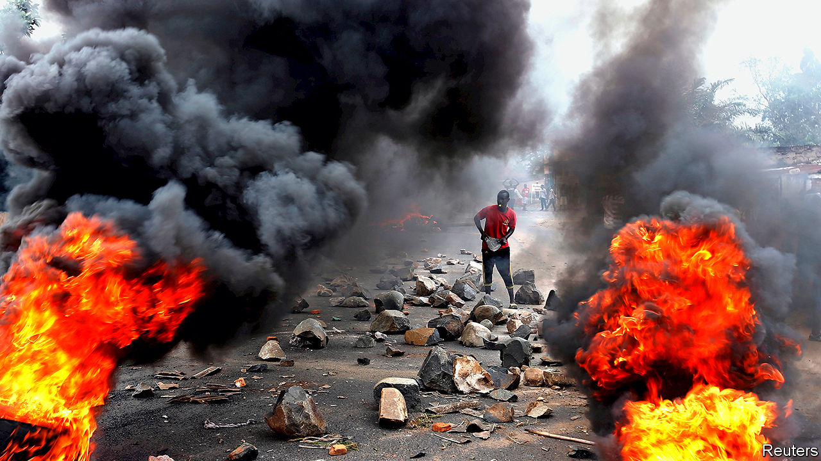

EVEN AFTER Tanzanian policemen had hung him from the ceiling and beaten him with sticks, Crispin (not his real name) would not confess to being a rebel leader with plans to overthrow the government of neighbouring Burundi. It was only when they injected a liquid into his testicles that he caved in and said he was plotting a coup.

He was not. Some years ago Crispin was photographed at an anti-government protest in Burundi. Thugs from the ruling party’s youth wing, the Imbonerakure (“those who see far”), painted a red cross on his door and turned up one night to threaten him. So in 2016 he fled to a refugee camp in western Tanzania. But men from the Imbonerakure also stalk the camps with lists of dissidents provided by Burundian intelligence. They target them, allegedly with help from Tanzanian police. Desperate families often pay the Imbonerakure to have their relatives freed. The spoils are shared with local cops. Most of those picked up are accused of hoarding weapons or plotting against Burundi’s government.

In December last year men from the Imbonerakure turned up at Crispin’s shelter flanked by Tanzanian policemen. They bundled him into a police car and took him to a cell where he spent three months. He was released only because his wife paid 1m Tanzanian shillings ($430) to the Imbonerakure. “They said if she paid I would not be killed or returned to Burundi” to face imprisonment, he says.

Others were not able to buy their way out. Human Rights Watch (HRW), a New York-based watchdog, interviewed 18 refugees who had been arrested in camps by Tanzanian policemen in the past year. Several had been tortured. Eight of them were forcibly returned to Burundi, where they have been locked up without charge. Another rights group, CBDH/VICAR, based in Rwanda, says that about 170 Burundian refugees have disappeared from Tanzania since 2015. “There seems to be collusion between the Tanzanian and Burundian authorities,” says Mausi Segun of HRW. “Several of those tortured were told that Tanzanian officials had information on them from Burundi.”

About 300,000 Burundians have fled their country since 2015 after violence broke out when the then president, Pierre Nkurunziza, said he would stand for an unconstitutional third term. Hundreds were killed. Activists, journalists and anyone who might have been spotted at a protest rushed to neighbouring countries. Around half of them went to Tanzania.

A new president, Evariste Ndayishimiye, was elected in June in a rigged poll. His government is just as scary. Gervais Ndirakobuca, the new security minister, is nicknamed “Ndakugarika”, meaning “I will kill you” in Kirundi, the local language. He earned his reputation as a rebel commander during the civil war and has worked hard to maintain it since. As police commissioner under the former president, who has since died, he was responsible for some of the bloodiest crackdowns on protesters. Because of this the EU and America have imposed sanctions on him.

With such people in the government, few refugees seem likely to believe its assurance that the country is safe and that they should return. Officials in Tanzania and Burundi drew up a secret agreement that was leaked last year. It said all refugees should “return to their country of origin whether voluntarily or not”. Some 50,000 have gone back in the past two years. Many cite insecurity in the camps, in particular arbitrary arrests, as their reason for returning. Moreover, camp authorities have threatened Burundians, saying that if they do not sign up to go home they will lose their refugee status and risk arrest. Some of those returning say that they were threatened or detained when they crossed the border. Many have fled again, but this time into safer Uganda.

Crispin has no choice but to stay in Tanzania. He has been warned by the Imbonerakure that if he tries to leave for another neighbouring country, he will be stopped at the border and sent back to Burundi. “It is terrifying to live in a country where you can be arrested at any time. I am constantly frightened,” he said. “But there is nowhere for me to go.” ■

This article was downloaded by calibre from <https://www.economist.com/middle-east-and-africa/2020/12/03/tanzanias-police-are-torturing-refugees-from-burundi>

|  |  |  |  |
| --- | --- | --- | --- |
| Previous | Articles | Sections | Next |

|  |  |  |  |
| --- | --- | --- | --- |
| Previous | Articles | Sections | Next |

#### Victory, defeat and confusion

# In Ethiopia, Abiy Ahmed has won the battle but not the war

Tigray’s ousted rulers have fled, but they plan to fight on

Dec 1st 2020 | ADDIS ABABA

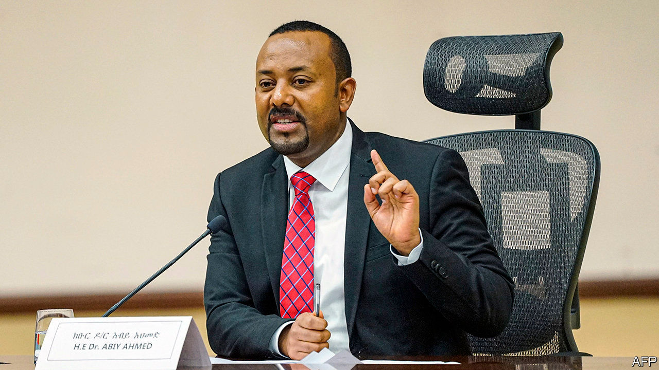

THE BATTLE, in the end, was mercifully short. The 500,000 inhabitants of Mekelle, the capital of Ethiopia’s northern region of Tigray, were spared a large-scale bloodbath. On November 28th Abiy Ahmed, Ethiopia’s prime minister, declared victory over Tigray’s ruling party, the Tigrayan People’s Liberation Front (TPLF). A military operation that had started a few weeks earlier was complete, he said. Shelling of the city began at about ten that morning. By the evening Tigray’s president, Debretsion Gebremichael, and other leaders had vanished into the mountains. Crowds in the national capital, Addis Ababa, broke into celebration.

But the fighting has not stopped. “Almost all the Tigrayan forces are outside the big towns and cities,” says a TPLF intelligence officer, explaining that they had withdrawn when Ethiopian forces started shelling towns. Only hours after Abiy’s announcement of victory, rockets were fired for the third time from Tigray into Eritrea, a country to its north that has been helping Ethiopian forces. There have since been reports of sporadic clashes and air raids, as well as looting in towns, including Mekelle. “We have a plan to retake our towns from the invaders,” Debretsion told The Economist by text message.

The fog of Ethiopia’s month-long civil war has thickened since it was declared over. Speaking to parliament on November 30th, Abiy claimed that not a single civilian life had been lost during the march into Tigray. The UN and the more than 40,000 refugees who have fled to Sudan reckon otherwise. Hospitals in the regional capital are flooded with injured people. Medical supplies for the wounded and body bags for the dead are running low. But a communications blackout imposed on the region since the start of the conflict means it is impossible to know the true figure. Counter-claims that TPLF forces downed a jet and recaptured the town of Axum are also unverified.

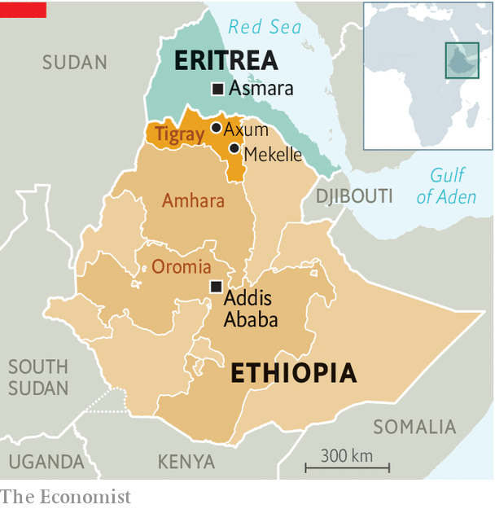

Harder to dispute is the federal government’s claim that it has the upper hand in the conflict. In the weeks before it fired the first shots on November 4th, the TPLF believed it would easily win a conventional war against the Ethiopian army. The retreat from Mekelle has put paid to that hubris. The TPLF does not seem to have counted on the government’s use of drones, for instance, which are thought to have been devastatingly effective. And it seems to have misjudged its ability to fight on several fronts, including one against even the small number of Eritreans thought to have attacked it along the northern frontier. “The TPLF totally overestimated at least their conventional force,” reckons René Lefort, a researcher who has known some of its leaders for decades.

The question now is whether it can sustain a prolonged guerrilla war. Its leaders certainly have a wealth of experience: in 1991 they overthrew a dictatorship in Addis Ababa after 17 gruelling years in the bush. For almost three decades after that they called the shots in the federal government, which means they know its vulnerabilities. Keeping the army tied up in Tigray may be enough to weaken Abiy’s control elsewhere. His home region of Oromia, for instance, is racked by an armed insurgency.

But many of the veterans of the TPLF’s bush war are now in their 60s and 70s. They also have few allies left in the region. The once porous border with Sudan, a lifeline in the 1970s and 1980s, has largely been sealed. On November 29th Sudanese security forces seized a large cache of weapons and ammunition en route to Tigray. “What happens when they run out of bullets?” asks a UN diplomat. “How do they expect to bring fuel trucks up long, winding roads without any air cover?”

Much will depend on whether Abiy can win over ordinary Tigrayans. His government promises to rebuild towns and villages battered by war. It also says it is welcoming back refugees. But many of those who fled, the vast majority of whom are Tigrayan, say they fear reprisals if they come back. Most are from western Tigray, which is now run by police and bureaucrats from the neighbouring Amhara region. Amhara claims this territory as its own. Its militiamen fought alongside the federal army in battles that reportedly saw some of the war’s worst atrocities. Militias on both sides appear to have targeted civilians, including at least 600 allegedly massacred by a youth group of the TPLF. Abiy may have won. But he still has a bitterly divided country to heal. ■

This article was downloaded by calibre from <https://www.economist.com/middle-east-and-africa/2020/12/01/in-ethiopia-abiy-ahmed-has-won-the-battle-but-not-the-war>

|  |  |  |  |
| --- | --- | --- | --- |
| Previous | Articles | Sections | Next |

|  |  |  |  |
| --- | --- | --- | --- |
| Previous | Articles | Sections | Next |

#### Death in a rice field

# Why 78 Nigerian farmers were murdered

Slaughtered by Boko Haram, and blamed by the state for their own deaths

Dec 3rd 2020 | ABUJA

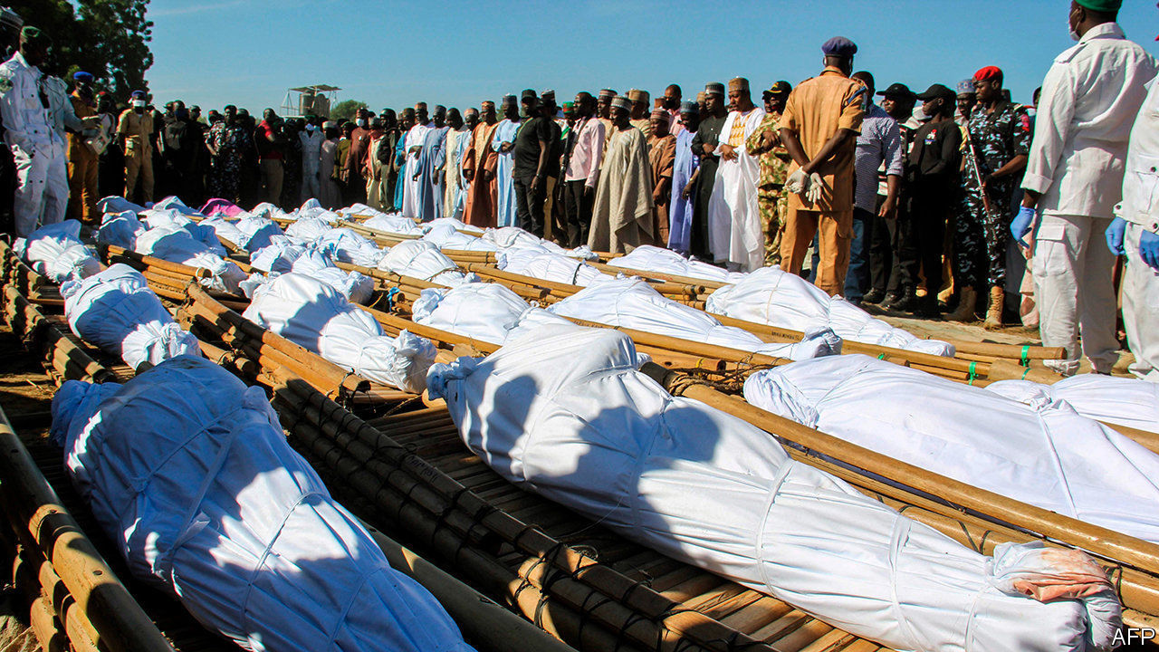

THE FARMERS—43 of them—were found in the rice fields where they had gone to work. Some had their throats slit. Others were beheaded. In the days that followed locals found evidence of yet more butchery, taking the toll to 78. Boko Haram, a jihadist group that has been fighting since 2009 to carve out a caliphate in north-east Nigeria, was quick to claim credit for the murders. It said they were revenge for the capture of a militant by locals.

The people of north-east Nigeria have grown wearily accustomed to the horrors of Boko Haram, whose name is loosely translated as “Western education is forbidden”. The group has been known to strap ticking bombs to children before sending them into markets and mosques. Its abduction of more than 200 girls from a school in Chibok in 2014 became emblematic of the many failures of President Goodluck Jonathan’s administration. He was defeated in an election the following year by Muhammadu Buhari, a former general who promised to restore security.

Yet the latest killings—and the government’s ham-fisted response to them—have rekindled outrage among Nigerians. Garba Shehu, Mr Buhari’s spokesman, initially blamed the victims, saying they had not been given permission from the army to go to the farm. An army spokesman accused them of collaborating with the insurgents and not tipping off the security forces.

But one survivor said they had told soldiers that jihadists were in the area. After the farmers nabbed one and handed him over, many feared Boko Haram would retaliate. When it did, the army was nowhere to be seen.

The government is unable to provide security in large swathes of the countryside. Jihadists are not the only scourge. Bandits loot villages in northern and central Nigeria, and kidnap for ransom. Many farmers have abandoned their homes and crops. “We will not have food sufficiency because people are afraid of going to their farms,” says the head of a farmers’ association.

Mr Buhari won a second term last year, largely thanks to the votes of rural northerners. Their support now seems to be dwindling. That may not matter much to a term-limited 77-year-old. But it matters to his party. Allies are pleading with him to fire his army chief. Mr Buhari remains remote and passive, however, even as his country burns. ■

This article was downloaded by calibre from <https://www.economist.com/middle-east-and-africa/2020/12/03/why-78-nigerian-farmers-were-murdered>

|  |  |  |  |
| --- | --- | --- | --- |
| Previous | Articles | Sections | Next |

|  |  |  |
| --- | --- | --- |
| Middle East & Africa | Sections | Europe |

The Americas

Cuba: The art of dissent

.

Canada: Alberta goes green

.

Bello: The man without a plan

.

|  |  |  |
| --- | --- | --- |
| Middle East & Africa | Sections | Europe |

|  |  |  |  |
| --- | --- | --- | --- |
|  | Articles | Sections | Next |

#### The art of dissent

# The Movimiento San Isidro challenges Cuba’s regime

The government has responded with repression. But the dissidents’ movement sees signs of progress

Dec 5th 2020 |

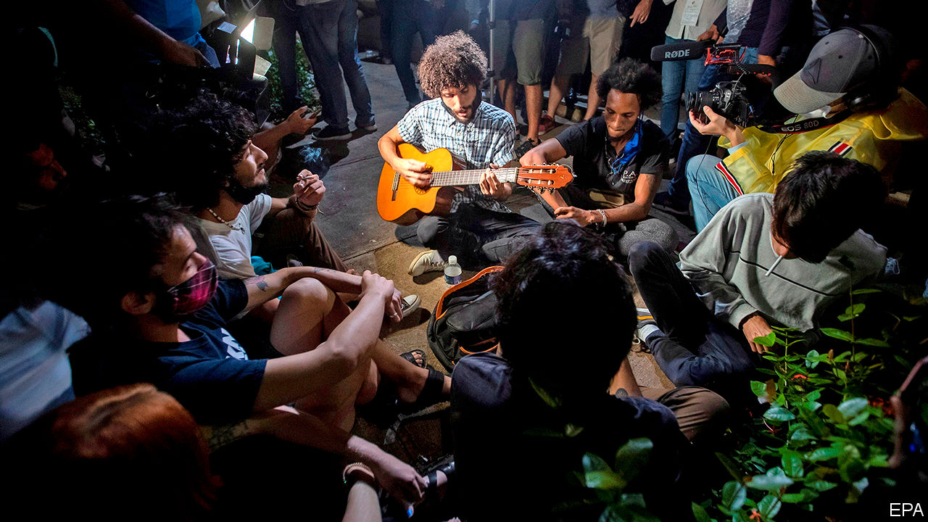

THE FRONT door of Damas 855, a ramshackle building in San Isidro, a poor neighbourhood of Havana, snapped like a wishbone when security agents charged through it on the evening of November 26th. The lock and chain tumbled to the ground. The agents, dressed in medical gowns, arrested 14 people (their pretext was that one of the residents had violated a covid-19 testing protocol). They had locked themselves in for eight days to protest against the arrest of Denis Solís, a young rapper who had been accused of disrespecting authority and sentenced to eight months in prison. A few of the Damas 855 denizens were on a hunger-and-thirst strike. Police cars took the detainees away. Facebook, YouTube and Instagram went down on most of the island for about an hour. Connections have been spotty since.

To defenders of Cuba’s 62-year-old revolution, the adherents of Movimiento San Isidro (MSI) are reprobates. On Twitter the country’s president, Miguel Díaz-Canel, called it an “imperial show to destroy our identity and subjugate us again”. A photo of President Donald Trump accompanied the tweet. State media echoed the message.

Some Cubans take a kinder view of the movement, which includes artists, scholars, journalists, rappers, poets and scientists who advocate freer expression and more democracy than the communist regime allows. Its leaders are Luis Manuel Otero, a performance artist, and Maykel “El Osorbo” Castillo, a musician who sewed his lips shut in prison in August. They gather in a part of Old Havana where the mainly black residents live in rickety housing in the shadows of luxury hotels. When a balcony collapsed in January, killing three girls, Mr Otero wore a hard hat for nine days to honour them. He has been arrested more than 20 times over the past two years. His hunger strike landed him in hospital.

The movement began in September 2018 in response to Decree 349, which proposed to restrict cultural activity that is not authorised by the culture ministry. After a protest that month outside Cuba’s legislature, the government suspended enforcement of the decree. That has not stopped it from silencing voices it doesn’t like.

MSI is not comparable to Belarus’s mass movement to overthrow a dictatorship. Cuba has no such movement, though pro-democracy activists were among the 1,800 people who have been arbitrarily arrested in the first eight months of 2020, according to Human Rights Watch. MSI has more in common with other recent home-grown protests that have wrung small concessions from the regime.

In August 2017 cuentapropistas (entrepreneurs) proposed reforms, such as the right to incorporate, to the labour ministry. Initially they were rebuffed. The government forced the cancellation of events meant to help budding entrepreneurs. When in 2018 it threatened to restrict each entrepreneur to one line of business, cuentapropistas, who run much of the economically vital tourist industry, said they would strike. The rules were eased.

A clash between the gamers who cobbled together SNet, a private intranet, and the communications ministry played out in a similar way, though the government yielded less. On an island with poor and expensive connectivity, the network was a way for gamers to play with one another, often games they had created. When the government restricted the use of such networks and threatened to confiscate the equipment in May 2019, SNet users were devastated. Several dozen gathered at the ministry to protest. Police cars quickly surrounded them. The government eventually decided that SNet and its hardware would be permitted, but under the supervision of the state-run youth computer clubs.

Like the cuentapropistas and the SNet gamers, MSI began in response to a threat to its members’ private pursuits. But it has more potential to grow. On the day after the Damas 855 raid nearly 300 people, many of them supporters of other movements, gathered outside the culture ministry, refusing to leave until the vice-minister, Fernando Rojas, agreed to meet them. Security forces and “rapid-response groups”, trained to shout communist slogans at sceptics, flooded the area. Agents in plain clothes snapped photos and took videos.

Mr Rojas met with 30-odd activists for nearly five hours on November 27th-28th and promised more dialogue. But the government then launched a media campaign against MSI. Police chased Mr Otero after his release from hospital.

Even so, the movement thinks it has made progress. The gathering outside the culture ministry is a sign of an emerging “collective unconformity”, says Carlos Manuel Álvarez, one of the Damas 855 detainees and a co-founder of El Estornudo (“The Sneeze”), an independent online magazine. He sees that as a direct threat to the culture of submission demanded by the regime. Its agreement to meet participants in such a large protest “was unprecedented”, says Camila Ramírez Lobón, a visual artist who joined the meeting with Mr Rojas. Artists who are both popular and acceptable to the regime, like Fernando Pérez, a film director, and Leoni Torres, a musician, have publicly backed MSI.

The internet, unreliable though it is, is making such movements harder to control. More than 60% of Cubans have access to a connection. That has led to “an explosion of civic activism” among groups advocating such causes as feminism, gay rights and animal rights, says José Jasán Nieves, editor of El Toque (“The Touch”), an independent online publication. Some were at the culture-ministry protest. If they joined forces more often, they might challenge the government more effectively.

Cuba’s ruling Communist Party, divided between hardliners who remember the revolution and younger officials who are slightly more liberal, is not about to yield. On December 1st the government released Silverio Portal Contreras, a prominent political prisoner (and supporter of Mr Trump, who has imposed sanctions on the Cuban regime). That is probably not a sign that the regime is growing tolerant of dissent. More likely, it was a way to allay anger about the San Isidro raid.

Most Cubans, who queue for hours for chicken or eggs, often to return home empty-handed, have little interest in the doings of agitators like those of MSI. Their suffering has got worse since the pandemic shut down tourism. But a vaccine, and perhaps a softening of American sanctions by the incoming Biden administration, might eventually ease shortages. More Cubans might then ask why they have so little freedom.■

This article was downloaded by calibre from <https://www.economist.com/the-americas/2020/12/05/the-movimiento-san-isidro-challenges-cubas-regime>

|  |  |  |  |
| --- | --- | --- | --- |
|  | Articles | Sections | Next |

|  |  |  |  |
| --- | --- | --- | --- |
| Previous | Articles | Sections | Next |

#### Reluctant revolution

# Oil-rich Alberta seeks ways to go green

Canada’s main fossil-fuel producing province mulls hydrogen and geothermal power

Dec 5th 2020 | CALGARY

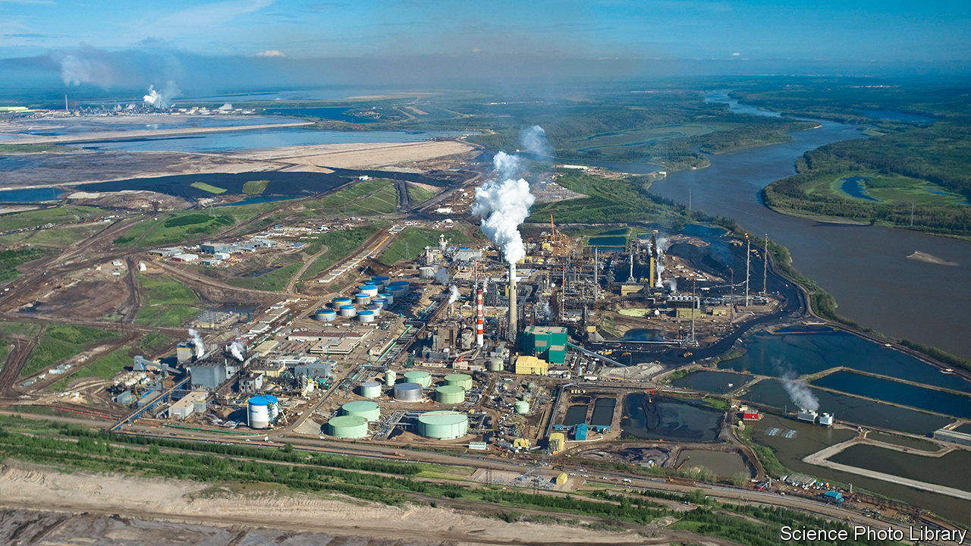

A YEAR AGO, when Canada’s government promised to end net emissions of greenhouse gases by 2050, Jason Kenney, Alberta’s Conservative premier, erupted. The government’s ideas were a “fantasy plan for a mythical country”, he said. He scoffed at the “California-style pieties” of the Liberals who govern Canada. They imagine that people in poor countries like India “are all going to be driving Teslas 15 years from now”, Mr Kenney said. In fact, “they want to stop burning cow dung”.

The premier’s fusillade was in defence of Alberta’s oil industry, which has made the province’s residents Canada’s richest citizens. But it has lately suffered setbacks, most of which are more damaging than the Liberals’ nefarious net-zero plans. Oil prices have yet to recover from a slump that began in 2014. Environmental activists have singled out Alberta’s oil sands as an especially dirty source of crude. The thick bitumen they contain requires more energy, and money, to extract and refine than lighter oils do. Investment in the province’s oil and gas sector plunged between 2014 and 2019 to C$26bn ($19bn), around 6% of GDP (see chart). The covid-19 pandemic has made matters worse. The provincial unemployment rate of 10.7% is now among the highest in Canada.

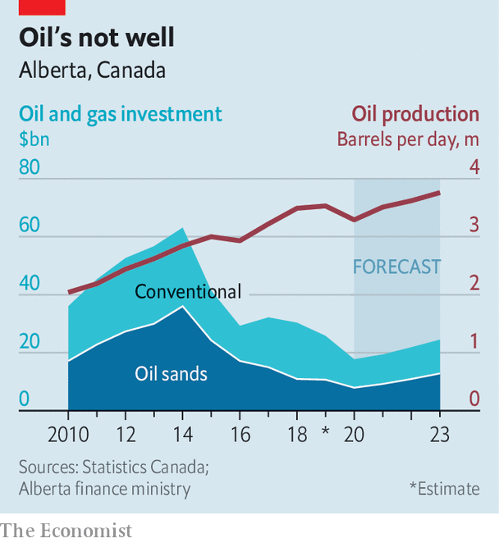

These reversals are prompting Alberta, a conservative province often at odds with the federal government in Ottawa, to rethink its economic future. While Alberta’s government expects demand for its oil to recover and resume its rise, it hopes to reduce its dependence on fossil-fuel investment for growth.

One sign of this is a series of recent initiatives to boost investment in cleaner forms of energy. In October Alberta’s government proposed a law to provide a regulatory framework for investment in geothermal energy. The province has the right geology, and expertise in drilling. Energy from below the earth’s surface can make use of abandoned oil and gas wells and the infrastructure that serves the industry.

On October 6th Mr Kenney announced that Alberta would seek to use its natural gas to produce and export hydrogen, a fuel that does not emit greenhouse gas. The carbon dioxide that comes from producing hydrogen would need to be captured and stored. He has joined the premiers of three other provinces to promote the development of small nuclear reactors. Alberta’s government recently set up a council to devise ways of boosting extraction of minerals such as lithium and vanadium, which are used to make batteries.

A vociferous opponent of the federal government’s policy of setting a price floor for carbon emissions, Mr Kenney has lately gone quiet on the issue. Alberta and several other provinces are still challenging in court the constitutionality of the broad-based carbon price, which is set to rise to C$50 a tonne by 2022. Alberta has a carbon-pricing scheme for large emitters, which supports a fund that promotes emissions reductions. In September its government said it would immediately spend the C$750m in that fund, especially to develop carbon capture and storage.

The greener tinge to Alberta’s policies is a big change from the fiery hue of Mr Kenney’s successful campaign for the premiership in 2019. Wearing a wide-brimmed cowboy hat and touring in a blue pickup truck, he blasted the critics of Alberta’s oil sands and vowed a return to the boom years. He accused the left-wing New Democratic Party (NDP), which then led the provincial government, of hobbling the oil industry with regulation. He excoriated Justin Trudeau, Canada’s prime minister, for failing to back the construction of pipelines to carry Alberta’s oil to foreign markets. The message was popular. In the election Mr Kenney won 55% of the vote.

His premiership has provided a humbling education. On a road show in New York last year investors told him bluntly that they really meant it when they talked of using environmental criteria to guide their decisions. Insurance companies are withdrawing coverage for pipeline construction projects that are opposed by environmentalists. Joe Biden, who will become the United States’ president in January, has said he will cancel the permit for building the Keystone XL pipeline, in which Alberta’s government has invested C$1.5bn.

Alberta’s plans for a greener future are not fanciful. Its idled workers have skills that can be used to produce cleaner forms of energy. But there are obstacles. The province is far away from big energy markets, points out Andrew Leach, a specialist in energy economics at the University of Alberta. Heat and hydrogen are harder to transport than oil. In five or ten years, solar power may replace natural gas as a way of producing hydrogen, Mr Leach warns.

If Alberta’s energy transformation is to improve Mr Kenney’s political fortunes, it will have to happen fast. The federal government in Ottawa is splashing out to fight the economic effects of the pandemic: on November 30th it said it would spend an extra C$70bn-100bn, 3-4% of this year’s GDP, over three years. But Mr Kenney’s government is cutting the pay of public servants, including doctors. Reported cases of covid-19 are surging in the province. The NDP, which gives Mr Trudeau’s minority government vital support in Parliament, has pulled ahead of Mr Kenney’s Conservatives in provincial polls. The next election is due to be held in 2023. Alberta’s pro-oil premier may not be the one to lead Alberta’s green revolution. ■

For more coverage of climate change, register for The Climate Issue, our fortnightly [newsletter](https://www.economist.com/theclimateissue/), or visit our [climate-change hub](https://www.economist.com/news/2020/04/24/the-economists-coverage-of-climate-change)

This article was downloaded by calibre from <https://www.economist.com/the-americas/2020/12/05/oil-rich-alberta-seeks-ways-to-go-green>

|  |  |  |  |
| --- | --- | --- | --- |
| Previous | Articles | Sections | Next |

|  |  |  |  |
| --- | --- | --- | --- |
| Previous | Articles | Sections | Next |

#### Bello

# Argentina’s president without a plan

Alberto Fernández is muddling through

Dec 3rd 2020 |



IN DEATH, as in life, Diego Armando Maradona represented his country to the full. The funeral of Argentina’s most famous footballer on November 26th was as passionate and chaotic as his country’s affairs (see Obituary). In defiance of his own government’s health rules, President Alberto Fernández ordered that Mr Maradona’s coffin lie in state in the Casa Rosada, the presidential palace. Like the president, El Diego was a lifelong supporter of Peronism, Argentina’s populist-nationalist movement. When the wake was curtailed, with thousands of fans queuing, pandemonium ensued.

Mr Fernández’s craving for popularity by association is a sign of his weakness. The funerary disorder extends to the economy, too. A social democrat, the president took office a year ago, at the head of an uneasy Peronist coalition in which much power lies with his vice-president, Cristina Fernández de Kirchner (no relation), a leftist who ruled from 2007 to 2015. Within three months, the pandemic struck. Mr Fernández was quick to impose a lockdown, which brought a surge in his approval rating, but which delayed rather than prevented a severe outbreak of covid-19. Argentina is among the top ten countries for recorded deaths as a proportion of the population. Only now is the lockdown being eased. Mr Fernández’s popularity is below its starting point.

In other matters, too, his government has little to show for its first year. Its main achievement was to renegotiate $65bn of debt with bondholders, though some economists question whether this was necessary. It has provided emergency aid to much of the population by printing money. The resulting inflation has been tempered, to 37%, by price controls. An already depressed economy will contract by around 12% this year, because of the pandemic. Now the government is negotiating, in slow motion, with the IMF, to which it owes $44bn as a result of a loan to its conservative predecessor that failed to stabilise the economy. Martín Guzmán, the finance minister, says he hopes for agreement by March or April.

The deal with the bondholders did not restore Argentina’s access to the international money markets, or confidence in the peso. The free-market exchange rate is now almost double the official rate (which has itself depreciated by around 25% since Mr Fernández took office). Critics complain that the government lacks an economic plan. It meanders between pragmatism—stressing exports and fiscal balance—and populism. It announced the expropriation of a big oilseed firm, only to change its mind. It is pushing through a swingeing wealth tax, of up to 3.5% on people with assets above $2.3m (at the official exchange rate).

“Imbalances in Argentina end either with rationality or an explosion,” notes a seasoned politician. This time the road to rationality may be slow. Mr Guzmán has chosen “a low-risk, low-reward equilibrium”, says Federico Sturzenegger, a former president of the Central Bank. The controls are buying time and may prevent an explosion. When the free-market peso plunged again in October, Mr Guzmán announced a reduction in money-printing. He has said he will cut the fiscal deficit from 11% of GDP this year to 4.5% in 2021. Pensions and public-sector wages are rising by less than inflation. The emergency aid will stop this month. “They may surprise us positively on the fiscal side,” says Mr Sturzenegger.

So far the Peronist coalition has remained united. But the Fernándezes’ political marriage is palpably loveless. The vice-president has complained of government “mistakes” and “functionaries who don’t function”. She and the president talked, briefly, for the first time in 45 days at Maradona’s wake. Her allies are trying to gain control of the judiciary. She is said to be furious that Mr Fernández has failed to halt corruption charges against her.

Economic recovery will be slow. The exchange controls and the wealth tax are discouraging investment. This year several multinationals (such as Walmart) have packed up. Much of the software industry has departed. Argentina, once Latin America’s most developed country, likes to live by its own rules, although that has engendered a long decline. In that, too, Maradona represented his nation. He had “so much football wealth that he thought he could squander it and it would not end”. That is Argentina, wrote Martin Caparrós, an Argentine author, in El País, a Spanish newspaper. “He fell, he got up, he fell again. He delighted in his past glories for lack of future ones: Argentina, perhaps.”

This article was downloaded by calibre from <https://www.economist.com/the-americas/2020/12/03/argentinas-president-without-a-plan>

|  |  |  |  |
| --- | --- | --- | --- |
| Previous | Articles | Sections | Next |

|  |  |  |
| --- | --- | --- |
| The Americas | Sections | Britain |

Europe

Belarus: A new country struggles to be born

.

Turkey: Picking up the pieces

.

France: A screeching U-turn

.

Dutch populism: On the Chopin block

.

Charlemagne: To ski or not to ski?

.

|  |  |  |
| --- | --- | --- |
| The Americas | Sections | Britain |

|  |  |  |  |
| --- | --- | --- | --- |
|  | Articles | Sections | Next |

#### A new country struggles to be born

# An interview with Svetlana Tikhanovskaya, Belarus’s leader in exile

It is a time of monsters

Dec 5th 2020 | VILNIUS

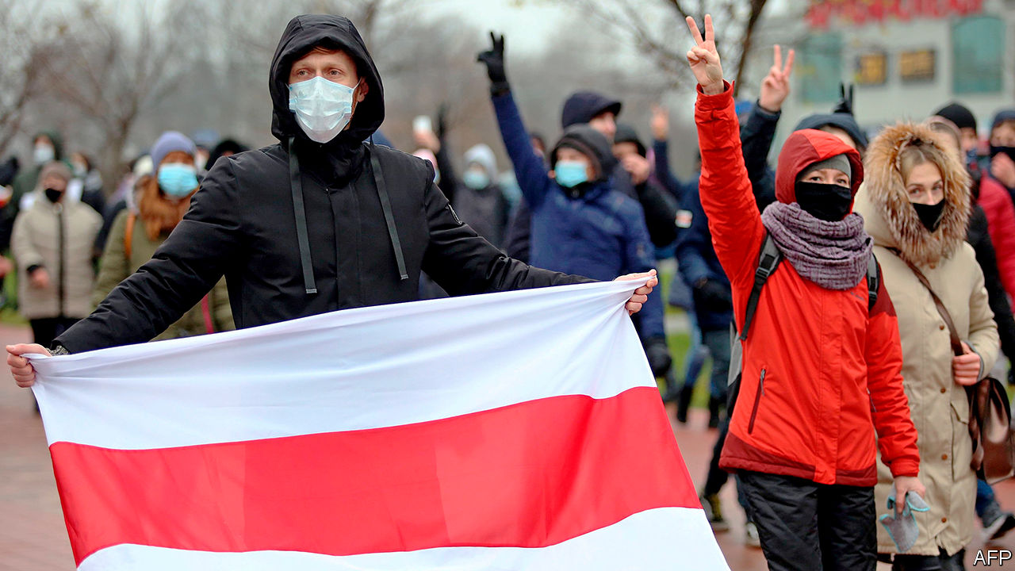

SVETLANA TIKHANOVSKAYA, a former teacher and a mother of two, did not choose to make history. But history has chosen her for a starring role. Despite her lack of political experience, she has come to personify the struggle to transform Belarus from docile former Soviet republic to free and truly independent nation. The leaders of rich democracies greet her as president-elect. Her own people derive comfort from her simple, calm words. Alexander Lukashenko, the gun-toting dictator who has ruled Belarus for the past 26 years, fears her enough to have forced her out of the country after she (probably) won a presidential election in August.

That was not meant to happen. All the main challengers, including Ms Tikhanovskaya’s husband, were in jail. Opinion polls were banned. The media and the security apparatus were firmly under the strongman’s control. Mr Lukashenko let a tongue-tied housewife with no taste for power register her candidacy, some say, just to demonstrate the futility of opposition.

But on August 9th, fed up with being treated like cattle, the people of Belarus voted for Ms Tikhanovskaya, whose only pledge was to release political prisoners and hold free and fair elections within six months. When Mr Lukashenko declared himself the winner, with 80% of the votes, they thronged into the streets. The dictator sent his goons to beat them up, just as he had done in 2006 and in 2010.

But this time the violence was so extreme that instead of clearing the streets of protesters, it detonated a national uprising. Petrified, Mr Lukashenko had Ms Tikhanovskaya taken hostage and coerced into reading a statement denouncing the protests before being driven out of the country. But this tactic, too, has failed.

Listen on: [Apple Podcasts](https://itunes.apple.com/us/podcast/id1449631195?mt=2&ls=1) | [Spotify](https://open.spotify.com/show/12zKAMNyS2GNentUzxq9QN) | [Google](https://www.google.com/podcasts?feed=aHR0cHM6Ly9yc3MuYWNhc3QuY29tL3RoZWludGVsbGlnZW5jZXBvZGNhc3Q) | [Stitcher](https://www.stitcher.com/s?fid=357733&refid=stpr) | [TuneIn](https://tunein.com/podcasts/News--Politics-Podcasts/The-Intelligence-p1186979/)

“When I got here, I was in despair, ready to give up,” she tells The Economist in an interview in Vilnius, the capital of neighbouring Lithuania. “I felt like a traitor and when I saw people emerge from detention half-alive, I felt guilt.” But instead of blame, she got support and compassion from the Belarusians. “When people came out again the next day, after all that happened, I knew I could not stop,” she says, struggling to hold back tears. And so, after three days of despair, she recorded a new appeal to the nation and called for the protests to go on.

Growing up in Mr Lukashenko’s tightly controlled Belarus, Ms Tikhanovskaya had little interest in politics or in the country’s history, its symbols or even its language. “I spoke Belarusian in the summer when I went to see my grandparents in the country,” she says: Russian the rest of the time. She never bothered with elections, and was unaware of a national revivalist movement that simmered under the surface among the country’s artistic and intellectual elite. She could not have imagined that members of that circle, including Franak Viacorka, a journalist and one of the chief ideologists of the movement, would become her right-hand advisers.

Unlike them, she was not exercised by the red-and-white flag of the short-lived 1918 Belarusian republic, briefly readopted as the national banner of post-Soviet Belarus only to be crumpled by Mr Lukashenko three years later. She lived instead under a modified green-and-red flag taken from Soviet-era Belarus that Mr Lukashenko brought in. The Soviet Union’s victory in the second world war is the main national holiday. “To me Belarus was a geographic territory inside the former Soviet Union,” she says.

For years Mr Lukashenko, almost unique among post-Soviet leaders, cultivated a Soviet rather than a national Belarusian identity, in the hope that he might claim the throne of a reconstituted Russian-Belarusian empire. That hope was crushed by the emergence of Vladimir Putin as Russia’s all-powerful leader after 1999. And Mr Putin’s annexation of Crimea in 2014 made Mr Lukashenko nervous; he came instead to reimagine himself as the guardian of the country’s sovereignty against Russia.

But by doing so, he stepped into an unfamiliar space, already occupied by nationalists armed with social media, modern technology, history and ideas. Between them they have built uncontrollable Telegram social media channels that link 3m people, half the adult population of Belarus. Mr Lukashenko provided plenty of fuel for their movement. His ridiculous denials of the coronavirus pandemic mobilised civil society; his blatant election-rigging turned a routine election into a struggle for national emancipation. Ms Tikhanovskaya, an ordinary Belarusian woman, became the face of a mass movement.

The protesters lacked a radical edge. A perfect opportunity arose in late August, when thousands of people besieged a detention centre where people were being tortured, raped and beaten so that their screaming could be heard outside. But at the critical moment, out of nowhere, came a few hundred mysterious “volunteers” who formed a human chain and pleaded with their “fellow” protesters not to storm the jail. So the storming of the Belarusian Bastille never happened.

Since then, Mr Lukashenko has managed to regain some control and squeeze the protesters from the city centre. They have retreated into courtyards and residential areas, where protests are harder to monitor and control. Mr Lukashenko hopes to wear the protesters out. But a recent poll conducted by Warsaw-based sociologists shows that 84% of those protesting are prepared to go on until Mr Lukashenko is gone. The Kremlin, which has so far backed Mr Lukashenko politically and economically, is aware of this and is nudging him to start preparing for a transition, under a new constitution.

Mr Lukashenko may cling to power a little longer. But the red-and-white flag will not be put away. “I am proud to be Belarusian. We are an independent country in the middle of Europe. Our readiness to stand for each other is what makes us a nation,” says Ms Tikhanovskaya. Her story is surely not over. ■

This article was downloaded by calibre from <https://www.economist.com/europe/2020/12/05/an-interview-with-svetlana-tikhanovskaya-belaruss-leader-in-exile>

|  |  |  |  |
| --- | --- | --- | --- |
|  | Articles | Sections | Next |

|  |  |  |  |
| --- | --- | --- | --- |
| Previous | Articles | Sections | Next |

#### Picking up the pieces

# Turkey recovers from one earthquake and braces for more

Istanbul is not ready for the next big one

Dec 5th 2020 | IZMIR

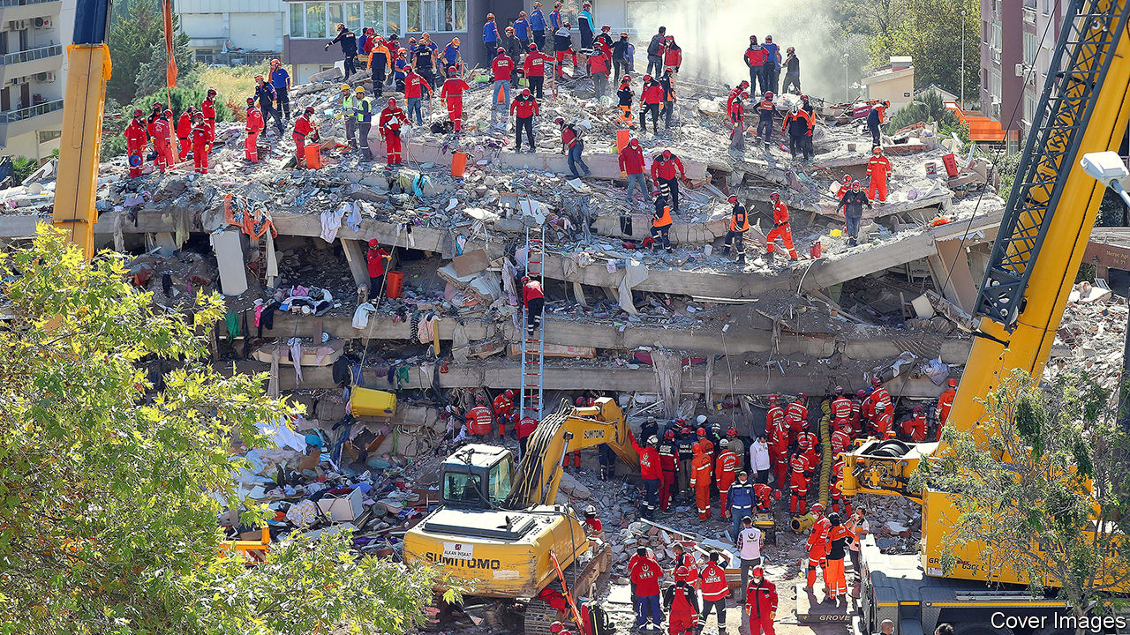

NEAR ONE of Izmir’s main thoroughfares, bulldozers and excavators power through a vast heap of rubble and steel wire, the ghastly remains of an apartment block levelled by an earthquake that struck Turkey’s third-biggest city in late October. Movers salvage furniture and kitchen supplies from buildings awaiting demolition or on the verge of collapse, their facades covered with deep cracks. A few hundred metres away, outside a shelter for those made homeless by the disaster, Meryem, a divorced teacher, and her two children are packing their belongings onto a pickup truck. Her house survived, says Meryem, but suffered so much damage that she refuses to go back. “I would not wish this on anyone,” she says.

At least 116 people died in the magnitude 7.0 quake, including a woman who drowned in a minor tsunami set off by the tremors. Rescue teams poured in from all over the country. Thousands of people volunteered to give blood. Local businesses distributed food to the survivors. Nearly three days into the search effort, exhausted workers pulled a three-year-old girl from the rubble of her home. A day later, they rescued another toddler.

Crisscrossed by major fault lines, Turkey has seen four deadly earthquakes this year alone and 18 tremors measured at 7.0 or above in the past 120 years. Almost 60m people, or 70% of the population, live in seismic zones. Yet disaster response is no longer a serious problem in Turkey. Preparedness is. Out of a total of about 10m buildings, 20-25% do not meet current standards for earthquake protection, says Mustafa Erdik, head of the Turkish Earthquake Foundation. Others put the figure even higher.

The risk is especially acute in Istanbul, home to over 15m people. Nearly 70% of the city’s housing stock dates from before 2000. Two decades ago, a 7.6 magnitude earthquake killed at least 17,000 people. Scientists agree that another big one is a matter of time. Some put the probability at up to 40% over the next 30 years. According to a recent study by the local planning agency, another earthquake of similar magnitude would destroy 48,000 buildings, damage 194,000 and cause 120bn lira ($15bn) in damages. Since Istanbul accounts for a third of Turkey’s GDP, the long-term economic damage could be severe.

Turkey’s president, Recep Tayyip Erdogan, and his government have taken steps to lessen the impact of future quakes. Over 500,000 vulnerable buildings have been demolished and replaced since the launch of an “urban renewal” programme in 2012. Under a scheme partly financed by the World Bank, the government has earthquake-proofed more than 1,200 schools and hospitals in Istanbul. A slew of recent infrastructure projects, including a new bridge over the Bosporus and an undersea tunnel, have been designed to withstand big quakes. Over 56% of Turkish homeowners have taken out earthquake insurance, one of the highest rates in the world, and up from 26% a decade ago.

But Turkey seems to have taken a step back for every step forward. Critics say urban renewal has enriched companies close to the government, overlooked environmental concerns and triggered a wave of evictions. “This was a very good programme,” says Naci Gorur, a geologist at Istanbul Technical University. “But they handed it to the developers, who prioritised those neighbourhoods where they could make the most profit.” The construction frenzy that propelled Turkey’s economy under Mr Erdogan has swallowed up open spaces and parks. Of the 470 assembly areas designated in Istanbul after the 1999 quake, only 77 remain, according to the mayor, Ekrem Imamoglu. Ahead of an election two years ago, the government announced an amnesty on unlicensed construction. The scheme benefitted the owners of over 7m properties across Turkey. One of these was an apartment building in Istanbul that collapsed on its own early last year, killing 21 people. Three of its eight floors had been illegally built. ■

This article was downloaded by calibre from <https://www.economist.com/europe/2020/12/05/turkey-recovers-from-one-earthquake-and-braces-for-more>

|  |  |  |  |
| --- | --- | --- | --- |
| Previous | Articles | Sections | Next |

|  |  |  |  |
| --- | --- | --- | --- |
| Previous | Articles | Sections | Next |

#### Demi-tour

# After police are filmed beating a black man, France does a U-turn

A gagging bill that could shield cops is being revised

Dec 5th 2020 | PARIS

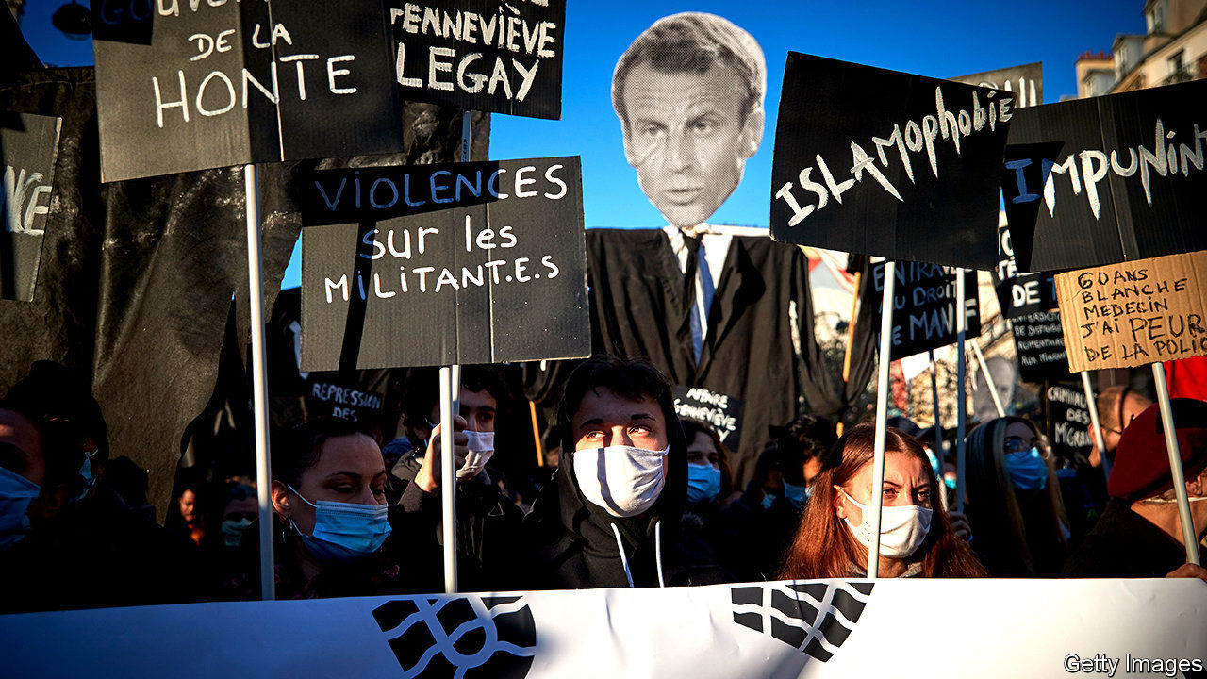

AT 6.42PM ON November 21st, three policemen forced their way into a recording studio in a smart area of Paris and savagely beat up Michel Zecler, a black record producer. Pursued for not wearing a face mask, Mr Zecler initially spent 48 hours in detention for violence against the police, and says that during the beating he was called a “sale nègre (dirty negro)”. On November 30th, four days after a surveillance video of his beating was posted on social media, contradicting the officers’ account, preliminary charges were brought against the three, for intentional violence and the falsification of police records. All have been suspended.

The episode not only shocked France; President Emmanuel Macron said on social media that it “put us to shame”. It has also prompted an extraordinary U-turn by the government. For the beating took place as a controversial “general security” bill designed to reinforce police powers was going through parliament. Article 24 of the draft law, which was passed by the lower house on November 24th and will next go to the Senate, would forbid the posting or broadcasting of any image that identifies an individual officer during a police operation “with the manifest aim of physically or psychologically causing them harm”. Had the bill already been on the statute books, it might have made posting the video that exposed Mr Zecler’s ordeal illegal.

The point of Article 24, according to Gérald Darmanin, the hard-line interior minister who drafted it (presumably with Mr Macron’s initial approval), is to protect the police from attempts to identify and target individuals, whether physically or on social media. French policemen regularly get online threats. In 2016 a police officer and a police employee were stabbed to death in front of their three-year-old son in Magnanville, a town north-west of Paris. Investigators found a list of names of police officers, among other figures, on the perpetrator’s computer.

The French media and others worried about press freedom, however, cried foul. An editorial in Le Monde, a newspaper, called Article 24 “pernicious”. Ten deputies from Mr Macron’s party, La République en Marche (LREM), voted against the bill, and 30 more abstained. On November 28th tens of thousands of people took to the streets of cities across France to protest. Even Macronistes are concerned about the president’s drift to the right on security matters.

At first, the government tried to defend Article 24. Faced with a groundswell of hostile opinion, however, Mr Macron on November 30th told parliamentarians at a crisis meeting at the Elysée Palace to rewrite the article completely. “It’s not a very glorious way of getting out of the situation,” says Roland Lescure, an LREM deputy. “But at least it’s clear and quick, and a way of saying ‘sorry, we got it wrong, let’s go back to the drawing board.’”

Mr Macron’s U-turn over Article 24 may now defuse the tension over press freedom. But the events that helped to prompt the reversal, and in particular Mr Zecler’s beating, will require a longer-term policy response. France does not collect data on its citizens’ ethnicity, so it is difficult to know the scale of racial discrimination. But an official study in 2016 found that a young man “perceived as black or Arab” is far more likely to be stopped for an identity-card check than anyone else. Mr Darmanin, who now finds himself under internal pressure, has promised to come up with a proper review of training and diversity, as well as police oversight and discipline. It may have taken a particularly nasty case, but the problem of racism among the French police is at least beginning to be acknowledged. ■

This article was downloaded by calibre from <https://www.economist.com/europe/2020/12/05/after-police-are-filmed-beating-a-black-man-france-does-a-u-turn>

|  |  |  |  |
| --- | --- | --- | --- |
| Previous | Articles | Sections | Next |

|  |  |  |  |
| --- | --- | --- | --- |
| Previous | Articles | Sections | Next |

#### On the Chopin block

# Thierry Baudet, a populist prodigy, blows up the party he created

The Forum for Democracy seems doomed

Dec 5th 2020 | AMSTERDAM

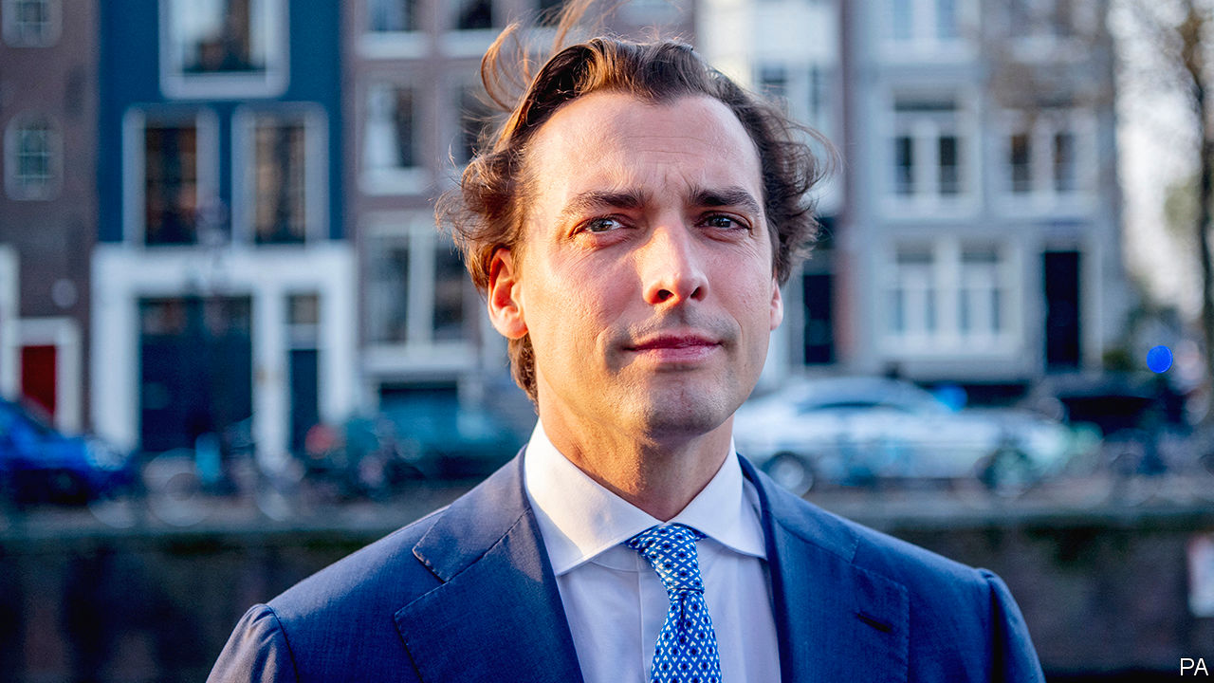

A PHOTO of Thierry Baudet from a newspaper profile in 2014 shows him sprawled on his grand piano, gazing fetchingly to camera. The Chopin-playing Dutch intellectual, then 31, had written a book denouncing the EU. Two years later he co-founded a party, Forum For Democracy (FVD), which won the largest vote-share in provincial elections in 2019. In a speech that night Mr Baudet described it as a world-historical turning point, invoking Hegel’s “owl of Minerva”, a symbol of wisdom that “spreads its wings only [at] dusk”.

This month the FVD blew itself up in a series of scandals, and music again played a role. At a dinner on November 20th a newly recruited politician wanted to play 1980s disco. Mr Baudet insisted on classical. Soon, says an FVD senator who later quit the party, Mr Baudet was ranting that covid-19 was a plot by George Soros. He answered worries about anti-Semitism in the party by saying that “almost everyone I know is anti-Semitic.” (He later repudiated these statements, but did not explain what he had meant.)

The next day a newspaper published chats full of racist and anti-Semitic vitriol among FVD’s youth wing, run by Mr Baudet’s ally, Freek Jansen. Rather than fire Mr Jansen, Mr Baudet quit as parliamentary leader. But he stayed on as an MP, and said he would return as leader if members asked. The FVD’s provincial and city office-holders began deserting the party. So did its other MP and most of its senators, including Paul Cliteur, a legal philosopher whose department at the University of Leiden served as FVD’s intellectual breeding ground.

As recently as March polls gave FVD about 11% of the vote. But as Mr Baudet flirted with covid-19 conspiracy nutjobbery, its support slid to around 3%. Many who once thought Mr Baudet merely provocative now see him as a dangerous crank. Henk Otten, a senator and one of the party’s co-founders, was pushed out last year after warning that Mr Baudet was being radicalised. He says he has turned into a “fascist psychopath”.

FVD’s board says the party’s 40,000-odd members will vote on whether or not Mr Baudet should return. Mr Otten says the statutes do not provide for that. But Chris Aalberts, author of a book about the party, says its rules do not matter much: “It is a one-man system.” Mr Baudet may stay on as head of a rump FVD and win a few seats at the general election in March. Geert Wilders, the head of the Netherlands’ other far-right populist party, is overjoyed. As FVD has withered, its voters have come over to him.

This article was downloaded by calibre from <https://www.economist.com/europe/2020/12/05/thierry-baudet-a-populist-prodigy-blows-up-the-party-he-created>

|  |  |  |  |
| --- | --- | --- | --- |
| Previous | Articles | Sections | Next |

|  |  |  |  |
| --- | --- | --- | --- |
| Previous | Articles | Sections | Next |

#### Charlemagne

# To ski or not to ski?

That is a question that reveals a surprising amount about Europe

Dec 5th 2020 |

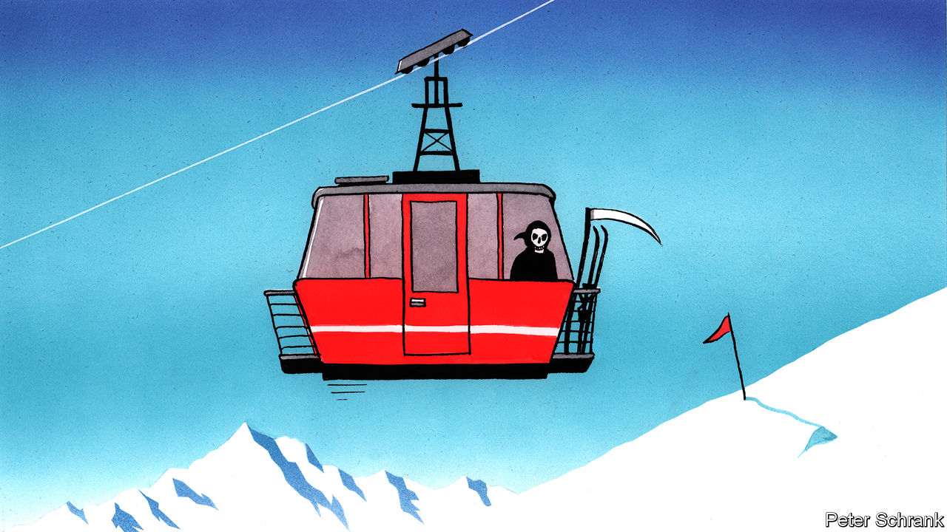

IT TOOK A pandemic to silence Gerhard Schmiderer. For the past quarter-century, the now 70-year-old “DJ Gerhard” has blasted trashy hits for drunken après-skiers at MooserWirt, a bar in St Anton, an Austrian ski resort. This year, however, the speakers will be silent rather than blaring out yet another rendition of “The Final Countdown”, a raucous anthem sung by big-haired Swedes. The usual revellers dancing on tables in ski boots will be absent. The 500-metre run back to the resort will no longer be strewn with those who have quaffed too much and fallen over in the snow.

This sad story is repeated across the rest of Europe’s nearly 4,000 ski resorts. Chairlifts have largely ground to a halt because of the pandemic. Bad memories linger from spring, when an outbreak in Ischgl, another Austrian resort, led to at least 6,000 cases in more than 40 different countries. Covid-19 loves ski resorts. People drive or fly in from all over Europe to crowded mountaintop villages. Queues for lifts are packed. Changing rooms are explosions of sweat as panting bankers heave themselves into salopettes. Bars are bacchanalian. Yodelling, an efficient way to spread the virus, is not unheard of. As the rich partied in the Alps in March, hospitals overflowed in Lombardy, a few hundred miles away. No one wants to see that again.

Agreeing to write off the first few weeks of the European ski season until the current wave of the pandemic has passed ought to be uncontroversial. Yet it has triggered a row. France, Germany and Italy all agreed to keep resorts shut until January. Austria was affronted. “We will not tell France when to reopen the Louvre,” harrumphed one Austrian minister. Bavaria’s premier warned that anyone who crossed the border for a few days on the slopes would face 10 days of quarantine on the way back. Austria eventually acquiesced, effectively banning skiing except for local day-trippers until next year. It was, however, a revealing fight.

Europeans ski a lot. In total, they spend roughly 200m days a year skiing—about the same as the rest of the world combined. Austria, France and America all rack up a similar number of days on the piste, despite their vastly different populations. Skiing is a quintessentially European invention. Its modern form started in Scandinavia, before it was seized on by 19th-century adventurers. It was commercialised across the Alps, after consumers found being pulled to the top of a mountain a more pleasant experience than schlepping up on foot. Each nation brings its own approach: proficient Austrians are notorious for taking it seriously; enthusiastic but terrible Dutch skiers much less so. It speaks to a certain ideal of Europe, in which it is possible to wake up in France and lunch in Italy. All European life is there at any resort—provided they can afford €1,000-plus for a few days of fun.

Skiing raises mountains of cash. During winter months it generates 4% of Austrian GDP, according to ING, a bank. For comparison, Germany’s mighty car industry makes up 5% of the country’s economy. This explains why Berlin’s demands that Austria rope off the slopes for Christmas went down so badly. Imagine if the Austrian chancellor had asked his German counterpart if she would mind temporarily closing the car industry. (There is a climate crisis, after all, Angela.)

For a bloc that prides itself on dissolving borders, skiing is a knotty issue. Mountains are immovable natural frontiers where questions of sovereignty are heightened. Governments in the EU may have pooled sovereignty, but they jealously guard what competences they do have, even if it only involves ski lifts. If resorts in some countries lock down for health reasons, another government could scoop up any spare revenue. Normally, EU regulations are supposed to stop such races to the bottom. When it comes to skiing, the EU has no say. As far as officials in Brussels are concerned, that is a bullet dodged. In Europe’s delicate ecosystem, mountain communities sit alongside farmers and fishermen as near-untouchable endangered species to be protected at all costs. Far better to let national politicians take the hit.

After all, there will be a political cost. French resorts can only watch as their Swiss peers—outside the EU and apparently free from any moral obligation not to shaft their neighbours—stay open only a few hundred metres down the valley. Nicolas Rubin, the mayor of Chatel, a resort on the French border, decked his town hall out in Swiss flags in protest.

Those who want to keep on skiing have a point. Sliding down a hill with planks attached to one’s feet is no riskier, in terms of catching coronavirus, than a cycling trip. (Although bellowing “We’re headin’ for Venus/ And still we stand tall” into the face of a Belgian stranger in a bar at 1,300 metres is another matter.)

## Not going downhill

Whether families can squeeze in a skiing holiday during a pandemic is a decadent debate—and a familiar one. A similar row erupted about whether to reopen the continent for tourism over the summer. If the priority had been to eliminate the virus, the answer would have been no. But Europeans could not bear the idea of being stuck at home in August, so they packed their bags and zipped across the continent. The consequences were predictable and predicted. Holidaymakers spread the virus.

Every polity has sacred issues that make rationality leap out of the window. In America, it is guns. In Britain, it is health care. In France, it is food. One such issue is a constant across every European country: politicians muck about with holidays at their peril. Whether consciously or not, a choice was made in the summer between health and holidays. Holidays won. This time, at least, a more difficult choice has been made. If resorts do fully reopen this season, the Austrian government has decreed that the throbbing après-ski parties will be banned. MooserWirt may have to wait until things are back to normal. When they are, expect to find a 71-year-old behind the decks. ■

Editor’s note: Some of our covid-19 coverage is free for readers of The Economist Today, our daily [newsletter](https://my.economist.com/user#newsletter). For more stories and our pandemic tracker, see our [hub](https://www.economist.com/news/2020/03/11/the-economists-coverage-of-the-coronavirus)

This article was downloaded by calibre from <https://www.economist.com/europe/2020/12/05/to-ski-or-not-to-ski>

|  |  |  |  |
| --- | --- | --- | --- |
| Previous | Articles | Sections | Next |

|  |  |  |
| --- | --- | --- |
| Europe | Sections | International |

Britain

The National Health Service: Unleashed

.

Trans rights: Bellwether?

.

The Brexit endgame: How late it was, how late

.

Eastern European migration: Farewell to all that

.

Cyber defence: Use the force

.

Retailing: Shopocalypse

.

Bagehot: Tidying Boris up

.

|  |  |  |
| --- | --- | --- |
| Europe | Sections | International |

|  |  |  |  |
| --- | --- | --- | --- |
|  | Articles | Sections | Next |

#### Health care

# How covid-19 unleashed the NHS

The pandemic has brought forth a wave of innovation

Dec 3rd 2020 | ASHFORD

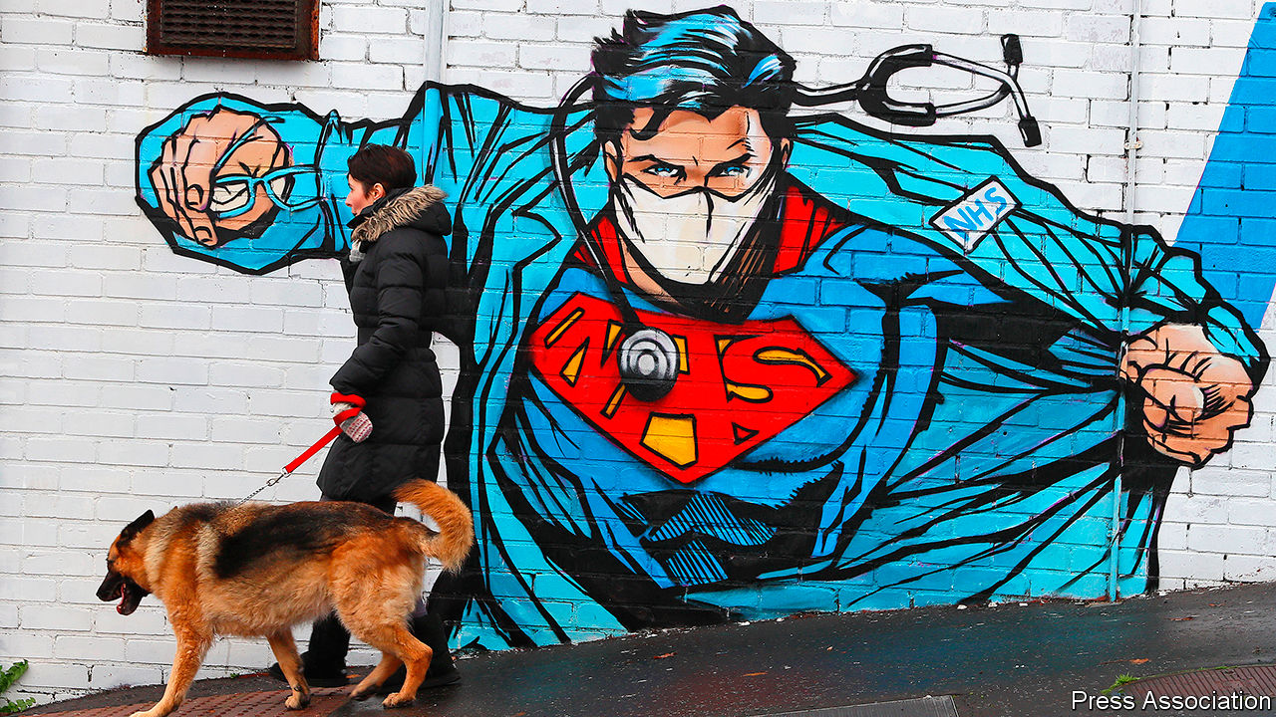

ACCORDING TO SHELAGH O’RIORDAN, a consultant in geriatric medicine, patients often experience the National Health Service (NHS) as a conveyor belt. “You feel ill, you call this number. This number calls an ambulance. That ambulance tells you that you should go to hospital. You go to hospital. And then, if you’re frail, you might not come out.” Her job, as she sees it, is to help people off the conveyor belt, and even on a quiet Sunday morning the telephone keeps ringing. Most calls are from nurses, paramedics or care-home workers. After a quick chat, each is given a set of instructions about the care of the patient to whom they are attending.

Dr O’Riordan set up this home-treatment service at the start of the pandemic, spurred by the need to keep patients out of hospital. The service offers acute care at home: diagnosing, assessing and looking after frail locals who wish to avoid hospital. Operating from a nondescript office on the edge of Ashford, a town of 75,000 in Kent, by the start of November it had treated more than 2,000 patients, around a third with covid-19. In the first wave of the pandemic it was unable to replicate the care received in hospitals, with people needing to head into an infirmary for oxygen or dexamethasone (a cheap but effective steroid). Both are now available at home.

The pandemic has put the NHS under unbearable strain, but it has also unleashed a wave of innovation. Freed from bureaucracy, and pressed by the need to keep patients out of hospital, medics and health officials have rethought how care is provided. In areas from remote care, to the use of technology, to breaking down silos across the health and social-care systems, covid-19 has accelerated policies that were making slow progress. As Jennifer Dixon of the Health Foundation, a think-tank, puts it: “The safety blanket was thrown off.”

This presents an opportunity. Matt Hancock, the health secretary, has drawn a comparison to the Great Fire of London in 1666, from which emerged the fire brigade, the first insurance firms, new water regulations and St Paul’s Cathedral: “Devastating shock can force people to find new and better ways of doing things.” Those in charge of the NHS now face two big questions. The first is which of these innovations make sense beyond the pandemic, and should become permanent features of the health service. The second is whether this burst of innovation can be sustained.

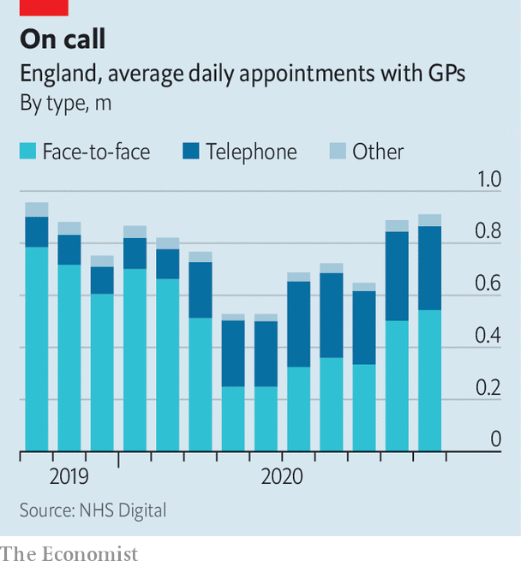

A senior NHS official calls the widespread adoption of remote care a “move away from the dominant mode of medicine for the last 5,000 years”. Before the pandemic, 80% of appointments in primary care were face-to-face. Now they count for many fewer (see chart), and those who do see a general practitioner (GP) mostly have to go through triaging first. “The change was arguably the most extensive and rapid the NHS has ever gone through,” says Trish Greenhalgh, a professor of primary care at the University of Oxford. Yet, despite the fears of many doctors, “nothing very terrible happened”.

Remote medicine—which is now more commonly used for hospital outpatient appointments, too—offers the hope of more convenient and possibly even cheaper care (see [article](https://www.economist.com/node/21795928)). Pre-pandemic evaluations found it was as effective as in-person treatment for lots of illnesses. There is, though, a caveat. Before the pandemic, remote consultations tended to be done on patients who were considered “very safe bets”, warns Dr Greenhalgh, who is leading a study to assess the impact of their widespread adoption.

Early in the pandemic, the health service signed contracts to provide Microsoft Teams and Attend Anywhere, a video-conferencing platform, to medics. It also offered reassurance on information-governance rules to those who used FaceTime, Skype or WhatsApp. In October 137,000 GP appointments took place online. Yet the same month 10m happened by telephone. “We went to products that were readily available, not the most earth-shattering, transformative digital solutions,” says Axel Heitmueller of Imperial College Health Partners, a non-profit consultancy that focuses on innovation. For the most part, existing care has been replicated (as far as possible) from a distance. In some places, though, it has been transformed.

## A breath of fresh air

In north-west London, doctors had been installing a remote-monitoring system for people with high-risk diabetes. When the pandemic hit, the focus switched to covid-19. Patients in a serious condition, but short of hospital admission, were given a pulse oximeter (to measure blood-oxygen levels) and an app into which they entered its readings. “We know people sat at home through the first wave feeling fine, but with their oxygen levels going down,” says Sarah Elkin, a respiratory consultant. “This is a way of picking up earlier the people who are becoming hypoxic.”

Remote monitoring of patients is one of the frontiers of digital medicine. The pandemic injected a new urgency into its introduction. The approval of the app used in north-west London took three weeks, instead of the six months or so that would be expected in normal times. Instead of weaving through a maze of committees, it went straight to those at the top who make the final decision. Covid-19 virtual wards have since sprung up in places from Manchester to South Tees, and NHSX, the health service’s tech unit, has offered support to others who want to follow their lead. In north-west London, medics now plan to use remote monitoring to keep track of people recovering from heart attacks and with lung disease.

People focus on the whizzy technology required to do this. In fact, says one insider, the bigger challenge in schemes like these is changing work patterns and getting disparate parts of the health system to work together. For covid-19, GPs referred patients to the remote-monitoring system, working alongside hospital consultants to decide when to admit patients. This teamwork was part of a broader shift during the first wave. Across the health service, staff, equipment and ideas were shared. Hospitals shuffled responsibilities, acting as part of wider networks rather than as standalone institutions.

Bob Klaber, a director at the hospital trust in north-west London, asks why it takes a pandemic for this to happen. In the popular imagination, the NHS is a monolithic organisation, powered by goodwill. In reality it is a tangled network of organisations, many of which have competing incentives, leading to behaviour that is, with varying degrees of intensity, territorial. Dr Klaber, who also works as a paediatrician, cites the payment-by-results mechanism as one obstacle: “If I see a new patient 240 quid will come into the hospital. If a local GP who I know phones me up and says, ‘I think we could probably clear this up in a five-minute conversation on the phone’: no payment for that.”



The doctor is seeing you now

The mechanism is part of the “internal market”, which was introduced by Conservative governments in the early 1990s. This separates purchasers of services (mostly GPs) from providers (mostly hospitals), which compete for contracts. Studies looking at its effectiveness have obtained mixed results, with none suggesting great success. In an age when rising numbers of (often elderly) patients have multiple health problems, and when the NHS is trying to focus on prevention rather than merely treatment, the bureaucracy and fragmentation it imposes is a problem.

Mr Hancock has said that health care must be “based on the needs of the population, not the design of the institution”, to ensure the co-operation of the pandemic continues. In recent years the government has tried to circumvent the internal market, bringing together purchasers and providers in local areas to plan services for the whole population—an idea imported from America, Germany and Singapore.

Improvements have so far been modest. A recent paper by academics at the universities of Kent and Manchester looked at “Vanguard sites”, which trialled the new approach from 2015 to 2018. It found that emergency admissions rose more slowly than elsewhere, but still increased, and that there was no significant difference in bed-occupancy rates. The NHS leadership thinks the solution is more integration; it hopes to match the financial and legal plumbing of the health service to this new reality. Accordingly, it has asked the government to introduce legislation to restructure the health service, either creating local health boards or adapting existing bodies to serve that purpose.

Along with the potential for the first major NHS legislation since 2012, next year is likely to be dominated by the need to shrink waiting lists, which ballooned during the pandemic. That places very different pressures on the health service from during the first wave, when non-urgent hospital admissions fell by around 70%. Spending has tightened and bureaucracy has reappeared. Mr Heitmueller, who formerly worked in the Cabinet Office, worries about where the spark for innovation will come from in the post-pandemic health service.

While the pace of change may slow, many of the changes will endure. Even over the summer, when the virus waned, the proportion of face-to-face appointments remained far lower than before the pandemic. Connections have been forged across the health system, and barriers broken. “The NHS surprised itself by how quickly it did some major things,” says Chris Hopson of NHS Providers, a representative group. “One of the things that will stick is that sense of the possibility of much, much more rapid change.” With lengthy queues and tight public finances, ministers must hope he is right. ■

This article was downloaded by calibre from <https://www.economist.com/britain/2020/12/03/how-covid-19-unleashed-the-nhs>

|  |  |  |  |
| --- | --- | --- | --- |
|  | Articles | Sections | Next |

|  |  |  |  |
| --- | --- | --- | --- |
| Previous | Articles | Sections | Next |

#### Keira Bell

# The judgment in Keira Bell’s case upsets trans groups

It becomes harder to prescribe puberty blockers to children

Dec 1st 2020 |

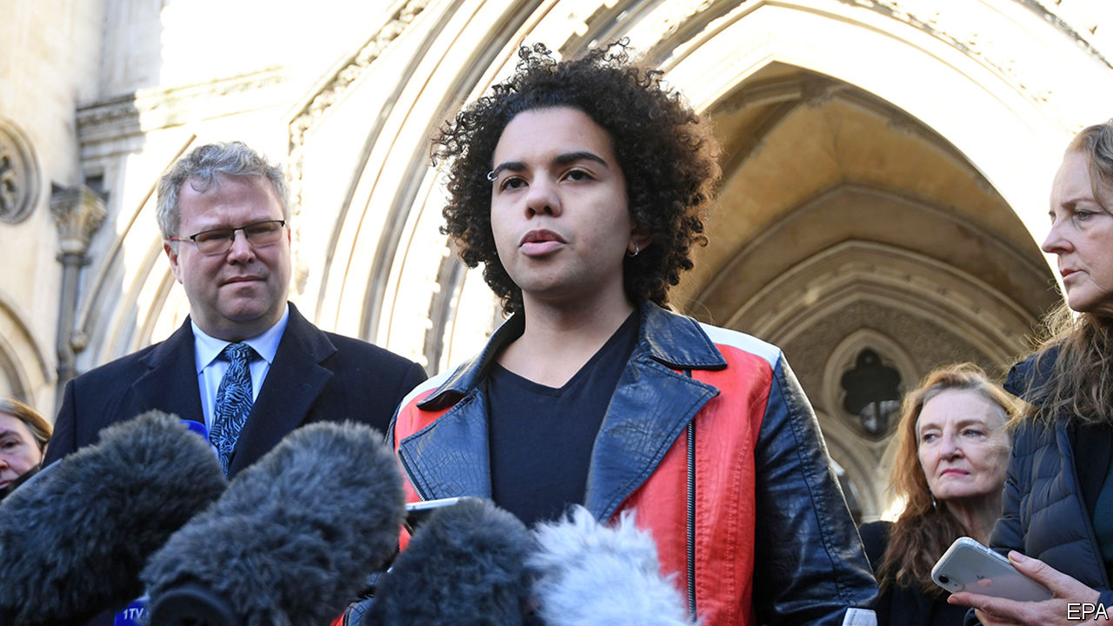

IN ANGLO-SAXON COUNTRIES, trans people have gained rights in the past few years. Those in Canada and some Australian states can be legally recognised as belonging to the gender of their choice, irrespective of whether they have had gender reassignment surgery. In America, the Equality Act, which Joe Biden has promised to sign, would have a similar effect. But in Britain there has been a push-back. In September, the government said it would not reform the Gender Recognition Act, which Theresa May, a former prime minister, had said she would change to allow gender self-identification. And now a High Court ruling has upset trans-rights activists.

On December 1st, three judges ruled that the youth gender-identity clinic at the Tavistock Hospital in London was not upholding the law, which requires that children have a mature understanding of the consequences of hormone treatment before consenting to it. The ruling was part of a judicial review brought by Keira Bell (pictured), a 23-year-old woman who identified as a boy when she was younger, and was given puberty blockers at 16, then testosterone, then a double mastectomy. She later detransitioned. Ms Bell argued that she was too young to understand the implications, and that the protocol for giving the drugs did not have an adequate scientific basis. The court agreed, calling the treatment “experimental”.

Last year 2,700 people were referred to the Tavistock’s youth gender-identity clinic. Around 40-50% of them were put onto puberty blockers. The clinic argued that the drugs are safe and reversible. Ms Bell’s lawyers produced a study showing that in 97% of cases they led on to further treatments such as cross-sex hormones and surgery. The court agreed that once on the pathway, “it is extremely rare for a child to get off it”.

The clinic said it would pause putting under-age patients onto puberty blockers. Most future cases will be referred to the courts. Trans campaign groups were aggrieved. The ruling was “shocking”, according to Nancy Kelley, head of Stonewall. “Hormone blockers,” she said, “play a vital role in helping to alleviate the distress many trans young people experience and offer much-needed time…to explore their identity. Denying this vital support is not a neutral act and can be deeply harmful.”

Some feminist lobby groups, who believe that there is a conflict between trans rights and women’s rights, are delighted. They maintain that mistaken beliefs about gender have led to children wrongly being put on the path to gender reassignment, as Ms Bell was, and that the court has cut through the ideology and got to the facts. Stephanie Davies-Arai of Transgender Trend, a campaigning group, points out that scientific studies that her group submitted to the court were accepted as evidence, while submissions from Stonewall and Mermaids, a trans support group, were denied because the evidence had either already been given or was irrelevant. The judgment is a victory for the trans activists’ opponents; but there are more legal battles due next year. ■

This article was downloaded by calibre from <https://www.economist.com/britain/2020/12/01/the-judgment-in-keira-bells-case-upsets-trans-groups>

|  |  |  |  |
| --- | --- | --- | --- |
| Previous | Articles | Sections | Next |

|  |  |  |  |
| --- | --- | --- | --- |
| Previous | Articles | Sections | Next |

#### EU-UK negotiations

# Brexit talks inch towards a last-minute deal—but it is not done yet

It will not be easy to get an agreement approved by the EU’s member states

Dec 5th 2020 |

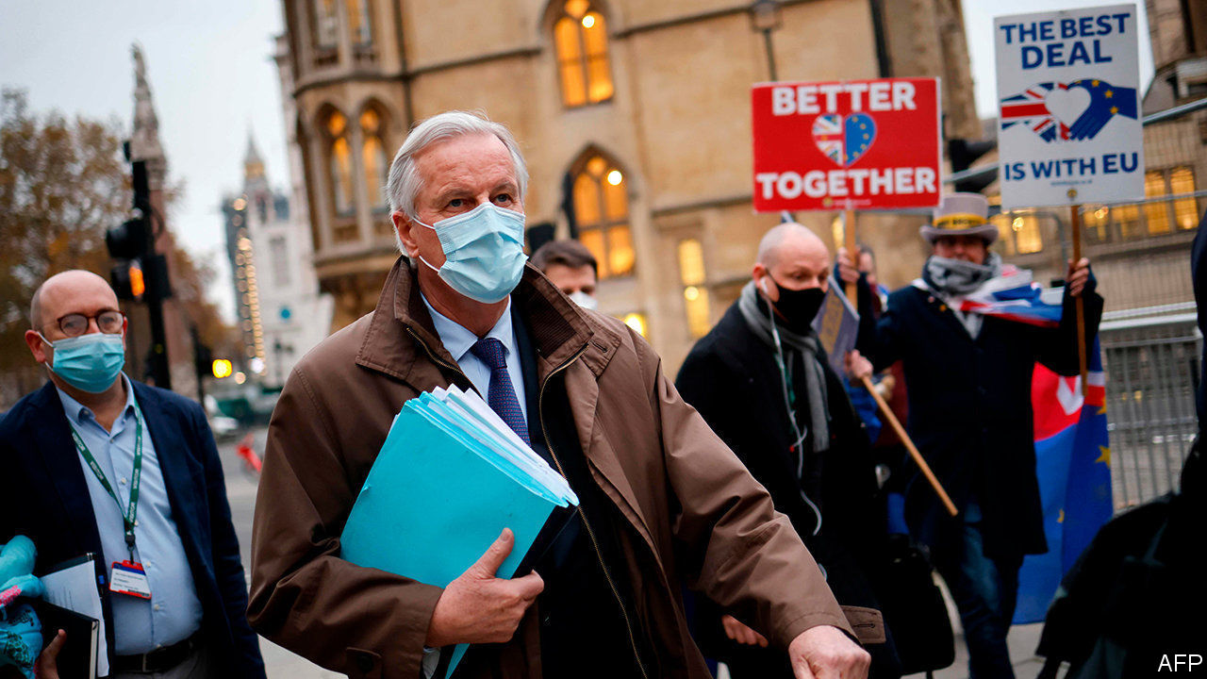

THE GOVERNMENT is urging businesses to step up preparations for the end of Britain’s transition out of the European Union on December 31st. This week Michael Gove, the cabinet office minister, announced the setting up of a new border operations centre, adding that significant change was coming with or without a trade deal. Yet many companies retorted that uncertainty over the negotiations made proper preparation all but impossible.

This week’s talks in London have made some progress, yet the old gaps remain over fisheries and a level playing-field for competition. Officials suggest Boris Johnson now needs to intervene to seal a deal. The prime minister is under pressure, especially after a big backbench Tory revolt on December 1st against his new covid-19 tier system. But Mujtaba Rahman of the Eurasia Group, a consultancy, sees little sign of early readiness to give more ground to the EU. And the mooted inclusion of more unilateral (and illegal) changes to the Northern Ireland provisions of the withdrawal treaty in next week’s finance bill could upset the applecart again.

As repeated Brexit deadlines come and go, the timetable for ratifying a trade treaty that runs to some 800 pages (plus annexes) becomes ever tighter. Getting a deal through Westminster should not be hard even with another revolt by hardline Tories, because the Labour opposition is unlikely to vote it down if the alternative is no deal. But rushed approval by the EU is a lot more problematic.

All national governments must agree. Some may jib if there is not enough time for full legal scrutiny and translation. In a few countries, such as Finland, parliamentary approval is needed before a government signs. Some parliaments may also demand a say if the deal is “mixed”, meaning it includes issues such as airline regulation or social security that fall within national not EU competence. But Georgina Wright of the Institute for Government, a think-tank, says lawyers in Brussels may still argue that the deal needs only EU approval. She also points to precedents for provisional application of trade deals pending any national ratifications later deemed necessary.

That is harder with the European Parliament, since its approval has always preceded a trade deal taking effect. Next week sees its last planned plenary meeting of the year. Two committees normally scrutinise and report on trade deals before they are voted on. Yet MEPs are well briefed on the Brexit trade talks, and are anxious not to be seen as an obstacle to a deal. They have already planned a remote session with a vote in the week of December 28th just in case.

Brexit’s potential cost is becoming clearer. The government tried unsuccessfully to head off this week’s backbench revolt by publishing a hasty economic-impact assessment of its covid-19 tiers. Yet Mr Johnson still refuses to offer a similar assessment of any Brexit trade deal (or of no deal). Fortunately the independent Office of Budget Responsibility has now done the job. It predicts a 4% long-term loss of output with a deal, and an extra cut in GDP of 2% next year with no deal. This echoes other forecasts and the Bank of England’s conclusion that Brexit will cost more than the pandemic. And it will come on top of a poor outcome in 2020. The OECD has just downgraded its forecasts, putting Britain second-to-last among leading members, with an expected fall in GDP this year of 11.2%. That is an unhappy position in which to inflict further disruption.■

This article was downloaded by calibre from <https://www.economist.com/britain/2020/12/05/brexit-talks-inch-towards-a-last-minute-deal-but-it-is-not-done-yet>

|  |  |  |  |
| --- | --- | --- | --- |
| Previous | Articles | Sections | Next |

|  |  |  |  |
| --- | --- | --- | --- |
| Previous | Articles | Sections | Next |

#### Demography

# Eastern European migrants stop coming to Britain

Brexit did not persuade them to depart, but an economic slump might

Dec 3rd 2020 | PETERBOROUGH

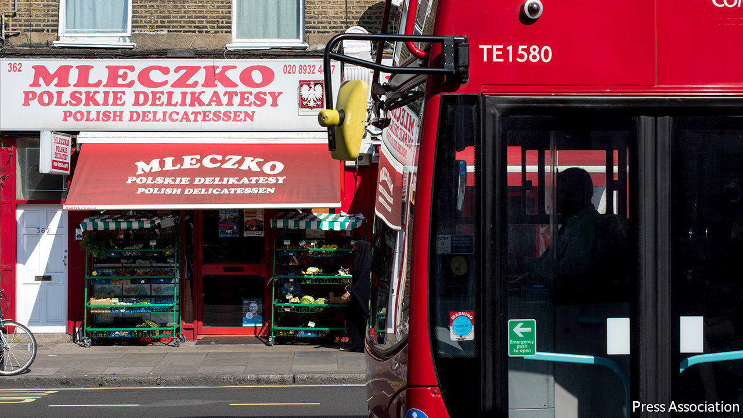

OLENA HRABOVENSKA, who owns several Polish food shops in Huntingdon and Peterborough, shudders to remember the Brexit referendum in 2016. The campaign to leave the EU had unleashed ugly prejudices. Cards about “Polish vermin” were posted through letterboxes. Her customers seemed despondent, asking: “what’s the point of being here if we’re not appreciated?” Soon afterwards, eastern Europeans’ numbers started to decline, but not because they rushed for the exit.

Eight Baltic and eastern European countries joined the EU in 2004: the Czech Republic, Estonia, Hungary, Latvia, Lithuania, Poland, Slovakia and Slovenia. Many of their citizens moved to Britain, which, unlike most European countries, imposed no transitional controls. But according to the Labour Force Survey, the number of adults in England and Wales born in those countries has fallen from 1,139,000 in 2016-17 to 926,000 (see chart). Other data tell a similar story. Last year fewer than 17,000 babies were born to Polish women—down from almost 23,000 in 2015.

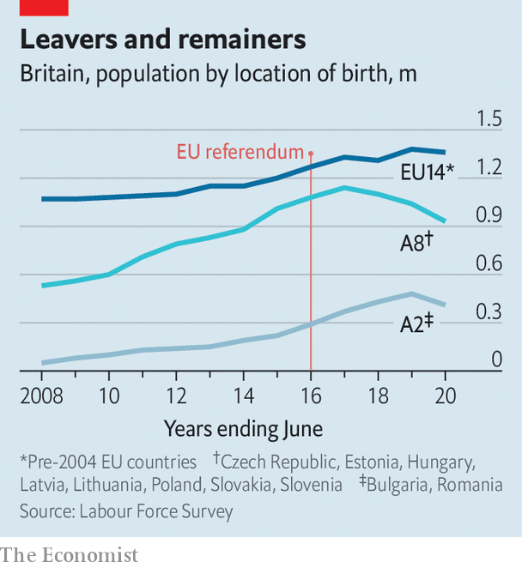

The Brexit vote caused sterling to fall, reducing the purchasing power of remittances sent from Britain. Two years later the government told people who wanted to settle to prove they had been mostly resident for five years in a row—a test that some found offputting. “You are treated as a number,” says Aga Dychton, a Polish immigrant who is now chairman of Watford borough council. Yet all Europeans face these problems. The number of French, German and Italian immigrants has not fallen much; nor has the number of Bulgarians and Romanians, who have been able to work in Britain since 2014.

The countries that joined the EU 16 years ago have changed in a way that makes Britain seem less attractive. Marius Vainauskar, who moved to Britain in 2005 to take a job sticking labels on vegetables, remembers that he used to feel rich when he went back to Lithuania. Today he has a better job, as a driving instructor, but no longer feels so flush. Over the past 16 years the average wage in Lithuania has risen from 41% of the British level to 61%, at purchasing-power parity. And many eastern Europeans are underemployed in Britain. The Oxford Migration Observatory, a think-tank, finds they have the lowest pay of any migrant group and are the most likely to be overqualified for the jobs they do.

Ruta Dalton, an accountant originally from Lithuania, suspects that Brexit itself persuaded few eastern Europeans to depart. Some have left—but most of them would have gone anyway, pulled back by family obligations or simply because they had saved as much money as they wanted to. The big change is that many fewer eastern Europeans are coming. Last year only 77,000 people from the 2004 accession countries received a British National Insurance number. In 2015, the year before the Brexit vote, 185,000 did so.

This is not exactly a ringing endorsement of the “global Britain” that Boris Johnson boasts about. But attracting eastern Europeans would be getting harder even if sterling and the economy were strong and Britain went easy on the immigration paperwork. A baby bust after the fall of the Iron Curtain and years of emigration means there are fewer potential migrants left in eastern Europe. The United Nations estimates that the number of 18-year-olds in Poland has fallen from 598,000 to 340,000 since 2005.

## New customers

Some immigrants are still arriving in Lincoln Road, the traditional starting-off point for newcomers in Peterborough. Shops that once specialised in Polish food now sell Romanian products. And Petr Torak, a former police officer who now runs a community centre, says that Roma from the Czech Republic and Slovakia are settling in the area. Unlike the Poles and Lithuanians who came before, they are fleeing persecution as well as looking for jobs. He struggles to imagine them returning to their homelands.

Ms Hrabovenska’s shops are doing fine for now. But, like a good businesswoman, she worries about the future. What will happen if Britain enters a prolonged economic slump and unemployment soars? If everyone ends up counting their pennies, she thinks, the eastern Europeans really will leave in a hurry. “They can count pennies in their own country,” she says.■

This article was downloaded by calibre from <https://www.economist.com/britain/2020/12/03/eastern-european-migrants-stop-coming-to-britain>

|  |  |  |  |
| --- | --- | --- | --- |
| Previous | Articles | Sections | Next |

|  |  |  |  |
| --- | --- | --- | --- |
| Previous | Articles | Sections | Next |

#### Digital defence

# Britain assembles a new cyber force of soldiers and spies

Cyber-activity is increasingly common, but most countries keep quiet about it

Dec 3rd 2020 |

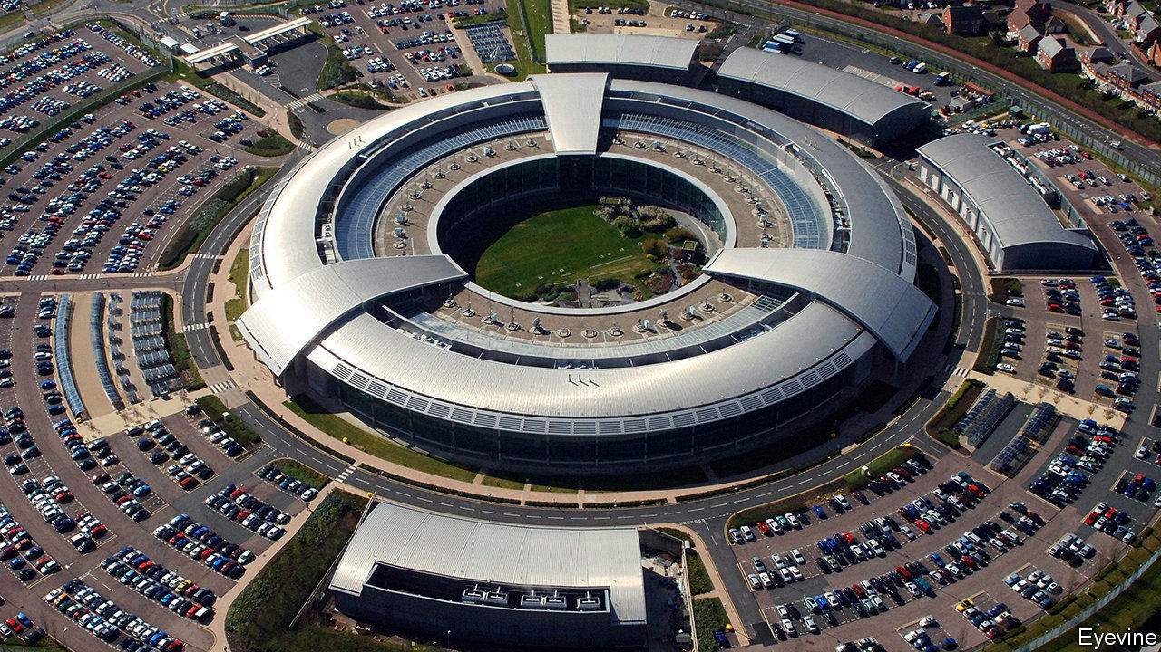

THE HEAD of America’s Cyber Command, Paul Nakasone, is a four-star general whose chest is plastered in medals. The commander of Britain’s National Cyber Force (NCF) is a bespectacled, middle-aged man in a beige blazer—a 20-year veteran of GCHQ, Britain’s signals-intelligence service, whose name the government has asked to keep secret. Unassuming as he may be, his agency, responsible for offensive cyber-operations, now stands at the centre of a sweeping overhaul of British defence capabilities.

On November 19th Boris Johnson announced the biggest programme of investment in defence since the Thatcher era. The cash, an extra £6.5bn ($8.7bn) during this parliament over previous manifesto plans, reverses nearly a decade of military cuts and cements Britain’s position as the second-largest military spender in NATO, behind America, and the largest in Europe, with a budget of £46.5bn this year. It includes a tilt towards the seas and skies, with more spending on ships, a commitment to send an aircraft-carrier to Asia next year (with American marines aboard) and a Space Command to watch for threats to satellites.

The central theme, though, is technology. Britain will establish a new agency for artificial intelligence (AI). It will invest more in drones and lasers. And it will beef up cyber capabilities. That explains Mr Johnson’s decision to avow the existence of the NCF, which has been quietly hacking away since the spring. The force brings under unified command for the first time personnel from GCHQ, the Ministry of Defence and MI6, Britain’s foreign intelligence agency, and the Defence Science and Technology Laboratory (DSTL). The force is thought to number in the hundreds, with the aim of growing to 3,000 staff over the next decade. Adverts are up online.

The NCF’s purpose is not to collect intelligence—GCHQ has done that since its inception—but to make things happen. That could include shutting down the communications of a terrorist group or disabling enemy air defences, but also something as simple as sending a message to dissuade someone from acting.

Such offensive cyber-activity is increasingly common, though most countries keep quiet about it. Britain broke its own silence in 2013, when Philip Hammond, the defence secretary at the time, said that Britain was building a cyber “strike” capability. In 2017 Britain acknowledged it was “routinely” using offensive cyber against Islamic State, a terrorist group.

Acknowledging these offensive cyber campaigns was a cheap way of demonstrating counter-terrorism prowess. Yet these campaigns served a secondary purpose, too. They were low-key shows of force obliquely directed at bigger foes. British officials are wary of discussing operations against Russia or China. But “the fact you don’t see that we use it doesn’t mean we don’t,” noted Mark Sedwill in October, freshly retired as national security adviser.

Therein lies some of the appeal. “Policymakers love offensive cyber, for the same reason that they love special forces and intelligence operations,” says a former senior British official, who worked closely with two prime ministers. “They are largely covert, can be deployed flexibly and don’t have to be disclosed to or debated in Parliament or the press.”

Some cyber-operations are dramatic attacks that literally destroy physical equipment. Most are more prosaic. The NCF will probably spend more time tackling online child sexual exploitation and fraud than threatening Russia’s power grid. That a mixture of soldiers and civilians should handle everything from criminality to all-out war is unusual. The NCF “has no equivalent anywhere else in the world”, notes Marcus Willett, GCHQ’s former deputy head, approvingly.

Yet if the NCF has laid its foundation stones, its intellectual scaffolding remains a work in progress. Ciaran Martin, who retired as head of GCHQ’s defensive arm in August, warns that “in all my operational experience, I saw absolutely nothing to suggest that the existence of Western cyber capabilities, or our willingness to use them, deters attackers.” A former British spy chief agrees. “The reality is that non-military uses of offensive cyber are massively over-played.” Outside wartime, he says, such operations “will always be niche and ephemeral, though occasionally useful for sending messages”.

Mr Martin expresses another concern: that Western cyber-armouries might be raided, with baleful consequences for civilian digital infrastructure. “No one is likely going to be able to steal a nuclear weapon. No one will accidentally lose or leak a ballistic missile…None of these statements hold true for cyber capabilities.”

GCHQ says that its operations are “responsible, targeted and proportionate, unlike those of some of our adversaries”. The NCF will be scrutinised by Parliament’s Intelligence and Security Committee. Even so, Mr Martin urges caution. “We weaponise the internet at our peril,” he maintains. “In the cyber domain, the best form of defence is defence.” ■

This article was downloaded by calibre from <https://www.economist.com/britain/2020/12/03/britain-assembles-a-new-cyber-force-of-soldiers-and-spies>

|  |  |  |  |
| --- | --- | --- | --- |
| Previous | Articles | Sections | Next |

|  |  |  |  |
| --- | --- | --- | --- |
| Previous | Articles | Sections | Next |

#### Covid-19 and employment

# The fates of Arcadia and Debenhams point to retail’s huge problem

Retail jobs lost during the pandemic may not return

Dec 3rd 2020 |

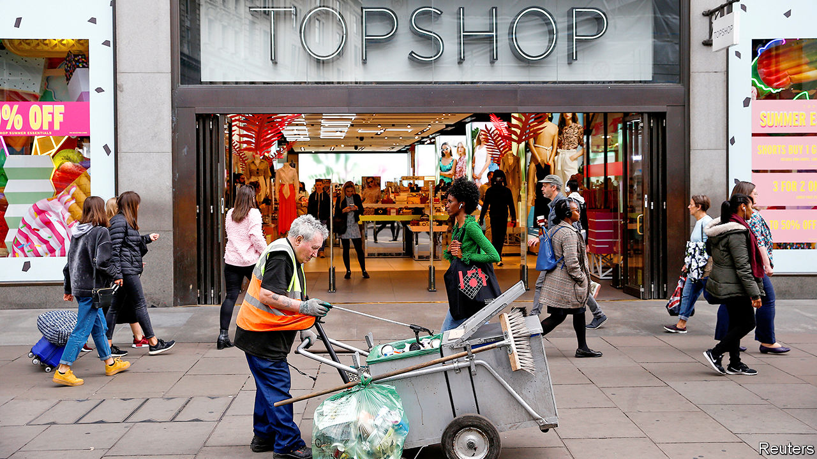

UNABLE TO COMPETE with the convenience of shopping online, the high street has been crumbling for years; and the covid-19 pandemic has accelerated the trend. Arcadia, a retailing conglomerate, announced that it would enter administration on November 30th. The next day Debenhams, a 207-year-old department store chain, which has been in administration since April, said it would start winding down its business. Some 25,000 jobs are at risk across the two companies. The real estate they occupy, some 15.5m square feet according to the Local Data Company, a research firm, risks falling fallow.

The retailing business employs 3m people and occupies vast swathes of property. The proportion of shopping done online has increased from 20% before the pandemic to 27% today, according to data compiled by the Royal Society for Arts. Whereas jobs in hospitality and leisure are likely to return as the virus subsides, the changes in retail are “a longer-term adjustment and the jobs won’t bounce back”, reckons Hannah Slaughter of the Resolution Foundation, a think-tank.

The full effects of the covid shock to retail are likely to arrive next summer. By then the government’s job-retention scheme, and its holiday on business rates, a commercial-property tax paid to local authorities, will have run out. The truth will be writ in retailers’ quarterly filings, which lag by three months. It will almost certainly mean a sharp rise in the number of unemployed retail workers, and the number of unoccupied commercial premises in town centres. Ms Slaughter notes that the long decline of retail over the past decade has been slow enough to manage itself from a policy perspective. The pandemic’s acceleration may require government help to minimise the pain.

Retail workers who lose their jobs as a result of covid-19—the British Retailers Consortium reckons they will number a quarter of a million by the summer—are more likely to find work in other sectors, such as care, which is short of labour. Ms Slaughter suggests that government work-coaches might focus more on this reallocation than they usually do.

Empty shops may be a harder problem to solve. A loosening of planning laws may encourage the repurposing of vacated shops for a trendier and more diverse range of businesses and allow a mix of retail and residential to revive town centres. But the results of an older retail bankruptcy suggest caution. A quarter of the property left empty by British Home Stores, which went bust in 2016, is still empty today. In the premises that have new tenants, the majority are other retailers paying knockdown rents, according to Ronald Nyakairu of the Local Data Company. In a few places, such as London, have they found new uses: one in Putney has become a swanky block of flats, while one on Oxford Street is an indoor golf course.

But for depressed town centres, left behind in myriad other ways, the hipsterfication of the cavernous corpses of shopping spaces looks an empty promise. Bringing vibrancy to those areas will be far more complicated. And for the retail workers there who have lost their jobs? A position at an Amazon logistics warehouse beckons. Those are being built apace.■

Editor’s note: Some of our covid-19 coverage is free for readers of The Economist Today, our daily [newsletter](https://my.economist.com/user#newsletter). For more stories and our pandemic tracker, see our [hub](https://www.economist.com/news/2020/03/11/the-economists-coverage-of-the-coronavirus)

This article was downloaded by calibre from <https://www.economist.com/britain/2020/12/03/the-fates-of-arcadia-and-debenhams-point-to-retails-huge-problem>

|  |  |  |  |
| --- | --- | --- | --- |
| Previous | Articles | Sections | Next |

|  |  |  |  |
| --- | --- | --- | --- |
| Previous | Articles | Sections | Next |

#### Bagehot

# Introducing Dan Rosenfield, Boris Johnson’s organisation man

The prime minister’s new chief of staff is the antithesis of Dominic Cummings

Dec 5th 2020 |

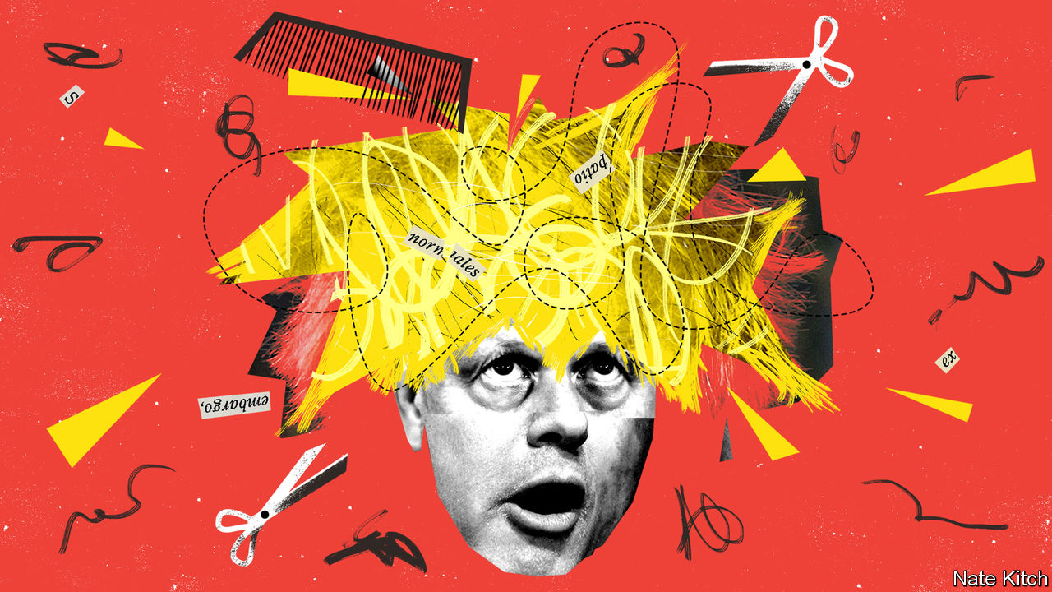

THE FIRST months of Boris Johnson’s tenure as mayor of London, back in 2008, were, by common consent, a mess. Projects fizzled. Senior aides flounced. Chaos reigned. Then “bungling Boris”, as the newspapers dubbed him, appointed a talented chief of staff. The self-effacing but effective Simon Milton brought order to chaos and turned dither into decisiveness. Mr Johnson became Britain’s most popular Tory and was re-elected by a landslide.

His first year in Downing Street recalls those early days in the mayor’s office. A slow response to the outbreak of covid-19 may have doubled the death rate; clumsy handling of the purchase of personal protective equipment left front-line workers vulnerable and led to dodgy deals to get hold of the stuff; faffing about exams generated confusion and anxiety. The angry departure of Dominic Cummings, Mr Johnson’s former chief adviser, and his Brexiteer acolytes left Downing Street shell-shocked. Party discipline has collapsed. On December 1st 53 Tory MPs voted against the government’s tiered-lockdown system and 16 abstained, the biggest revolt since Mr Johnson became prime minister.

But his premiership may be about to undergo a transformation, for he may have found himself a new Simon Milton. Dan Rosenfield is due to take over as his chief of staff on January 1st. In a political world in which almost nobody agrees on anything, almost everybody has a good word for Mr Rosenfield.

The new chief of staff’s most obvious qualification is that he is the antithesis of Mr Cummings. Mr Rosenfield is a peacemaker where Mr Cummings is a warmonger, an organiser where Mr Cummings is an ideas man, a smooth operator where Mr Cummings is spiky. Mr Cummings wanted to blow up the British establishment. Mr Rosenfield personifies it.

He spent more than ten years in the Treasury, the engine room of the British government, eventually serving as principal private secretary to both Labour’s Alistair Darling and the Conservatives’ George Osborne. He also has extensive experience in business. He left the Treasury to work as an investment banker and five years later moved to Hakluyt, a posh corporate-advisory firm with close links to the secret service, whose chairman, Paul Deighton, is also chairman of The Economist Group. Some Tories worry that, unlike two of his recent predecessors, Gavin Barwell and Nick Timothy, he is a neophyte when it comes to the ruling party’s internal machinations. But for a man with sensitive political antennae, which Mr Rosenfield clearly has, a certain distance from the warring Conservative tribes may be an advantage.

Mr Rosenfield has two qualities that his boss conspicuously lacks. As his success at Hakluyt suggests, he is a master of getting things done rather than generating ideas or spinning stories: the company expects its people to complete projects, not just to act as rainmakers. He is also steeped in economics and business. Mr Johnson’s indifference to economics puts him at a disadvantage in arguments with the Treasury, let alone in policymaking. His poor relations with business could also become a problem if Sir Keir Starmer succeeds in mending fences between Labour and the private sector. Mr Rosenfield is business-friendly to a fault.

The appointment of a new chief of staff is the centrepiece of a wide-ranging shake-up of Emperor Boris’s Praetorian Guard. The congenitally narcissistic media has fixated on the appointment of Allegra Stratton, one of its own, as head of press relations, but more interesting changes have taken place behind the scenes. Mr Johnson has appointed Neil O’Brien to run the Policy Review Board, the party’s internal think-tank. A northern MP, Brexiteer and former Treasury adviser, Mr O’Brien is a fount of ideas on what “levelling up” means in practice. Mr Johnson is also working hard to repair the damage Mr Cummings did to his relations with the parliamentary party. There are even rumours of a plan to move the Whips’ Office from Parliament back to Downing Street (Number 12, where it used to be, not Number 10). Most important of all, a big cabinet reshuffle is in the works.

Mr Rosenfield’s first day in the job could be difficult if, as looks quite possible, Britain leaves the European Union without a deal. Even if there is one, he will be wading into quicksand. The prime minister’s biggest problems are political rather than purely organisational. Brexit was always a bundle of contradictions held together by a shared hostility to the EU and a vague optimism about freedom. Mr Johnson’s taste for waffle and fudge made him the perfect leader of the movement as long as it was about protest. With the end of the transition period he will have to focus on what he likes least: making difficult decisions and tough trade-offs.

Party management is also becoming harder, as the dysmorphic Tory party completes its transition from the natural party of government into a British version of the Taliban, dominated by a bunch of right-wing revolutionaries and in a permanent state of fury and factitiousness. It was always going to be tricky for a prime minister who made his career by rebelling against the leadership to impose party discipline. The party’s disintegration into factions that reflect warring ideological and regional priorities has made it almost impossible: the One Nation group of liberal Tories, the 109 Group of new MPs (oddly named, since there are 66 of them), the Northern Research Group, the Covid Recovery Group and the grandmother of them all, the European Research Group of Eurosceptics. Many of the last lot are battle-hardened, addicted to revolt and already convinced that the Downing Street reset is an establishment plot to neuter Brexit and return to business as usual.

For all that, better organisation can improve things. Much of the mess that the government has made of the pandemic has been the result of poor management. And despite that, and despite the infighting, it is still level-pegging with Labour in the opinion polls. Imagine how things might look with a new team in Downing Street, a ruthless reshuffle and mass vaccinations under way. Don’t bet against another Miltonic resurrection. ■

This article was downloaded by calibre from <https://www.economist.com/britain/2020/12/05/introducing-dan-rosenfield-boris-johnsons-organisation-man>

|  |  |  |  |
| --- | --- | --- | --- |
| Previous | Articles | Sections | Next |

|  |  |  |
| --- | --- | --- |
| Britain | Sections | Business |

International

The modern household: Nuclear retreat

.

|  |  |  |
| --- | --- | --- |
| Britain | Sections | Business |

|  |  |  |  |
| --- | --- | --- | --- |
|  | Articles | Sections | Next |

#### Nuclear retreat

# The pandemic may be encouraging people to live in larger groups

In lockdown people see the appeal of housemates

Dec 5th 2020 |



Editor’s note: Some of our covid-19 coverage is free for readers of The Economist Today, our daily [newsletter](https://my.economist.com/user#newsletter). For more stories and our pandemic tracker, see our [hub](https://www.economist.com/news/2020/03/11/the-economists-coverage-of-the-coronavirus)

IN MARCH, WHEN Britain went into lockdown for the first time, Andrew Davidson, a 69-year-old retiree who lives alone, was in the middle of renovating his house in the small town of Leamington Spa. The kitchen was a building site so he accepted an offer from his sister to move in with her and her husband in Birmingham for a couple of weeks. Before leaving he asked the builder to put in temporary kitchen surfaces so he could move back in if they couldn’t stand living together. Mr Davidson ended up staying away for nine weeks. It was “absolutely brilliant”, he says.

In the mornings he would go for a walk with his sister or brother-in-law, or they would do gardening. In the afternoons they retreated to their own spaces to work on their own hobbies: German lessons via Zoom, Spanish study, and textile printing. They ate dinner together, sharing cooking and all-important baking duties. “Living together was a bit of a revelation,” says Mr Davidson. “I was quite sorry to move out.” He says after his experience he would consider moving in with other people on a permanent basis in the future.

As lockdowns have limited socialising beyond cohabitants or small groups known as “pods” or “bubbles”, stories abound of people moving in with others to lessen isolation or share housework. In fact, the pandemic may merely have accelerated an existing trend. More and more, people in the rich world are once again choosing to live together.

In Britain households where couples share with at least one other adult were the fastest-growing type in the two decades to 2019. In Canada 6% of the population lived in multigenerational households by 2016, and it was the fastest-growing type of living. By the same year a fifth of Australia’s 24.5m people were living with others from outside their immediate family, a 42% increase on 15 years earlier.

Such enthusiasm runs counter to Western notions of individual freedom and privacy. Fights with family or flatmates are the stuff of common lore. But it is single-family households that are the outlier in the broad sweep of human history. From hunter-gatherers to workhouses, people lived in big groups, often including non-relatives, pooling resources such as food and sharing tasks such as cooking and child care. It is only after industrialisation, when work moved outside the home, that people in the Western world started to live in nuclear families.

In much of the world living in bigger family groups never stopped. Almost two thirds of households are extended family ones in Senegal, for example. Extended families provide a safety net where the state does not, pooling cash to pay medical bills and letting jobless nephews eat from the communal pot. Even in the West, the perception that the two-adults-two-kids family is the norm is outdated. In America the share of households made up of married couples with children halved between 1970 and 2019. People are marrying less and later. Marriages are less likely than they were to last until death.

Yet the splitting of the nuclear family has taken its time to create an explosion of new household types. Instead, much of the West has seen a dramatic rise in single-person households. From France to Japan, they make up over a third of the total number. In Germany they account for 40% of the total, in Finland 41%. Communal living, at least beyond student halls, retirement villages or monasteries, is “often seen negatively or as a cult”, says Irene Pereyra, a designer who is running a project on communal living with IKEA, a Swedish furniture firm.

Indeed, that is the appeal to some people. David and Kim Gotterson, an Australian couple in their 60s who lived for many years in communes, said they were rebelling against the materialistic society of their post-war-generation parents. “We wanted a pure, more natural way to live,” says Mr Gotterson. Environmentalists note that sharing homes is friendlier on the environment than having separate ones. Since the 1970s some feminists have emphasised the benefits for women of living with other women.

## Communal infiltration

Although some choose to share out of belief, recent interest in shared housing has been sparked in large part by economic pressure. In Britain, where NIMBYism makes it extremely difficult to build new homes, the average house costs more than eight times the average salary, up from four times in the mid-1990s. Homes are less affordable for single women, who earn less than men. The number of older divorcees who live alone has gone up. In the absence of new construction, this squeezes the supply for younger people, who are less wealthy. “As more people lose their jobs [because of the pandemic] or have their pay or their hours cut, sharing a household with more people is a way to pay the bills,” says Bella DePaulo of the University of California, Santa Barbara, the author of “How We Live Now”.

Companies have jumped on this opportunity. The Collective, a British outfit, runs three co-living buildings, one in New York and two in London. Its “members”, whose average tenancy is nine months, live in studio flats but share lounges, gyms and a roster of events from cocktail-mixing to running clubs. The firm has another 9,000 units in development.

Although urban buildings run by the likes of The Collective are aimed mainly at young, single professionals, the types of people seeking to live this way are growing more diverse. The Collective houses people aged 18 to 67 years old (the average is 30). A survey by Build Asset Management, a British firm that runs serviced accommodation, said that in the year to June 2020 it saw a 136% rise in inquiries about shared rental accommodation from couples. Kin, an American company, last year opened two buildings in New York designed for families rather than singles or couples. Would-be residents can choose an apartment with up to four bedrooms and access to communal facilities and services, including a play area and nannies.

The most experimental housing today involves multiple generations of unrelated people who did not get a say on whom they lived with. Perhaps unsurprisingly it is found in Scandinavia. Some 60% of the residents of the 51 apartments in Sällbo, a public-housing project in the Swedish town of Helsingborg, are over 70. The other 40% are young people, half of them refugees. Residents must pass an interview to get into the community, and sign a contract to spend two hours per week socialising with neighbours. This could mean sitting in a shared lounge reading a book or doing shopping for one of the older members. The project is to run for two years. If it is judged successful, tenants will be given permanent homes.

Crossing multigenerational boundaries has social benefits, says Dragana Curovic, the manager. The young, especially the newcomers, learn from the older people, who in turn appreciate the young people’s help with practical things, she says. Isolation is unhealthy. One metastudy reported that people without strong social connections have a 50% higher chance of dying early—equivalent to smoking 15 cigarettes a day. A Swedish study of people over 75 years old found those with a variety of happy connections with friends and family had a lower risk of dementia.

Many other aspects of life can benefit from communal housing, too. Parents of small children find it easier to go out to work if they can leave their offspring at home with other friendly adults. Chloe and Alex Wolff, a couple in their 30s, and their baby son moved in with Alex’s parents for seven months from March to September. Ms Wolff says she would not have been able to go back to work six months after giving birth, had she not been living with her in-laws. At that point all the nearby nurseries were shut because of covid-19.



Ben Brock-Johnson, a 40-year-old journalist, moved from New York to live in Pioneer Valley, a community of 32 homes in rural Massachusetts, with his wife and their now five-year-old twins. The community has shared gardens, as well as a large communal dining area and an events space. He says it is “like having 100 parents for your kids”. There are people around—including his parents, who live on the same estate—who can play with them, baby-sit them and just generally look out for them. His family, he reckons, have a much better work-life balance for it.

The disadvantages of sharing can be mitigated by design. Grace Kim, a Seattle-based architect who lives with eight other families in a building designed by her and her husband, says her development balances community and privacy—most people’s concern about living communally. “You can see into some people’s kitchens but not their living rooms,” she says.

Decision-making can be slow. You have to work with neighbours even if you do not like them. You cannot simply ignore them. However, as in the workplace, people who have to get things done together often put aside their differences and get on with the job. Communal living might, conceivably, help bring divided societies together, at least a little.

## Fallout shelter

Few governments promote it, though. Landlords in Britain need a special licence to let single homes to multiple families. In New York individually rented apartments with shared bathrooms are banned (to discourage brothels). During the pandemic governments have warned of the dangers of big households: sociable youngsters may bring the virus home to their grandparents. Multigenerational living may partly explain why ethnic minorities have been so hard-hit by covid-19 in Britain.

Proponents of communal living say it has made lockdowns more bearable. Ms Kim’s community stopped having 40-person communal meals. Instead, it set up pods of two to three families who could dine in well-ventilated shared spaces. In Sällbo, younger residents have gone out to shop for older ones who are shielding, says Ms Curovic. Lisa Feardon, a doctor who worked long, arduous shifts, says returning to her home at The Collective in London was “a lifesaver”. In a normal rented flat she would have “just come home and collapsed doing nothing,” she says. “But as everything is under one roof here I was able to still have some sort of work-life balance.”

Mr Davidson, whose house is now renovated, says while the pandemic continues he will be staying at his sister’s a couple of nights each week (in a support bubble). The pandemic has forced people apart. But for an increasing number, communal living offers a way to stay connected. ■

This article was downloaded by calibre from <https://www.economist.com/international/2020/12/05/the-pandemic-may-be-encouraging-people-to-live-in-larger-groups>

|  |  |  |  |
| --- | --- | --- | --- |
|  | Articles | Sections | Next |

|  |  |  |
| --- | --- | --- |
| International | Sections | Finance & economics |

Business

Health care and technology: The dawn of digital medicine

.

Pandemic gastronomy: Malls’ last stand

.

Carmaking: In the hot seat

.

Exchange-traded fiends: Boiling point

.

Business software: Get me some Slack

.

Chinese hoteliers: Hospitable climate

.

Stakeholderism: Swiss miss

.

Bartleby: Managing by Zooming around

.

Schumpeter: Feathering its own Nestlé

.

|  |  |  |
| --- | --- | --- |
| International | Sections | Finance & economics |

|  |  |  |  |
| --- | --- | --- | --- |
|  | Articles | Sections | Next |

#### Health care and technology

# The dawn of digital medicine

The pandemic is ushering in the next trillion-dollar industry

Dec 2nd 2020 | NEW YORK



LAST JANUARY Stephen Klasko, chief executive of Jefferson Health, which runs hospitals in Philadelphia, chatted to a bank boss. The financier told him that 20 years ago health care and banking were the only industries yet to embrace the consumer and digital revolutions. “Now”, Mr Klasko recalls him adding, “you are alone.”

The banker had a point. The McKinsey Global Institute, the in-house think-tank of the eponymous consultancy, reckons that when it comes to digitisation, health care has indeed lagged behind not just banking but travel, retail, carmaking and even packaged goods. Some 70% of American hospitals still fax and post patient records. The CEO of a big hospital in Madrid reports virtually no electronic record-sharing across Spain’s regions when the first wave of covid-19 washed over the country this spring.

By exposing such digital deficiencies, the pandemic is at last spurring change. Confronted with shutdowns and chaos, doctors have embraced digital communication and analytics that have been common in other industries for years. Patients are growing more comfortable with remote and computer-assisted diagnosis and treatment. And enterprising firms, from health-app startups and hospitals to insurers, pharmacies and tech giants such as Amazon, Apple and Google, are scrambling to provide such services.

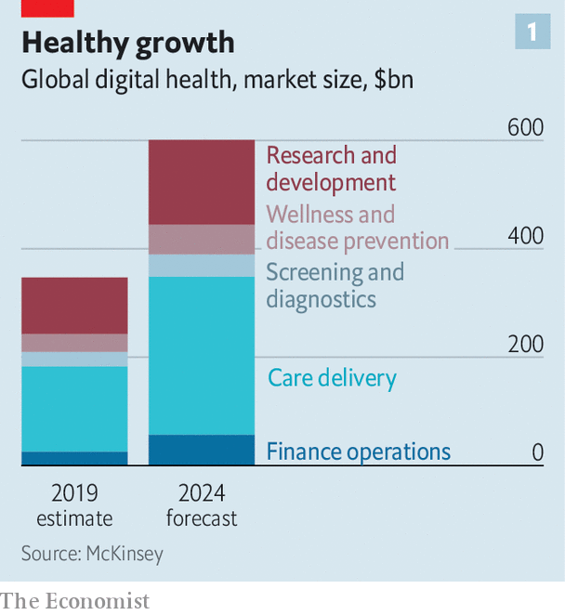

McKinsey estimates that global digital-health revenues—from telemedicine, online pharmacies, wearable devices and so on—will rise from $350bn last year to $600bn in 2024 (see chart 1). Swathes of America’s $3.6trn health-care market are in for a digital makeover. The same is happening in China, Europe and most other places where doctors ply their trade.

The groundwork for what looks poised to be the next trillion-dollar business has been accelerated by the pandemic. Money is pouring in. According to CB Insights, a research firm, a record $8.4bn of equity funding flowed into privately held digital-health darlings in the third quarter of 2020, more than double the amount a year ago (see chart 2). The industry’s unlisted “unicorns”, worth $1bn or more apiece, have a combined value of over $110bn, according to HolonIQ, a research firm. In September AmWell, a telemedic in which Google has invested $100m, raised $742m in an initial public offering (IPO); its market capitalisation is $6bn. On December 2nd JD Health, a digital pharmacy affiliated with JD.com, a Chinese online emporium, raked in $3.5bn in Hong Kong’s second-biggest IPO this year.



No wonder investors are giddy. Demand for digital medicine is surging. Doctolib, a French firm, says its video consultations in Europe have shot up this year from 1,000 to 100,000 a day. Ping An Good Doctor, a Chinese online health portal viewed by some as the choicest part of its insurer parent (see article), is expanding to South-East Asia in a joint venture with Grab, a Singaporean ride-hailing giant.

As with many technology fads, some of this will turn out to be hype. Sober analysts at Gartner, a research firm, pour cold water on exaggerated claims made by proponents of individualised “precision medicine” and medical artificial intelligence (AI). But even they admit there are reasons to think that not all the excitement is overblown.

Technologies such as sensors, cloud-computing and data analytics are becoming medical-grade just as the risk of contracting covid-19 in hospitals and clinics makes their adoption look more enticing than ever. Specialist firms like Livongo and Onduo make devices to monitor diabetes and other ailments continuously. A study by Stanford University found that nearly half of American doctors surveyed used such devices. Of that group, 71% regarded the data as medically useful. In June the Mayo Clinic, a prestigious non-profit hospital group, teamed up with a startup called Medically Home to provide “hospital-level care”, from infusions and imaging to rehabilitation, in patients’ bedrooms. Even the Apple Watch has been shown to predict a medical problem known as atrial fibrillation in a clinical trial.

## An Apple a day

Patients are keen. A study of some 16m American ones just reported in JAMA Internal Medicine, a journal, found that their use of telemedicine surged 30-fold between January and June. American consumers surveyed in May by Gartner were increasingly using internet and mobile apps for a variety of medical needs (see chart 3).

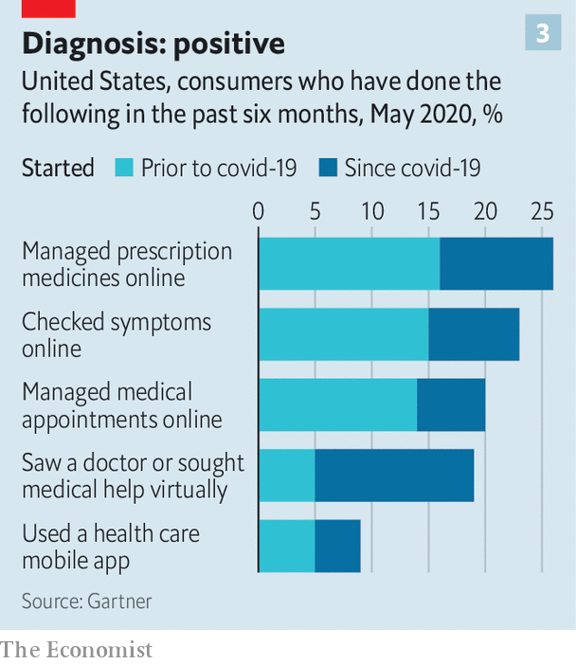

Critically, regulators around the world are pressing health-care providers to open up their siloed systems—a precondition for digital health to flourish. The EU is promoting an electronic standard for medical records. In August the Indian government unveiled a plan for a digital health identity with interoperability at its core. Kuantai Yeh of Qiming, a VC firm, says that China’s government, too, is trying to overcome resistance to electronic records from hospitals fearful of losing patients to rivals. Yidu Cloud, a big-data platform for hospitals, may already be the world’s largest health data set, thinks Lee Kai-fu of Sinovation Ventures, another VC firm.

Apple, with its reputation for protecting users’ privacy, is also championing a common standard. A combination of such efforts and regulatory pressure heralds “a new era” for digital medicine, thinks Aneesh Chopra, a former White House technology chief. Judy Faulkner, boss of Epic, a leading maker of software to manage electronic health records that Mr Chopra has long urged to be more open, declares she is all for it; 40% of the data managed by her firm are already shared with non-customers, she says. Kris Joshi, who runs Change Heathcare, which handles over $1.5trn in American medical-insurance claims a year, sees more interoperability, at least between businesses.

All this is helping medicine evolve from “a clinical science supported by data to a data science supported by clinicians”, argues Pamela Spence of EY, a consultancy. Does this make health care big tech’s for the taking? Amazon wants Alexa, its digital assistant, to be able (with your permission) to analyse your cough and tell you if it is croupy or covidy. In November the online giant, which already sells just about everything else, launched a digital pharmacy to take on America’s drug-distribution coterie of pharma firms, middlemen and retailers. AliHealth, a division of Alibaba, China’s e-commerce champion, is disrupting its home pharmacy market. Its revenues leapt by 74% in the six months to September, year on year, to $1.1bn. Apple has its watch and nearly 50,000 iPhone health apps. Google’s parent company, Alphabet, has Verily, a life-sciences division.

Tech giants’ earlier forays into health care flopped, argues Shubham Singhal of McKinsey, because they had gone it alone. Medicine is a regulatory minefield with powerful incumbents where big tech’s business models, particularly the ad-supported sort, are not a natural fit. But the pandemic has also highlighted that existing providers’ snazzy hardware and pricey services too seldom genuinely improve health outcomes. If the new generation of digital technologies is to thrive it must “improve health, not increase costs”, thinks Vivian Lee of Verily. Her firm is moving away from fee-for-service to risk-based contracts that pay out when outcomes improve (eg, if diabetics get blood sugar under control or more people get eye exams).

That points to a hybrid future where Silicon Valley works more closely with traditional health-care firms. Epic is using voice-recognition software from Nuance, a startup, to enable doctors to send notes to outside specialists; it has also teamed up with Lyft, a ride-hailing firm, to ferry patients to hospitals. Siemens Healthineers, a big German health-tech firm, is working with Geisinger, an American hospital chain, to expand remote patient monitoring. Patients of India’s Apollo Hospitals can use an app to get drug refills, tele-consultations and remote diagnoses—and even secure a medical loan through Apollo’s partnership with HDFC Bank.

Dr Klasko, keen to prove the banker wrong, is embracing the hybrid approach with gusto. “You must have partnerships with providers, not just hundreds of unconnected apps.” He has brought bright sparks from General Catalyst, a VC firm that made early bets on many digital-health startups including Livongo, to work alongside his innovation team in Philadelphia. “Moving fast and breaking things does not work well in health care,” observes Hemant Taneja of General Catalyst. But nor does standing still. ■

Correction (December 3rd 2020): A previous version of this article referred to Change Healthcare as Change.

This article was downloaded by calibre from <https://www.economist.com/business/2020/12/02/the-dawn-of-digital-medicine>

|  |  |  |  |
| --- | --- | --- | --- |
|  | Articles | Sections | Next |

|  |  |  |  |
| --- | --- | --- | --- |
| Previous | Articles | Sections | Next |

#### Malls’ last stand

# The surprising resilience of American restaurant chains

The secrets behind successful pandemic gastronomy

Dec 3rd 2020 | NEW YORK



COVID-19 HAS been brutal for big tenants of American shopping centres, such as clothing stores and cinemas. Not so for the casual eateries that surround these outlets. Many of America’s sit-down dining chains are on track to emerge stronger after two quarters of pandemic-driven innovation. The final hurdle is the winter.

Independent restaurants were early victims of lockdowns. Chewing, chatter and low air-flow made their busy floors prime candidates for super-spreader events. As early as March, state and local regulations shut down dining halls and began to whittle down the ranks of sit-down eateries. Yelp, a popular review website, reported more than 32,000 restaurant closures between March and September; 61% of these were predicted to be permanent.

Larger chains fared better. With the credit lines and corporate infrastructure to roll out new delivery methods and safety measures, they steadily stemmed losses. Plenty have now recovered or exceeded their pre-pandemic valuations.

New off-premises business has helped. Texas Roadhouse, a steakhouse chain, introduced to-go “family packs” and an online butcher selling meat to grill at home. This tided it over as it installed protective equipment and slowly reopened dining rooms. In October it reported a year-on-year increase in same-store sales.

Other chains dealt with a fall-off in diners by propping up profit margins. Darden Restaurants, the parent company of Olive Garden, slashed promotional spending and simplified menus to reduce waste and costs. Olive Garden’s margins improved even as a lack of clients in flagship locations depressed overall sales. The company felt sufficiently self-assured after the second quarter to reinstate its dividend.

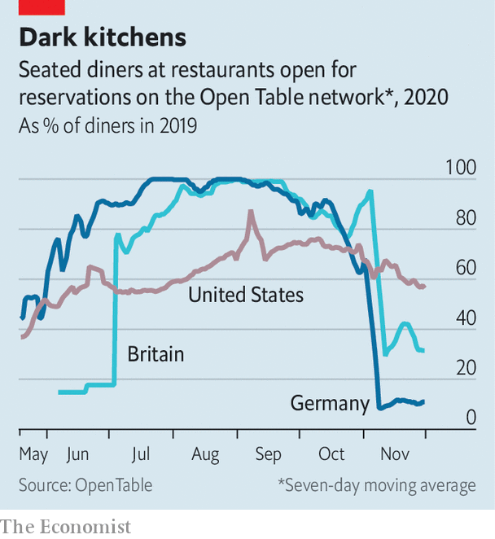

America’s restaurant chains are outperforming international rivals, says Dennis Geiger of UBS, a bank. American consumers have steadily returned to fill seats as officials lift restrictions (see chart). In other markets stricter regulations and shyer consumers are holding back recovery. Hong Kong’s dining sector has yet to turn around from its spring collapse; receipts fell to an all-time low in the third quarter and even fast-food purchases fell by 23% relative to last year. The share price of Vapiano, a big German chain, stands at less than a tenth of its pre-pandemic level. Darden’s is back to where it was in January. Texas Roadhouse’s is up by a third.

Winter will test the strength of American chains once more, as lockdowns loom to staunch the flood of new covid cases. At least chains with a national presence think that even as northern locations grow frosty, southern states will be opening patios. And data from Yelp show that interest in outdoor dining is breaking records: it was up tenfold in early October, year on year.■

Editor’s note: Some of our covid-19 coverage is free for readers of The Economist Today, our daily [newsletter](https://my.economist.com/user#newsletter). For more stories and our pandemic tracker, see our [hub](https://www.economist.com/news/2020/03/11/the-economists-coverage-of-the-coronavirus)

This article was downloaded by calibre from <https://www.economist.com/business/2020/12/03/the-surprising-resilience-of-american-restaurant-chains>

|  |  |  |  |
| --- | --- | --- | --- |
| Previous | Articles | Sections | Next |

|  |  |  |  |
| --- | --- | --- | --- |
| Previous | Articles | Sections | Next |

#### In the hot seat

# Volkswagen’s boss takes on the unions

The fight may cost him his job

Dec 3rd 2020 | BERLIN

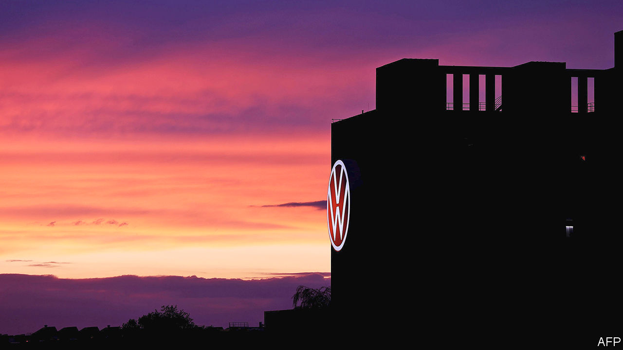

FIVE YEARS ago the Porsche and Piëch families, who control just over half of Volkswagen’s voting rights, poached Herbert Diess from BMW, a posh Bavarian carmaker. He was hired to run VW, the biggest by far of the the group’s 12 marques, because of his reputation as a cost-cutter and hard-nosed manager who would not shy away from taking on the unions. Untainted by VW’s “Dieselgate” emissions scandal, he made a good start by improving its poor profit margins. In 2018 he was rewarded with the job of running the entire group.

Only two years later the dynamic Bavarian’s job is on the line after a series of clashes with organised labour. In June Mr Diess almost got the boot because of a dust-up with the supervisory board over a leak of confidential information about the group’s software failings. He alleged it might have come from the board’s union representatives. After that he was relieved of his job as boss of vw (which he had kept).

This time the clash is more serious still. On December 1st the executive committee of the group’s 20-member supervisory board, the non-executive conclave that holds management to account, met to discuss his request for an extension of his contract. The current one runs to 2023, so extending it now would constitute a vote of confidence. No decision has been made public. The whole board will convene on December 10th.

Mr Diess demands unequivocal backing from the board so that he can fulfil his mission to cut vw’s bloated workforce and boost profitability (which is lagging far behind Audi and Porsche, the stars of the group). He wants to fill the soon-to-be-vacant job of chief financial officer with an ally, perhaps Arno Antlitz, Audi’s finance chief. He also intends to make his confidant the group’s head of procurement. The two roles are central to his drive to boost efficiency at VW, which recently approved a €150bn ($181bn) investment plan.

Bernd Osterloh, who heads the works council and also sits on the supervisory board’s executive committee, voted down Mr Antlitz and other candidates for the two jobs suggested by Mr Diess. That provoked Mr Diess to ask the board for support. Stefan Weil is the state premier of Lower Saxony, which, as the owner of 20% of VW shares, is entitled to two seats on the supervisory board. The Volkswagen law from 1960, which limits the voting rights of any shareholder to 20%, gives Lower Saxony a veto on any major decision. To protect investment and jobs in the region, representatives of the Land invariably back the board’s ten labour representatives, which means that organised labour tends to call the shots on VW’s board.

“Osterloh and Weil will try to bring down Diess,” predicts Ferdinand Dudenhöffer of the Centre for Automotive Research, a think-tank. Mr Diess, who can be gruff, clashed with Mr Osterloh soon after he arrived from BMW—and regularly since then. On November 28th he published a manifesto on how to transform VW into a digital company focused on electric vehicles. “When I started in Wolfsburg, I was determined to change the Volkswagen system,” he wrote of his early days at VW’s headquarters. Mr Diess wanted to “break down antiquated structures, and make the company more agile and modern”. He succeeded in some areas, he said, but not everywhere.

“Lower Saxony should give up its voting rights,” thinks Mr Dudenhöffer. Otherwise VW will remain constrained by its “provincial corset”. Mr Dudenhöffer believes that Dieselgate would not have happened without VW’s skewed corporate governance. With unions refusing to allow lay-offs, he explains, cheating may have seemed the only way to increase its profit margins. Toyota sells almost the same number of cars worldwide as VW with roughly two-fifths of the workforce.

Bernstein, a research firm, published an open letter to board members in November urging them either to back Mr Diess or to sack him. Corporate Germany’s traditional model of co-determination has gone too far at vw, the letter says. It is supposed to help bosses and labour to work together rather than fight each other at every turn. Even if the board backs Mr Diess this time, the infighting will soon resume. It may be time to consider repealing the counterproductive Volkswagen law.■

This article was downloaded by calibre from <https://www.economist.com/business/2020/12/03/volkswagens-boss-takes-on-the-unions>

|  |  |  |  |
| --- | --- | --- | --- |
| Previous | Articles | Sections | Next |

|  |  |  |  |
| --- | --- | --- | --- |
| Previous | Articles | Sections | Next |

#### Exchange-traded fiends

# Congress wants to boot Chinese firms from American exchanges

A spat over Chinese firms listed in America

Dec 3rd 2020 |

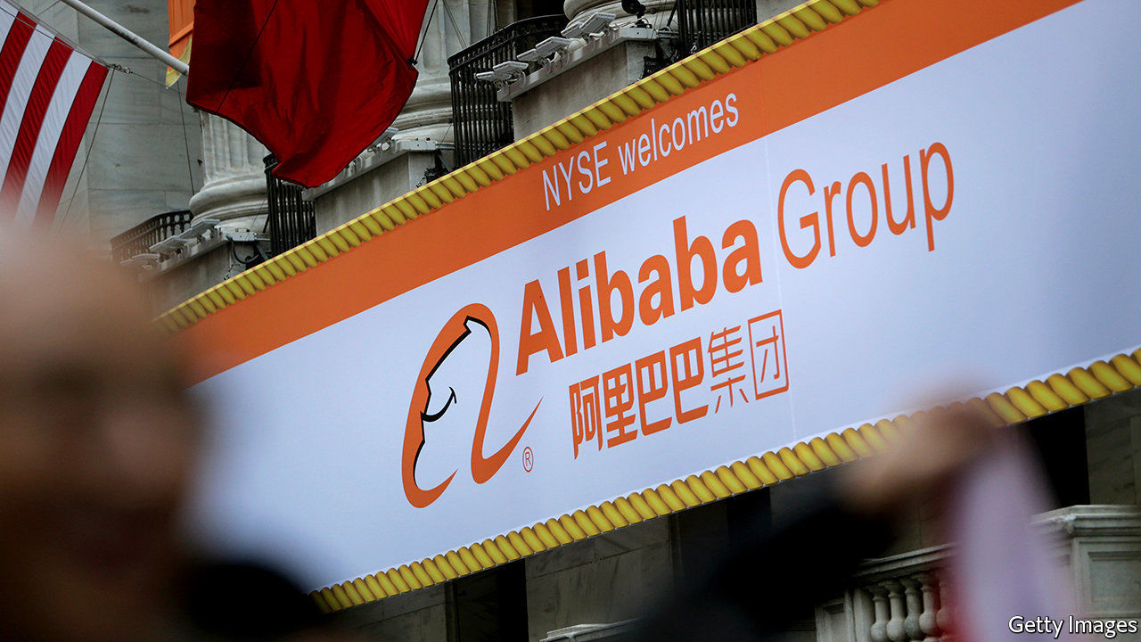

FOR 18 YEARS American regulators have implored Beijing to let them inspect the China-based auditors of Chinese companies listed on America’s stock exchanges. Dream on, China’s Communist regime responded, citing sovereignty and national security. On December 2nd Congress had had enough. The House of Representatives passed a bill that would boot offending firms off American bourses if their auditors fail to comply with regulators’ information requests for three years running. Since it had earlier sailed through the Senate by 100 votes to nil, it can expect a presidential signature.

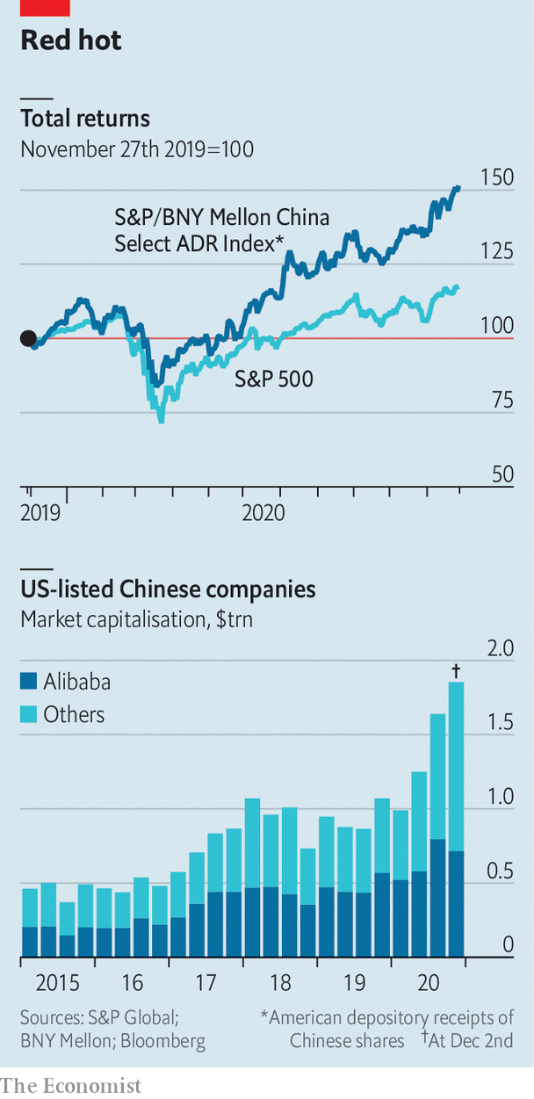

This would put Chinese businesses worth a combined $2trn at eventual risk of expulsion, including Alibaba, a New York-listed internet titan (see chart). It would make it harder for Americans to get exposure to China through American exchanges. Those hungry for juicy Chinese stocks might end up buying them abroad instead, through channels over which Washington exerts no control.

This article was downloaded by calibre from <https://www.economist.com/business/2020/12/03/congress-wants-to-boot-chinese-firms-from-american-exchanges>

|  |  |  |  |
| --- | --- | --- | --- |
| Previous | Articles | Sections | Next |

|  |  |  |  |
| --- | --- | --- | --- |
| Previous | Articles | Sections | Next |

#### Business software

# Salesforce gets some Slack

Marc Benioff has his sights set on tech’s big league

Dec 5th 2020 |

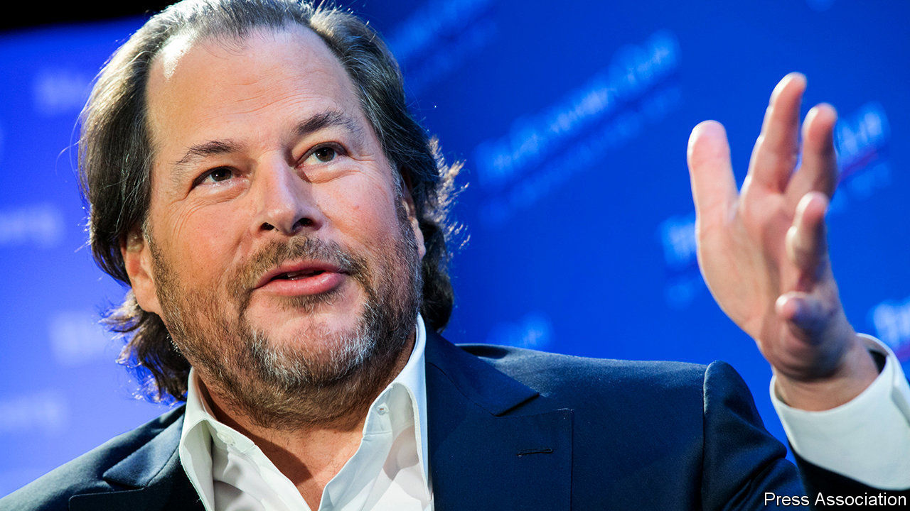

MARC BENIOFF got the idea for the “ohana” corporate culture on a sabbatical in Hawaii. The term refers to a network of families bound together. He likes to think of Salesforce, the world’s third-biggest software firm, which he founded and runs, as just such a network. On December 1st Mr Benioff welcomed Slack, an instant-messaging tool, to his ohana. The $27.7bn deal is one of the biggest ever in the software industry.

Like many family alliances the tie-up is partly about power and feuds. Slack’s product has a cultlike following, which Salesforce wants to harness to build a tech platform that sells digital tools that no firm can do without. Stewart Butterfield, Slack’s co-founder, hailed it (hyperbolically) as “the most strategic combination in the history of software”. The feud is with Microsoft, whose advances Slack spurned four years ago. The deal makes Salesforce a far more formidable challenger to the giant.

Mr Benioff may be best known to the public for championing corporate “purpose” (and owning Time magazine). But in his own industry he wins kudos for disruptive innovation. In the 2000s the young Salesforce basically invented software-as-a-service (SaaS)—accessing programs remotely rather than installing them on office computers—particularly for managing customer relationships. Microsoft, Oracle, SAP and others had to follow suit.

The explosive growth of SaaS has propelled Salesforce to ever greater heights. And to greater breadth: since 2016 it has spent over $25bn snapping up over a dozen firms to boost its computing chops. It bought Tableau, a data-analytics platform, and MuleSoft, which helps firms connect legacy IT systems to the cloud.

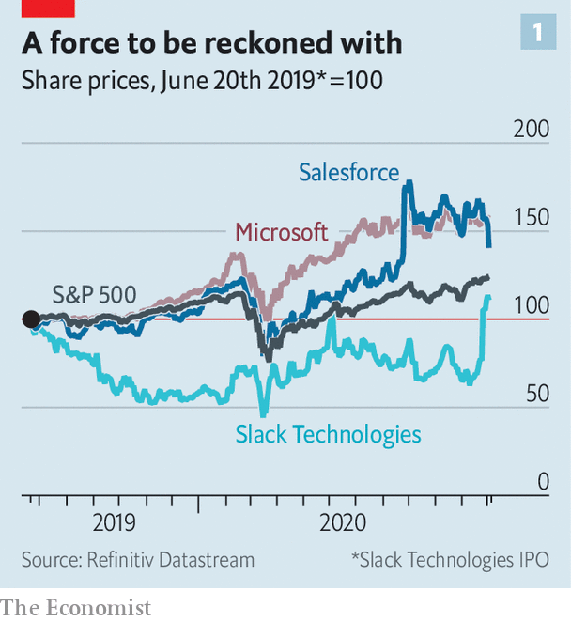

Then came the pandemic. A boom in tech stocks lifted Salesforce’s market value from $144bn to $225bn this year. Slack, whose share price has lagged behind those of Zoom and other enablers of remote work, suddenly looked affordable. Mr Benioff is paying with a mix of cash and Salesforce stock. His firm’s valuation is still well behind Microsoft’s $1.6trn. But it may at last have a shot at tech’s top table. It already rules in customer-relationship software and thrives in other areas of business software, especially since acquiring Tableau. Aaron Levie, boss of Box, a cloud firm, describes Slack as “another dot on the graph” that plots Salesforce’s rise to become the world’s number-two business-software company (behind Microsoft). Perhaps, Mr Levie muses, “even the largest”.

Such sentiments explain why for Microsoft the Slack deal is a red rag. Slack got the giant’s attention a few years ago when Mr Butterfield promised to wipe out email, which would threaten Outlook, Microsoft’s popular inbox, and its email server, Exchange. “If you are going to come at the king, you’d better not miss,” quips Charles Fitzgerald, a former executive at Microsoft who is now an angel investor. Back then Mr Butterfield did miss—and Microsoft shot back with a new product, Teams, combining messaging with videoconferencing and other functions. Slack has launched an antitrust complaint against it for offering Teams free of charge in its Office bundle, together with its popular word processor and Excel spreadsheets.

Teams is a big reason why Mr Butterfield is in an ohana-ish mood. Like Zoom, it has videoconferencing—and far more active users than Slack, which explains the latter’s lacklustre stockmarket performance. Salesforce will invest to reinvigorate it, presumably adding more video-meeting capability. Its sales machine will push Slack beyond early adopters into the corporate mainstream.

That will intensify Salesforce’s rivalry with Microsoft, with which it will compete in three main areas. With Slack it will directly take on Office, now that Teams has been folded into it. Slack also offers a gateway to 2,400 software tools, mostly created by independent companies, that compete with other Microsoft products. Salesforce and Slack could bundle all this software into a convenient alternative to Microsoft. Second, Salesforce competes with the giant in customer-relationship management, where it plans to make Slack the user interface, and other business functions.

Then there is the bigger battle over platforms. Both Salesforce and Microsoft aim to give businesspeople who do not themselves write software the tools to build customised programs—“with clicks not code”, as Salesforce puts it. Salesforce’s Developer 360 is punier than Microsoft’s Power Platform but is improving, thanks to MuleSoft and Einstein, a set of artificial-intelligence services. Slack could be a “Trojan horse” to hook customers of Salesforce’s own clients on more of the company’s applications, says George Gilbert of TechAlpha Partners, a consultancy.

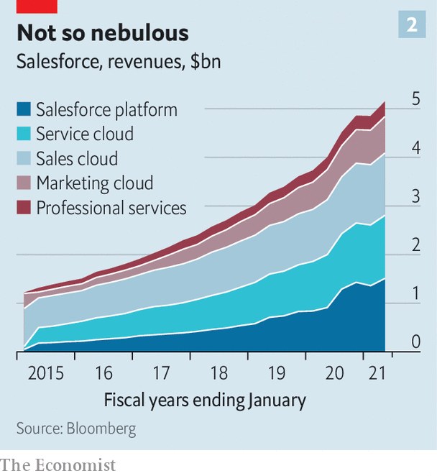

Success is not in the bag for Salesforce. Mr Benioff may fail to turn his vision into reality. Even if Slack gets its video act together it would be late to videoconferencing, which has matured rapidly during the pandemic. Most large corporate clients already use Zoom, Teams or Cisco’s Webex software. And Salesforce might mistakenly end up sacrificing Slack’s growth while trying to bolster its own businesses.

Moreover, Slack is not in and of itself enough to make Salesforce into a genuine rival to Microsoft. Mr Benioff would need to build (or buy) capabilities in document storage, cyber-security and more, reckons Mark Moerdler of Bernstein, a broker.

Wall Street is already wary of Salesforce’s big acquisitions; the firm’s share price dipped when news of the Slack deal surfaced. Still, SaaS holds vast potential, as Microsoft shareholders know well. And, as Mr Butterfield noted on the deal’s announcement, Mr Benioff has already started one revolution. Betting against this ohana is not for the faint-hearted.■

This article was downloaded by calibre from <https://www.economist.com/business/2020/12/05/salesforce-gets-some-slack>

|  |  |  |  |
| --- | --- | --- | --- |
| Previous | Articles | Sections | Next |

|  |  |  |  |
| --- | --- | --- | --- |
| Previous | Articles | Sections | Next |

#### Accommodating climate

# How China’s Jin Jiang and Huazhu put Marriott and Hilton to shame

Two Chinese hospitality groups thrive as Western rivals struggle

Dec 3rd 2020 | BEIJING

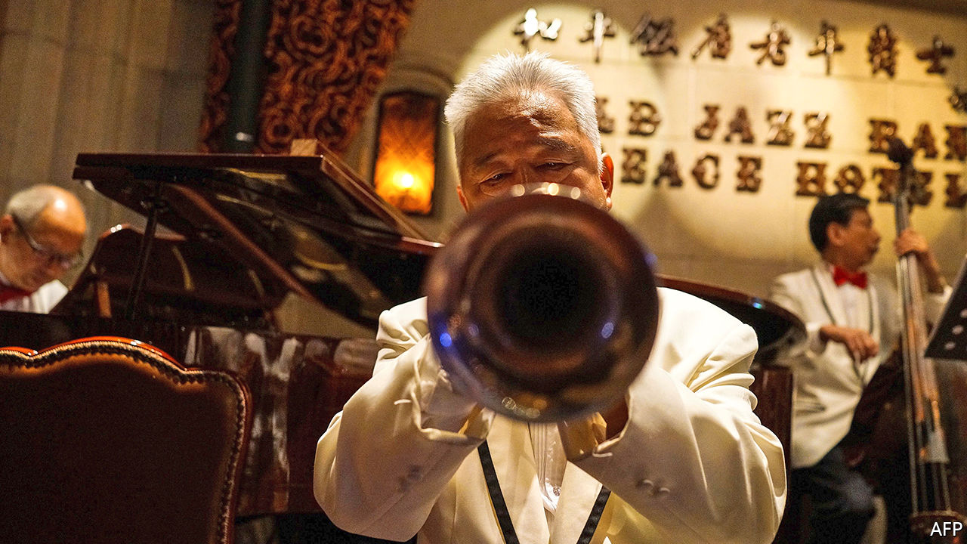

COVID-19 HAS, received wisdom has it, been terrible for hotels. The share prices of the eight biggest listed Western groups by room count have slipped by 14%, on average, this year. The glum consensus is, though, being challenged by two big Chinese chains. Both are enjoying resurgent demand for domestic travel as China has tamed its epidemic. And strength at home is fuelling ambitions abroad.

Jin Jiang, the world’s second-biggest hotel firm by capacity, boasted an occupancy rate of 74% in the third quarter, in line with last year and more than double that of its bigger rival, Marriott International. Its market value has soared by three-quarters this year, to $6.4bn, above better-known Asian brands such as Shangri-La and Mandarin Oriental. Huazhu, which like Jin Jiang is based in Shanghai, saw revenue per available room recover by 40% from the second quarter, to 179 yuan ($27). The group is now worth $16bn, behind only Marriott and Hilton Worldwide among the world’s listed hoteliers.

Similarly to their big Western rivals, Jin Jiang and Huazhu each owns a portfolio of brands that cater to different customers. Jin Jiang, which is controlled by Shanghai’s local government, operates everything from budget digs (think Marriott’s Fairfield Inn) to the upper end of the mass market (like Sheraton). Huazhu is a more all-encompassing group, which also competes in the luxury segment. Both companies prefer to offload the costs of hotel construction to franchisees in exchange for lower franchise fees, which enables them to expand much more rapidly.

The pair indeed look poised to capture a greater market share at home, reckons Yulin Zhong of 86Research. In America chain hotels accounted for 72% of all hotel rooms at the end of 2019. In China the equivalent figure was just 27%.

As incomes rise and Chinese travellers become more discerning, the standardised, dependable amenities and good service that big chains guarantee begin to look more appealing. Domestic providers of such things enjoy a substantial first-mover advantage. The number of hotel rooms in China held by Wyndham, the biggest foreign operator, is merely a third that of Huazhu and a fifth that of Jin Jiang. And their advantage is growing—the two firms have more than 7,300 hotels under development between them, mostly in China, equivalent to 47% of their existing stock.

In a bid to break into the global market, two years ago Jin Jiang purchased a majority stake in Radisson, the world’s 11th-biggest hotel operator by capacity, for $332m. In January Huazhu paid $868m for Deutsche Hospitality, a posh German group. Such tie-ups allow the new owners to study the nuances of serving a sophisticated foreign clientele without spending millions on marketing their unfamiliar brands in the West (or raising the sort of hackles that Chinese acquisitions often do in more sensitive industries such as technology or finance). As American and European hoteliers continue to reel amid the pandemic’s second wave, more last-minute deals may be on offer for the Shanghai duo. ■

This article was downloaded by calibre from <https://www.economist.com/business/2020/12/03/how-chinas-jin-jiang-and-huazhu-put-marriott-and-hilton-to-shame>

|  |  |  |  |
| --- | --- | --- | --- |
| Previous | Articles | Sections | Next |

|  |  |  |  |
| --- | --- | --- | --- |
| Previous | Articles | Sections | Next |

#### Swiss miss

# Swiss multinationals narrowly avoid new ethics standards

A referendum on stakeholderism wins the popular vote but fails to secure enough support from cantons

Dec 5th 2020 | PARIS

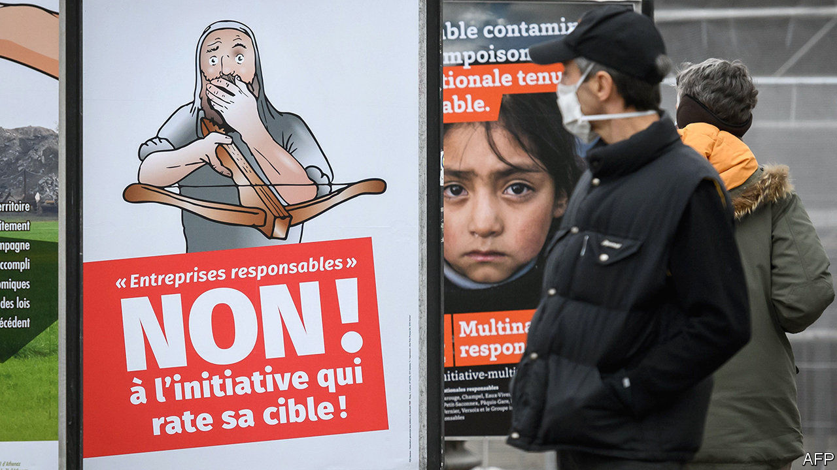

CORPORATE CHIEFTAINS can barely keep tabs on what their own staff are up to, let alone suppliers and subsidiaries in far-flung places. A referendum in Switzerland on November 29th proposed to change that, making Swiss multinationals liable in domestic courts for lapses in human rights or environmental stewardship along their global supply chains. The proposal failed by the narrowest of margins—a watered-down version will come into force instead.

The changes were championed by the usual foes of big business—NGOs, pressure groups and the like—with their long-standing gripes over cacao that Nestlé uses in KitKats or cobalt traded by Glencore. This political push to make companies more accountable chimes with boardroom proclamations about purpose-driven business, shareholders be damned. Corporate bosses nonetheless fiercely opposed the measures. Vague threats were made about footloose multinationals moving to laxer jurisdictions.

That won’t be necessary. Though the Responsible Business Initiative gained 50.7% of votes, it failed to carry enough cantons under the arcane Swiss system. (Another proposal, to ban the central bank from investing in defence companies, was roundly defeated.) The Swiss government, which opposed the measures, will still bring in some less stringent norms. Reporting standards will be tightened, with fines for erring. But campaigners will not be allowed to bring wayward companies to civil courts, as they had hoped.

No Swiss business is—at least publicly—in favour of child labour, human-rights abuses or environmental vandalism. But low taxes, pleasant living conditions and a historical penchant for business-friendly policies like bank secrecy have helped the Alpine confederation attract more than its fair share of global firms, some with tricky supply chains. All proclaim their attachment to corporate social responsibility, as proven by glossy brochures. But none felt being dragged through Swiss courts for misbehaviour elsewhere would do anything but enrich lawyers. Some argued that the risk of litigation may dissuade them from being open about inevitable shortcomings they are working to fix.

The referendum was seen as a prequel to wider European efforts to hold businesses accountable beyond their immediate operations. Germany has mulled a law on supply-chain standards; next year the EU will push for firms to be held responsible for human-rights abuses and environmental harm. If the Swiss experience is anything to go by, bosses will resist, stakeholder-friendly rhetoric notwithstanding.■

This article was downloaded by calibre from <https://www.economist.com/business/2020/12/05/swiss-multinationals-narrowly-avoid-new-ethics-standards>

|  |  |  |  |
| --- | --- | --- | --- |
| Previous | Articles | Sections | Next |

|  |  |  |  |
| --- | --- | --- | --- |
| Previous | Articles | Sections | Next |

#### Bartleby

# How the pandemic is forcing managers to work harder

Remote work brings benefits to employees and employers alike—but requires more effort on the part of executives

Dec 3rd 2020 |

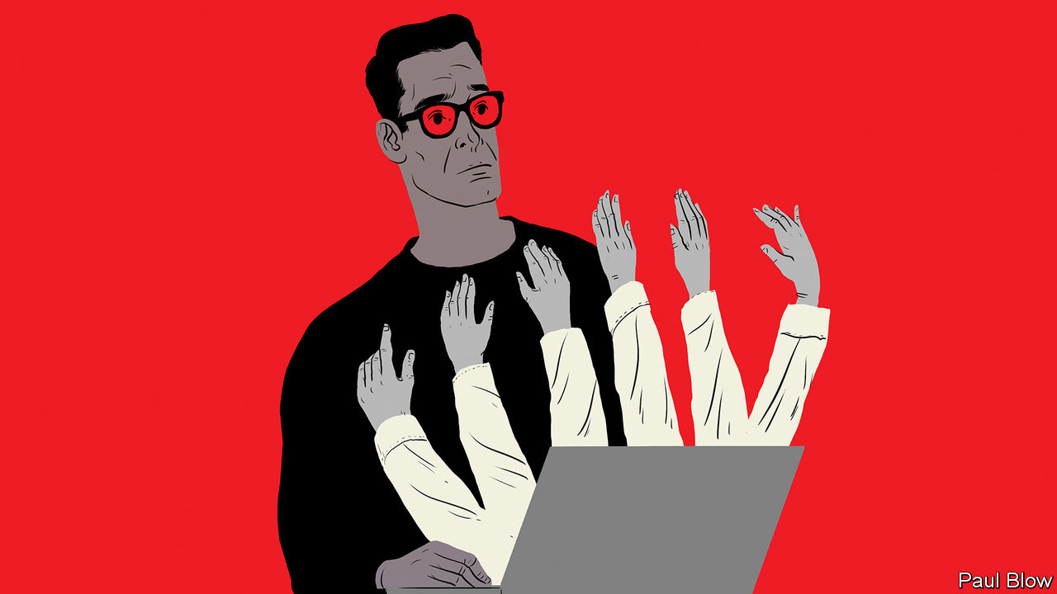

BUSINESSES ARE still struggling to understand which of the pandemic’s effects will be temporary and which will turn out to be permanent. Three new reports attempt to analyse these longer-term trends. One is from Glassdoor, a website that allows workers to rank their employers. Another is from the Boston Consulting Group (BCG), a management consultancy. The third is from the Chartered Management Institute (CMI), a British professional body. Read together, they imply that firms stand to benefit—but that managers’ lives are about to get more difficult.

One change that is all but certain to last is employees spending more of their time working at home. The Glassdoor report finds that less commuting has improved employee health and morale. Splitting the week between the home and the office is also overwhelmingly popular with workers: 70% of those surveyed wanted such a combination, 26% wanted to stay at home and just 4% desired a full-time return to the office. Perhaps as a consequence, remote work has not dented productivity—and indeed improved it in some areas. Flexible work schedules can be a cheap way to retain employees who have child-care and other home responsibilities.

Telecommuting offers other potential cost savings, and not just the reduced need for office space. Remote workers do not need to live in big cities where property is expensive. If they live in cheaper towns and suburbs, companies need not pay them as much. Glassdoor estimates that software engineers and developers who leave San Francisco could eventually face salary cuts of 21-25%; those quitting New York could expect reductions of 10-12%. As the report points out, remote employees are, in essence, competing with a global workforce and are thus in a much weaker bargaining position.

This point is reinforced by the BCG report, which finds that the pandemic has increased the willingness of companies to work with freelancers. Previously, many managers worried that legal and compliance issues prevented them from using outside staff. The pandemic forced firms to adjust their business models rapidly, and simultaneously led to growth in the pool of talented freelancers, as full-time employees had to be laid off. BCG says that “by embracing flexibility in whom they hire, internally or externally, [companies] can finally speed up operations and deliver faster on strategy.”

Despite its advantages, a remote workforce, or one consisting of more outsiders, brings challenges for managers, as the third report demonstrates. The CMI surveyed 2,300 managers and employees. The results highlight just how important effective communication, and concern for workers’ well-being, is to good management. They also unearthed an interesting difference of perspective: nearly half of senior executives thought they were engaging employees more in decision-making since the pandemic, but only 27% of employees agreed.

The survey also shows that the experience of remote working has not been uniform. Of those working virtually, 69% of women with children want to work at least one day from home when the pandemic ends, compared with 56% of men with kids. These women have had less contact with managers during the lockdown than their male peers have had, suggesting they have been neglected.

Strikingly, 48% of British staff from minority ethnic backgrounds thought that workplace culture had got better during the crisis, against 34% of all employees. This suggests something was wrong with office culture beforehand: the CMI survey found that black employees were more likely than any other ethnic group to feel their manager did not trust them to undertake their role.

So managers have a lot more work to do in responding to the pandemic. Executives need to tailor their behaviour to individual employees’ needs. Ironically, though managers may have feared that remote working would allow employees to slack, it may be that managers have not been up to the challenge. Bosses may have spent too much time videoconferencing and not enough speaking directly with subordinates.

Ask someone what it is like to work at a firm and they may respond by saying what the offices are like—whether they are cramped, in a nice location and so on. In a world of remote working, employees may stress instead how the employer communicates with them. Not so much “management by walking around” as management by phoning—or Zooming—around. Time to get dialling.

Editor’s note: Some of our covid-19 coverage is free for readers of The Economist Today, our daily [newsletter](https://my.economist.com/user#newsletter). For more stories and our pandemic tracker, see our [hub](https://www.economist.com/news/2020/03/11/the-economists-coverage-of-the-coronavirus)

This article was downloaded by calibre from <https://www.economist.com/business/2020/12/03/how-the-pandemic-is-forcing-managers-to-work-harder>

|  |  |  |  |
| --- | --- | --- | --- |
| Previous | Articles | Sections | Next |

|  |  |  |  |
| --- | --- | --- | --- |
| Previous | Articles | Sections | Next |

#### Schumpeter

# Nestlé gives a flavour of the future

Its boss is cautious about the outlook for the world economy

Dec 3rd 2020 |

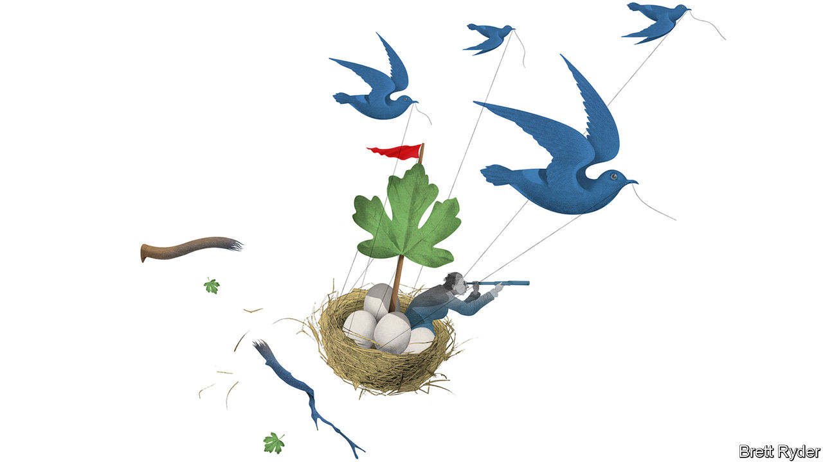

SWITZERLAND IS KNOWN for its timepieces. But it is also home to another business that for most of its history has operated with metronomic regularity. That is Nestlé, the world’s biggest food company. Established in the 1860s in Vevey, a small town on the shores of Lake Geneva that remains its home to this day, it has long been seen as an opaque behemoth with an insular culture and the occasional brush with scandal. Yet a billion of its products are consumed every day. Its sales last year surpassed $93bn. When it talks coffee, it talks in 100bn cupfulls. Data may be the new oil in America and Asia, but in Europe hot beverages are hotter than either crude or computing. With a market value of $320bn, Nestlé is worth more than Royal Dutch Shell, the continent’s biggest energy firm, and SAP, its software giant.

Many global food firms have been models of reliability. Other venerable names, such as Campbell’s, Danone, Kraft Heinz and Unilever (which sells more non-food items than food), also have roots stretching back over a century. Yet five years ago, amid a sharp slowdown in growth, the industry suddenly found itself under siege. 3G, a Brazilian private-equity group with a zeal for ruthless cost-cutting, merged H.J. Heinz and Kraft Foods. Two years later American activists targeted Nestlé, demanding the same recipe. The same year Kraft Heinz tried and failed to take over Unilever, and later saw its profits tumble, leaving 3G’s reputation in tatters.

Europe’s consumer-goods business is still growing at about half the pace it did a decade ago. It badly needs a caffeine shot. No one has shown better how to administer one than Mark Schneider, Nestlé’s first chief executive from outside the firm in almost a century—and the barista-in-chief of its three-year turnaround.

Mr Schneider, a straight-talking German with an American passport and a fondness for quips, is the perfect foil for bossy hedge funds. He is not prone to panic. But nor is he complacent. He came from outside the food industry, so sees it with fresh eyes. He carried out what Martin Deboo of Jefferies, a bank, calls “the chief-executive version of Blairism”, steering a middle course between the aggressive profit-margin targets desired by the Americans and the meagre restructuring tolerable to the Swiss. Most significant, he revived confidence in organic sales growth, a metric that had fallen at Nestlé from an annual 7.5% in 2011 to 2.4% the year he took over. During the slash-and-burn era of 3G, sales growth was for wimps. No longer—partly thanks to Mr Schneider.

The importance of sales growth is hard to overstate in food. Bernstein, a broker, calls it the “lifeblood” of the industry. In recent years it has been pummelled by changing diets, digitalisation and deflation in parts of the rich world, as well as sluggishness in emerging markets. But Mr Schneider swiftly found remedies.

The first was innovation. Thanks to e-commerce, small upstart brands were able to elbow aside the behemoths and sell directly to consumers. He responded by forcing boffins to bring Nestlé’s ideas to market more quickly, often digitally. The three years it sometimes took them was fine for a car, but not for a chocolate bar, he says. New ideas he cherishes include allergy-busting cat foods and vegan burgers. Second, he was quick to strike transformative deals. Within six months of licensing Starbucks coffee in 2018, Nestlé had already launched 24 of the chain’s products. Third, he bought and sold companies, adding to fast-growing nutritional-health businesses and selling down pedestrian ones such as ice cream in America and packaged meat in Europe.

Nestlé has sped up growth in other areas, too. It is moving relentlessly upmarket. Last year the share of sales from premium products rose to more than a quarter, including items with naked snob appeal such as “flat white over ice” Nespresso pods. It has joined the craze for plant-based foods and other healthy fare (never mind that this makes its confectionery business look increasingly out of place). And it is desperate to improve its reputation for sustainability. On December 3rd it said it would invest SFr1.2bn ($1.3bn) over five years to help its farmers improve their soils as part of a SFr3.2bn effort to combat climate change. It has also pledged to make packaging recyclable or resuable by 2025. These are attempts to soften its image as a corporate goliath, which puts off not just young shoppers but snobby well-off ones, too.

For now, investors are impressed. As Mr Deboo notes, the share price has already awarded Nestlé ten out of ten for the turnaround, though that may be premature. Sales growth has still not recovered to the 4-6% a year that the firm once promised. Infant formula remains a laggard. So does water, with its cheapest bottled products, consumed in offices, battered by the pandemic. And Nestlé is not immune to industry-wide problems. Growth is slowing in emerging markets as people there spend less on ingestible treats and more on digital goods. Moreover, low incomes among the young will dampen their appetite for premium products.

## Not so sweet

Relatively speaking, the virus has been kind to Nestlé. Most of its products are used at home, rather than on-the-go, so extra sales for the pantry easily eclipsed what was lost at the sweet shop. Danone, a European rival that was already struggling to keep up with Nestlé at the start of the year, has slipped much further behind.

Still, Mr Schneider is no blithe optimist. In a recent Zoom meeting held amid stockmarket euphoria about the prospects for a covid-19 vaccine, he was cautious. As a former health-care executive used to handling cold chains, he expressed doubts about the ability to distribute vaccines at the required temperatures, especially in the developing world. The longer it takes to spread the vaccine, the higher public debts will pile up, potentially casting a “long shadow” over the 2020s. On top of that, he notes, a demographic challenge is looming with rising numbers of elderly requiring medical care. “I’m quite muted in my outlook,” he admits. But Nestlé, in more than 150 years of history, has survived worse. ■

This article was downloaded by calibre from <https://www.economist.com/business/2020/12/03/nestle-gives-a-flavour-of-the-future>

|  |  |  |  |
| --- | --- | --- | --- |
| Previous | Articles | Sections | Next |

|  |  |  |
| --- | --- | --- |
| Business | Sections | Science & ... |

Finance & economics

Ping An: Metamorphosis

.

Financial-market data: Go figure

.

Joe Biden’s advisers: Top picks

.

Buttonwood: The ABC of the euro zone

.

Music rights: Tuning in

.

India’s market rally: Dramatic disconnect

.

Free exchange: The disintermediation dilemma

.

|  |  |  |
| --- | --- | --- |
| Business | Sections | Science & ... |

|  |  |  |  |
| --- | --- | --- | --- |
|  | Articles | Sections | Next |

#### Metamorphosis

# How Ping An, an insurer, became a fintech super-app

Could others follow the Chinese firm’s lead?

Dec 3rd 2020 | HONG KONG

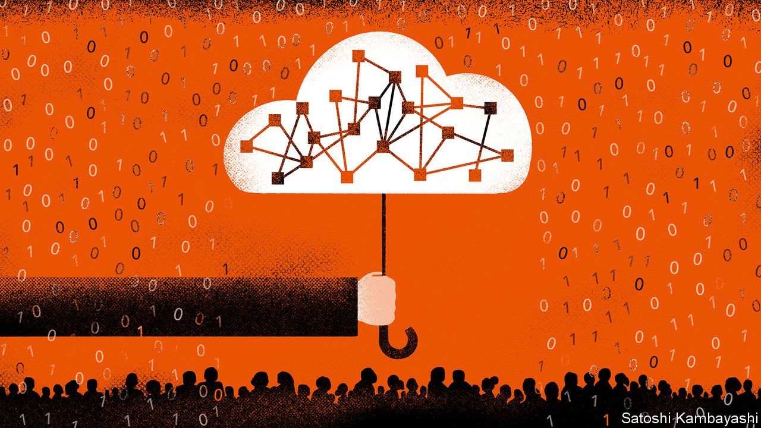

A JOB INTERVIEW at Ping An is a strange experience. To become an agent at the insurance group, the world’s largest by market capitalisation, candidates must take questions from an intelligent machine. As they respond, their voice, choice of words and gestures are scrutinised for the qualities of the most productive salespeople. After accruing data from millions of such interviews, the firm believes its artificial-intelligence (AI) system can quickly pluck talent and weed out the duds. Judged by the company’s agent-productivity scores, it is working.

Just as the recruitment tool offers a glimpse into the future of hiring, Ping An itself may offer a window on to the future of finance. The tool is just one of thousands of applications built by the group’s army of engineers. They support a sprawling array of services, from insurance and banking to health care and education, which this year alone have been used by close to 600m people. No other traditional financial-services group in the world comes close to rivalling Ping An’s ability to develop technologies and deploy them at such a scale.

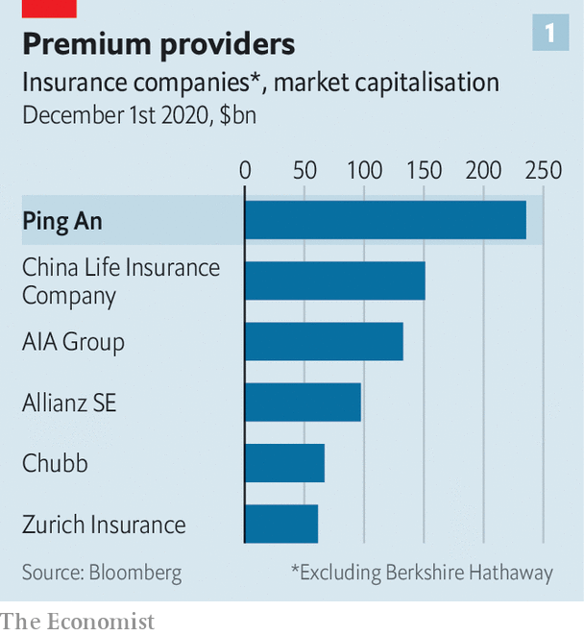

The firm, set up by Peter Ma, began life as a small unit at a state-owned enterprise in Shenzhen, selling bosses insurance against worker-compensation claims. It was eventually spun out in 1988. By the mid-2000s it had become one of China’s largest life and property insurers, and attracted investment from HSBC, a bank. Today it is worth 1.5trn yuan ($236bn; see chart 1), and has redefined itself as a technology conglomerate built around an insurance business. It is now the largest investor in HSBC.

Three things distinguish Ping An’s operating model from that of a standard insurer: its vast platform of services; its approach towards its hundreds of millions of users and customers; and, underpinning it all, its technological prowess. Take its array of subsidiaries first. The firm sells life and health insurance, which in the first three quarters of the year accounted for 67% of net profit. It provides health care through Good Doctor, its digital-medicine group (see article). Customers can park their cash with Ping An’s bank or invest it through Lufax, its wealth-advisory arm (which listed in New York on October 30th). They can buy a car or sign up for education services, and then finance the payments through Ping An’s consumer-credit unit.

The sheer breadth of services on offer allows Ping An to treat customers more as a social-media firm would, rather than an insurer—the second distinctive feature of its business model. Unusually for a financial institution, Ping An considers the majority of people buying its products to be users instead of customers. They may buy a health service from Good Doctor or a car from Autohome, its car-purchasing app, contributing to the company’s data pool, yet remaining outside its core customer base. “You don’t have to jump through hoops. All you need to do is download our app,” says Jessica Tan, one of the group’s three co-chief executives. Only when they hold a financial product at one of the core units of the company, such as an insurance policy, do users become customers.

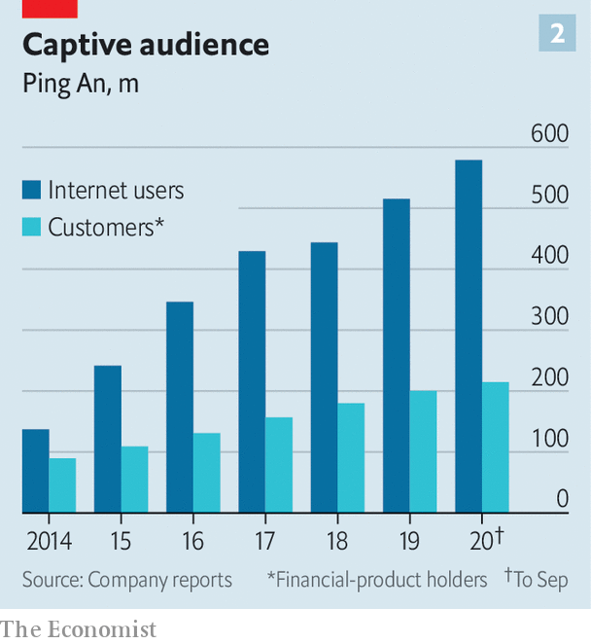

By allowing hundreds of millions of people to dip their toes in its product offering, Ping An has created a pool of users that can be targeted for sales of more sophisticated products. More than 578m people used its platform in the first nine months of the year (see chart 2). Some 214m were customers who had contractual agreements with the company. The rest were considered users. In the first half of the year, about 35% of its 18m new customers were sourced from its users. As the company has won over more users, that percentage has risen steadily in recent years.

Ping An is also becoming better at the lucrative business of “cross-selling”, or selling customers more products from other parts of the group, which increases income without incurring the cost of acquiring new clients. The share of retail customers that have contracts with more than one subsidiary rose from around 19% in 2015 to about 37% in June. That puts Ping An about 20 percentage points above the average cross-selling rate for insurers in Asia, according to Bain, a consulting firm.

None of this would be possible without Ping An’s technological prowess—the third and by far most important ingredient of its success. AI allows cross-selling pitches to customers to be made when they are most useful, for instance. “The final sale is done by an agent but the system develops the recommendation,” says Henrik Naujoks of Bain. “And it’s done at the right time.”

Large banks and insurers often sponsor “fintech incubators” that develop new technologies, or buy in applications that can be patched on to their core operations. HSBC, for instance, hired Identitii, an Australian fintech, this year to build a digital-payments tool. But for regulatory reasons such experiments tend to be ring-fenced from the financial institution.

Ping An, by contrast, has fully internalised these operations, apparently unafraid of regulatory blowback. The group has a 110,000-strong technology development team—larger than the commercial-banking divisions of all but the biggest banks—including 3,000 scientists. It submitted 4,625 technology patents in the first half of the year alone. The tools developed within the group’s technology unit are often used across the company. These include credit-risk models that use vast stores of data to make quick lending decisions at Ping An’s consumer-finance division, Puhui. Similar data crunching can track a customer’s driving habits through movements detected on a mobile-phone sensor and price car insurance accordingly. More accurate pricing on both fronts saves the company money.

When large financial firms do develop systems in-house, they jealously guard them from competitors. Mr Ma has turned that notion on its head by transforming Ping An’s technology division into a sales unit and profit centre. When the company developed its own cloud-computing tech for hosting its banking and insurance systems, it eventually turned the technology into products that now serve 630 banks and 100 insurers across China—a “software-as-a-service” model for banking that is often compared to what Amazon Web Services has done for website hosting.

Ping An’s lending algorithms facilitated 47.4bn yuan in loans at rival banks in the first half of the year. That unit, renamed OneConnect, went public last year. Another, called Smart City, builds and operates internal systems for hospitals. Local governments in 118 cities buy Ping An’s administrative technology.



Its technology business, which includes the sale of cloud-computing services, generated just 4.5% of group net profits in the first nine months of 2020. But making the transition from financial institution to fintech means turning tech into a profit centre, says Leonard Li at Oliver Wyman, a consultancy. That tech turns a profit at all, rather than adding to its cost base, makes Ping An unusual.

Could elements of the model be adopted elsewhere? Many of the individual technologies developed by Ping An will soon be applied by western insurers; some are already talking about how to become “the Ping An of Europe”. But wholesale fintech adoption will be harder in countries with stricter regulation on big data (and will probably become more difficult in China, too). Customers in America and Europe may also be more reluctant than those in China to buy insurance, health-care and wealth-management from one company.

Meanwhile, Ping An’s approach is being put to the test. When covid-19 first struck in January the company was a year into restructuring its life-insurance business. That involves improving its force of over 1m agents, who are still the main channel for insurance sales in China. The country’s insurers are not only battling among themselves for talent, they are also fighting off new entrants. “We are competing with the tech companies too,” says Jason Yao, another co-CEO. Companies with their own financial technologies, such as Ant Group, have launched rival insurance offerings.

The AI-powered recruitment and training tool has been one of Ping An’s top solutions. It appeared to be working in 2019, when the value of new business per agent in the company’s life-insurance division rose by a healthy 16.4% compared with the previous year. The gauge fell by almost as much in the first half of 2020. Analysts say that rivals in China have fared even worse. But the risk, says one consultant, is that the effectiveness of some of Ping An’s tech solutions may have been overestimated because of rapid growth in the insurance industry in China at the time. A prolonged downturn could show that some of its tech is less effective than first thought.

Another threat comes from leadership changes. In part, these reflect Ping An’s position on the tech frontier, which has led rivals to sniff around its executives. Ericson Chan, chief executive of Ping An Technology, was poached in September by Zurich, another insurer. Lee Yuan Siong, Ping An Insurance’s chief executive, took over as the boss of AIA, a Hong Kong-based insurer, this year. The loss of the pair has been a blow to the group. More could follow.

Questions also hang around the future of Mr Ma, who is 65 this year. He stepped down as group chief executive in July, prompting industry watchers to expect him to retire soon. But he continues to call the shots as chairman, and there is no talk of succession planning yet. Were Mr Ma to depart, some worry that Ping An’s rapid rise would come to a swift end. “There’s only one person driving innovation,” says a consultant. For all its use of machines, Ping An is still subject to key-man risk. ■

This article was downloaded by calibre from <https://www.economist.com/finance-and-economics/2020/12/03/how-ping-an-an-insurer-became-a-fintech-super-app>

|  |  |  |  |
| --- | --- | --- | --- |
|  | Articles | Sections | Next |

|  |  |  |  |
| --- | --- | --- | --- |
| Previous | Articles | Sections | Next |

#### Go figure

# Meet the data firms cashing in on the quant-investing boom

S&P’s plan to buy IHS Markit is the latest in a slew of deals in the industry

Dec 5th 2020 | NEW YORK

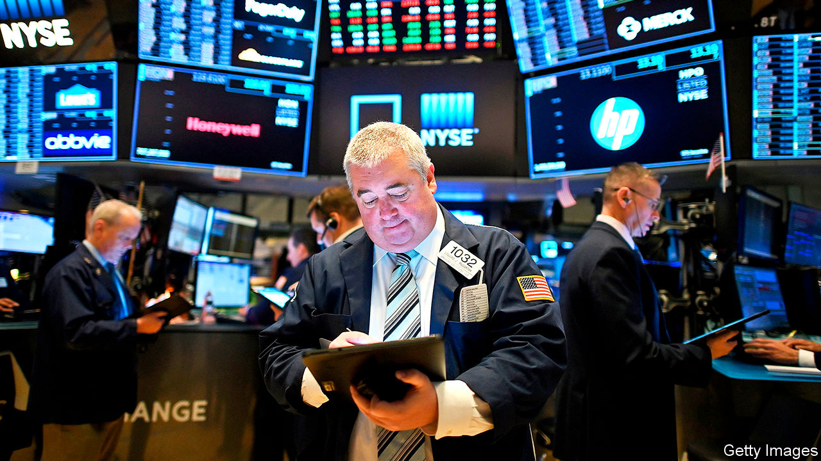

TRADERS AND their Bloomberg terminals are seldom parted. Some 330,000 people fork out around $25,000 annually to access Bloomberg’s suite of services: financial-market data; graphing and pricing tools; the ability to chat with other market participants. These functions are so vital for bond traders, hedge-fund managers and pension-fund investors that, when the pandemic closed offices worldwide, many lugged their terminals home in taxi cabs.

As quantitative investing swells and algorithms dominate financial markets, though, the demand for data is changing. A human stock-picker might prefer a single slick platform through which they can build charts and chat to their broker, but quantitative firms want to be plugged into vast data sets that they can sift for signals. One of the quickest-growing slices of the market-data industry for the past five years has been direct selling to investment managers, rather than traders. And a motley, fragmented bunch of providers are having enormous success selling proprietary data directly to quantitative managers. A reminder of this came on November 30th when S&P, a rating agency and financial-information firm, said it would buy IHS Markit, a credit-data provider, for $44bn. The tie-up is the second-largest acquisition announced this year, behind only a $56bn Chinese oil-pipeline deal in July.

The providers that are winning from the quant boom are doing so almost by historical accident. Some—such as Nasdaq and Intercontinental Exchange (ICE), which run exchanges—were once merely financial-market plumbers, clearing transactions and matching trades. Other niche players, like IHS Markit, started off by providing pricing for the opaque market in credit-default swaps, hoping to tap investors’ growing appetite for derivatives. The transaction data these firms accumulated used to be a by-product. Now they are “the lifeblood of finance”, says Audrey Blater of Aite Group, a research firm. Market-data revenues have grown by around 5-8% per year for the past five years and margins are fat. S&P has an operating margin of 56%, 16 percentage points more than five years ago.

Now these once entirely disparate firms are teaming up. The S&P and IHS Markit merger follows a slew of similar deals. In 2019 the London Stock Exchange (LSE) agreed to buy Refinitiv, a financial-data service once owned by Thomson Reuters, for $27bn. In September this year ICE bought Ellie Mae, a mortgage-information provider, for $11bn.

Incumbents hope these mega-mergers will allow providers to reap economies of scale and create data bundles that appeal to clients. Like the giants of consumer technology, financial-data firms are seeking to create “ecosystems” that clients never have to leave, says Ms Blater. Such scale economies certainly seem to exist for S&P and IHS Markit. The companies expect around $480m in annual savings, but Hamzah Mazari of Jefferies, an investment bank, thinks they could end up closer to $600m. The transaction should also create revenue-generating synergies, which the pair estimates at an annual $350m. That is because they have complementary businesses and serve the same pool of clients. S&P provides equities indices, for instance, whereas IHS Markit looms large in the pricing of bonds. The combined entity could sell its array of products through enterprise-wide contracts, charging clients a fee for all-you-can-consume data.

All this makes regulators worry about the growing market power of a shrinking group of data providers. European watchdogs are due to make a decision on LSE’S purchase of Refinitiv by mid-January. But they may not do much to block the union between S&P and IHS Markit. Mr Mazari says overlaps between the firms’ businesses do not amount to more than 10-12% of their revenues, so concentration in their various segments will not rise by much. But whether the deals are pulled off or not, their size shows how the industry is being recast. For decades rivals attempted to usurp Bloomberg by offering similar but cheaper platforms. Traders may still clutch at their terminals, but the market for data is being transformed. ■

This article was downloaded by calibre from <https://www.economist.com/finance-and-economics/2020/12/05/meet-the-data-firms-cashing-in-on-the-quant-investing-boom>

|  |  |  |  |
| --- | --- | --- | --- |
| Previous | Articles | Sections | Next |

|  |  |  |  |
| --- | --- | --- | --- |
| Previous | Articles | Sections | Next |

#### Presidential picks

# Joe Biden’s choice of economic advisers signals his priorities

The team stands out for its diversity, and its emphasis on climate change and labour rights

Dec 5th 2020 | WASHINGTON, DC

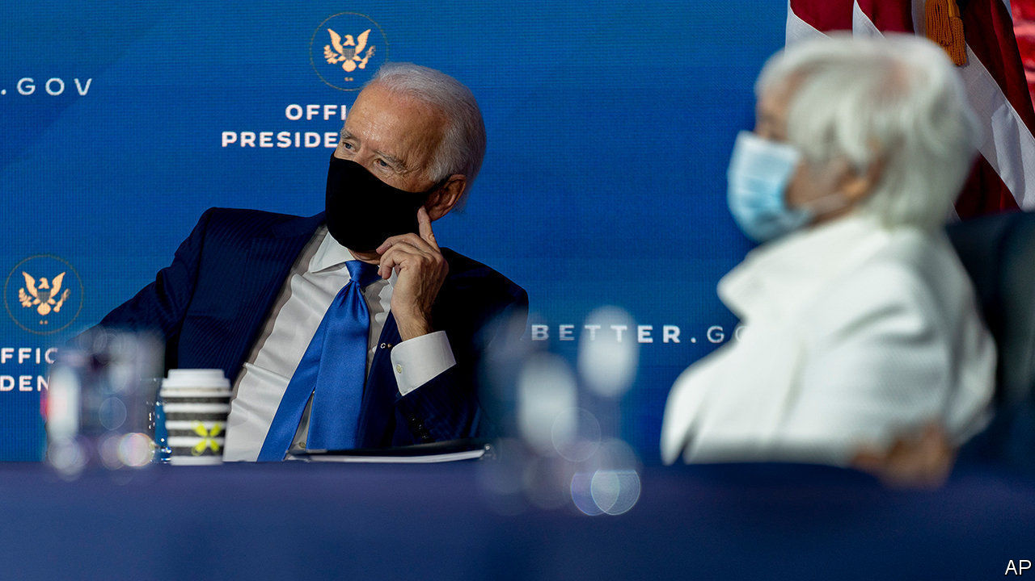

JOE BIDEN’S record as president may well hinge on his response to America’s economic woes. On December 1st the president-elect launched his effort to right the economy, when he formally unveiled his choices for top policy jobs. His economic team stands out for its diversity, its interest in climate change, and its emphasis on the welfare of working people, sending a clear signal of Mr Biden’s priorities. Its overriding challenge, though, will be to repair an economy battered by covid-19.

Many of the names on the slate are familiar. If confirmed by the Senate, Janet Yellen will become America’s first female treasury secretary. She is assembling one of the more impressive public-service careers in the economics profession, having led the Council of Economic Advisers (CEA) during the Clinton administration, and the Federal Reserve from 2014 to 2018.

Experience aside, Ms Yellen’s broad acceptability across Democratic factions no doubt was a point in her favour. By contrast, Mr Biden’s CEA—an advisory body of wonks that aims to ground the president’s policies in sound economics—may be the most progressive in recent memory. It will be led by Cecilia Rouse, an economist at Princeton University, who if confirmed would be the first black woman to chair the council. Ms Rouse is no stranger to Washington, having advised both Bill Clinton and Barack Obama during their terms. She has also done impressive research; her work showing that student debt may deter low-income students from enrolling at university, for instance, may be especially pertinent given a running debate in Washington over the wisdom of cancelling student loans. Jared Bernstein, who advised Mr Biden on economic policy during his vice-presidency and has long been an advocate of pro-labour policies, will join Ms Rouse. So too will Heather Boushey, who runs the Washington Centre for Equitable Growth, a left-leaning think-tank. Ms Boushey has argued forcefully that generous government support for women and families is a key ingredient of broad-based prosperity. (Neither Mr Bernstein nor Ms Boushey require Senate confirmation.)

Other appointments have been greeted less warmly by the left. Brian Deese, who has been chosen to lead the National Economic Council, the president’s top economic-policymaking body, worked at BlackRock, an asset manager, after serving as an adviser to Mr Obama—causing some to worry about a revolving door between government and business. But Mr Deese’s portfolio, which involves directing investment in climate and sustainability initiatives, has muted some of the criticism—and shows the importance that Mr Biden places on tackling climate change.

Neera Tanden, the head of the Centre for American Progress, a left-leaning think-tank, and Mr Biden’s choice to run the Office of Management and Budget, is a more divisive figure, known for picking fights with far-left supporters of Senator Bernie Sanders. Republican senators have expressed discomfort with her nomination too; she may face the fiercest confirmation row of them all. But confirmation will be only the first of the team’s many challenges. Reforming the economy in the face of a slump and Republican opposition will be no easy task. ■

Dig deeper:  
Read our [latest coverage of the presidential transition](https://www.economist.com/us-election-2020), and then sign up for Checks and Balance, our [weekly newsletter](https://www.economist.com/checksandbalance/) and [podcast](https://www.economist.com/checks-and-balance-our-weekly-podcast-on-american-politics) on American politics.

This article was downloaded by calibre from <https://www.economist.com/finance-and-economics/2020/12/05/joe-bidens-choice-of-economic-advisers-signals-his-priorities>

|  |  |  |  |
| --- | --- | --- | --- |
| Previous | Articles | Sections | Next |

|  |  |  |  |
| --- | --- | --- | --- |
| Previous | Articles | Sections | Next |

#### Buttonwood

# Should you buy European shares?

The meat of the pitch is that things are not as bad as you probably think

Dec 3rd 2020 |

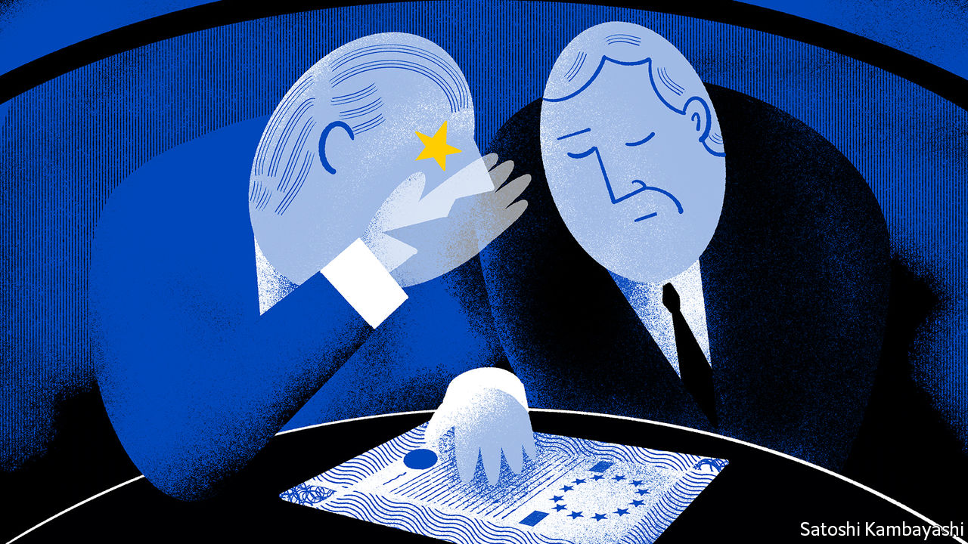

TWO MEN are sitting in adjacent restaurant booths. One is talking at length—about train journeys, women, morality, taking chances, living one day at a time. The other is captivated. “When you die, you’re going to regret the things you don’t do,” says the speaker. After more of this, he sighs, pauses and offers his new friend a drink. He then takes out a map. “This is a piece of land,” he says. “Listen to what I’m going to tell you now.”

This is how Richard Roma, the alpha salesman in “Glengarry Glen Ross”, a play by David Mamet, seduces a stranger into buying a tract of undeveloped land. The scene comes to mind when considering the investment case for euro-zone stocks. The phrase “time to buy European equities” can elicit the same sort of alarmed response as an invitation to buy Florida swampland. An oblique sales pitch is generally advisable—even though now might be a better time than usual to make it.

How would a stockbroking Ricky Roma sell the euro-zone story? The main thing would be not to oversell it: Europe is hardly transformed. The meat of it is that things are not as bad as you probably think. The euro-zone’s weaknesses have not gone away, but are much less crippling. It is likely to do quite well in the early stages of economic recovery. That might just be enough to close the deal.

One sure-thing trade that the euro zone has spawned is in books and articles about how it is a half-finished project. It is a monetary union, but not a political one. The single market is fragmented in services and banking. Tax and spending decisions are made at the national level. But things have changed quite a bit. The European Central Bank looks a lot more like its peers than it did in, say, 2010. Like them, it is more or less committed to reflation. The hawkish German influence on its apparatus has waned. And the pandemic is curing hang-ups around fiscal stimulus. The European Union’s recovery fund is a step towards a shared fiscal policy. It is not huge. But it is not nothing either.

The euro zone’s equity market has suffered from a weakness in its make-up: too few of the digital companies of the future; too many of the industrial companies of the past. But time has whittled away at this, too. After years of under-performance, Europe’s banks and energy companies had dwindled to a 10% share of market capitalisation by the late summer, as Graham Secker of Morgan Stanley, a bank, noted at the time. Technology had become the largest single sector in the Euro Stoxx 50 benchmark index, at 14%. The public-equity market is still a more cyclical play than that in America. But it is no longer true to say that Europe is a technology desert. Venture capitalists talk excitedly about the strength of the pipeline of software startups across continental Europe.

In any event, it is its old-economy cyclical stocks that are piquing interest. If Europe has been the big loser from the pandemic, it ought to be a big beneficiary of reopening, goes one argument. The forecast for earnings-per-share growth next year is as high as 50% for the Euro Stoxx, according to Mislav Matejka of JPMorgan. A one-off bounce might not impress much. But there is a decent case that euro-zone equities might sustain interest beyond 2021—that the “runway is longer”, as Mr Secker puts it. The stimulative effect of the EU’s recovery fund will probably not be felt until 2022. As global economic recovery takes a stronger hold, investors will start to worry more about higher inflation. That might favour a more longer-lasting tilt towards cyclical stocks.

Why not simply buy emerging-market stocks instead? You still get exposure to companies that benefit from economic recovery; you also get plenty of tech stocks; and on top of all this you benefit from a weaker dollar, which is generally helpful for financing costs in developing economies. Yes, the dollar is expected by many to lose further ground. But what if it doesn’t? And what if Treasury yields start to rise quickly? That would be a tricky combination for emerging markets. Europe would be the sounder bet. (A stockbroking Ricky Roma might say that you don’t have to choose. Buy a bit of both.)

ABC—always be closing—is the mantra of Roma and his fellow salesmen. It is trickier to seal the deal when the story is not “things are great” but rather “things are a lot better than they were". Still, this counts as a more-than-decent pitch as far as the euro zone goes, even if it is an odd one to close on. After all, it is mostly about reopening.

This article was downloaded by calibre from <https://www.economist.com/finance-and-economics/2020/12/03/should-you-buy-european-shares>

|  |  |  |  |
| --- | --- | --- | --- |
| Previous | Articles | Sections | Next |

|  |  |  |  |
| --- | --- | --- | --- |
| Previous | Articles | Sections | Next |

#### Tuning in

# Music royalties are proving a hit for investors

Apart from being fun to own, they offer steady dividends

Dec 3rd 2020 |



BEN STENNIS is a country-music songwriter from Nashville who has written hits for performers such as Tim McGraw and Jason Aldean. Earlier this year, as the music industry was stopped in its tracks by the coronavirus, a company called Royalty Exchange offered him the chance to raise some cash. Since 2016 it has run an online marketplace that brings together musicians who want to sell their work and punters wanting to invest in royalties. Anthony Martini, a partner in Royalty Exchange, says it has 25,000 potential investors on its books, from pension funds to “dentists from Ohio”. The rate of investors signing up has doubled this year, compared with 2019.

Music royalties are a complicated business. When a song is recorded, copyrights are created both for the composition of the song and the recording itself. Each of those rights is then split into mechanical rights (generated when a song is sold in a physical format or streamed), performance rights (when it is played on the radio or live at a concert) and synchronisation rights (when it appears in a film, television programme or a video game).

The idea of investing in royalties is not new. In 1985 Michael Jackson forked out $47.5m for the rights to the recordings of around 250 songs by The Beatles; Taylor Swift is trying to buy the rights to some of her master tapes after her previous record label was sold. But firms like Royalty Exchange are making rights affordable to a wider pool of investors; some auctions start with prices in the four figures. (Mr Stennis sold his rights, and paid off his mortgage with the proceeds.)

There are several reasons why music royalties seem attractive at the moment. Mr Martini believes investors are drawn in by a rate of return that is insulated from macroeconomic trends. Music rights offer a predictable stream of income—people tend to tune in no matter what the economy is doing. Owning a song is more fun than buying a slice of a company. And once they have been bought, songs need not require much attention.

Not everyone agrees that buying royalties should be a passive business, though. In 2018 a former manager of Iron Maiden and Guns N’ Roses, Merck Mercuriadis, founded an investment company called Hipgnosis. More than 90% of the firm’s shares are held by institutional investors, including AXA, an insurer, and the Church of England. The aim is to improve the lot of songwriters, who do not have the same opportunities as performers to make money through tours and merchandise.

Hipgnosis has spent more than £650m ($870m) buying the rights to over 13,000 songs. It now owns a share of eight of the 25 most-played songs of all time on Spotify, a streaming platform, including tunes co-written with Ed Sheeran (“Shape of You”) and Justin Bieber (“Love Yourself”). In addition to the hits, Mr Mercuriadis also wants to boost returns from songs that have “been left to languish” by big labels.

Hipgnosis seeks to promote its catalogue by trying to place them in films, TV programmes and streaming playlists. Since it went public in July 2018, the cumulative return on its net asset value is just shy of 40%. Music to investors’ ears. ■

This article was downloaded by calibre from <https://www.economist.com/finance-and-economics/2020/12/03/music-royalties-are-proving-a-hit-for-investors>

|  |  |  |  |
| --- | --- | --- | --- |
| Previous | Articles | Sections | Next |

|  |  |  |  |
| --- | --- | --- | --- |
| Previous | Articles | Sections | Next |

#### Dramatic disconnect

# Despite a weak economy, India’s stockmarket is at record highs

What do investors know that economists don’t?

Dec 5th 2020 |

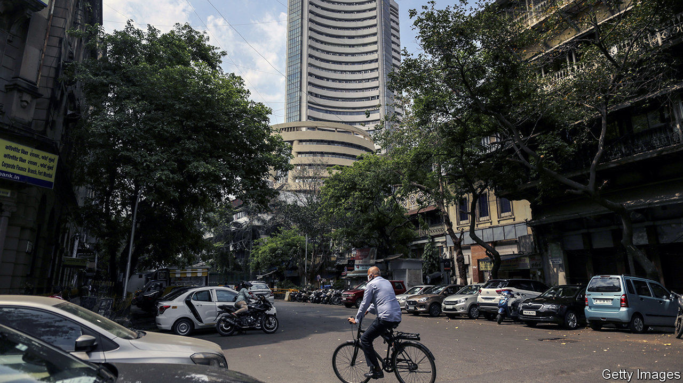

THE MOOD ON Dalal Street, Mumbai’s version of Wall Street, is jubilant. Record highs are being achieved in one session after another on the Bombay Stock Exchange, most recently on December 2nd. The Sensex, an index of the country’s biggest 30 firms, is up by around 72% since March 23rd, the day before India went into its strict lockdown; so too is the broader-based BSE 500. That is one of the largest rises among the world’s ten biggest economies. Share prices across all of the 79 sectors tracked by Capitaline, a data provider, have risen. Those for makers of cement products have gone up by 139%; those of carmakers by 89%; even those of real-estate investment trusts, hobbled by shutdowns, have risen by 5%.

This picture seems in striking contrast to that of the economy, which sustained the deepest downturn of all large countries. In the second quarter India’s GDP fell by 24% compared with the previous year; in the third, according to figures released on November 27th, it was still 7.5% lower than a year ago. The Centre for Monitoring Indian Economy (CMIE), a research firm, estimates that more than 21m jobs have been lost since the pandemic struck. In November the labour-participation rate dropped below 40% for the first time.

Meanwhile, inflation has been rising, limiting the Reserve Bank of India’s ability to cut interest rates. In October, consumer prices rose by 7.6%, well above the upper bound of the central bank’s target range. Years of deficit spending and a shortfall in tax collection mean there is little latitude for fiscal policy, either. In the third quarter, government spending fell by 22% compared with the same three months in 2019.

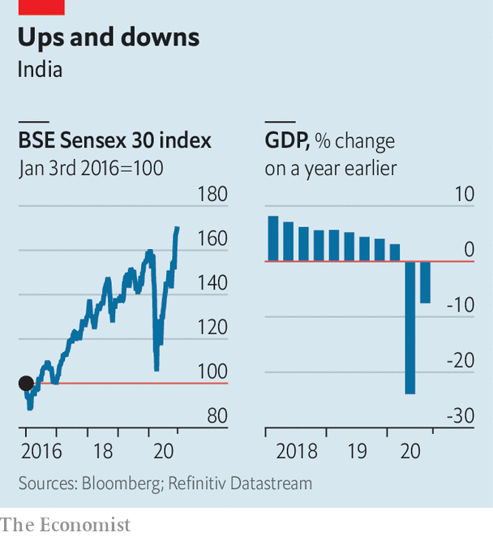

Yet it is not necessarily a contradiction for the stockmarket and the economy to go in different directions. They measure different things: the present value of future profits in the first case, and current business conditions in the second. Perhaps the stockmarket has been early in understanding India’s resilience, just as it was quick to grasp the severity of the epidemic. Share prices fell by nearly 40% between mid-February and late March, as supply chains fell apart and activity came to a standstill. Now factories are open, airports are crowded, the roads jammed with traffic and the air clogged by pollution. A renewed appetite for global risk, especially after news of effective vaccines broke, has only helped. In recent months India has been the recipient of record portfolio flows from abroad.

Investors may also have become more optimistic on growth prospects. The crisis has allowed the government to push through rule changes, such as agricultural and labour reforms, which could introduce needed efficiency. Its “Make in India” campaign is tariff-heavy, but also offers incentives to lure in foreign producers. Recent policy moves, such as the adoption of a goods-and-services tax, may have also toughened the environment for small, less formal firms, and pushed profits towards larger, listed ones.

Companies’ profits rose in the third quarter, even though revenues fell. The cost-cutting could signal greater efficiency. But it could also be a story that ends unhappily for investors, if it explains low employment and why, in the recent GDP numbers, household spending remained depressed. Growth in power consumption and freight traffic has begun to slow, suggesting the recovery may be sputtering. That would seem to bode ill for both the economy and the stockmarket. For now, though, investors are unfazed. ■

Editor’s note: Some of our covid-19 coverage is free for readers of The Economist Today, our daily [newsletter](https://my.economist.com/user#newsletter). For more stories and our pandemic tracker, see our [hub](https://www.economist.com/news/2020/03/11/the-economists-coverage-of-the-coronavirus)

This article was downloaded by calibre from <https://www.economist.com/finance-and-economics/2020/12/05/despite-a-weak-economy-indias-stockmarket-is-at-record-highs>

|  |  |  |  |
| --- | --- | --- | --- |
| Previous | Articles | Sections | Next |

|  |  |  |  |
| --- | --- | --- | --- |
| Previous | Articles | Sections | Next |

#### Free exchange

# Will central-bank digital currencies break the banking system?

Perhaps. But that might not be so bad

Dec 5th 2020 |

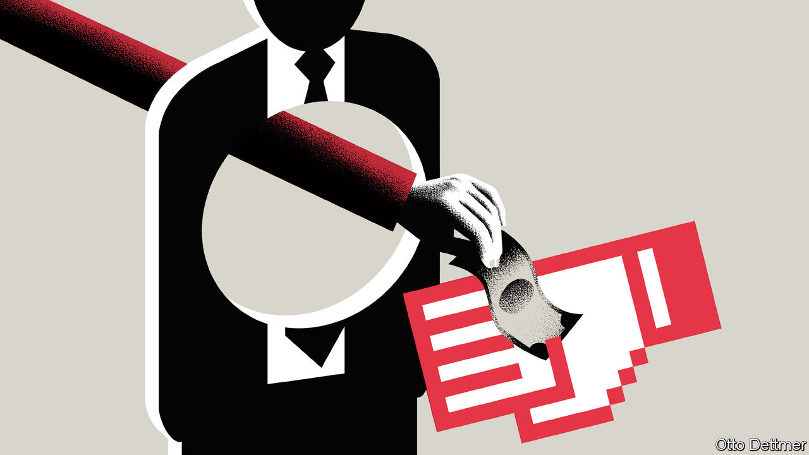

IMAGINE IT IS 2035 and a financial crisis is raging. Credit is drying up; banks’ share prices look like ski slopes and every news report features sweaty traders in shirtsleeves tugging at their collars. You log on to your banking app and peer anxiously at your savings. You could transfer them to another bank, but none seems safe. Fuelling a traditional bank run by withdrawing physical banknotes, even if there were any branches left, would be tragically passé. Luckily, there is a new escape route. At the touch of a button, you can move your funds into a central-bank digital currency (CBDC), a government-issued virtual store of value that is completely safe.

This is one scenario worrying economists working on CBDCs (of whom there are many: a survey at the start of the year found that more than 80% of central banks were studying the subject). There are many potential advantages to publicly backed digital currencies. They might make payments easier. They might “democratise” central-bank money, the part of the central bank’s balance-sheet which, unlike physical cash, only banks can access now. And they would reduce the risk that cryptocurrencies replace government tender; bitcoin has been on a tear lately, and Facebook’s digital coin—which on December 1st changed its name from “Libra” to “Diem”—will reportedly launch in January. But wouldn’t CBDCs also make it dangerously easy to flee the banks in times of stress?

It is not just in a crisis that CBDCs might compete with banks. They would be attractive assets to hold in normal times, too, especially if, like today’s central-bank money, they were a tool of monetary policy and therefore paid interest (assuming that rates are solidly positive again by 2035). Thus, commercial banks might be drained of the deposits with which they today fund their lending. Disintermediation of the banking system might make impossible the financial magic that allows households to pair long-dated mortgage borrowing with instantaneously redeemable deposits.

The budding architects of CBDCs are looking for ways round the problem. One option, which has been suggested by researchers at the Bank of England and the European Central Bank, is to limit the amount that can be held in a CBDC. Another idea, pointed out in a recent paper by Sarah Allen of the Initiative for Cryptocurrencies and Contracts, a research group, and 12 co-authors, is to rely on banks to manage the public’s holdings of CBDCs, much as many people rely on “wallets” to hold their cryptocurrency (though if the public could not hold CBDCs directly, it would not be much of an improvement on existing central-bank digital money).

The problem of disrupting the banks may be avoidable with clever engineering. But it would be wise to consider whether it even needs avoiding in the first place. For those willing to entertain futuristic ideas, CBDCs may offer an opportunity to rethink the financial system from the ground up.

Several research papers, as summarised by Francesca Carapella and Jean Flemming of the Federal Reserve in a recent review, argue that central banks could preserve maturity transformation by reordering the chain of funding. Today, households deposit money at banks, which park funds at the central bank. If people prefer CBDCs, however, the central bank could in effect pass their funds on to banks by lending to them at its policy interest rate. “The issuance of CBDC would simply render the central bank’s implicit lender-of-last-resort guarantee explicit,” wrote Markus Brunnermeier of Princeton University and Dirk Niepelt of Study Centre Gerzensee in a paper in 2019. Explicit and, perhaps, in constant use.

More central-bank lending might sound like an unwarranted expansion of government. But today’s market for deposits is hardly laissez-faire. It is not as if households inspect banks’ loan books before entrusting them with cash; they rely on the backstop of government-provided deposit insurance. And deposits are increasingly concentrated in big banks. (In fact, a recent working paper by researchers of the Bank of Canada finds that, by increasing competition for deposits, a CBDC could increase bank lending and GDP.)

The real problem with central-bank financing of banks is the risk of default. To avoid picking winners, policymakers would probably need to fund any institution that can provide satisfactory collateral. Determining which loans and other assets qualify is uncomfortable work. But central banks already make such evaluations in times of crisis. The understanding that they will accept only high-quality assets, plus minimum equity requirements to protect creditors, is supposed to prevent moral hazard.

## Carpe diem

Another idea is to make banks fund themselves with much more equity, rather than rely on deposits. That would make them look more like today’s mutual funds or other unleveraged investment vehicles. This is precisely what economists such as John Cochrane of Stanford University and Laurence Kotlikoff of Boston University have long advocated: that lenders should shed their dependence on flighty sources of financing, and that households’ funds should instead be parked in completely safe assets. For Mr Cochrane, CBDCs are an opportunity to pursue such “narrow banking”.

To fear disintermediation at the hands of CBDCs is to believe that narrow banking would starve the economy of something it needs, and that today’s “fractional-reserve” system must be preserved. But banks are not necessary for lending and borrowing to take place—in America a high share of this activity takes place in capital markets instead. If bank credit must be kept flowing, governments could subsidise it directly—making explicit what today’s architecture obscures. Better that than suppressing useful technological innovations.

Making subsidies explicit, however, is not always comfortable for the beneficiaries—or for regulators; obvious support attracts more public opprobrium. The real risk of CBDCs to the financial system may be that they eventually precipitate a new kind of run: on the idea that banks need to exist at all. ■

This article was downloaded by calibre from <https://www.economist.com/finance-and-economics/2020/12/05/will-central-bank-digital-currencies-break-the-banking-system>

|  |  |  |  |
| --- | --- | --- | --- |
| Previous | Articles | Sections | Next |

|  |  |  |
| --- | --- | --- |
| Finance & economics | Sections | Books & arts |

Science & technology

Computational biology: The shapes of things to come

.

Space flight: Tally ho!

.

Sustainable fishing: The ones that got away

.

Vaccine safety: An injection of urgency

.

|  |  |  |
| --- | --- | --- |
| Finance & economics | Sections | Books & arts |

|  |  |  |  |
| --- | --- | --- | --- |
|  | Articles | Sections | Next |

#### The shape of things to come

# How do proteins fold?

AI may have the answer to one of biology’s biggest challenges

Nov 30th 2020 |

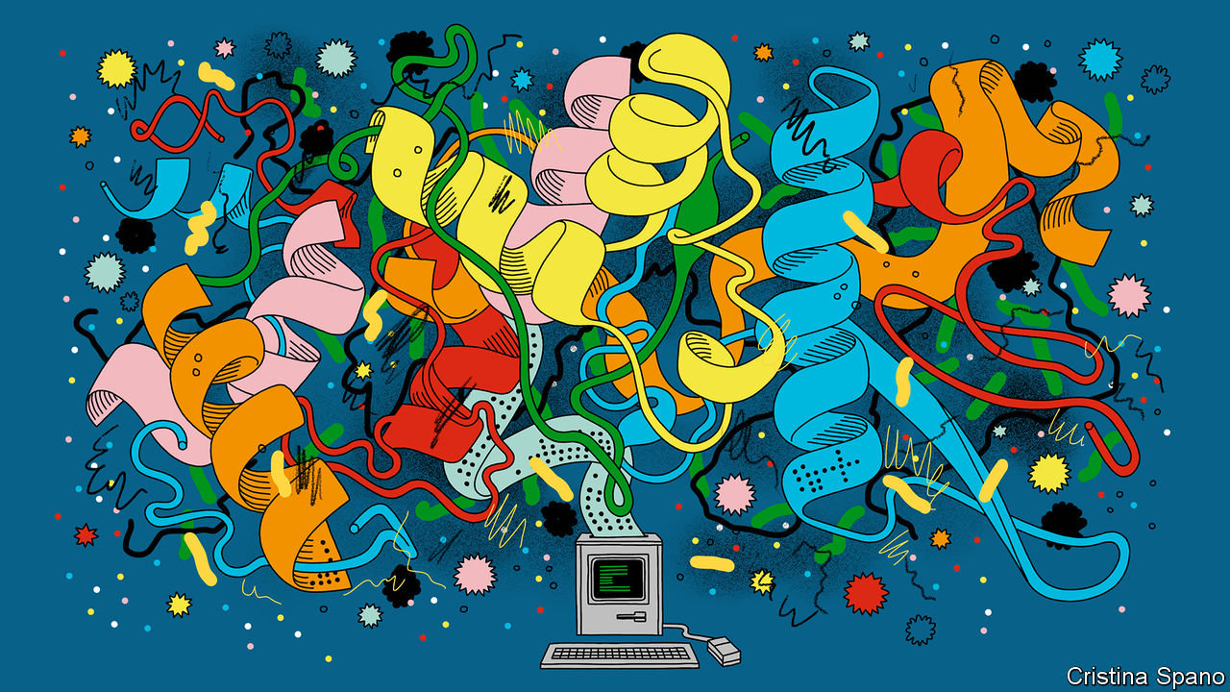

TO UNDERSTAND LIFE, you must understand proteins. These molecular chains, each assembled from a menu of 20 types of chemical links called amino acids, do biology’s heavy lifting. In the guise of enzymes they catalyse the chemistry that keeps bodies running. Actin and myosin, the proteins of muscles, permit those bodies to move around. Keratin provides their skin and hair. Haemoglobin carries their oxygen. Insulin regulates their metabolism. And a protein called spike allows coronaviruses to invade human cells, thereby shutting down entire economies.

Listing a protein’s amino acids is easy. Machines to do so have existed for decades. But this is only half the battle in the quest to understand how proteins work. What a protein does, and how it does it, depends also on how it folds up after its creation, into its final, intricate shape.

At the moment, molecular biologists can probe proteins’ shapes experimentally, using techniques like X-ray crystallography. But this is fiddly and time-consuming. Now, things may be about to get much easier. On November 30th researchers from DeepMind, an artificial-intelligence (AI) laboratory owned by Alphabet, Google’s parent company, presented results suggesting that they have made enormous progress on one of biology’s grandest challenges—how to use a computer to predict a protein’s shape from just a list of its amino-acid components.

## Chain gangs

To non-biologists, this may sound somewhere between arcane and prosaic. In fact, it is a big achievement. Replacing months of experiments with a few hours of computing time could shed new light on the inner workings of cells. It could speed up drug development. And it could in particular suggest treatments for diseases like Alzheimer’s, in which misshapen proteins are thought to play a role.

But there is yet more to it than that. Until now, the machine-learning techniques which DeepMind’s team used to attack the protein-folding problem have been best known for powering things like face-recognition cameras and voice assistants, and for defeating human beings at tricky games like Go. But Demis Hassabis, DeepMind’s boss, who founded in 2010 what was then an independent firm, did so hoping that they could also be employed to accelerate the progress of science. This result demonstrates how that might work in practice.

The idea of using computers to predict proteins’ shapes is half a century old. Progress has been real, but slow, says Ewan Birney, deputy director of the European Molecular Biology Laboratory, a multinational endeavour with headquarters in Germany. And it has been marked by a history of wrong turns and premature declarations of victory.

These days a humbler field, protein-shape prediction now measures its progress by how well algorithms perform in something called Critical Assessment of Protein Structure Prediction (CASP). This is a biennial experiment-cum-competition which started in 1994 and is jokingly dubbed the “Olympics of protein-folding”. In it, algorithms are subjected to blind tests of their ability to predict the shapes of several proteins of known structure.

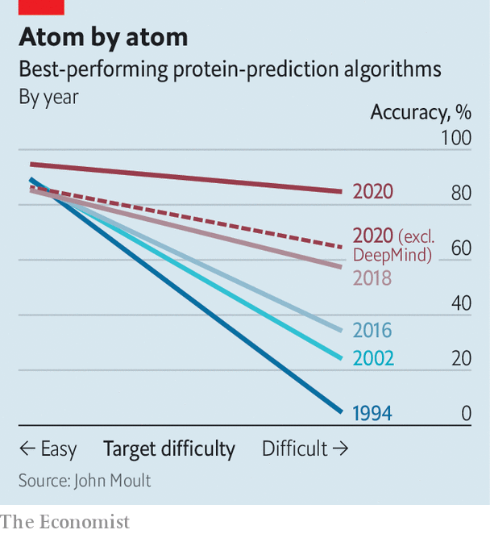

DeepMind’s first entry to CASP, two years ago, was dubbed AlphaFold. It made waves by performing much better than any other then-existing program. The current version, AlphaFold 2, has stretched that lead still further (see chart). One measure of success within CASP is the global-distance test. This assigns algorithms a score between zero and 100 by comparing the predicted locations of atoms in a molecule’s structure with their location in reality. AlphaFold 2 had an average score of 92.4—an accuracy that CASP’s founder, John Moult, who is a biologist at the University of Maryland, says is roughly comparable with what can be obtained by techniques like X-ray crystallography.

Until now, DeepMind was probably best known for its success in teaching computers to play games—particularly Go, a pastime of deceptively simple rules but fiendish strategy that had been a totem of AI researchers since the field began. In 2016 a DeepMind program called AlphaGo defeated Lee Sedol, one of the world’s best players. Superficially, this may seem of little consequence. But Dr Hassabis says that more similarities exist between protein-folding and Go than might, at first, appear.

One is the impracticality of attacking either problem with computational brute force. There are thought to be around 10170 legal arrangements of stones on a Go board. That is much greater than the number of atoms in the observable universe, and it is therefore far beyond the reach of any computer unless computational shortcuts can be devised.

Proteins are even more complicated than Go. One estimate is that a reasonably complex protein could, in principle, take any of as many as 10300 different shapes. The shape which it does eventually settle into is a result of a balance of various atom-scale forces that act within its amino-acid building blocks, between those building blocks, and between the building blocks and other, surrounding, molecules, particularly those of water. These are all matters of considerable complexity which are difficult to measure. It is therefore clear that, as with playing Go, the only way to perform the trick of predicting protein-folding is to look for shortcuts.

The progress that computers have made on the problem over the years demonstrates that these shortcuts do exist. And it also turns out that even inexpert humans can learn such tricks by playing around. Dr Hassabis recalls being struck by the ability of human amateurs to achieve good results with FoldIt, a science-oriented video game launched in 2008 that invites its players to try folding proteins themselves, and which has generated a clutch of papers and discoveries.

## Alpha-helix dogs

Getting players of FoldIt to explain exactly what they have been up to, though, is tricky. This is another parallel with Go. Rather than describing step by step what they are thinking, players of both games tend to talk in vaguer terms of “intuition” and “what feels right”. This is where the machine learning comes in. By feeding computers enough examples, they are able to learn and apply shortcuts and rules-of-thumb of the sort that human beings also exploit, but struggle to articulate. Sometimes, the machines come up with insights that surprise human experts. As Dr Moult observes, “In general, the detail of the backbone [the molecular scaffolding that joins amino acids together] is extraordinary. [AlphaFold 2] has decided that if you don’t get the details right, you won’t get the big things right. This is a school of thought that’s been around for some time, but I thought it wasn’t correct.”

As an achievement in AI, AlphaFold 2 is not quite so far ahead of the field as was AlphaGo. Plenty of other research groups have applied machine learning to the protein-structure problem, and have seen encouraging progress. Exactly what DeepMind has done to seize the lead remains unclear, though the firm has promised a technical paper that will delve into the details. For now, John Jumper, the project’s leader, points out that machine learning is a box which contains a variety of tools, and says the team has abandoned the system it used to build the original AlphaFold in 2018, after it became clear that it had reached the limits of its ability.

The current version, says Dr Jumper, has more room to grow. He thinks space exists to boost the software’s accuracy still further. There are also, for now, things that remain beyond its reach, such as how structures built from several proteins are joined together.

Moreover, as Ken Dill, a biologist at Stony Brook University in New York state, who is the author of a recent overview of the field, points out, what AlphaFold 2, its rivals and, indeed, techniques like X-ray crystallography discover are static structures. Action in biology comes, by contrast, from how molecules interact with each other. “It is”, he puts it, “a bit like someone asking how a car works, so you open the hood [bonnet] and take a picture and say, ‘There, that’s how it works!’” Useful, in other words, but not quite the entire story.

Nonetheless—and depending on how DeepMind decides to license the technology—an ability to generate protein structures routinely in this way could have a big impact on the field. Around 180m amino-acid sequences are known to science. But only some 170,000 of them have had their structures determined. Dr Moult thinks that boosting this number could help screen drug candidates to see which are likely to bind well to a particular protein. It could be used to reanalyse existing drugs to see what else they might do. And it could boost synthetic biology, by speeding up the creation of human-designed proteins intended to catalyse chemical reactions.

Some promising successes have, indeed, already happened. For example, AlphaFold 2 was able to predict the structures of several of the proteins used by the new coronavirus, including spike. As for Dr Birney, he says, “We’re definitely going to want to spend some time kicking the tyres. But when I first saw these results, I nearly fell off my chair.” ■

This article was downloaded by calibre from <https://www.economist.com/science-and-technology/2020/11/30/how-do-proteins-fold>

|  |  |  |  |
| --- | --- | --- | --- |
|  | Articles | Sections | Next |

|  |  |  |  |
| --- | --- | --- | --- |
| Previous | Articles | Sections | Next |

#### The Starship SN8

# Elon Musk’s latest adventure

He hopes it will be a stepping stone to the Moon and Mars

Dec 5th 2020 |

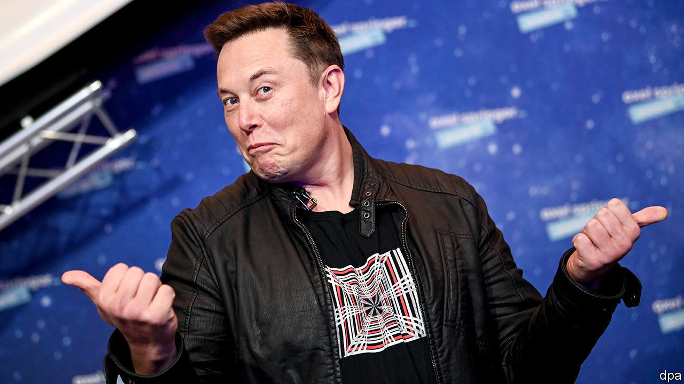

IF ALL GOES well, Elon Musk’s plan to conquer the universe will soon take another step forward, with the flight of Starship SN8, a rocket built by his company, SpaceX. SN8 is expected to rise from its launch pad at Boca Chica, in Texas, sometime between December 4th and 6th. (SpaceX have not confirmed this, but a local flight restriction has been imposed on the area for that period.) The idea is that it will fly to an altitude of 15km, cut its engines, tip slowly forward until it is parallel with Earth’s surface, and let gravity take its course. Then, shortly before it hits the ground, it will fire its thrusters again to realign itself vertically and will thus come gently to rest on a landing pad a few hundred metres away from where it took off.

SN8 is, as its name suggests, the eighth in the current series of prototypes for SpaceX’s proposed Starship (SN stands for “serial number”). It is, though, the first to have a nose cone, and thus to assume the distinctive atmosphere-penetrating shape normally sported by space rockets. It also has more oomph than its predecessors. Previous SNs have used just one of SpaceX’s Raptor engines, and have, if launched (some were used for ground tests), reached a height of no more than 150 metres. SN8 includes three Raptors—half the number expected for the finished design.

Strictly, SN8 is a prototype of only the second stage of the Starship that SpaceX proposes eventually to build. Its successors are intended to sit on an as-yet-to-be-constructed “Super Heavy” rocket that will deliver the bulk of the firepower. This first-stage vehicle is expected to house up to 37 Raptors. These will give it double the thrust developed by the first stage of a Saturn V, the launch vehicle America used for its crewed Moon missions. And the Moon is, indeed, an intended destination, though the craft will earn most of its bread and butter ferrying goods and people into orbits close to Earth—a task for which it has a capacity of 100 tonnes.

## Here I am, sitting in my tin can

Crucially, unlike a Saturn V, every part of which except the capsule containing the crew was thrown away during the course of a mission, a Starship will be fully recyclable, with both stages returning to Earth in a manner similar to SN8. Moreover, unlike Saturn’s partially recyclable successor, the Space Shuttle, refurbishing a Starship for relaunch will not cost $1bn a pop. Instead, Mr Musk estimates, the turnaround will require only a few million dollars.

Starships should also be cheap to build. Instead of a fancy carbon-fibre composite they are made of stainless steel, which is a seventieth as expensive, but is, in many ways, better. Not only is it resistant to the fracturing to which a composite might be prone in the low temperatures of outer space, but its melting-point is also high enough to prevent damage in the fiery conditions of re-entry. This is an important part of a Starship’s easy recyclability.

When an entire Starship will fly is still anyone’s guess. Mr Musk has a good record of doing what he says, but his timings have a tendency to slip. For a man who famously once said his ambition was to die on Mars, but not on impact, the Starship project is an important step on the road to his intended retirement home. Bases on the Moon or Mars would need frequent resupply from Earth. That would be made easier by high-powered reusable rockets.

Mr Musk has, himself, put the odds of SN8’s flight being successful at three to one against. If it does succeed, however, the odds against his wider vision of the future coming true will shorten.■

This article was downloaded by calibre from <https://www.economist.com/science-and-technology/2020/12/05/elon-musks-latest-adventure>

|  |  |  |  |
| --- | --- | --- | --- |
| Previous | Articles | Sections | Next |

|  |  |  |  |
| --- | --- | --- | --- |
| Previous | Articles | Sections | Next |

#### The ones that got away

# A device called Nemo will shed light on small-scale fisherfolk

No one knows the size of their catch

Dec 5th 2020 |

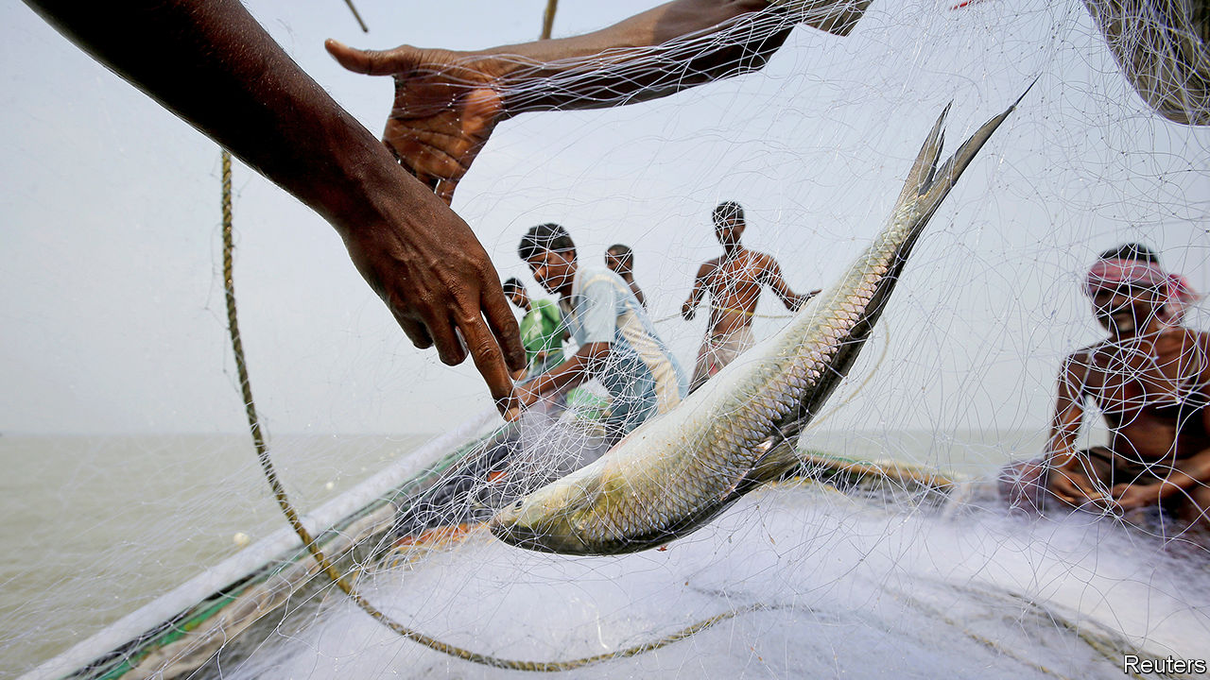

FISH ARE being plundered from the ocean at an alarming rate. According to the UN Food and Agriculture Organisation some 90m tonnes of commercial catch are hauled from the sea every year. And that is only for legitimate, commercial fishing vessels. Even setting aside the huge amount of illegal fishing that goes on, few authorities monitor the activities of the 50m or so fisherfolk who operate small boats in local waters with the aim of feeding their families, or of selling their catch harbourside or into local markets. So an attempt is now under way to collect some of these missing data.

The combined catch of such small-scale fishing could be half as much again as the reported global catch, according to Michel Dejean, director of sustainable fisheries for CLS Group. CLS is a subsidiary of France’s space agency that, among other things, helps monitor, via satellite, the transponders on large fishing boats operating around the world. (Those that switch off their transponders are tracked by radar.)

For small craft, though, CLS requires something simpler and cheaper. This is where the group’s experience in another area has come in useful—for the organisation also tracks marine birds and sea mammals, and for this it employs low-powered transponders. Engineers at CLS have used that expertise to come up with Nemo, a self-contained transponder powered by a built-in solar panel, since many small fishing boats do not have electrical power on board. Nemo is about the size of a shoe. Once attached to a boat, it transmits its position either via satellite or, if within range of local services, mobile phone.

Working with local fishery authorities and other organisations in Asia and South America, CLS hopes to have deployed around 1,000 Nemos by the end of 2020. Costs are still being worked out, but the price of such a transponder is generally a few hundred dollars. That compares with several thousand for the sorts of system fitted to large commercial boats. Local fishing groups are also likely to come up with their own schemes to supply or lease the units.

From CLS’s point of view the idea is that, by knowing when a vessel has put to sea and where it has been fishing, it will be possible to build up a clearer picture of how small-scale fisheries operate in particular places. Also, reported catches can be verified against vessels’ actual locations. For this to stand any chance of working, however, fisherfolk must be persuaded that they, too, have an interest in having a Nemo attached to their boat. To do this, says Mr Dejean, means building a good safety and business case.

As far as safety is concerned, fish-depleted inshore waters mean that many people are being forced to sail farther out to sea—often beyond mobile-phone range. This scuppers their only way of contacting home if something goes wrong. Nemo’s satellite connection overcomes that, and, to make doubly sure, the device is fitted with a single-button distress beacon which can summon help in a crisis. As to commercial incentive, the record of fishing grounds visited will, CLS hopes, allow crews to obtain higher prices from concerned customers by proving their catches come from “sustainable” sources.

Whether either of these baits will, in practice, hook enough of the world’s small fisherfolk remains to be seen. But even if only a few sign up, it may help plug a worrying hole in the planet’s fishery data. ■

This article was downloaded by calibre from <https://www.economist.com/science-and-technology/2020/12/05/a-device-called-nemo-will-shed-light-on-small-scale-fisherfolk>

|  |  |  |  |
| --- | --- | --- | --- |
| Previous | Articles | Sections | Next |

|  |  |  |  |
| --- | --- | --- | --- |
| Previous | Articles | Sections | Next |

#### An injection of urgency

# Britain becomes the first country to license a fully tested covid-19 vaccine

Inoculations with the Pfizer-BioNTech jab could start in less than a week

Dec 5th 2020 |

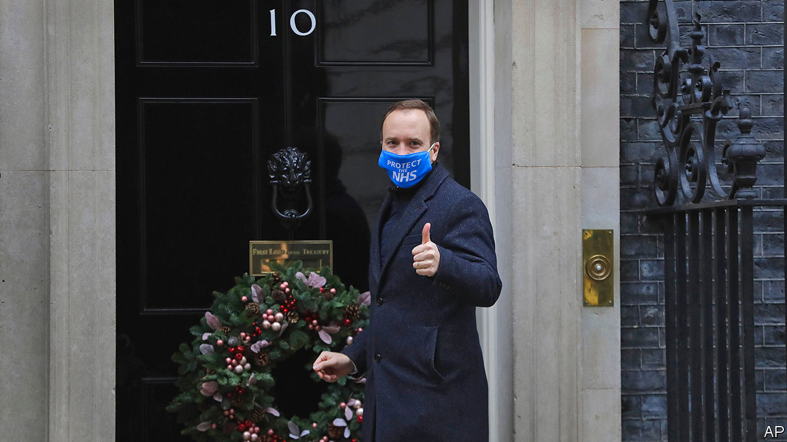

ON DECEMBER 2ND Britain became the first country to permit the general use of a fully tested covid-19 vaccine. The decision to grant this emergency authorisation had been made late the previous evening by the country’s Medicines and Healthcare-products Regulatory Agency (MHRA).

The vaccine licensed is code-named BNT162b2 and was developed by Pfizer, an American pharmaceutical giant, and BioNTech, a smaller German firm. It has an efficacy of 95%, a figure that seems consistent across a range of ages and ethnicities. Britain had already ordered 40m doses of BNT162b2 and Pfizer, as soon as it was informed of the decision, activated the procedures needed to start importing it from the site in Puurs, Belgium, where it is being made. The plan is to start vaccinating people on December 7th, and Matt Hancock, Britain’s chief health minister (pictured), has said that he expects “a matter of millions of doses” of the vaccine to be available in the country by the end of the year.

According to Pfizer, other countries are now looking to Britain and wondering if they can similarly speed up their regulatory processes. And the World Health Organisation, which runs an emergency licensing procedure for countries without medical regulators, said on December 2nd that it was in discussions with the MHRA about the details of that agency’s assessment, in order to expedite its own work in this area.

## Safety first

The speed with which this anticovid vaccine and others are moving through some of the world’s regulatory systems is a result of rolling reviews of their trials. Instead of waiting for firms to collate and submit full data-and-safety packages, regulators have studied results as they became available.

For some, though, things are not moving quickly enough. On December 1st, the day before Britain’s announcement, Stephen Hahn, the head of America’s Food and Drug Administration (FDA), was summoned to the White House to answer questions about why his agency has not moved faster to approve BNT162b2. As it happens, both the FDA and its counterpart in the European Union, the European Medicines Agency, have arranged public meetings in coming weeks in which covid-19 vaccines will be discussed ahead of regulatory decisions. Melanie Ivarsson, chief development officer at Moderna, an American firm that announced encouraging results for its own vaccine, mRNA-1273, a week after Pfizer and BioNTech, said these were important, as they allow independent experts to look at the safety and the analysis, and also let the public ask questions—something that will build confidence in these vaccines. “We want people to feel really comfortable,” says Dr Ivarsson.

Both BNT162b2 and mRNA-1273 belong to a class known as mRNA vaccines. Though this is the first time such a vaccine has been authorised for human use, experts are optimistic about their general safety because they have been tested in various cancer-related applications for over a decade. As to BNT162b2 and mRNA-1273 in particular, these have now been in trials involving 73,000 volunteers, half of whom have been given the vaccine and the other half a placebo of some sort. This constitutes a hefty set of data. And both vaccines seem to have been well tolerated, with no serious adverse events recorded.

On top of all this, health authorities have already laid safety-related follow-up plans, says Penny Ward, chairwoman of the education and standards committee of the Faculty of Pharmaceutical Medicine, a British group of doctors. These include systems for examining apparent adverse reactions and using anonymised health-care records to see how incidence of covid-19 varies between the vaccinated and the unvaccinated. One concern with any new vaccine is that it may increase the risk of infection in some groups. Another is that, in rare cases, vaccines trigger autoimmune reactions—something viral infections also do. With covid-19 vaccines being delivered to hundreds of millions, and then billions of people, much surveillance will be needed.

There are, as it happens, reasons to think that mRNA vaccines might actually be safer than some other kinds. Live vaccines (that against polio, for example) are weakened versions of the virus itself. This brings a risk that the virus will revert to a more dangerous form. With an mRNA vaccine, which is merely a bunch of strands of genetic material—mRNA—encapsulated in tiny spheres of fat, this cannot happen. This mRNA encodes not the instructions for how to make a virus, but rather how to make just one of its proteins, called spike. Thus directed, body cells turn out spike in quantity, and that stimulates a response which primes the immune system to react quickly if it comes across spike again—this time as part of an invading virus.

Also, mRNA is a natural component of living cells, which make and destroy it continuously. Its turnover rate is measured in days. So, once the mRNA from the vaccine has done its job it is quickly broken down. Yet misinformation is already being spread. One particularly pernicious falsehood is that the mRNA in the vaccine will alter a recipient’s DNA. This is about as likely as Isaac Newton’s apple falling upwards. RNA and DNA are different, and mammalian cells have no molecular mechanism for transcribing the former into the latter.

Maintaining public trust in any authorised vaccine is important. That trust may be more forthcoming in Britain than in many places. Polls say 79% of the country’s inhabitants intend to get vaccinated against covid-19, which is above the international average. In America, for example, only 64% state such an intention.

## But whose safety exactly?

Ultimately all decisions to approve medicines are made on a balance of risks versus benefits. For the approval of a vaccine, however, the likely benefits must vastly outweigh the possible risks. This is because, unlike drugs, which are generally prescribed to those who are already sick, vaccines are usually administered to healthy people.

The MHRA, for one, takes advice from an independent scientific committee in making its choices. But, though its members will have taken into account many factors when deciding to grant emergency authorisation to BNT162b2, one brutal calculation will surely have been near the fronts of their minds. This is that each day of waiting will be measured in lost lives. In Britain alone, on the day the government gave permission to use BNT162b2, covid-19 killed 603 people. ■

Editor’s note: Some of our covid-19 coverage is free for readers of The Economist Today, our daily [newsletter](https://my.economist.com/user#newsletter). For more stories and our pandemic tracker, see our [hub](https://www.economist.com/news/2020/03/11/the-economists-coverage-of-the-coronavirus)

This article was downloaded by calibre from <https://www.economist.com/science-and-technology/2020/12/05/britain-becomes-the-first-country-to-license-a-fully-tested-covid-19-vaccine>

|  |  |  |  |
| --- | --- | --- | --- |
| Previous | Articles | Sections | Next |

|  |  |  |
| --- | --- | --- |
| Science & ... | Sections | Economic & ... |

Books & arts

Books of the year: Cold comforts

.

Books by Economist writers: Private passions

.

|  |  |  |
| --- | --- | --- |
| Science & ... | Sections | Economic & ... |

|  |  |  |  |
| --- | --- | --- | --- |
|  | Articles | Sections | Next |

#### Cold comforts

# Our books of the year

They were about corruption, revolutionaries, Glasgow in the 1980s, John Maynard Keynes and musical lives

Dec 5th 2020 |

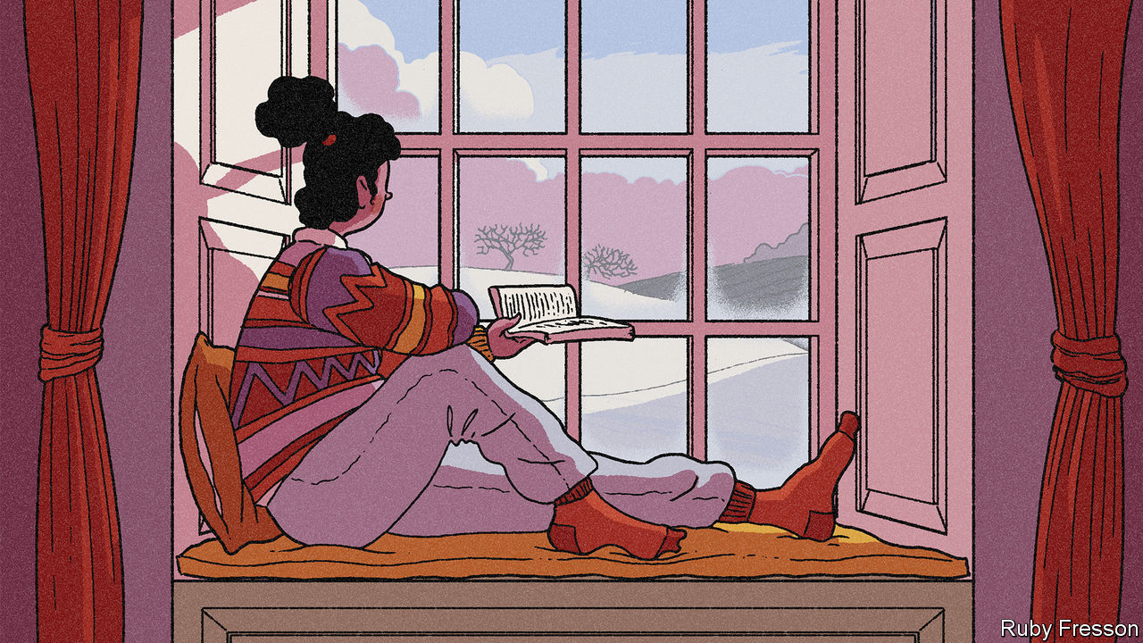

## Politics and current affairs

Kleptopia: How Dirty Money is Conquering the World. By Tom Burgis. Harper; 464 pages; $28.99. William Collins; £20

It is hard to write about international corruption in an accessible and colourful way, while retaining an urgent sense of moral condemnation. This book beautifully captures both the murkiness and turpitude involved. Its ultimate theme—the intersection of politics and personal enrichment—is one of the most important stories of the age.

Putin’s People. By Catherine Belton. Farrar, Straus and Giroux; 640 pages; $35. William Collins; £25

Many books have tried to explain the rise and ruthlessness of Vladimir Putin; this one is the closest yet to a definitive account. It draws on extensive interviews and archival sleuthing to tell a vivid story of cynicism and violence. On this view, a massive concentration of wealth and power in the hands of a few is used to quash dissent and project force abroad.

Eat the Buddha: Life and Death in a Tibetan Town. By Barbara Demick. Random House; 352 pages; $28. Granta; £18.99

This is the grippingly told story of Ngaba, a county seat near the edge of the Tibetan plateau, and of the sufferings of its people under the Chinese Communist Party’s rule. Exploring an area rarely visited by foreigners, the author paints striking portraits of people living there, with a fine eye for detail and a keen grasp of Tibet’s history.

Irreversible Damage. By Abigail Shrier. Regnery Publishing; 276 pages; $28.99 and £22

A critical look at the enormous rise in recent years in people identifying as trans, especially among girls. It covers a brewing scandal over the provision of irreversible treatments, whether surgical or pharmaceutical, to teenagers. Predictably controversial—yet there is not a drop of animosity in the book.

Should Auld Acquaintance Be Forgot. By John Lloyd. Polity; 224 pages; $25 and £20

A timely, forceful rehearsal of the painful consequences that might follow independence for Scotland, and of the virtues of union with England. The author, a distinguished journalist, makes a case for enhanced devolution, powerfully enlisting and evoking his own childhood in a Scottish fishing village.

Why the Germans Do It Better. By John Kampfner. Atlantic Books; 320 pages; £16.99

This breezy but comprehensive paean argues that Germany’s culture of consensus and stability has bred a resilience unusual among crisis-prone democracies. Despite the teasing title—a jab at the author’s native Britain—it acknowledges Germany’s problems, from creaking infrastructure to somnolent foreign policy.

Twilight of Democracy. By Anne Applebaum. Doubleday; 224 pages; $25. Allen Lane; £16.99

Mixing personal anecdote and analysis, a well-connected historian of communism chronicles the collapse of the international liberal coalition that was forged during the cold war. A perceptive insight into the rise of authoritarian populism.

## Biography and memoir

Black Spartacus. By Sudhir Hazareesingh. Farrar, Straus and Giroux; 464 pages; $30. Allen Lane; £25

The subject of this superbly researched book was born a slave and grew up to be the leading figure in the uprising of 1791, in modern Haiti, which reverberated around the world. Fragmentary records have until now meant Toussaint Louverture was a shadowy historical character; this reconstruction gives his political, military and intellectual accomplishments their due.

A Promised Land. By Barack Obama. Crown Publishing Group; 768 pages; $45. Viking; £35

There is little score-settling and much introspection in this account of the author’s rise to the White House and his first few years in it. Reflective and reasonable almost to a fault, the book is also a reminder that the 44th president is one of the best writers ever to serve in that office.

Stranger in the Shogun’s City. By Amy Stanley. Scribner; 352 pages; $28. Chatto & Windus; £16.99

Set in the first half of the 19th century, this story of an obscure woman’s everyday struggles in what is now Tokyo is a triumph of scholarship. Using a trove of documents about her downtrodden subject, the author lifts the veil on a half-remembered world of beauty and cruelty.

House of Glass. By Hadley Freeman. Simon & Schuster; 352 pages; $26. Fourth Estate; £16.99

Living out her final years in Florida, the author’s grandmother, Sala, longed for Paris. She was actually born in what today is Poland, fleeing from the pogroms to France. Her family’s intricately reconstructed lives are a moving parable of the Jewish 20th century. One of her brothers was murdered in Auschwitz. Another leapt from a train, joined the resistance and later became friends with Picasso.

Kiss Myself Goodbye. By Ferdinand Mount. Bloomsbury; 272 pages; $30 and £20

This is the hilarious tale of a bizarre, multi-bigamist, pathologically inventive aunt in raffish, upper-class Britain either side of the second world war. Part detective story, part social history, it moves from the backstreets of Sheffield to Claridges.

## History

Underground Asia. By Tim Harper. Harvard University Press; 864 pages; $39.95. Allen Lane; £35

A brilliant study of Asian revolutionary movements in the first decades of the 20th century, showing how a collective consciousness emerged in the liminal cracks of empire—in steerage class on steamships, in the doss houses of port cities and radical circles in London and Paris. Western ideas raced back to Asia, undermining colonial rule. The revolutionaries’ big truth, says the author, was that Asia lay “at the forefront of human futures”.

Every Drop of Blood. By Edward Achorn. Atlantic Monthly Press; 336 pages; $28. Black Cat; £19.99

Abraham Lincoln’s second inaugural address, delivered towards the end of the civil war, is etched on the wall of his memorial in Washington. Declining to gloat, the soon-to-be victorious—and assassinated—president instead advocated “malice toward none” and “charity for all”. This book richly evokes the intellectual origins and context of a speech that remains a model of political magnanimity.

A House in the Mountains. By Caroline Moorehead. Harper; 416 pages; $29.99. Chatto & Windus; £20

After the country capitulated to the Allies in 1943, around 80,000 partisans in northern Italy died in a fight for freedom against fascist loyalists and their Nazi backers. Weaving deep research into a compelling narrative, this book tells the story of four women involved in the struggle.

Alaric the Goth. By Douglas Boin. W.W. Norton; 272 pages; $26.95 and £19.99

History may mostly be written by the victors, but the destruction of Rome by the far less literate Goths in 410AD is an exception. This colourful portrait of the city and empire in the fifth century tells their side of the story. Rich Romans lived in splendour while Goths endured slavery. Alaric, their leader, served in the Roman army—before turning on the oppressors.



India’s Founding Moment. By Madhav Khosla. Harvard University Press; 240 pages; $45 and £36.95

A punchy reminder of the success of India’s birth as a democratic republic. The genius of its constitution kept the country on course for seven decades of peace and (slow) growth; but it has suffered erosion in the era of Narendra Modi.

## Fiction

The Slaughterman’s Daughter. By Yaniv Iczkovits. Translated by Orr Scharf. MacLehose Press; 528 pages; £18.99. To be published in America by Schocken in February; $28.95

Echoes of Russian and Yiddish literature resound in this delightful picaresque, but you need not hear them to enjoy it. It is the late 19th century, and a Jewish mother in the Pale of Settlement sets out to retrieve her wayward brother-in-law from Minsk. Technicolour characters, pathos and humour are all wonderfully captured in a nimble translation from the Hebrew.

Shuggie Bain. By Douglas Stuart. Grove Press; 448 pages; $17. Picador; £14.99

This richly told coming-of-age story, set in the deprived Glasgow of the 1980s, won this year’s Booker prize. Though the title character charms with his humorous sideways look at the world, the emotional centre of the book is his “disintegrating mother”, Agnes, whose high hopes are tragically derailed by alcoholism.

My Dark Vanessa. By Kate Elizabeth Russell. William Morrow; 384 pages; $27.99. Fourth Estate; £12.99

The title comes from a novel by Vladimir Nabokov, and the story is in part a reworking of “Lolita”, recounting a teenage girl’s grooming and abuse by a middle-aged teacher. In intercut sections she looks back on those events from adulthood, through a haze of twisted memory. A powerful tale that will strike a chord with many women—but really ought to be read by men.

The Glass Hotel. By Emily St John Mandel. Knopf; 320 pages; $26.95. Picador; £14.99

This immersive novel’s main character is a bartender who becomes the trophy wife of a con-man, then a cook on a container ship. Evoking the atmosphere of the financial crash of 2008, its real theme is the difficulty of outrunning the past. “There are so many ways to haunt a person,” the author writes, “or a life.”

The Ministry for the Future. By Kim Stanley Robinson. Orbit; 576 pages; $28 and £20

Climate change is a notoriously tough subject for novelists—this is its most important treatment for some time. Led by an Irish former minister, an intergovernmental body explores avenues from terrorism to geoengineering to central banking as it bids to avert disaster. At times horrifying, at others seeming almost to spin out of control, the book is powered by a hopeful yet illusionless vision of the future.

Homeland Elegies. By Ayad Akhtar. Little, Brown; 368 pages; $28. Tinder Press; £18.99

A dazzling, part-autobiographical tale about growing up as a Pakistani-American through the age of 9/11 and then Donald Trump. It grapples with ambivalence about Islam, permanent feelings of unbelonging and the hazards of material success. By a Pulitzer-prizewinning playwright.

The Perfect Nine. By Ngugi wa Thiong’o. The New Press; 240 pages; $23.99. Harvill Secker; £12

Most writers lose their energy and inventiveness as they grow old. Not the 82-year-old Kenyan author of this fresh and magical novel. Written in galloping blank verse, it tells of the very first Kikuyu and their passionate attachment to Mount Kenya, the home of their god, Ngai.

Burnt Sugar. By Avni Doshi. The Overlook Press; 240 pages; $26. Hamish Hamilton; £14.99

“I would be lying,” the narrator begins, “if I said my mother’s misery has never given me pleasure.” Antara, now an adult, cannot forgive her parent’s failings and cruelties yet feels compelled to care for her as dementia takes hold. This gripping debut novel probes the ties that bind as well as the slippery nature of memory.

## Culture and ideas

Magdalena: River of Dreams. By Wade Davis. Knopf; 432 pages; $30. Bodley Head; £25

The river of the title is the heart and soul of Colombia. As well as bisecting the country, the waterway is “the wellspring of Colombian music, literature, poetry and prayer”, says the author, a Canadian anthropologist and explorer. Travelling the 1,000-mile length of the Magdalena, on foot, horseback, by car or—often—by boat, he has produced an enchanting chronicle blending culture, ecology and history.

Mozart: The Reign of Love. By Jan Swafford. Harper; 832 pages; $45. Faber & Faber; £30

Mozart’s compositions, notes this outstanding account of his life and work, display “a kind of effortless perfection so easily worn that they seem almost to have written themselves”. In this telling Mozart was a fundamentally happy man, a genius with an enduringly childish sense of humour. The author, a composer himself, peppers his narrative with penetrating insights into the music.

Time of the Magicians. By Wolfram Eilenberger. Translated by Shaun Whiteside. Penguin; 432 pages; $30. Allen Lane; £25

High thinking and low politics meet in this lively group portrait of four revolutionary German-language philosophers in the 1920s. Ludwig Wittgenstein, Walter Benjamin and Martin Heidegger all gazed thrillingly into the post-war cultural abyss; as a Nazi stooge, Heidegger jumped in. Only the decent, liberal Ernst Cassirer, “thinker of the possible”, entirely kept his head.

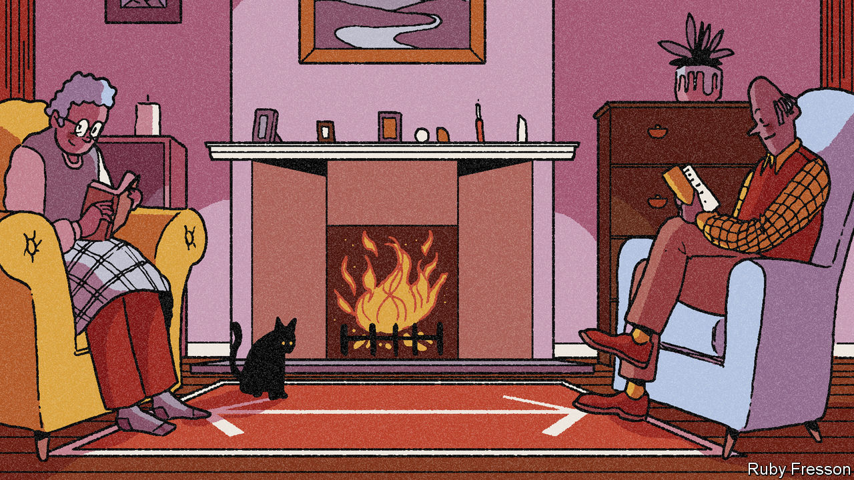

Leo Tolstoy. By Andrei Zorin. Reaktion Books; 224 pages; $19 and £11.99

The lineaments of Tolstoy’s astonishing life are well known: the libertinism, the remorse, the masterpieces, the infamously unhappy marriage and death at the train station in Astapovo. But this elegant, perceptive biography weaves together his times, his writing, his faith and his political activism into a single, seamless whole.

150 Glimpses of the Beatles. By Craig Brown. Farrar, Straus and Giroux; 592 pages; $30. Published in Britain as “One, Two, Three, Four”; Fourth Estate; £20

Books about the Beatles often get bogged down in minute details of the band’s career. This one cuts through the morass with wit and style, in an ingenious history that homes in on 150 revealing and entertaining anecdotes. Ringo comes out well, the others not so much.

## Science and technology

A Dominant Character. By Samanth Subramanian. W.W. Norton; 400 pages; $40. Atlantic Books; £20

The subject of this astute book was a giant of British science. J.B.S Haldane helped flesh out Darwin’s theory of natural selection by marrying it to genetics and grounding it in maths. He served in the trenches during the first world war and wrote prodigiously. A committed communist, he was slow to acknowledge the Soviet Union’s depredations. “Even if the professors leave politics alone,” he remarked, “politics won’t leave the professors alone.”

The End of Everything (Astrophysically Speaking). By Katie Mack. Scribner; 240 pages; $26. Allen Lane; £20

The universe had a beginning and, one day, it will end. The author uses the latest physics to explore the possibilities for doomsday. Despite her solemn theme, her humour and eclectic references (from Shakespeare to “Battlestar Galactica”) carry the book along. Even through discussions of cutting-edge science, the general reader is never bewildered.

The Human Cosmos. By Jo Marchant. Dutton; 400 pages; $28. Canongate; £16.99

From the beginning of human civilisation, religion, art and science have been preoccupied by the stars and other celestial wonders. This is a thought-provoking look at how fascination with the heavens has shaped human culture, and still does.

Privacy is Power. By Carissa Véliz. Bantam Press; 288 pages; £12.99. To be published in America in June; $24.95

The constant and ubiquitous collection of data on private citizens is an abusive system that undermines their rights, argues an Oxford philosopher. Her solutions, such as banning the trade in personal data, may be extreme, but she galvanises an urgent conversation.

Apollo’s Arrow. By Nicholas Christakis. Little, Brown; 384 pages; $29 and £20

A leading sociologist and scientist considers the history of plagues and how some countries blundered in their responses to covid-19. Pandemics are not just biological but sociological, he notes: viruses mutate but human behaviour changes, too.

## Business and economics

No Filter. By Sarah Frier. Simon & Schuster; 352 pages; $28. Random House Business; £20

Drawing on the author’s close access to insiders at Instagram, this is a lively and revealing view of how the world came to see itself through the platform’s lens. Her tale includes glimpses of Silicon Valley’s weirdness, and an account of Instagram’s sale to Facebook—and its sour aftermath.

No Rules Rules. By Reed Hastings and Erin Meyer. Penguin Press; 320 pages; $28. Virgin Books; £20

Limitless holiday and no formal expense caps sound like a recipe for corporate chaos. In a rare book by a chief executive that is both readable and illuminating, the boss of Netflix—and his co-author—explain how he arrived at these and other radical management rules, and why they are not as bonkers as they sound.

The Price of Peace. By Zachary Carter. Random House; 656 pages; $35 and £25

This wonderfully written portrait of John Maynard Keynes traces the evolution of his thinking about political economy. It recasts his contributions to 20th-century intellectual life in a way both enlightening and truer to his thought than most accounts given in the classroom.

The Myth of Chinese Capitalism. By Dexter Roberts. St Martin’s Press; 288 pages; $28.99 and £22.99

An unvarnished look at the rural migrants who have fuelled China’s long boom but remain second-class citizens. The author combines sharp analysis with the story of a family he followed for two decades.

Fully Grown. By Dietrich Vollrath. University of Chicago Press; 296 pages; $27.50 and £20

A wide-ranging and original study of the slowdown in economic growth in America in recent decades. The author attributes it to the exhaustion of returns from the spread of education and women entering the workforce, and the switch towards services as people have become richer. These trends are welcome, he argues: a lack of low-hanging fruit means you have successfully picked it all.

Open: The Story of Human Progress. By Johan Norberg. Atlantic Books; 448 pages; $24.95 and £20

Progress depends on openness, this book contends, yet that creates a backlash, since people are hard-wired to fear rapid change. The author marshals arresting examples from every continent and era, ending on an optimistic, timely note. Recent years have seen the rise of populist demagogues who want to pull up drawbridges—but such leaders eventually lose power because they are hopeless at governing.

This article was downloaded by calibre from <https://www.economist.com/books-and-arts/2020/12/05/our-books-of-the-year>

|  |  |  |  |
| --- | --- | --- | --- |
|  | Articles | Sections | Next |

|  |  |  |  |
| --- | --- | --- | --- |
| Previous | Articles | Sections | Next |

#### Private passions

# Books by our writers

Our correspondents pondered economics, jewellery, revolution, sport and the pandemic

Dec 5th 2020 |



More. By Philip Coggan. Hachette; 496 pages; $34. Profile Books; £25

A history of the global economy by our Bartleby columnist. Covering the development of key sectors such as manufacturing and energy production, it shows how links between people and countries have allowed individuals to grow not just more prosperous, but taller and stronger, and to live longer and have more choice in how they run their lives. A “brilliant survey”, thought the Times; a “fantastic sweep”, reckoned the Financial Times.

Coveted. By Melanie Grant. Phaidon; 208 pages; $89.95 and £69.95

When, asks the picture and luxury editor of 1843, does jewellery make the leap from fashion accessory to art? Her richly illustrated profiles of leading designers range from Fabergé’s and Cartier’s links to Art Nouveau and Art Deco, to the collaboration between Georg Jensen, a Scandinavian brand, with the architect Zaha Hadid. The New York Times said the book showed “the complexity, power and artistic impact of great design”.

Independence Square. By A.D. Miller. Pegasus Books; 228 pages; $25.95. Harvill Secker; £14.99

A nation’s future, and a man’s fate, hang in the balance in this novel of revolution and betrayal. Set between an icy upheaval in Kyiv and a London summer, it stars a sly oligarch, an idealistic young activist and a disgraced British diplomat. “Utterly gripping,” said the Observer, “a novel with its finger on the pulse of geopolitics that still manages to move deeply.” The Spectator called it “a searing indictment of our times”. By our culture editor.

Unconventional Wisdom. Edited by Tom Standage. Economist Books; 272 pages; $11.99. Profile Books; £8.99

A compendium of our explainer articles and daily charts, which spell out how much a ghost reduces a house’s value, how pregnancy makes people more law-abiding and why friends prefer sloppily wrapped Christmas gifts. Compiled by one of our deputy editors.

The Best. By Tim Wigmore and Mark Williams. Mobius; 256 pages; $24.95. Nicholas Brealey; £20

A contributor on sport and his co-author cover topics such as why younger siblings have more chance of becoming elite sportsmen, why mid-sized towns produce the most champions and the science of performance. They draw on interviews with Marcus Rashford, Pete Sampras and Steph Curry, among others. “Excellent,” said the Australian.

The Classical School. By Callum Williams. Hachette; 288 pages; $16.99. Profile Books; £20

A high-speed history of Western economic thought, by our senior economics writer, told in the form of 20 biographies. Alongside household names such as Adam Smith and John Stuart Mill, there are chapters on lesser-known figures such as Harriet Martineau and Dadabhai Naoroji. The Times called it a “brisk, absorbing and entertaining history lesson” with “an engaging cast of characters” that “leaves you a lot wiser”.

The Wake-Up Call. By Adrian Wooldridge and John Micklethwait. HarperVia; 176 pages; $18. Short Books; £9.99

The pandemic, say our political editor and Bloomberg’s editor-in-chief, proves that government is not just a diversion for politicians but a matter of life and death. The poor performance of Western democracies, particularly America and Britain, shows how far they have fallen behind the Far East, notably China. “A shot in the arm,” said the Financial Times. “Full marks for sounding the alarm,” said the Times Literary Supplement.

This article was downloaded by calibre from <https://www.economist.com/books-and-arts/2020/12/05/books-by-our-writers>

|  |  |  |  |
| --- | --- | --- | --- |
| Previous | Articles | Sections | Next |

|  |  |  |
| --- | --- | --- |
| Books & arts | Sections | Graphic detail |

Economic & financial indicators

Economic data, commodities and markets

.

|  |  |  |
| --- | --- | --- |
| Books & arts | Sections | Graphic detail |

|  |  |  |  |
| --- | --- | --- | --- |
|  | Articles | Sections | Next |

# Economic data, commodities and markets

Dec 5th 2020 |

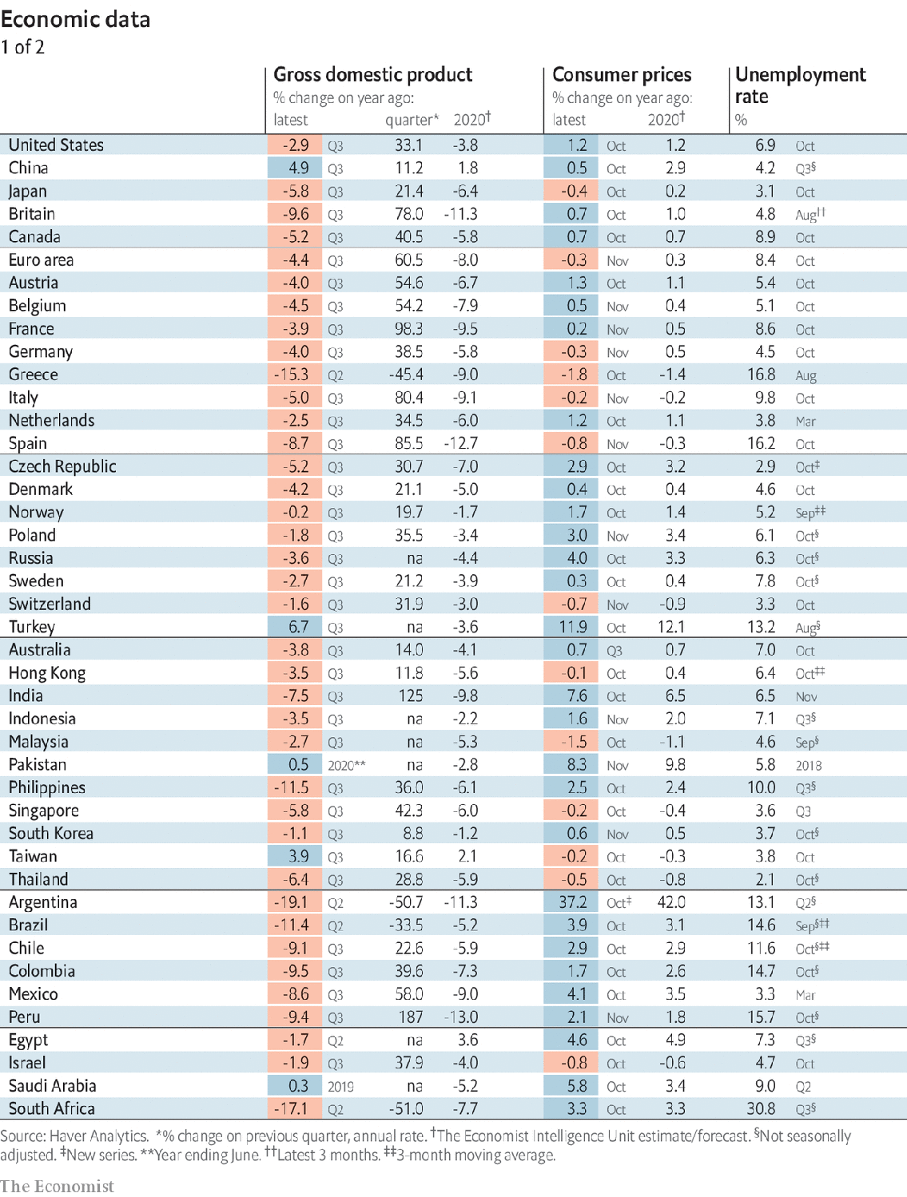

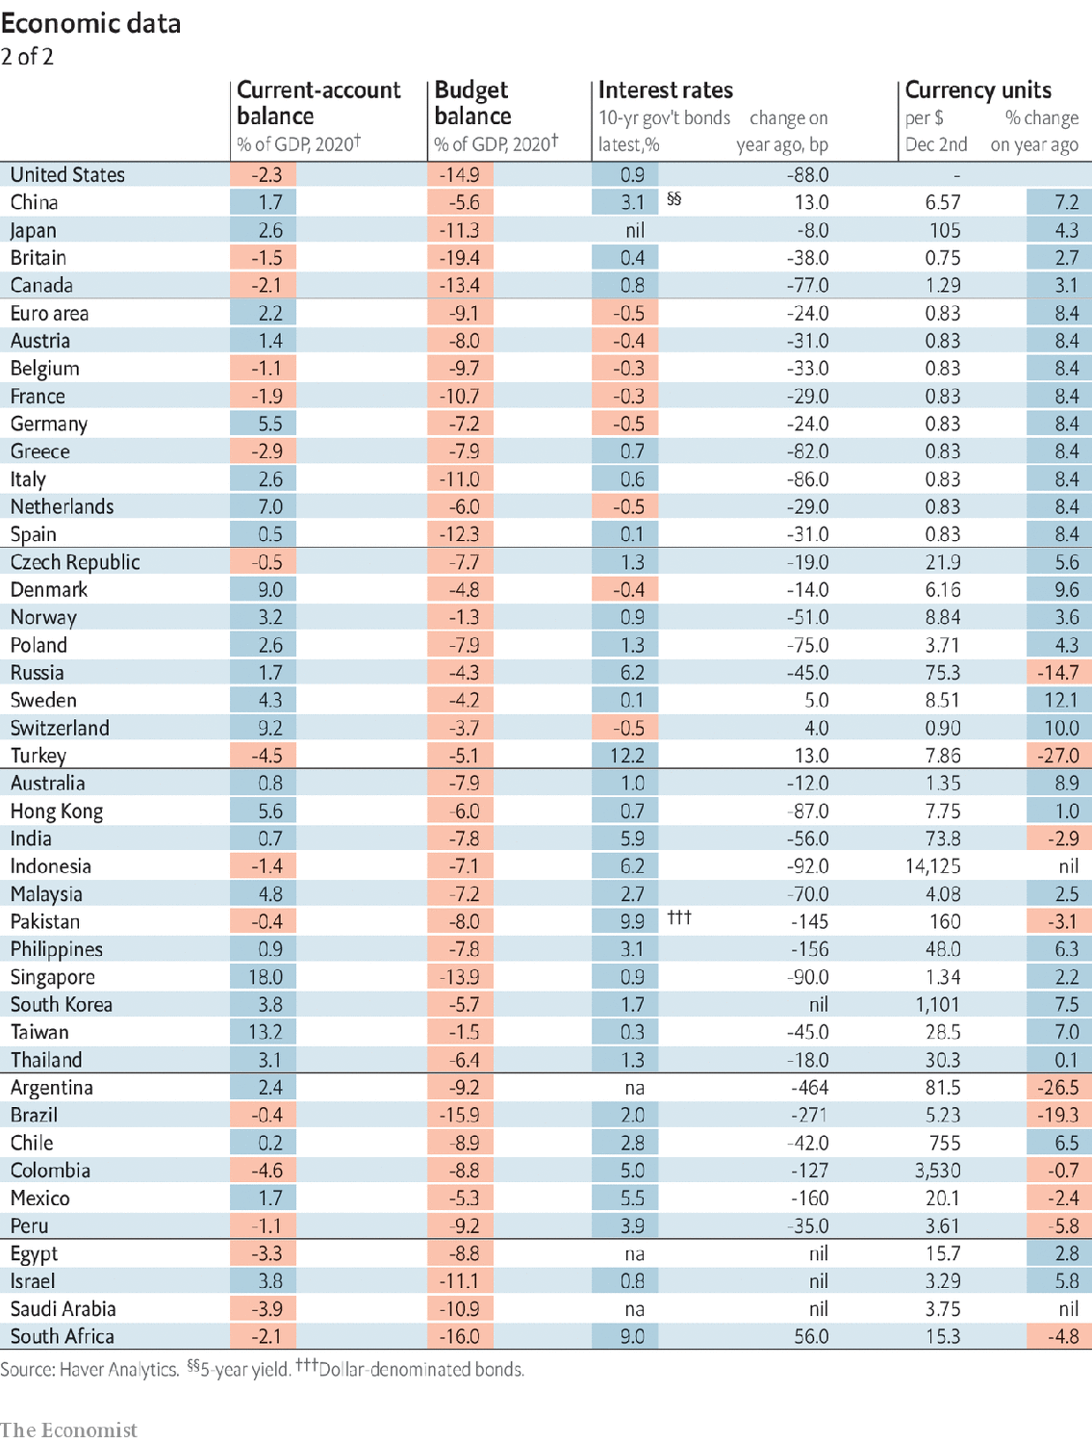

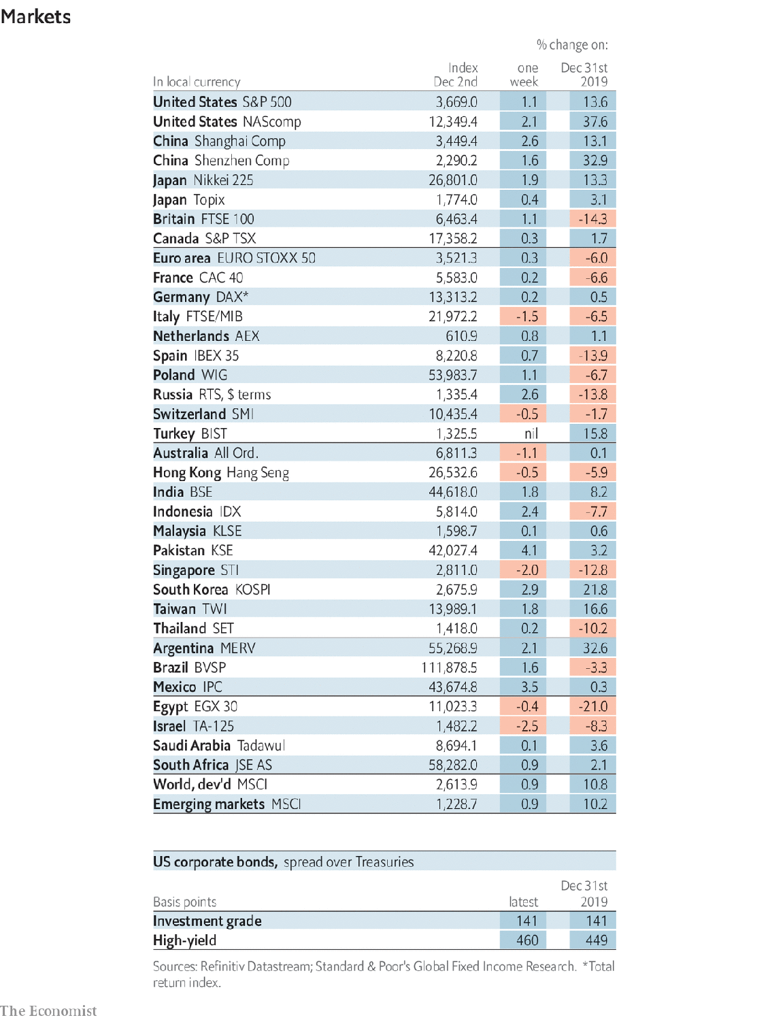

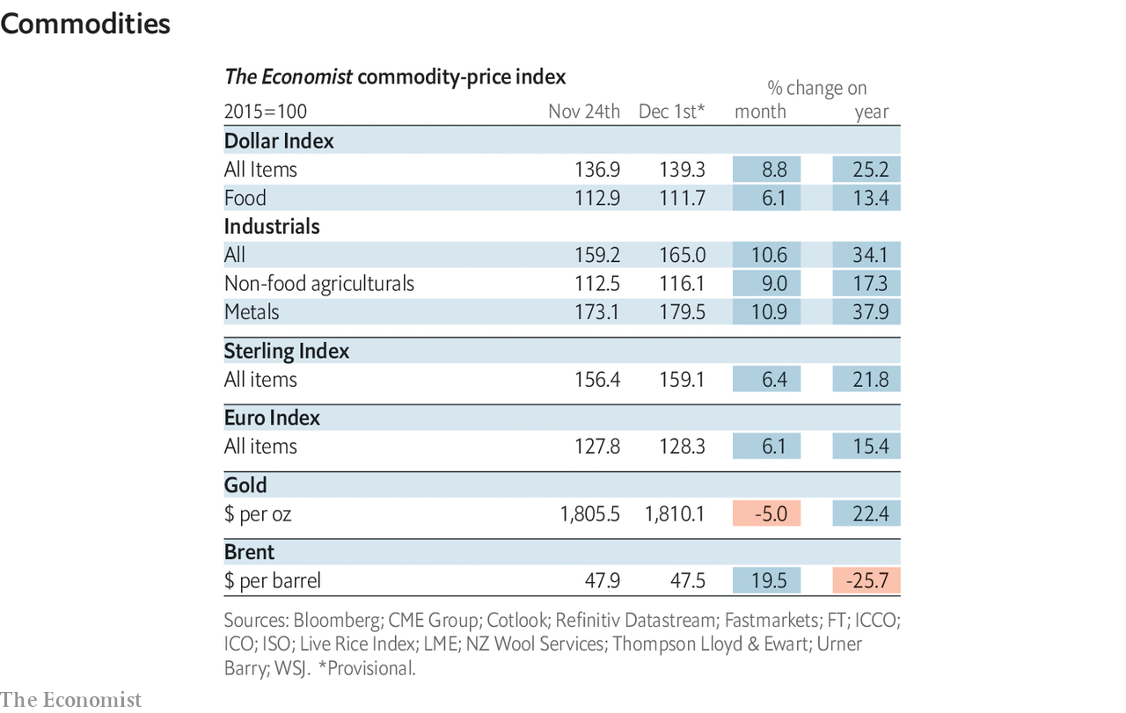

This article was downloaded by calibre from <https://www.economist.com/economic-and-financial-indicators/2020/12/05/economic-data-commodities-and-markets>

|  |  |  |  |
| --- | --- | --- | --- |
|  | Articles | Sections | Next |

|  |  |  |
| --- | --- | --- |
| Economic & ... | Sections | Obituary |

Graphic detail

Vaccines and stockmarkets: What goes up

.

|  |  |  |
| --- | --- | --- |
| Economic & ... | Sections | Obituary |

|  |  |  |  |
| --- | --- | --- | --- |
|  | Articles | Sections | Next |

#### What goes up

# A covid-19 vaccine helps people, but not some firms’ share prices

Consumer-durables stocks have sold off on news of vaccine breakthroughs

Dec 5th 2020 |



WHEN PFIZER and BioNTech, two pharmaceutical companies, revealed in November that their covid-19 vaccine was over 90% effective, health experts celebrated around the world. Stockmarkets, however, responded with a mere golf clap. The S&P 500, a technology-heavy index of big American firms, rose by just 1.2% that day.

There are at least two plausible explanations for this muted reaction. One is that investors already expected such success. Although markets’ views on vaccine prospects cannot be measured directly, Good Judgment, a consultancy that uses a group of “superforecasters” to make predictions, offers a proxy. In April it began publishing a daily probability that enough vaccines to inoculate 25m Americans will be distributed by March 31st 2021. When Pfizer released its results, the forecasters raised this value from 53% to 88%, showing that the outcome was indeed a surprise. (Pfizer’s own shares also rose by 7.7% on the news.)

That leaves the other probable cause of the markets’ mixed signals: a successful vaccine may not help companies that have benefited from social changes caused by covid-19. In one study testing this theory, Goldman Sachs, a bank, analysed how shares in each industry had responded to shifts in the odds of an early-arriving vaccine. It found that technology companies, whose products have enjoyed faster adoption during lockdowns, lagged behind the market when vaccine prospects improved. Conversely, energy and materials firms rallied the most under such conditions.

To expand on this research, we have applied its “excess return” calculation—performance relative to market averages—to all listed firms worldwide worth at least $10bn, on every day since April 27th. We then measured the relationship between each company’s excess returns and daily changes in the superforecasters’ estimated probability of mass vaccination by March 2021. Finally, we grouped the results by industry, breaking out the sub-sectors most likely to show large effects.

This method yielded a more intuitive list of winners and losers. Hotel, restaurant and airline shares have traded closely in line with the vaccine’s estimated arrival date. In contrast, consumer-durables firms—including manufacturers of swimming-pool supplies, appliances and exercise bicycles—tended to trail behind the market when vaccine producers made breakthroughs, and beat it when they suffered setbacks. Health-care stocks (save those of vaccine makers themselves), and technology and e-commerce firms buoyed by lockdowns, also showed this pattern.

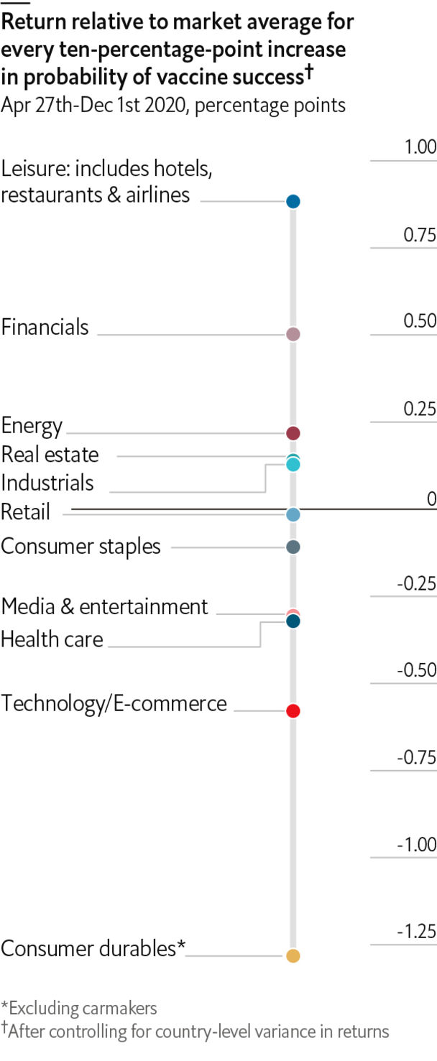

However, we also found more surprising results. Financial firms’ fortunes tend to mirror the broader economy, but the link between progress on vaccines and financial stock returns was unusually strong—nearly as robust as for leisure companies. Banks, which have made big provisions for loan defaults, would enjoy a windfall if such losses do not occur. And credit-card issuers like American Express will gain from the return of international travel.

Meanwhile, retailers’ share performance has been curiously uncorrelated to vaccine news. When Pfizer announced its results, shares of discount department stores like Burlington, Ross and TJX surged. However, those of big-box stores such as Best Buy and Target sold off—perhaps because investors expected consumers to switch to other types of spending once they feel safe travelling and mingling again. ■

Sources: Good Judgment; Bloomberg; The Economist

This article was downloaded by calibre from <https://www.economist.com/graphic-detail/2020/12/05/a-covid-19-vaccine-helps-people-but-not-some-firms-share-prices>

|  |  |  |  |
| --- | --- | --- | --- |
|  | Articles | Sections | Next |

|  |  |  |
| --- | --- | --- |
| Graphic detail | Sections |  |

Obituary

Diego Maradona: A boy and a ball

.

|  |  |  |
| --- | --- | --- |
| Graphic detail | Sections |  |

|  |  |  |  |
| --- | --- | --- | --- |
|  | Articles | Sections | Next |

#### A boy and a ball

# Diego Maradona died on November 25th

The best footballer of his generation, some say the best-ever, was 60

Dec 5th 2020 |

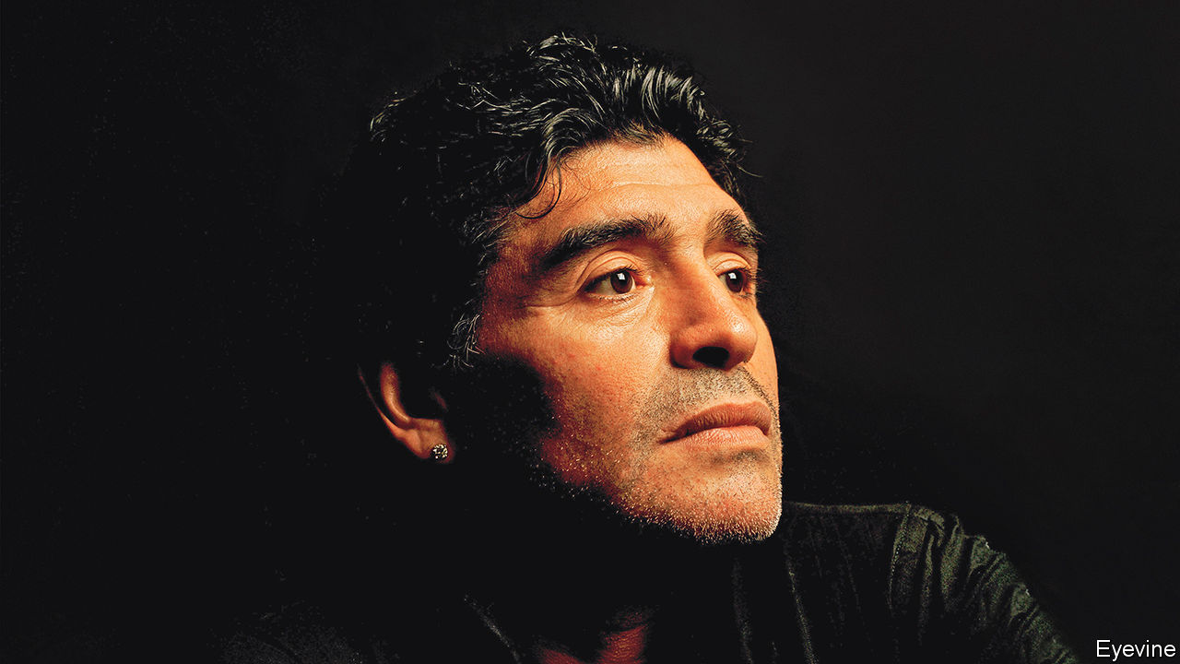

SENT ON AN errand, or packed off to school, Diego Maradona didn’t walk. He practised keepie-uppies, instep to thigh to back-heel to head, with anything roughly round he could find. Scrumpled paper would do, or an orange, or a ball of rags. Tac-tac-tac, on and on and on. Then he hopped on his right foot, especially up the steps of the railway bridge, while his left foot tried out skills. If no one was wanting him he would head for the waste ground of Villa Fiorito, one of the worst shanty-towns in Buenos Aires, but home to him, to have kickabouts with friends until night fell, or later.

He wanted nothing from life but football. He could live on it. Then, perhaps, he might have enough money to buy a second pair of trousers to replace the tired old corduroys he always wore, winter and summer. Little did he think that by 1986, after playing for Argentinos Juniors and Boca Juniors in the first division, at Barcelona and at Napoli, as well as in the national side, he would be able to have all the fine clothes he wanted, as well as all the flash cars; and that he would be on a podium in Mexico City, as Argentina’s captain, kissing and shaking the shining gold World Cup, hardly knowing what to do with it, except to keep it in his hands.

How had he been propelled so far, so fast? Evidently God, the Beard as he called him, had something to do with it. The Beard had plans for him, starting with the squat, strong body He gave him, and the huge thighs, which made it almost impossible to tackle him at speed. He filled him with love of the beauty and possibility of the game, and with talent that saw him transferred for record sums of money. There were other good assists, too. In the 1986 World Cup quarter-final against England, where God’s hand and his own fist shot up to engineer a goal he knew was illegal, the Beard then blinded the officials so they didn’t see it. Four minutes later the Beard helped out to create the goal of his life, allowing him to weave past five England players, trick the goalie with a dummy—tic—and put the ball in, tac.

A certain urchin cunning also helped. It showed in the way he played, revelling in tricks and touches: nutmegs, like his debut pass in his first game for Argentinos Juniors, straight through a defender’s legs; back-heel flicks and sombreros, kicking the ball over an opponent to retrieve it on the other side. Humiliating England, he said, was like stealing a wallet. Though he hated being called a hustler, he had to take every chance. It might look like cheating or deceiving, or it might be skill. The line was narrow sometimes. If it won games, it didn’t matter. His drug problems started in the same way: if ephedrine or cocaine gave him an edge over the opposition, fine. He was sure he could control it as sweetly as a ball, at the beginning. Things got a lot more complicated later.

What really fuelled him, though, was anger, bronca, fury tinged with resentment. Life in Villa Fiorito, in a struggling family of ten in a tiny corrugated-iron house on a bone-crusher’s wage, was a giant kick up the backside. He had to get out or go under, and defeat was unbearable. Because he was so small and young in his first teams, he was sometimes left on the bench, and couldn’t stand it. He would weep for hours, knowing he was as good as anyone, better, and could prove it. When César Menotti left him out of Argentina’s World Cup squad in 1978, when he was so up for it, he got his own back by leading the youth team to victory in the World Youth Cup the next year. He did not forgive Menotti. Most of the coaches and managers he dealt with, he thought, betrayed him somehow. They held him back, or forced him to train when he preferred to sleep. One even tried to teach him a sliding tackle, down to the ground. He would never go down to the ground, unless pushed.

Sometimes his longing for revenge went as far as war. When Barcelona lost the final of the Copa del Rey, Spain’s FA Cup, in 1984 to Athletic Bilbao, and a Bilbao player gave him two fingers, he started a mighty brawl on the pitch in front of the king himself. In 1986, marching out to take on England, his mind was full of Argentina’s defeat in the Malvinas not so long before, and the Argentine boys who had died there, killed like little birds.

It was not only his country he wanted to defend but, often, himself. The media infuriated him, to the point where he once opened fire with an air rifle on a posse of reporters who came to his house. They hammered him over women and, especially, drugs. Those had led to a 15-month ban at Napoli in 1991 and in 1994 to his ejection from the World Cup in the United States mid-tournament, but he argued that he was largely innocent. At Barça he had got into the habit of testing himself, and found himself quite clean. In 1994 he blamed his personal coach for giving him a power drink full of American chemicals. As for his hobnobbing with the Camorra crime syndicate at Napoli, he considered them protectors and nice people, who gave him gold Rolexes and seemed to want nothing in return. But then he never had much of a handle on his business affairs. He left those to others, while he had fun.

In other ways Napoli showed him at his best. He went to a poor, volatile southern city, scorned by the rich north, and won major trophies for it, the first it had ever had. He was revered as a saint for restoring its pride by thrashing everybody else. And of course he had done that first in Argentina, idolised like God himself for salving with his brilliance the loss of the Malvinas and the junta years. Yet winning the World Cup, he mused as he came home, had not brought down the price of bread. Only politicians who spoke for the masses could do that. So he was both a Peronist and a chavista; Fidel Castro (whose beret he begged from him) was tattooed on his left leg, Che Guevara on his right arm. He told the pope that he should sell the Vatican’s gold ceilings to feed the poor.

As he grew stouter and sicker, he coached the national side and returned as director of Boca Juniors, the team he had most wanted to play for as a boy. His aim stayed just the same, to bring joy to people with a ball. He was el Diego de la gente, the people’s player. And despite the force of the kick that Villa Fiorito had given him, up to the stars, he still felt he had those corduroy trousers on, the old pair he always wore, winter and summer.■

This article was downloaded by calibre from <https://www.economist.com/obituary/2020/12/05/diego-maradona-died-on-november-25th>

|  |  |  |  |
| --- | --- | --- | --- |
|  | Articles | Sections | Next |